Dear Santosh Moily & Family,

Thank you for your blessings for the wedding.

I would also like to bring to your notice about my Giveindia.org Pledge page where in you get a chance to donate some money, in case you did not get a chance to look at it. You can find more details on [this page](http://www.latish-sherigar.com/marriage_gift.html).

Here are some of your friends who donated.

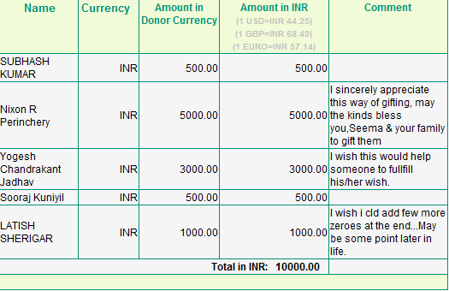

|  |
| --- |
| Regards, |
| Latish & Seema |