Deliverable3

Models have been created individually for each of the product and each of the balance just to understand how the 4 channels and 8 outreaches impact them.

For instance: 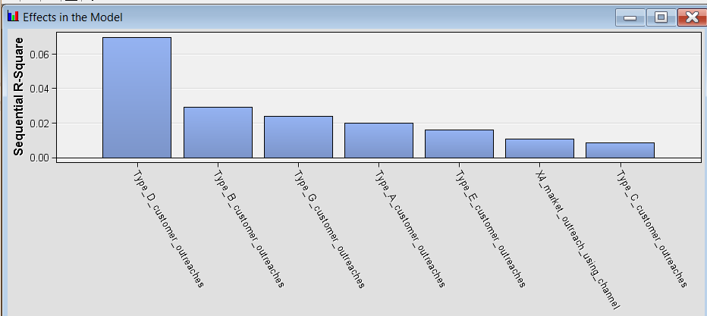

Effect of outreaches and channels on the product purchase of c type products

**Similarly we found which customer outreach is impacting other products and other balances**

**We have found out that channel 3 has no impact on the product purchase.**

**Impact of channels:**

**Channel 1 : 231 out of 571 product purchasing customers had channel 1 impact**

**Channel 2 : 428 out of 571 product purchasing customers had channel 2 impact**

**Channel 4: 110 out of 571 product purchasing customers had channel 4 impact**

**Hence among the four channels 3rd is of no impact and 2nd channel is of highest impact for customers purchasing products.**

**Channels and demographic regions.**

**Among the 25 demographic regions we observed the concentration of channel impact is not uniform.**

**1 is represented by demography ai=1 aii=1 and so on**

**Purchasing customers are related to demographics of (ai,aii) (1,1),(2,1),(2,2)(2,3),(3,1),(3,4),(4,4),(5,5)**

**We also observed that demographic customers of ai=2 have highest tendency of purchase.**

**Orange represents channel 2 , blue represents channel 1 and grey represents channel 4.**

**Channel 2 Not only has high impact but also targets the demographic of ai=2**

**Increase In balance**

**Individual balances of account A,B,C have been studied and model are created .**

**Based on insights we found that**

Customer outreaches of type A,B,D and G have a significant positive impact on increase in overall balances. Channel 1 has the maximum positive impact in increasing the balance. Outreaches of type C, E have minimal effect.