**Project Overview:**

This purpose of this project is to create a program which can be used to book flights in a manner similar to air travel sites like expedia.com.

Functional Requirements:

1- The program should utilize a graphical user interface(GUI) for user inputs and display a splash screen on start up.

2- The program should be able to create and store user accounts and information

3- There should be two types of users accounts: admins and customers. The admins will have additional permissions beyond a customer.

4- The program should allow for new users to register. Registration will involve the input of user information including such as first name, last name, address, zip, state, username, password, email, SSN and a security question for password recovery.

5- Users who have already registered should be able to login by entering their username and password.

6- Program should allow a user to retrieve their password by providing username and answering their stored security question.

7- There should be a main menu that prompts the user to log in or register.

8- There should be a database that stores information on user accounts and flights.

9- The application should track each flight’s maximum passenger capacity and keep track of the amount of passengers booked for each flight.

10- After logging into the application, users should be able to perform the following actions:

10.1- Search flight database for flights based on various parameters such as criteria from city/ to

city/ date and time of flight etc.

10.2. Book a flight and add it to their account.

10.3. Delete booked flights from their account.

11- The application should alert users and prevent the user from booking a flight in the following scenarios

11.1- The flight is full.

11.2- There is an overlap between the date and time of a flight the user is attempting to book and a previously booked flight

11.3- The user has already booked this flight once

10.5. If there is a conflict about date and time of a flight, application should warn the customer about this and should not let user book the conflicting flight.

12- The application should track each flight’s maximum passenger capacity and keep track of the amount of passengers booked for each flight.

13- A user with an admin account should be able to add, update or delete a flight in addition to all the actions available to a customer account.

14- Users should be able to logout; previously booked reservation should be there in his/her account.

15- The program should provide an option in any case to return to main Main Menu from any page.

**Functionality and Flow**

1. Program starts with a Login screen
   1. Contains a 2 textfields in which a user inputs their username and password. Clicking login will send them to the flight menu
   2. Contains a Registration button which will send them to a Registration form screen
      1. Several textfields will ask for the user’s information and clicking submit will add their data to the User table by a INSERT query.
2. Flight Menu
   1. Several textfields on the left side allows the user to type in certain information on a flight such as the Destination and date.
      1. Clicking the Search button will send a SELECT query for the specified textfields.
   2. When a flight is searched, it will display in the ListViews in the middle. If a flight is not found, a dialog will say a flight was not found.
   3. A user can book a flight only based on the Flight ID. They must enter it into a textfield and click submit to send a INSERT query for the specified Flight ID into a randomly generated Booking.
   4. Clicking Add a Flight will send the user to a Add a Flight screen
   5. Clicking View Account will show a user’s booked flights
   6. Clicking Logout will send the user back to the login screen
3. Add a Flight
   1. Several textfield ask for certain information about a flight such as the ID, Destination, and Origin.
   2. Clicking Add Flight will send a INSERT query to the Flight table. A user will get a response saying it was added.
   3. Clicking Main menu sends the user back to the Flight menu
4. View Account
   1. The User must click “Click to view my Flights” to display their flights in the ListViews. It only shows the Booked flight and Flight ID; the user can go back to find the specific information on their flight.
   2. A user can delete a flight by typing in a Flight ID and clicking Delete. This sends a DELETE FROM query to the Booking table and removes the specified Flight ID.
   3. Clicking Flight Menu sends the user back to the main flight menu.

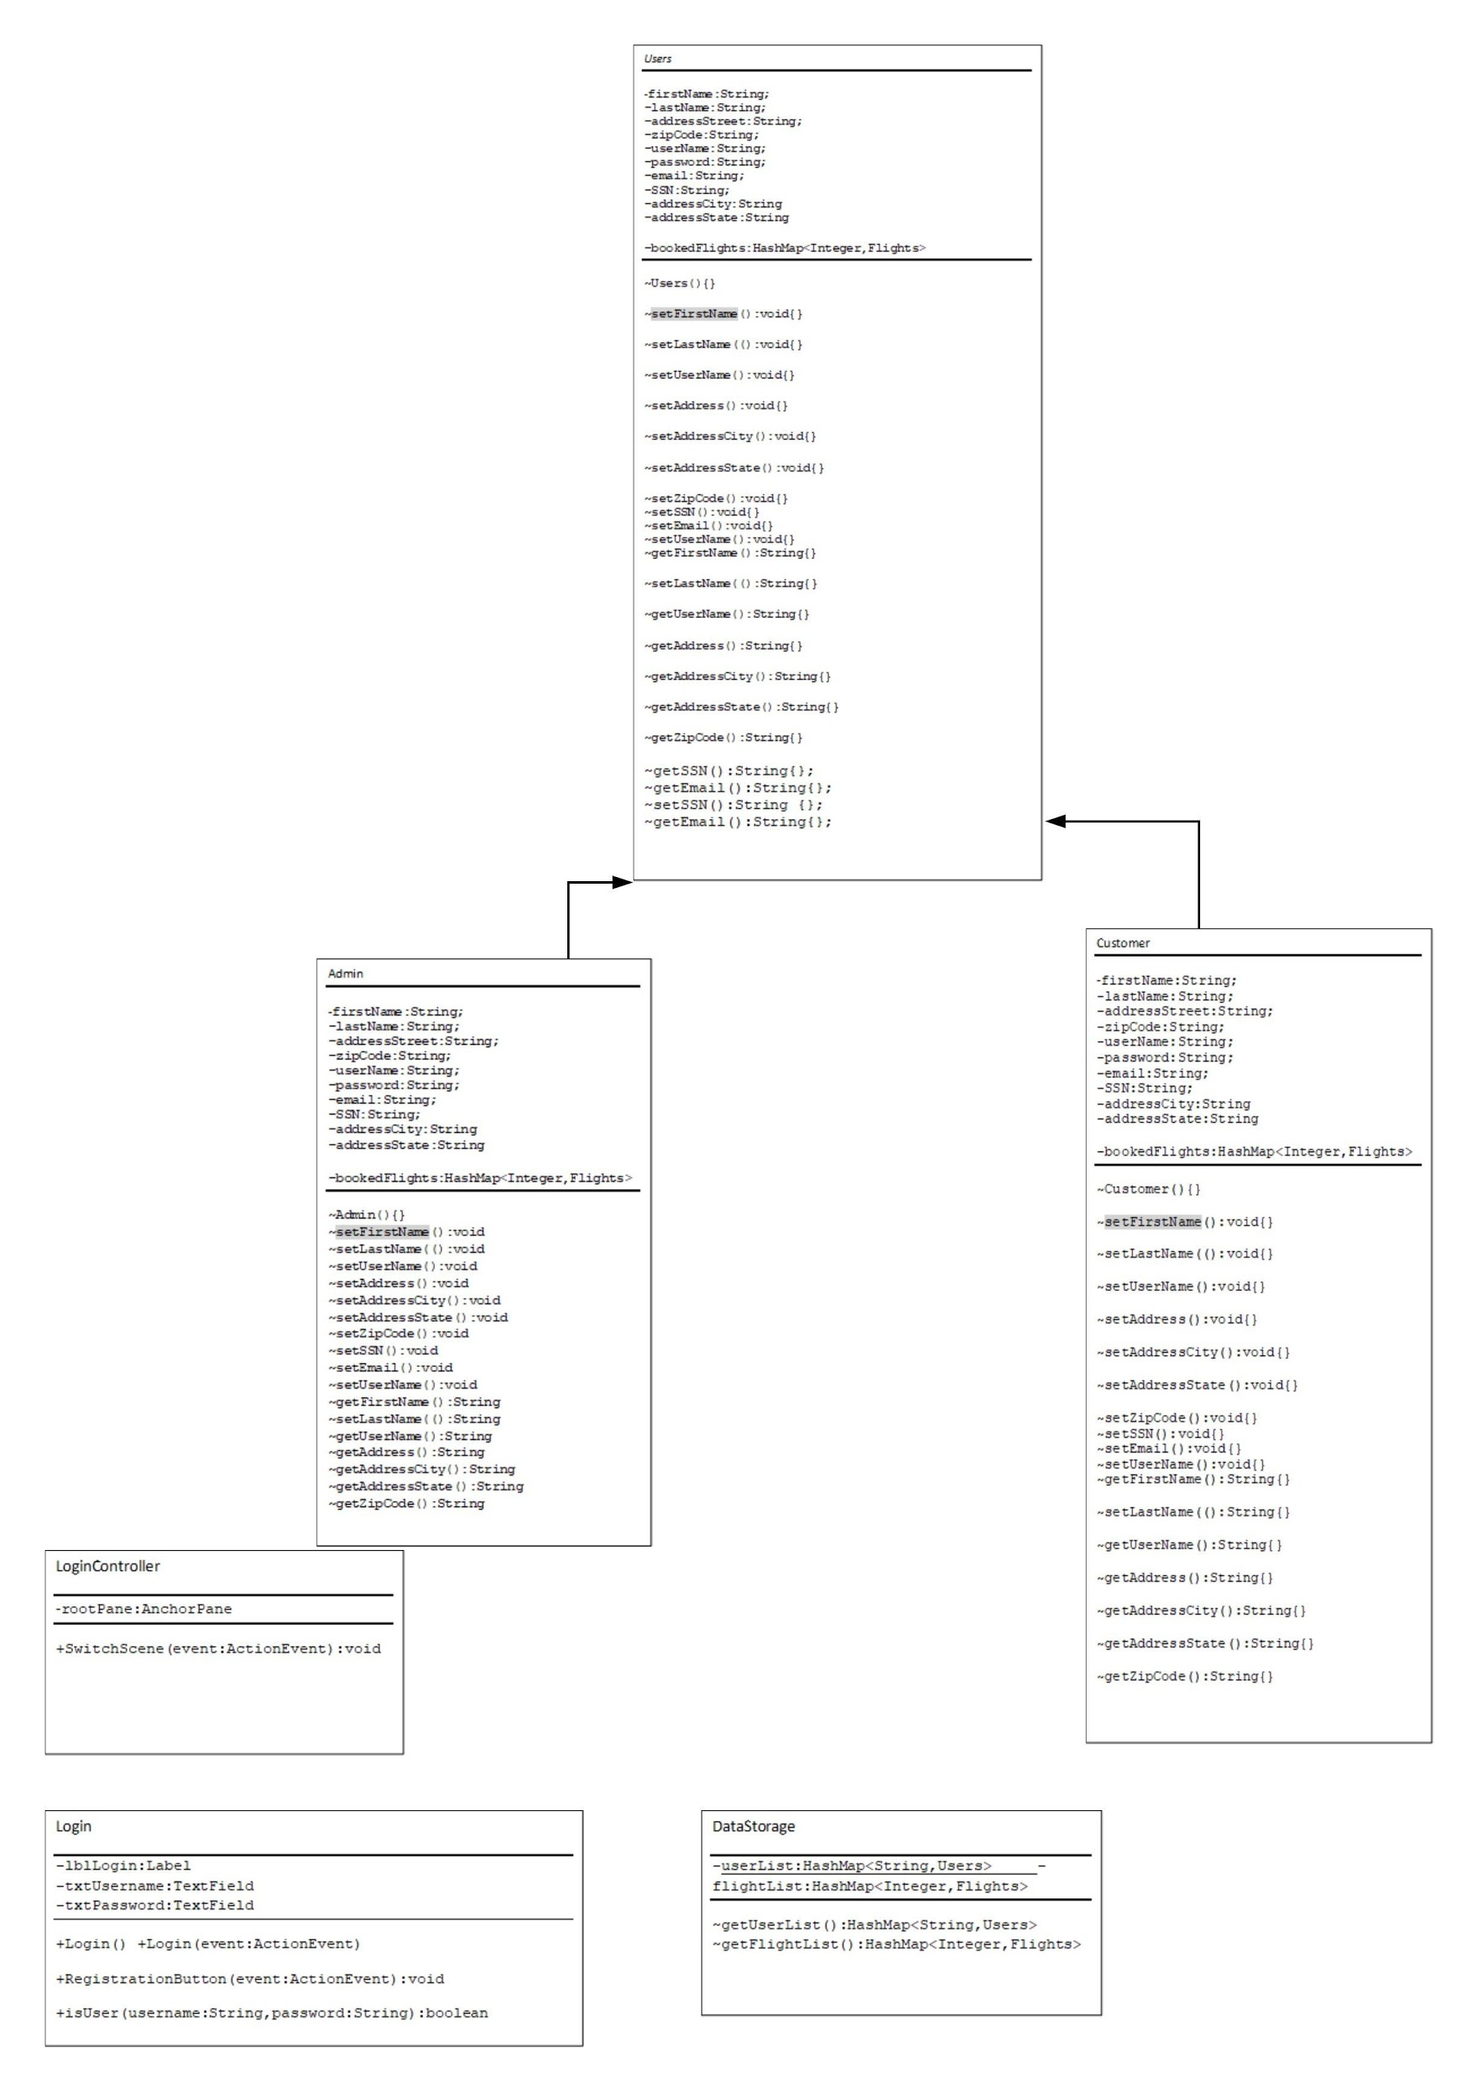

Functionality and Flow

