Machine Learning hw3

Nan Hu

Experiment 1

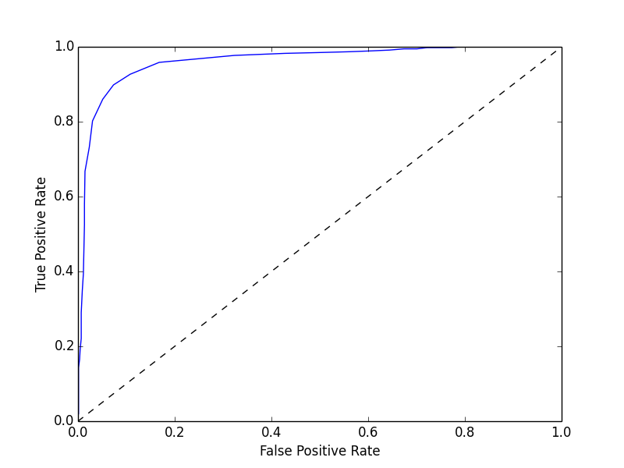

I am using SVM light package with python to do this homework.

My C is 0.5

Accuracy on test set: 91.29% (1655 correct, 158 incorrect, 1813 total)

Precision/recall on test set: 92.47%/90.04%

Experiment 2

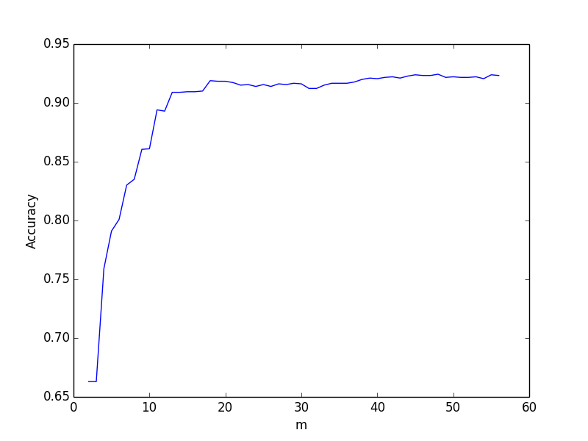

My top five features are char_freq_$, word_freq_000, word_freq_edu, word_freq_remove, word_freq_our.

We know that weight vector can decide the bias. Therefore, features that have highest absolute weight vector value means these features are little easier to classify than the other features. In this opinion, we are selecting the most important features that we can classify.

Experiment 3

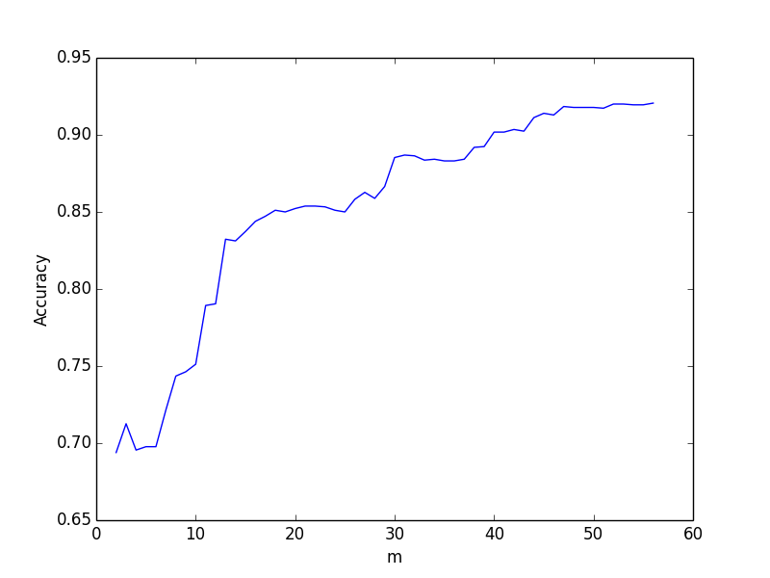

Since I did not selecting the most important features from start. The accuracy starts lower than the experiment 2. In addition, it is not growing fast as the number of features selected as experiment 2 which is make sense. We also can see that the final accuracy is pretty much the same when number of selected features get to close to 57.