Machine Learning

Homework 5

Nan Hu

Experiment 1

Accuracy: 0.793544796884

Sum Squared Error: 2478872.37873

Sum Squared Separation: 56837.3910721

Mean Entropy: 0.801686306287

Confusion Matrix:

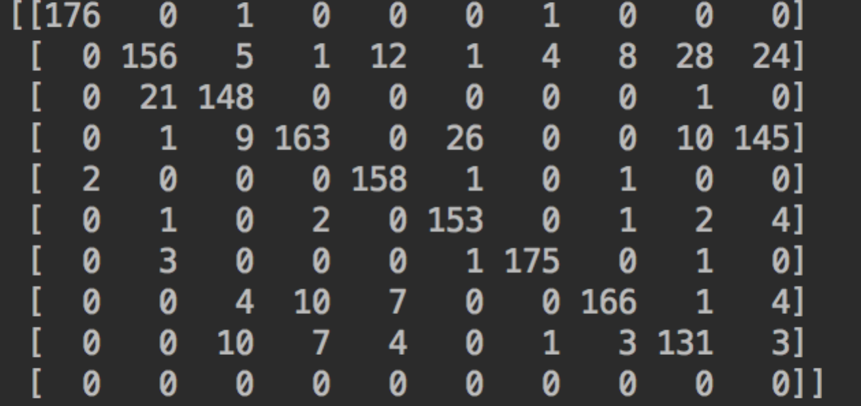





The order of these virtualize centers:

[2, 8, 1, 3, 7]

[1, 0, 6, 4, 5]

Experiment 2

Accuracy: 0.886477462437

Sum Squared Error: 2069038.3401

Sum Squared Separation: 1320059.90114

Mean Entropy: 0.491788933359

Confusion Matrix:

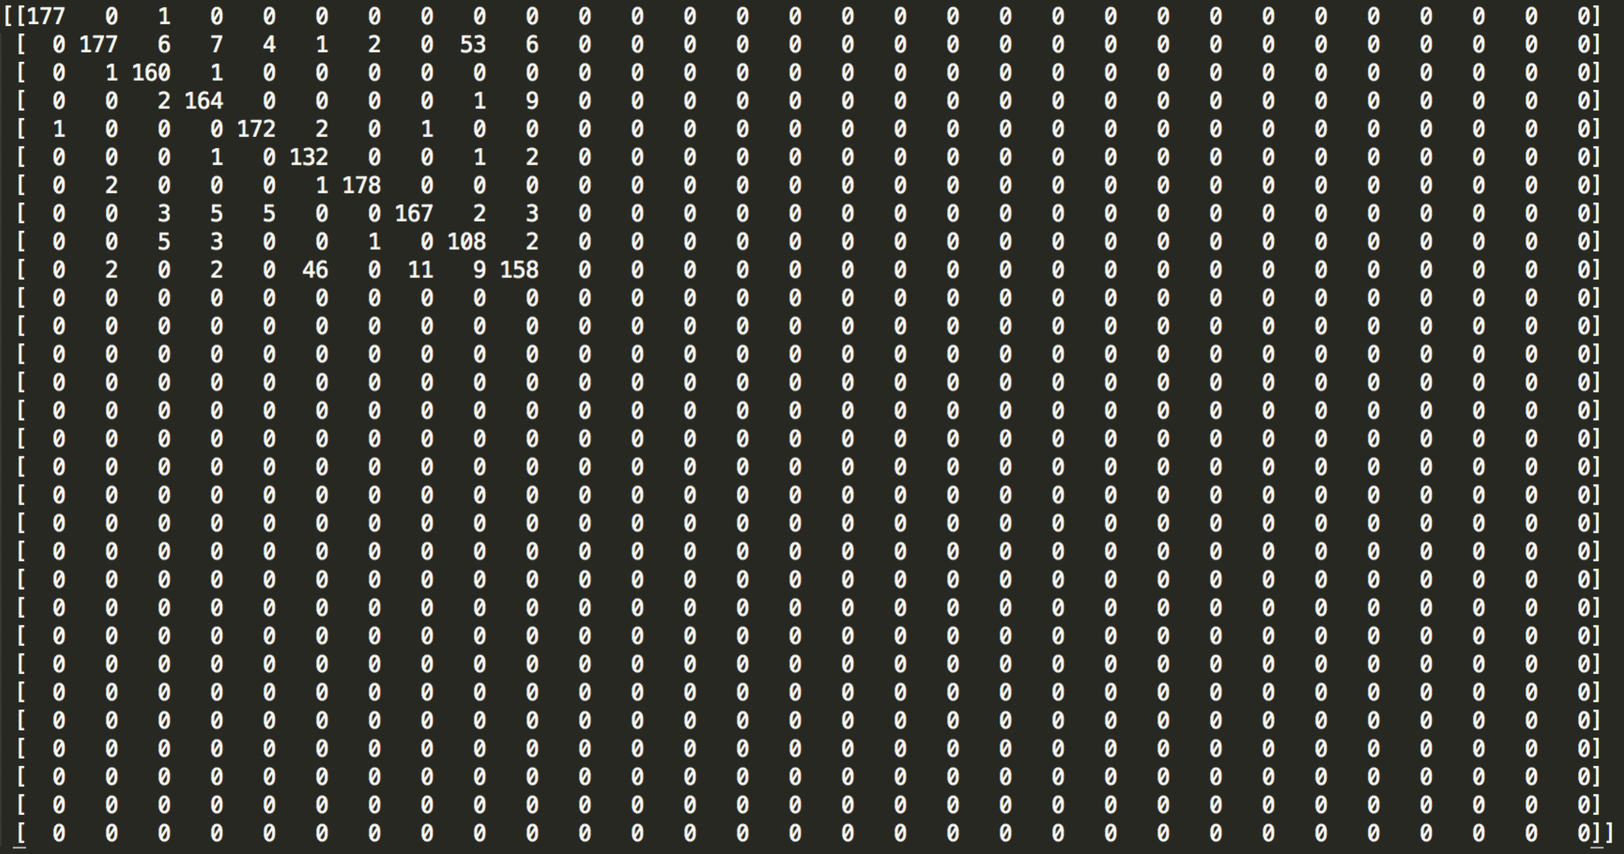

[4, 1, 28, 29, 2, 3, 18, 8, 9, 6, 4, 6, 12, 2, 3, 4, 21, 5, 1, 7, 1, 8, 5, 0, 26, 7, 24, 1, 9, 3]