Machine Learning hw2

Nan Hu

Experiment 1

Learning rate 0.3

Momentum = 0.3

Hidden units = 4

Epoch = 100

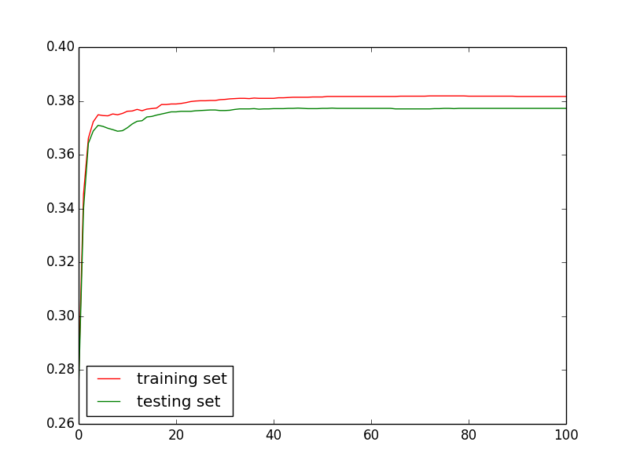

Experiment 2.1

Learning rate 0.05

Momentum = 0.3

Hidden units = 4

Epoch = 50

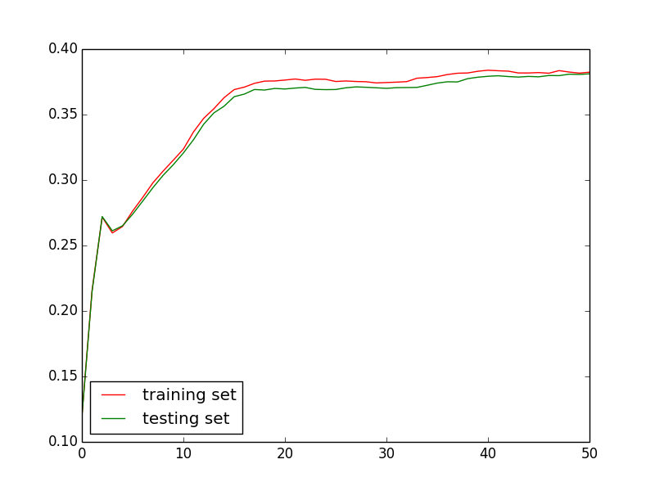

Experiment 2.2

Learning rate 0.6

Momentum = 0.3

Hidden units = 4

Epoch = 50

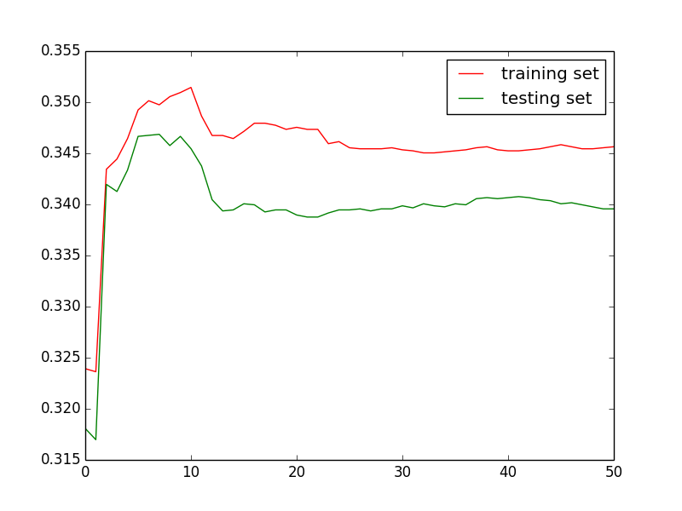

Experiment 3.1

Learning rate 0.3

Momentum = 0.05

Hidden units = 4

Epoch = 50

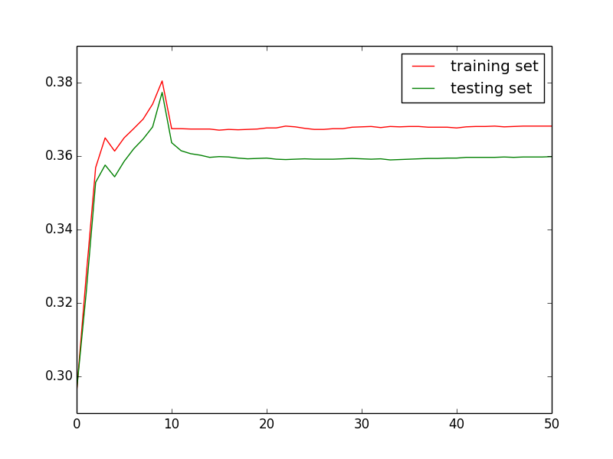

Experiment 3.2

Learning rate 0.3

Momentum = 0.6

Hidden units = 4

Epoch = 50

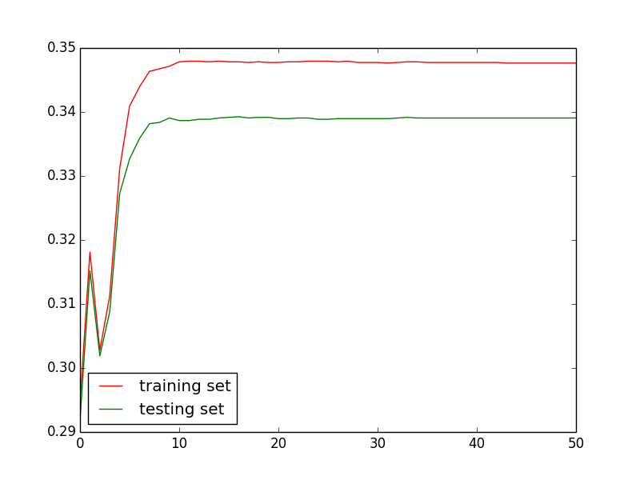

Experiment 4.1

Learning rate 0.3

Momentum = 0.3

Hidden units = 2

Epoch = 50

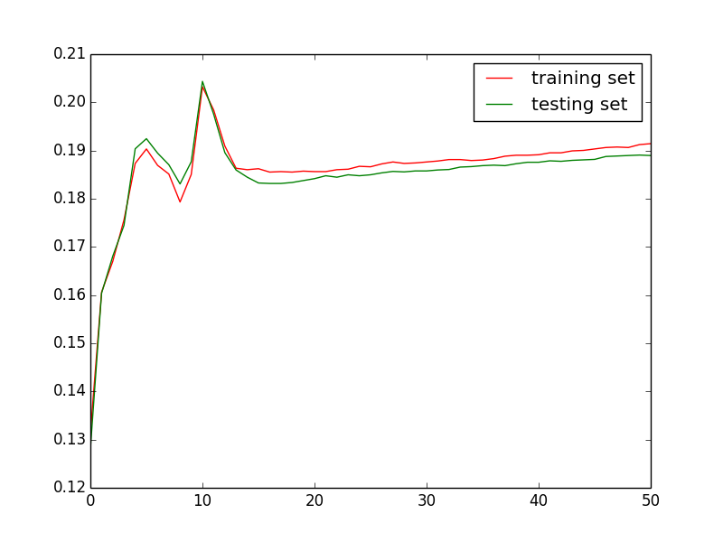

Experiment 4.2

Learning rate 0.3

Momentum = 0.3

Hidden units = 8

Epoch = 50

