CS510 Computer Vision

Project1

Color Transfer between images

I used two sunset picture described in paper which are:

This is the input I use for source image

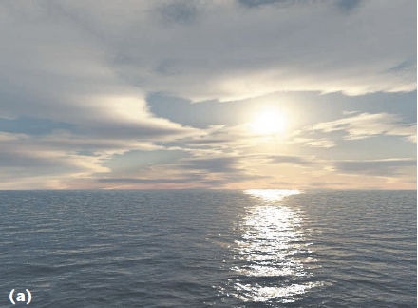

This is input I use for target image

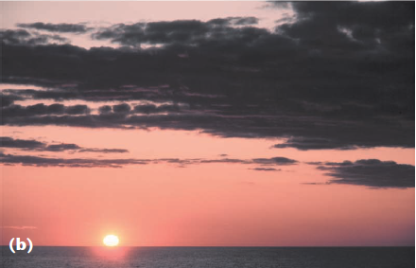

The output will be the picture that shows below

This is the output I have.

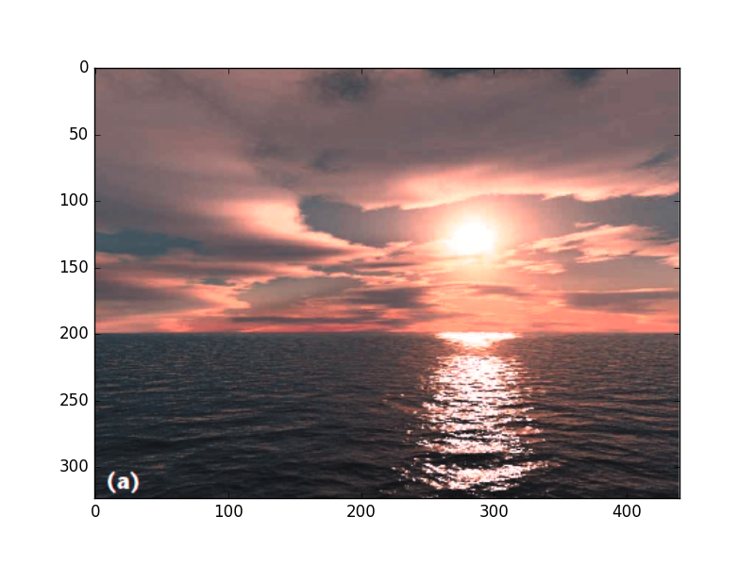

This result is based on the algorithm from research paper. I follow exactly the same step on the paper to get the result.

Here is the other two color space result. Both of then are using the same result for the first run.

The first one is RGB channel:

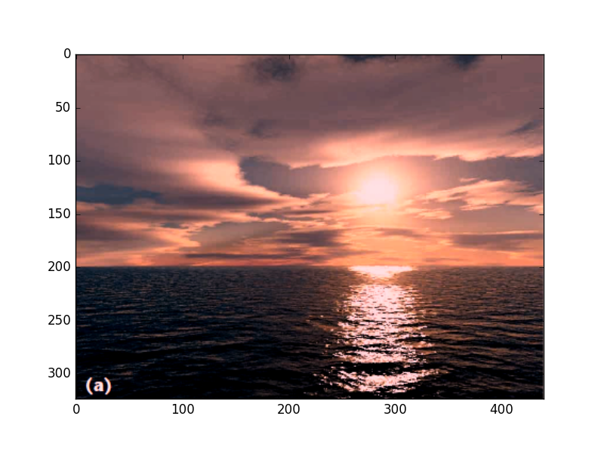

The other luv color space result shows here:

