# CSE2MAD Lab 4 – broadcast receivers

AIMS

Today we will me making 2 apps, one to Broadcast a message and another to receive the broadcast.

Step 1 – Making the Broadcast application UI

We are to send a custom broadcast to another app and handle the broadcast via a Context-registered receiver.

1. Create a new project & choose the empty activity template. (See week 1 lab)
2. Create a new Android Project using API 25: Android 7.1.1 (Nougat)
3. Create the UI in the visual DESIGN view for the main activity as in Figure 1. If you need a hint see the component tree in Figure 2 and layout code from previous labs.

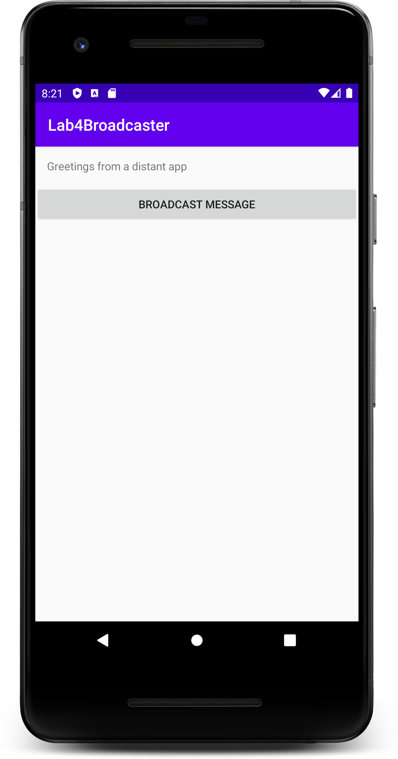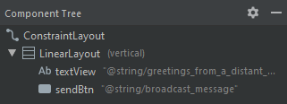

Figure 1 Figure 2

Step 2 – code the Broadcast application

1. In the MainActivity.java file do your regular setup and initialisation of the UI widgets, add a listener to onClick event from the button and call a method to send a broadcast.

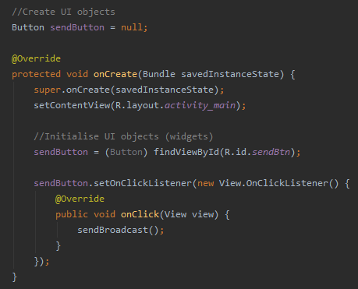

1. Add the method to send the broadcast

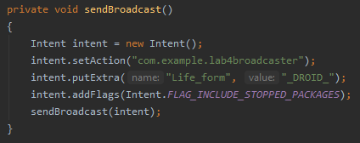

Remember from the lecture, this is the package name and will vary depending on how you have set up your project

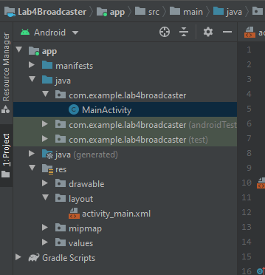

You can check by looking at the package name in the project files.

We are now broadcasting to all potential listeners. This is an asynchronous process, your code will continue while listeners process the broadcast.

Step 3 – Making the RECIEVER application UI

Now we are making the separate app to receive the broadcast.

1. Create a new project & choose the empty activity template. (See week 1 lab)
2. Create a new Android Project using API 25: Android 7.1.1 (Nougat)
3. Create the UI in the visual DESIGN view for the main activity as in Figure 3. We do not need a linear layout this time as all we have is one view (the textView) which can be constrained directly. If you need a hint see the component tree in Figure 4.

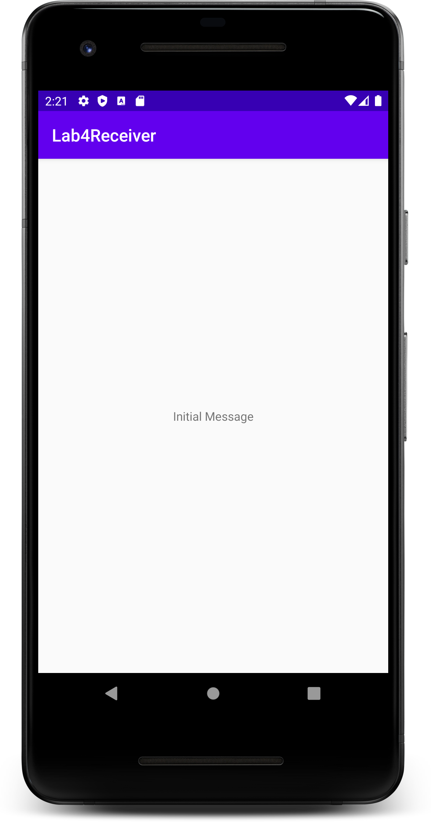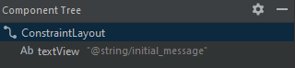

Figure 3 Figure 4

Step 4 – CODE the RECIEVER application

1. In the MainActivity.java file do your regular setup and initialisation of the TextView.

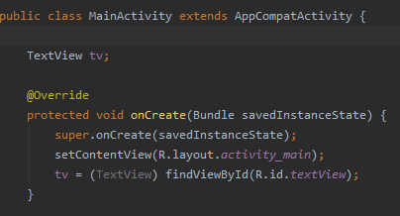

1. In the onCreate() method add an Intent Filter to specify which broadcasts your application will receive.

This is the package name from the Broadcast application we made initially, as that’s the broadcast we wish to receive in this filter.

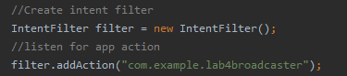

1. Now we need to make the Broadcast receiver, right click on the package name and select New > Other > Broadcast Receiver and in the resulting pop up set the name to **MyStandAloneReceiver**. A new java file will be generated

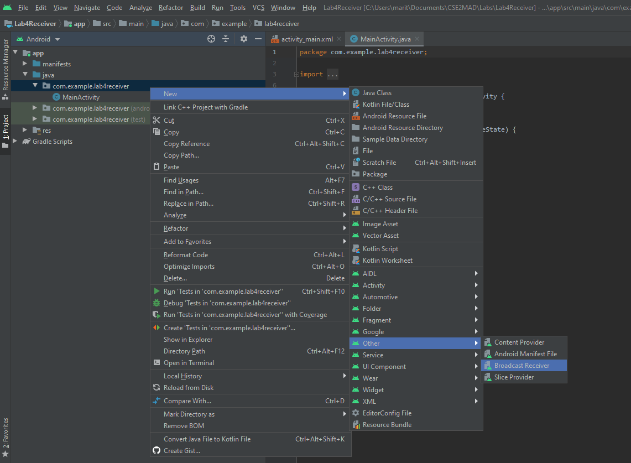

1. Navigate to the newly created **MyStandAloneReceiver.java** file**.**  Now we need to add code to the receiver, to extract the message and generated a toast message for the user to view.

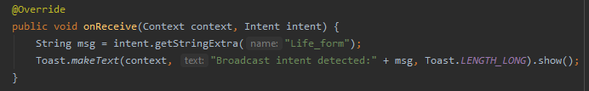

1. In the MainActivity.java file add a member variable for the broadcast receiver.



1. And instantiate the receiver object, using it and your previously created filter object to register the receiver. If you are wondering where this code belongs think about at what stage of the android lifecycle do you want to start receiving broadcasts?

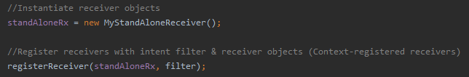

1. Add the onDestroy() method to unregister the reciever is the activity is destroyed. Why would you do this?

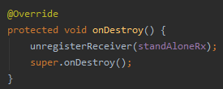

Now run both apps on your emulator/hardware, navigate to the Broadcast app (with the receiver in the background) and click on the broadcast message, you should receive the toast message as below;

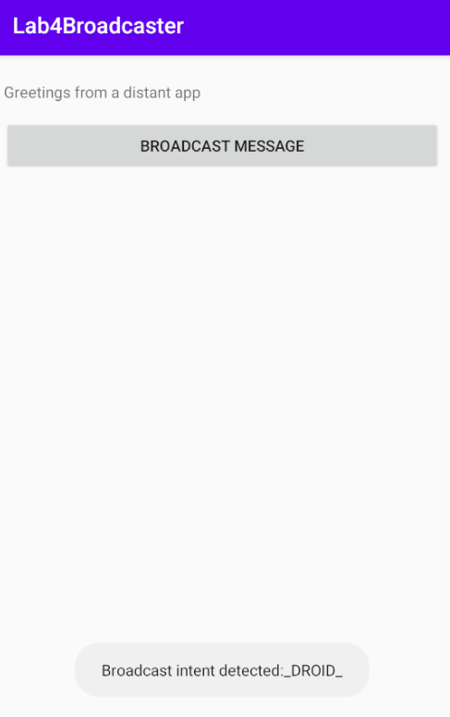

Step 5 – add a subclassed broadcast reciever (OPTIONAL BUT Recommended)

There are some instances where you would like the receiver to interact directly with an activity, in these instances you can create a subclass within the activity itself. Now we will add a receiver as a subclass but listen for the same broadcast as the MyStandAloneReceiver.

1. As per the stand alone receiver we will need to add a member variable for the broadcast receiver.



1. And instantiate the receiver object (subClassedRx), same as before, and using it and your previously created filter object to register the new receiver with the registerReciever(subClassedRx, filter) method.
2. Now we need to add the method receive the broadcast. This code will extract the message from the broadcast and display it in the TextView. As we have already registered the receiver in the onCreate() where do you think this code will go?

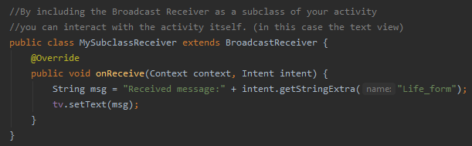

1. Finally unregister the subClassedRx object in the onDestroy() same as you did for the standAloneRx object.
2. Now run both apps on your emulator/hardware, navigate to the Broadcast app (with the receiver in the background) and click on the broadcast message, you should receive the toast message as previously but if you navigate back to the Receiver app the TextView content should have changed to reflect the message.

