

“Therefore what God has joined together, let no one separate." Mark 10:9

The Jackson Love Affair

Date: August 18, 2017

Location: Detroit, MI

Formal Invitation to follow.

Accommodations: Hotel reservations are available at the XXX in xxx, MI at a discounted rate of $XX if booked by xx/xx/xx. You must mention XXX when booking your reservation to receive the discounted rate.

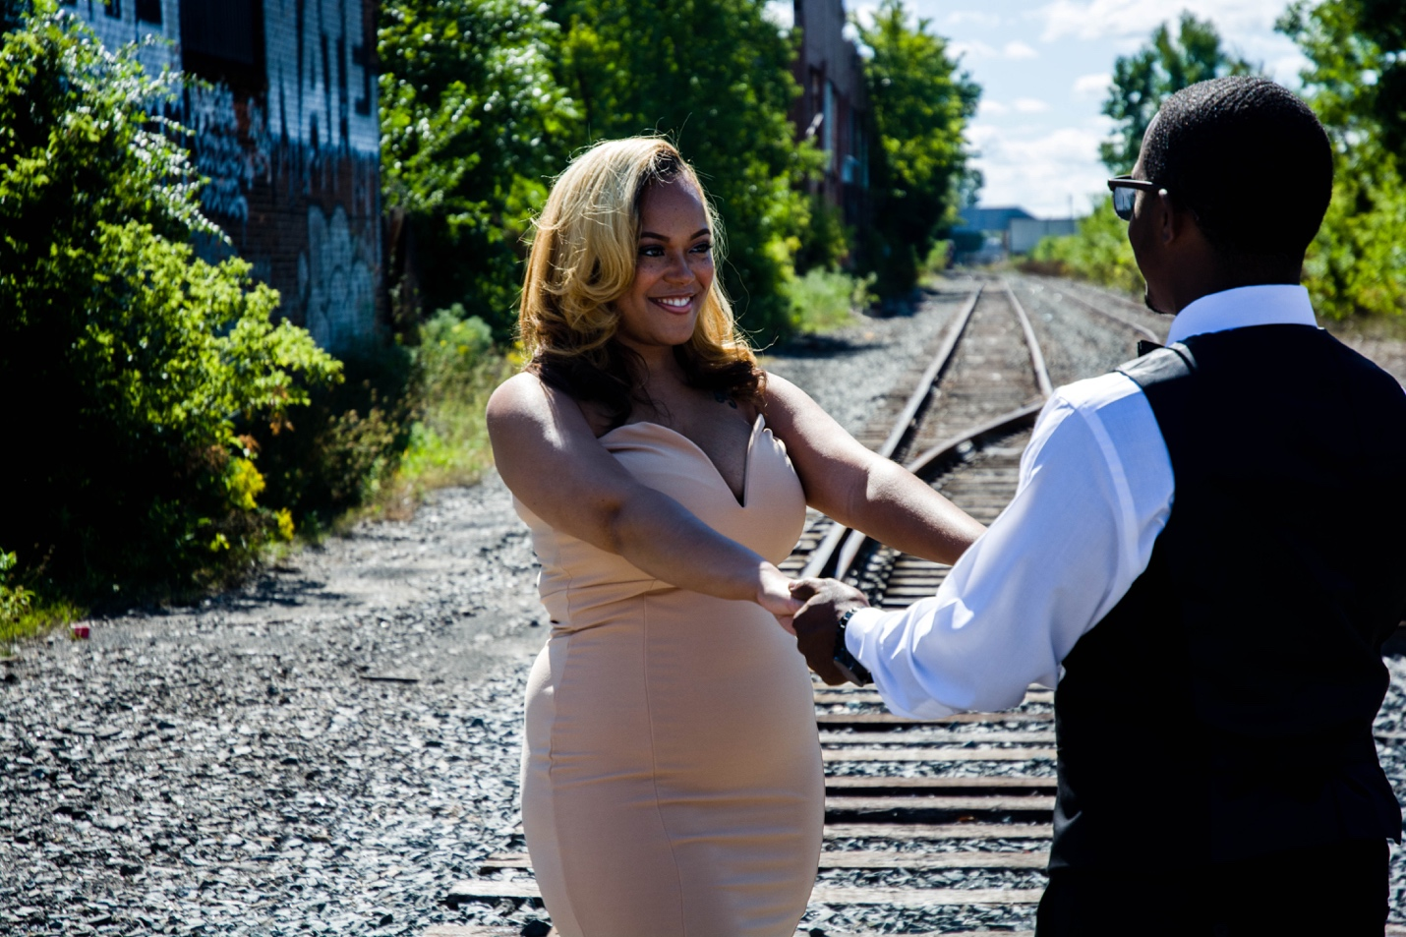

“Walking with your hands in mine and mine in yours, that’s exactly where I want to be, always.” —Fawn Weaver

corey’s quote:

I love you more than any word can say, I love you more than any action I take, I'll be right here loving you until the end.



As our special day approaches details will be updated on our exclusive website. This will be your primary source for all information related to #TheJacksonLoveAffair. We hope to see you all there!

With Love,

The Soon To-Be Mr. & Mrs. Jackson



Bride: Erika Elyse Willis

When I saw you I fell in love, and you smiled because you knew. William Shakespeare

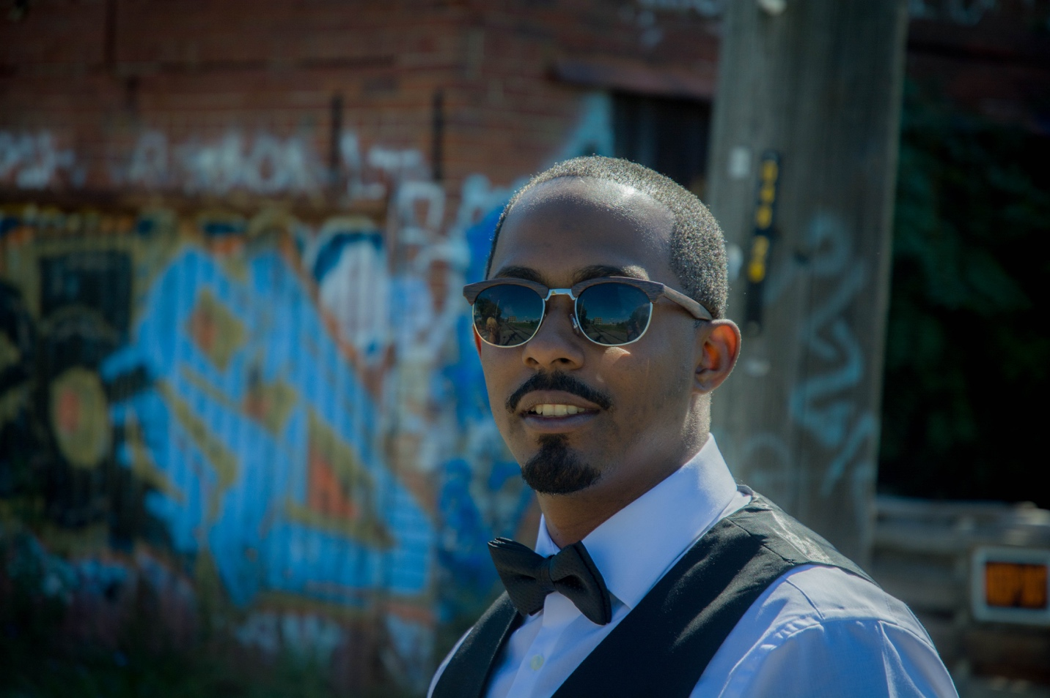

Groom: Corey Antoine Jackson

TBA



Our Love Story:

Corey and Erika met in 2006, during Erika's first week at Michigan State University. The two quickly developed a strong friendship, affectionately nicknaming each other "Fav" short for Favorite. As their friendship flourished their bond became evident to those closest to them, as they began to notice what Corey and Erika would soon find out...they were meant to be. March 14, 2009 the two officially began dating, an adventure that would lead them from East Lansing MI, to Orlando, FL as Erika went on to law school.  The two returned to their home in Detroit, MI in September 2013. Corey asked Erika to marry him on May 30, 2015 at an intimate dinner in Saint Clair Michigan, with friends. Shortly after the two decided to start off their new chapter in Los Angeles CA, where they currently reside.

**Today, and every day forward we trust those closest to us will support, encourage, and most of all pray for the fruitfulness of this union.**

**Bridal Party**

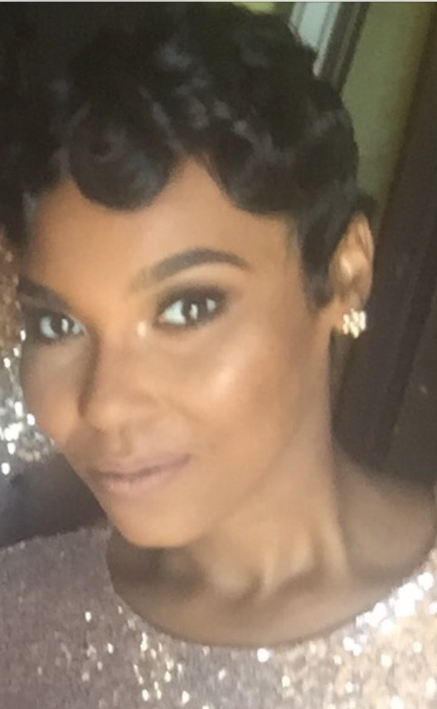 Matron of Honor – Brittany Roberts

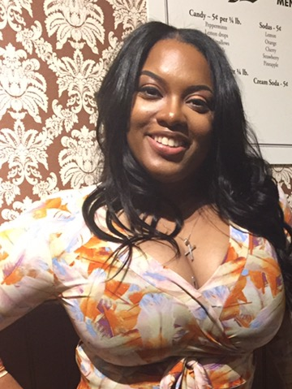 Maid of Honor – Ottumn Kennedy

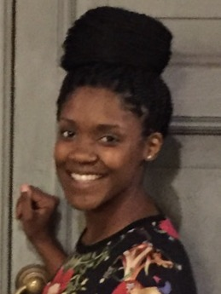 Bridesmaid – Traci Simmons

 Bridesmaid – Ashley Horde

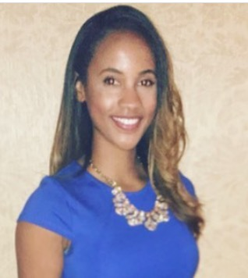 Bridesmaid – Michelle Gay

 Bridesmaid – Taylor Moore

 Bridesmaid – Jazmine Chase

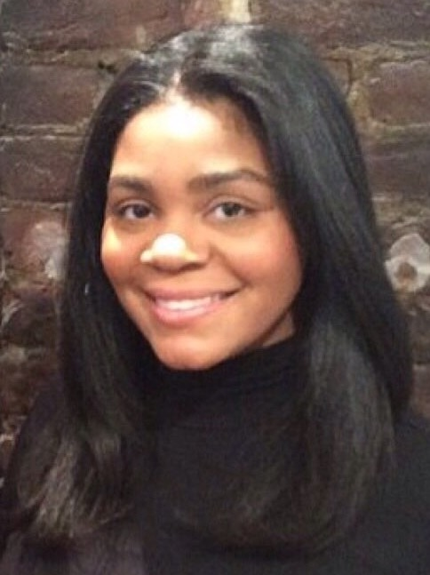 Bridesmaid – Latrice Davis

 Bridesmaid – Maanami Puryear

 Junior Bridesmaid – Jamie Watson

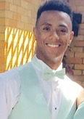 Best Man – Chauncey Jackson

Groomsman – Chase Jackson

 Groomsman – Dale Smith

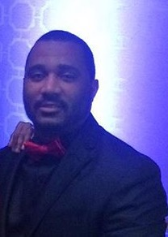 Groomsman – Markelo Jones

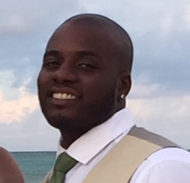 Groomsman – JuJuan Davis

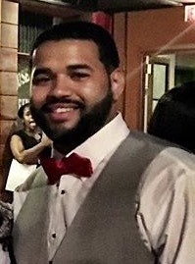 Groomsman – Michael Love Jr.

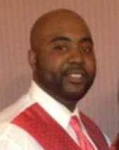 Groomsman – Kyle Wimbush

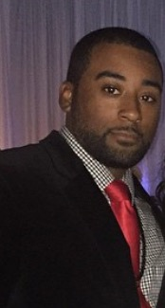 Groomsman – Gregory Butts

Groomsman – Kellen Roquemore

I love you for all that you are, all that you have been, and all you’ve yet to be.

