CMP304

Project Report

by Matthew Wallace

Human Emotion Recognition

Instructions:

- This is a template that you will fill to complete your assignment report.

- Please read the assessment brief document before attempting this.

- The gray text is meant as guidelines. You are to replace it with your own.

- Delete the instructions part and any gray text before submission.

- After you complete this report, save it as pdf, and submit it along with the compressed folder of your application.

# Introduction

*Relevant overview properly setting the context of the project.*

The project is based on the [face_recognition](https://github.com/ageitgey/face_recognition) python library, one of its python example applications called ‘find_facial_features_in_picture’ (with my changes to save the results in .csv files) and my own C++ application which uses extracted facial features, saved into .csv files, to learn an emotion and to recognize an emotion from a picture.

# Methodology

*Description of the steps followed and methods used including a complete explanation and rationale for the techniques and features chosen. You should also acknowledge the tools you used.*

## Python application

[face_recognition](https://github.com/ageitgey/face_recognition) python library allows for extracting facial features from a picture. It basically just gives a position (relevant to the picture) of the chin, left eyebrow, right eyebrow, nose bridge, nose tip left eye, right eye, top lip, bottom lip. These positions are saved in a .csv file that look like this:

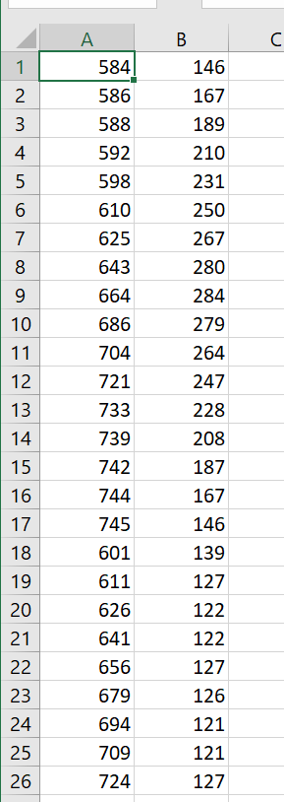

And this is how the facial features extraction of the python application look like in macOS terminal ([face_recognition](https://github.com/ageitgey/face_recognition) library works only on Linux and macOS):

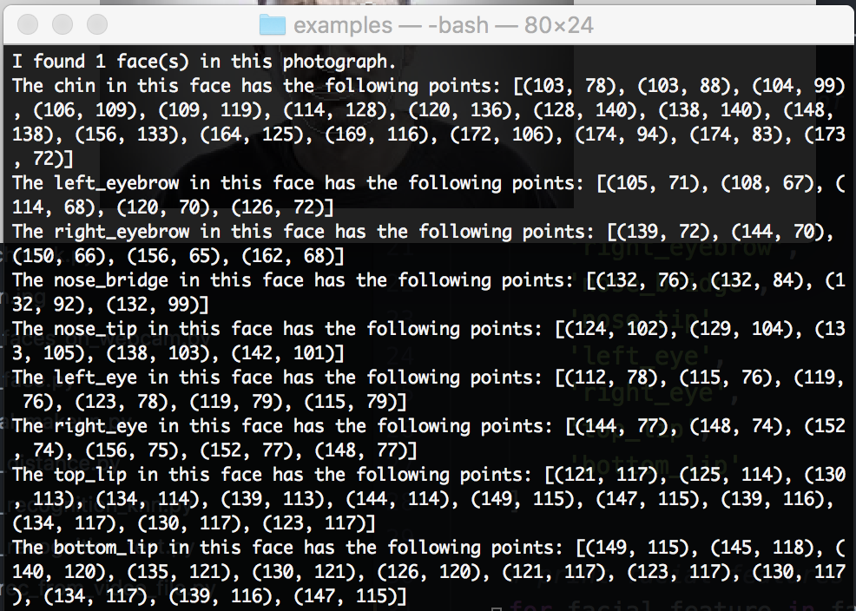

Terminal results

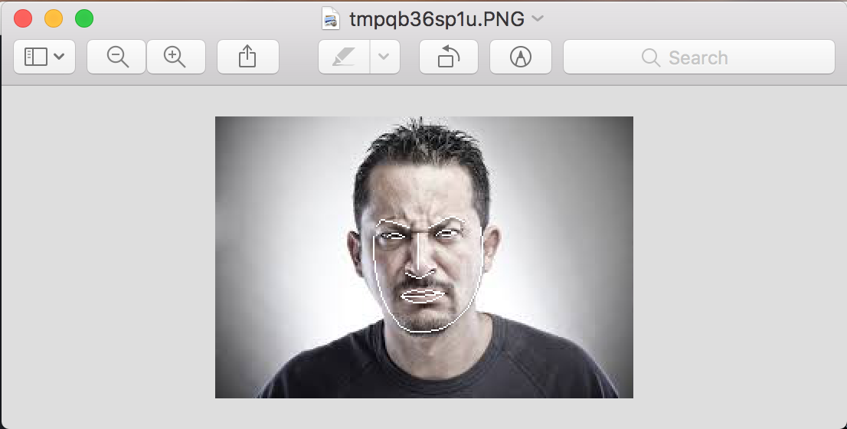

Extracted facial features

The python application saves facial features in .csv files that are later used for machine learning of each individual emotion and emotion recognition from a picture, e.g.: 3 smiley faces will be examined by the python application and the results (positions of the extracted facial features) will be saved in one .csv file, e.g.: ‘smile.csv’. Then 4th picture with a smiley face will be examined and the results will be then saved in a .csv file, e.g. ‘smile_test_1’.

## C++ application

# Results

*Comment on the performance of your application, including test cases. Tabulate and discuss your results. A quantitative measure of performance must be presented.*

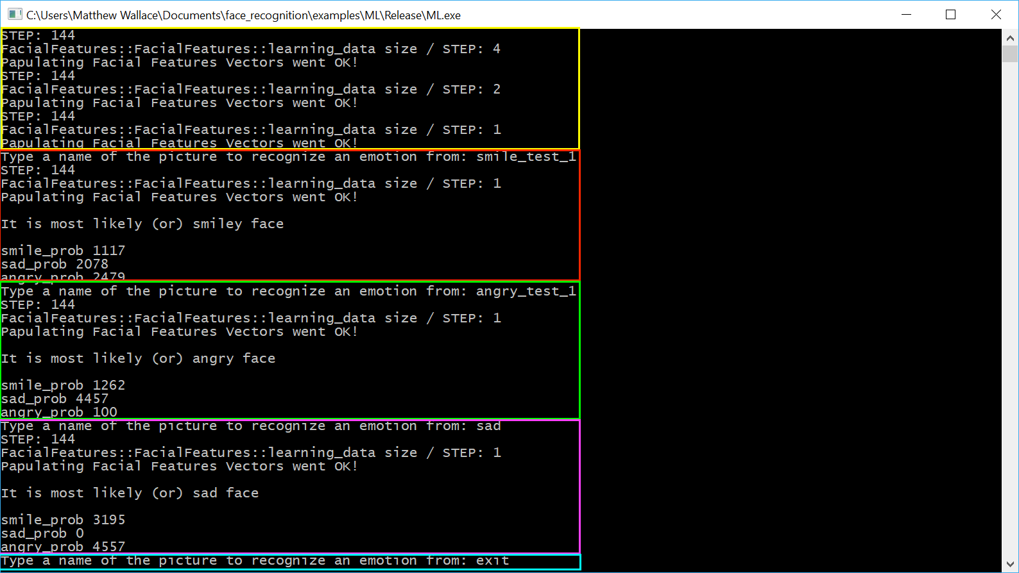

# Conclusions

*Full analysis and summary of the project.*

# References

*A number of references properly cited in Cite Them Right Harvard style.*