Chapter 3

3.1 Introduction
The Entity-Relationship (ER) Diagram for the Vilvah Natural Skincare Database Management System provides a conceptual representation of the database structure. It identifies the key entities involved in the system, such as Customer, Product, Category, Supplier, Inventory, Orders, Order Details, Payment, and Admin, along with their attributes, primary keys, and foreign keys. The relationships between these entities are defined using appropriate cardinality and participation constraints to accurately represent the interactions within the business operations. The ER diagram serves as the foundation for designing the relational database schema, ensuring data integrity, minimizing redundancy, and supporting the efficient implementation and management of the Vilvah Database Management System

3.2 Entity Relationship (ER) Diagram and Relationships

i. Customer

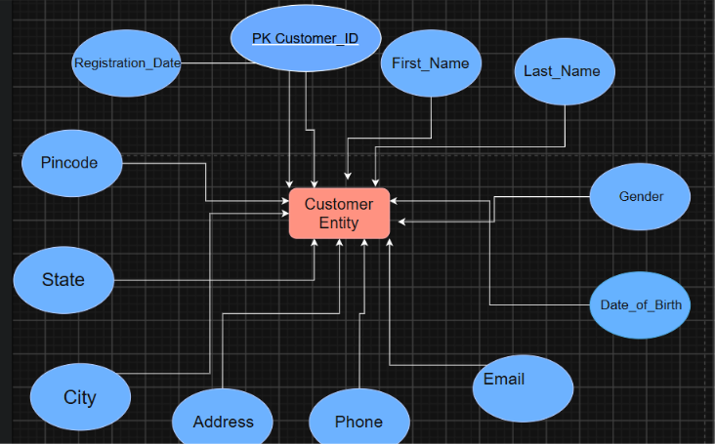

ii. Product

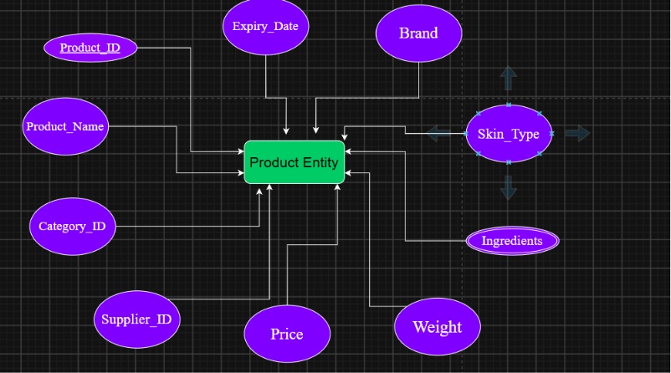

iii. Category

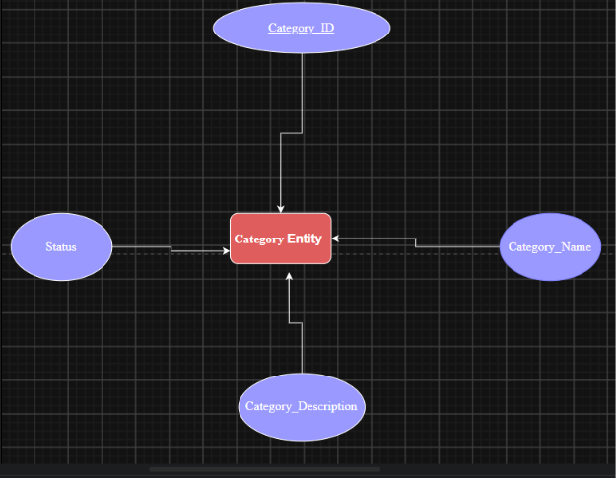

iv.Supplier

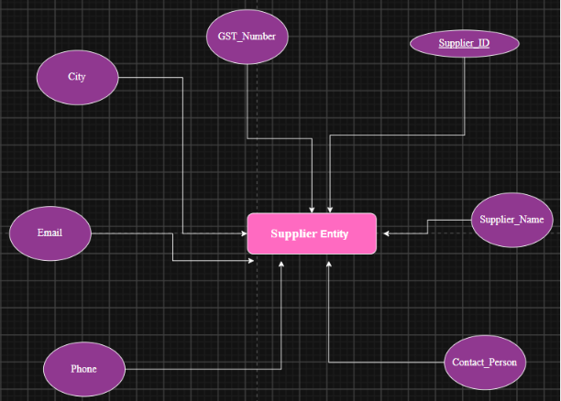

v. Inventory

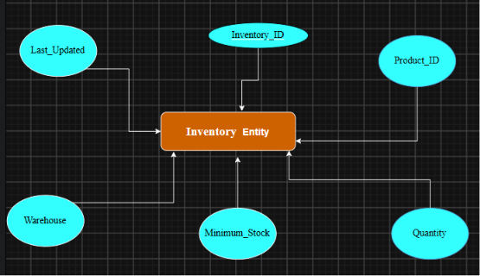

vi.Orders

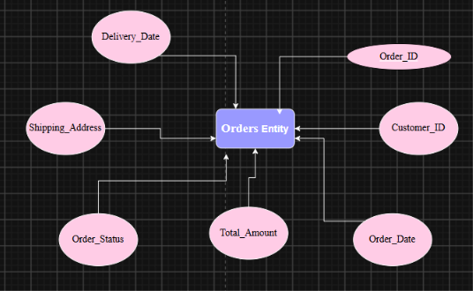

vii. Order Details

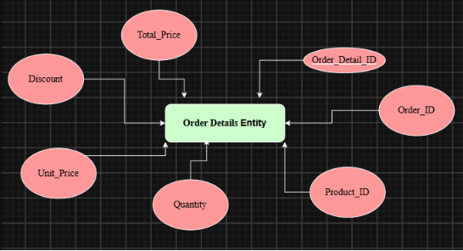

viii. Payment

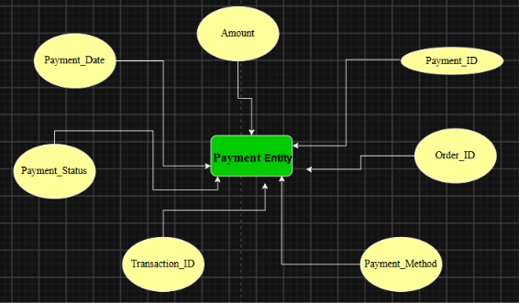

ix. Admin

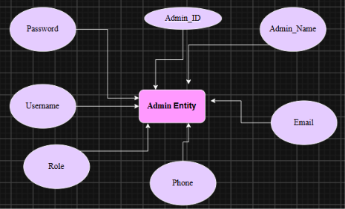

3.3 Relationships

