hw4

Morgan Lattomus

2/8/2022

library(vegan)

## Loading required package: permute

## Loading required package: lattice

## This is vegan 2.5-7

data(dune)  
data(dune.env)  
?dune

## starting httpd help server ...

## done

1.1 Conduct an indirect ordination on the dune plant community. Specifically, visually examine a NMDS plot using the bray-curtis distance metric. Below is some code to help you develop a potential plot that emphasizes the role of the environmental variable “Moisture”.

dune_mds = metaMDS(dune)

## Run 0 stress 0.1192678   
## Run 1 stress 0.1808911   
## Run 2 stress 0.1192678   
## ... New best solution  
## ... Procrustes: rmse 1.746102e-05 max resid 5.338817e-05   
## ... Similar to previous best  
## Run 3 stress 0.1808911   
## Run 4 stress 0.1183186   
## ... New best solution  
## ... Procrustes: rmse 0.02027817 max resid 0.06501492   
## Run 5 stress 0.1183186   
## ... New best solution  
## ... Procrustes: rmse 3.351334e-06 max resid 7.277936e-06   
## ... Similar to previous best  
## Run 6 stress 0.1183186   
## ... Procrustes: rmse 3.02184e-06 max resid 9.750097e-06   
## ... Similar to previous best  
## Run 7 stress 0.1183186   
## ... Procrustes: rmse 2.366094e-06 max resid 5.08158e-06   
## ... Similar to previous best  
## Run 8 stress 0.1192678   
## Run 9 stress 0.1183186   
## ... Procrustes: rmse 2.089458e-05 max resid 6.123943e-05   
## ... Similar to previous best  
## Run 10 stress 0.1192678   
## Run 11 stress 0.1183186   
## ... Procrustes: rmse 1.911176e-05 max resid 5.890425e-05   
## ... Similar to previous best  
## Run 12 stress 0.2035424   
## Run 13 stress 0.1183186   
## ... New best solution  
## ... Procrustes: rmse 1.820993e-06 max resid 5.237934e-06   
## ... Similar to previous best  
## Run 14 stress 0.1192678   
## Run 15 stress 0.1808911   
## Run 16 stress 0.1192679   
## Run 17 stress 0.1192679   
## Run 18 stress 0.1809577   
## Run 19 stress 0.1889648   
## Run 20 stress 0.1183186   
## ... Procrustes: rmse 5.530872e-06 max resid 1.736319e-05   
## ... Similar to previous best  
## *** Solution reached

plot(dune_mds, type='n')  
 text(dune_mds, 'sp', cex=.5)  
 # generate vector of colors   
 color_vect = rev(terrain.colors(6))[-1]  
 points(dune_mds, 'sites', pch=19,   
 col=color_vect[dune.env$Moisture])  
 legend('topright', paste("Moisture =", 1:5, sep=''),   
 col=color_vect, pch=19)

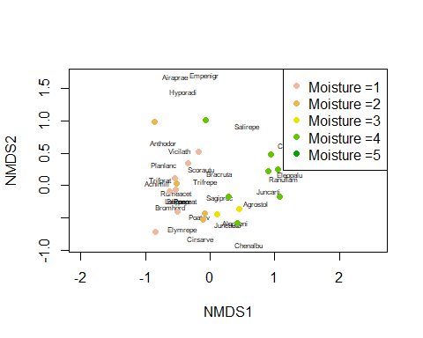 1.2 Describe how you interpret the graphic. What is the goal of creating such a plot? Does this analysis suggest any interesting findings with respect to the dune vegetation? The above plot displays the relationship between site moisture and the species present at those sites, specifically through the distance between the species and the moisture present at those sites. We can see that the more moist sites are farther away from the less moist sites, and the presence of certain species is often dependent on the moist located at those sites. The goal of creating such a plot would be to show the relationship between these two variables, mostly to see if there is any visually discernible relationship between the two.

1. Carry out a direct ordination using CCA in order to test any potential hypotheses that you developed after examining the MDS plot. Specifically, carry out a test of the entire model (i.e., including all constrained axes) and also carry out tests at the scale of individual explanatory variables you included in your model if you included more than one variable. Plot your results.

rda_dune = rda(dune ~ . , data=dune.env)  
rda_dune

## Call: rda(formula = dune ~ A1 + Moisture + Management + Use + Manure,  
## data = dune.env)  
##   
## Inertia Proportion Rank  
## Total 84.1237 1.0000   
## Constrained 63.2062 0.7513 12  
## Unconstrained 20.9175 0.2487 7  
## Inertia is variance   
## Some constraints were aliased because they were collinear (redundant)  
##   
## Eigenvalues for constrained axes:  
## RDA1 RDA2 RDA3 RDA4 RDA5 RDA6 RDA7 RDA8 RDA9 RDA10 RDA11   
## 22.396 16.208 7.039 4.038 3.760 2.609 2.167 1.803 1.404 0.917 0.582   
## RDA12   
## 0.284   
##   
## Eigenvalues for unconstrained axes:  
## PC1 PC2 PC3 PC4 PC5 PC6 PC7   
## 6.627 4.309 3.549 2.546 2.340 0.934 0.612

cca_dune = cca(dune ~ ., data=dune.env)  
RsquareAdj(cca_dune, 100)

## $r.squared  
## [1] 0.7106267  
##   
## $adj.r.squared  
## [1] 0.2314438

anova(cca_dune, permutations = 999)

## Permutation test for cca under reduced model  
## Permutation: free  
## Number of permutations: 999  
##   
## Model: cca(formula = dune ~ A1 + Moisture + Management + Use + Manure, data = dune.env)  
## Df ChiSquare F Pr(>F)   
## Model 12 1.5032 1.4325 0.033 *  
## Residual 7 0.6121   
## ---  
## Signif. codes: 0 '***' 0.001 '**' 0.01 '*' 0.05 '.' 0.1 ' ' 1

anova(cca_dune, by='margin', permutations = 999)

## Permutation test for cca under reduced model  
## Marginal effects of terms  
## Permutation: free  
## Number of permutations: 999  
##   
## Model: cca(formula = dune ~ A1 + Moisture + Management + Use + Manure, data = dune.env)  
## Df ChiSquare F Pr(>F)  
## A1 1 0.11070 1.2660 0.228  
## Moisture 3 0.31587 1.2041 0.224  
## Management 2 0.15882 0.9081 0.566  
## Use 2 0.13010 0.7439 0.784  
## Manure 3 0.25490 0.9717 0.496  
## Residual 7 0.61210

plot(cca_dune, type='n', scaling=1)  
orditorp(cca_dune, display='sp', cex=0.5, scaling=1, col='blue')  
text(cca_dune, display='bp', col='red')

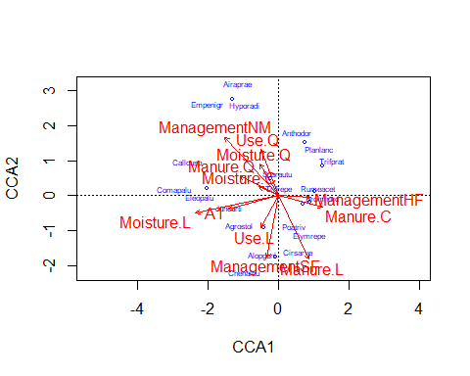

1. Do your two analyses agree with another or do these two analyses seem to be suggesting different take home messages? Which analysis do you find more useful?

They seem to be suggesting two different take home messages. When looking at moisture on our NMDS plot, we can see that the the presence of moisture had a positive variance, however when all the variables are looked at together in a CCA plot, the the presence of moisture has a negative variance. The NMDS plot is a bit easier to read, however doesn’t take into account the relationship between all the variables in the dune data set. When we did the ANOVA for the fulls set of data within the CCA, we noticed that while the P value for the individual variables was not significant, whereas the P value for the entire data set is significant, meaning that data isn’t very parsimonious even though the relationship between the variables is significant.