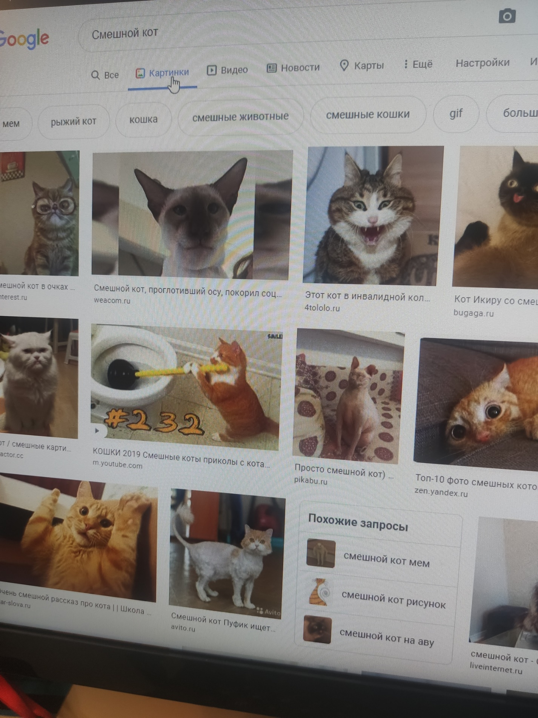
ExifTool Version Number : 12.11
File Name : 1.jpg
Directory : .
File Size : 7.5 MiB
File Modification Date/Time : 2020:11:30 15:52:46+03:00
File Access Date/Time : 2020:11:30 15:53:08+03:00
File Inode Change Date/Time : 2020:11:30 15:53:15+03:00
File Permissions : rw-r--r--
File Type : JPEG
File Type Extension : jpg
MIME Type : image/jpeg
Exif Byte Order : Big-endian (Motorola, MM)
Camera Model Name : MI 9
Orientation : Rotate 90 CW
Modify Date : 2020:11:30 15:19:58
Y Cb Cr Positioning : Centered
ISO : 324
Exposure Program : Program AE
F Number : 1.8
Exposure Time : 1/100
Sensing Method : Not defined
Sub Sec Time Digitized : 437264
Sub Sec Time Original : 437264
Sub Sec Time : 437264
Focal Length : 4.8 mm
Flash : Off, Did not fire
Light Source : D65
Metering Mode : Center-weighted average
Scene Capture Type : Standard
Interoperability Index : R98 - DCF basic file (sRGB)
Interoperability Version : 0100
Focal Length In 35mm Format : 26 mm
Max Aperture Value : 1.7
Create Date : 2020:11:30 15:19:58
Exposure Compensation : 0
Exif Image Height : 3000
White Balance : Auto
Date/Time Original : 2020:11:30 15:19:58
Brightness Value : 1.64
Exif Image Width : 4000
Exposure Mode : Auto
Aperture Value : 1.7
Components Configuration : Y, Cb, Cr, -
Color Space : sRGB
Scene Type : Directly photographed
Shutter Speed Value : 1/100
Exif Version : 0220
Flashpix Version : 0100
Resolution Unit : inches
X Resolution : 72
Y Resolution : 72
Make : Xiaomi
Image Width : 4000
Image Height : 3000
Encoding Process : Baseline DCT, Huffman coding
Bits Per Sample : 8
Color Components : 3
Y Cb Cr Sub Sampling : YCbCr4:2:0 (2 2)
Aperture : 1.8
Image Size : 4000x3000
Megapixels : 12.0
Scale Factor To 35 mm Equivalent: 5.5
Shutter Speed : 1/100
Create Date : 2020:11:30 15:19:58.437264
Date/Time Original : 2020:11:30 15:19:58.437264
Modify Date : 2020:11:30 15:19:58.437264
Circle Of Confusion : 0.005 mm
Field Of View : 69.4 deg
Focal Length : 4.8 mm (35 mm equivalent: 26.0 mm)
Hyperfocal Distance : 2.35 m
Light Value : 6.6
Задание 2
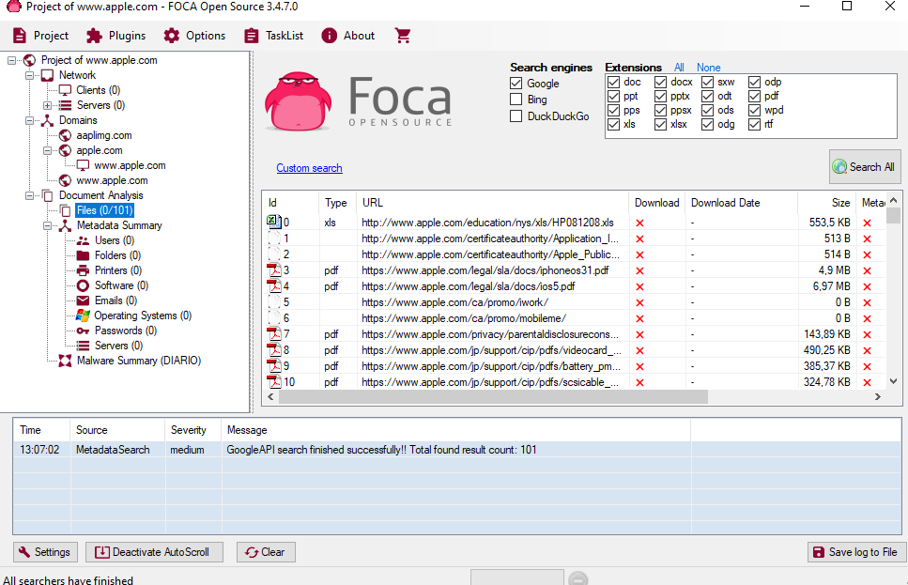
В ходе анализа apple.com были найдены файлы и дополнительные домены.

Задание 3
Анализируем реестр и устраняем ошибки
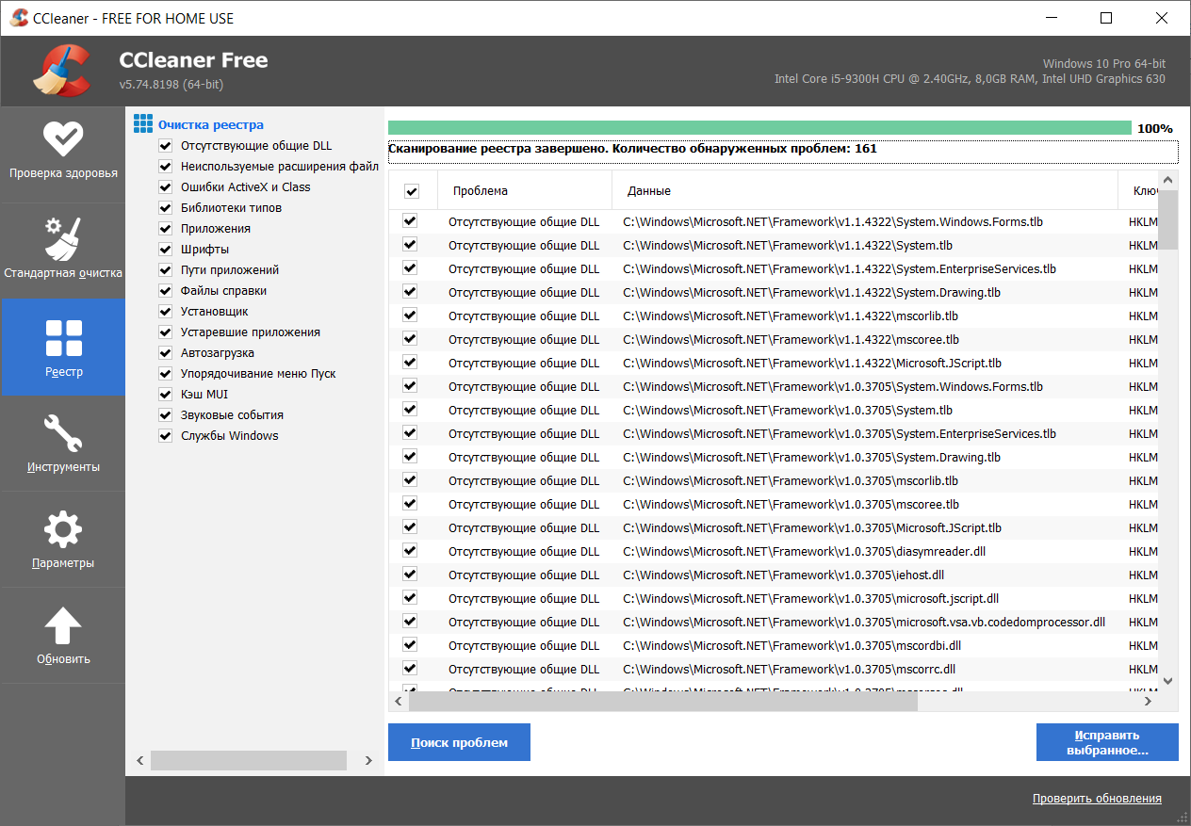
Удаление дубликатов
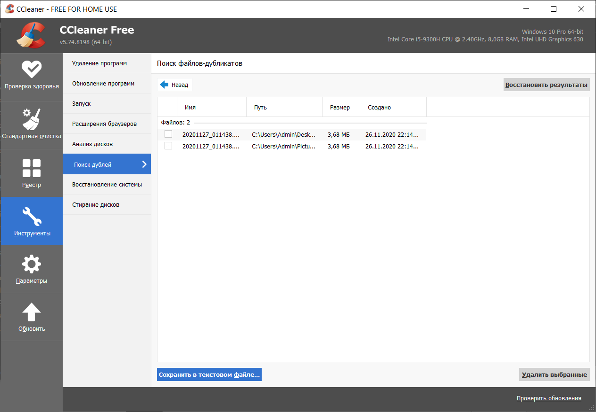

Удаление программ.
