Boundary-Inversion Cosmology VI:
A Sqrt-Reg EFT-Clock Inflationary Branch and Calibration-Frame Late-Universe Extension
Working manuscript skeleton | July 2026
Prepared for external audit and manuscript assembly

Abstract
We present Boundary-Inversion Cosmology VI (BIH-VI) as a boundary-anchored effective-field-theory cosmology built around the invariant marginal-horizon seam chi = h^{ab} nabla_a R nabla_b R = 0, equivalently R = 2G E_MS. The early-universe branch realizes a Sqrt-Reg entropy-selected density shield through a stable EFT clock with H^2 = H_c^2 y(2-y), y_N = -m(y)y, and epsilon_H = m(1-y)/(2-y). For the frozen benchmark m(y)=mu(1-y)^3, mu=1, c_s=1, and N_*=55, the model gives n_s ~= 0.9652, r ~= 1.4e-3, and alpha_s ~= -5.8e-4. The late-universe branch is formulated only as a falsifiable calibration-frame extension: the universal metric-lapse route is rejected at the diagnostic level, while C3 isolates Delta M_B ~= 0.18 mag as a local readout target and uses Q_bulk(z) smoothness as the thermodynamic falsifier.
Scope boundary. BIH-VI is presented as an EFT-level cosmological framework. It does not claim to be a UV-complete microscopic theory. The early-universe branch is frozen at the Sqrt-Reg/EFT-clock benchmark. The late-universe branch is a diagnostic calibration-frame extension motivated by the failure of universal metric-lapse deformations. The calibration-frame branch is falsifiable through full distance-likelihood tests and through the smoothness, boundedness, and physical interpretability of Q_bulk(z).

1. Introduction
The paper is organized as a hierarchy of claims: frozen early branch, late-universe stress test, metric-lapse rejection, calibration-frame extension, and Q_bulk falsifiability. This draft intentionally avoids claiming a solved Hubble tension or a UV-complete substrate theory.
Pivot paragraph: Having established the stable EFT-clock realization of the Sqrt-Reg density shield as an early-universe branch, we now assess whether the same boundary-centered framework can be extended to late-time cosmology without modifying its frozen inflationary mechanics. The low-density expansion of the Sqrt-Reg background shows that the entropy shield acts as a UV regulator rather than an infrared dark-energy mechanism. We therefore treat the late universe as a separate observational gate on the BIH clock/stress sector. A direct metric-lapse interpretation, in which a redshift-dependent clock factor multiplies all distance integrals, is rejected at the diagnostic level by supernova-shape and BAO-geometry constraints. Consequently, we define a calibration-frame branch: the global geometry remains governed by H_geom(z), while the local distance ladder is allowed to measure a substrate-dependent calibration offset Delta M_B ~= 0.18 mag. This recasts the Hubble tension as a testable calibration-frame hypothesis rather than a universal modification of light-propagation distances.

2. Boundary seam and Sqrt-Reg thermodynamics
chi = h^{ab} nabla_a R nabla_b R
chi = 1 - 2G E_MS/R
chi = 0 <=> R = 2G E_MS
theta_+ theta_- = -4 chi/R^2 [for l_+ . l_- = -2]
The real invariant seam is chi=0. The B-map of null-expansion signs is useful as orientation language, but it is not itself the invariant physical seam.
S_sqrt(A) = (1/(4G))[sqrt(A(A-A_c)) + A_c arcosh sqrt(A/A_c)]
S_A = 1/[4G sqrt(1-A_c/A)], G_eff = 1/(4S_A)
F_sqrt(x) = 2 x_c [1 - sqrt(1 - x/x_c)]
H^2 = (8 pi G/3) rho [1 - 2 pi G rho/(3 H_c^2)]

3. Frozen EFT-clock branch
S_EFT = int d^4x sqrt(-g)[M_Pl^2 R/2 - Lambda(t) - c(t)g^{00} + (M_2^4/2)(delta g^{00})^2 + ...]
H^2 = H_c^2 y(2-y), y_N = -m(y)y, epsilon_H = m(1-y)/(2-y)
m(y) = mu(1-y)^p, benchmark: p=3, mu=1, c_s=1, N_*=55
n_s = 0.9652, r = 1.4e-3, alpha_s = -5.8e-4
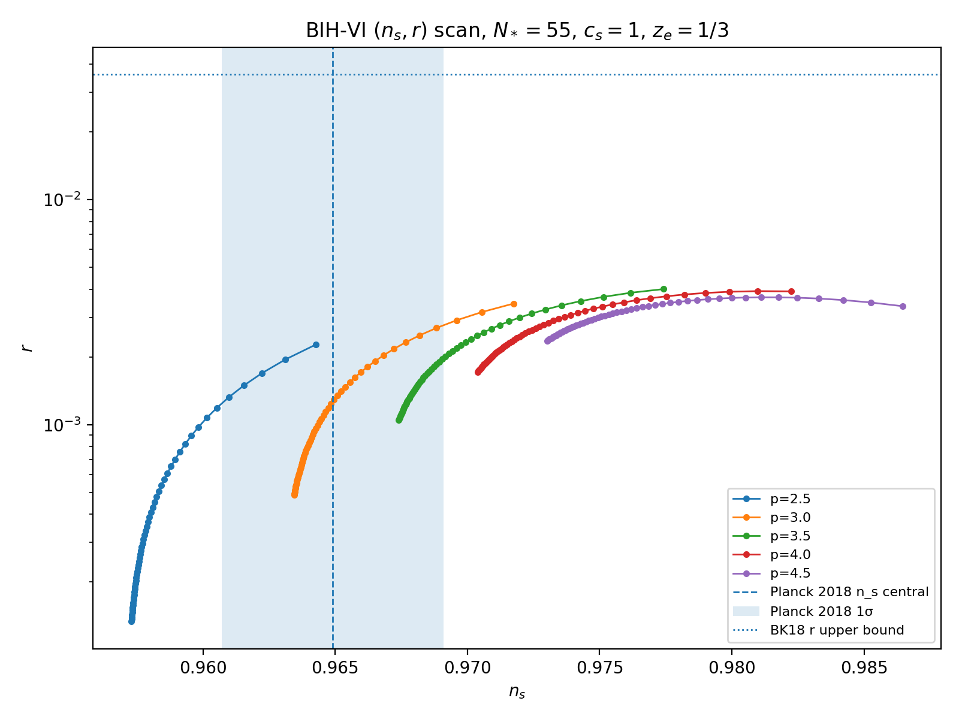
Figure. Frozen early-branch parameter island in the (n_s,r) plane.

4. Exit switch and UHF relic
m(y) = mu(1-y)^3 + m_post/[1 + exp((y-y_g)/Delta)]
Benchmark: y_g = 2/3, Delta = 0.01, m_post = 4
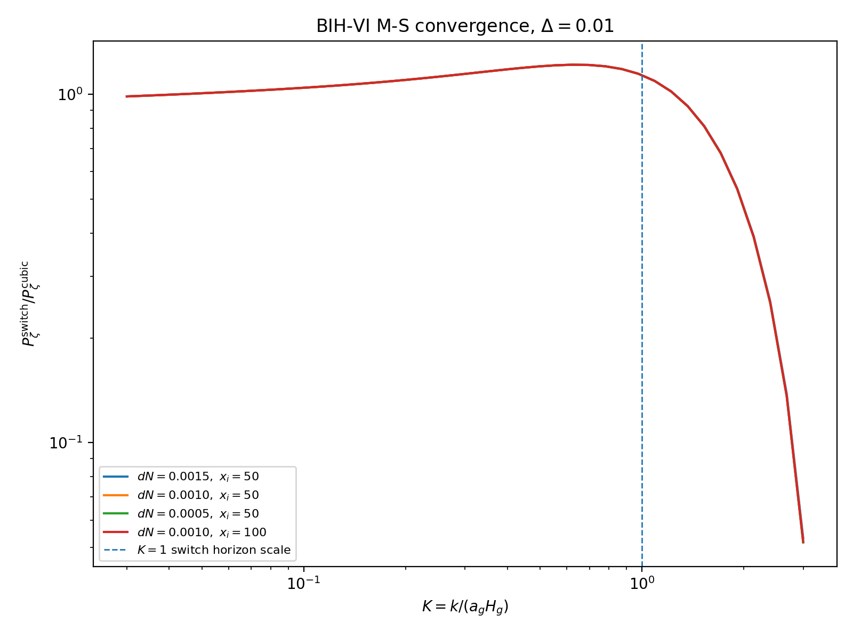
Figure. Mukhanov-Sasaki convergence for the exit switch.
S_3^switch superset (M_Pl^2/2) int dt d^3x a^3 epsilon_H dot(eta_H) zeta^2 dot(zeta)
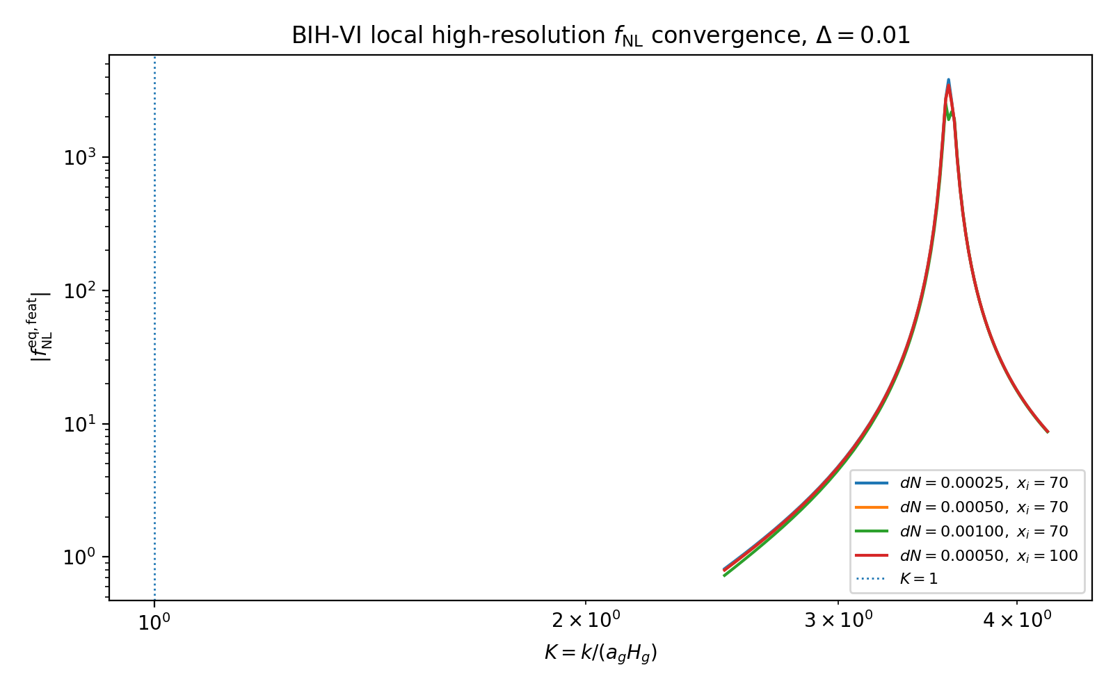
Figure. High-resolution exit feature-bispectrum diagnostic.
k_peak ~ 1.3e23 Mpc^-1, f_peak ~ 2.0e8 Hz ~ 200 MHz
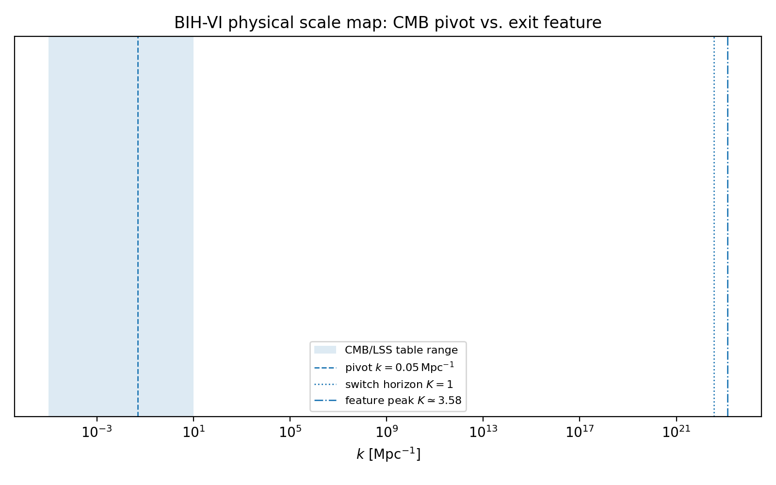
Figure. Scale mapping for the exit feature.
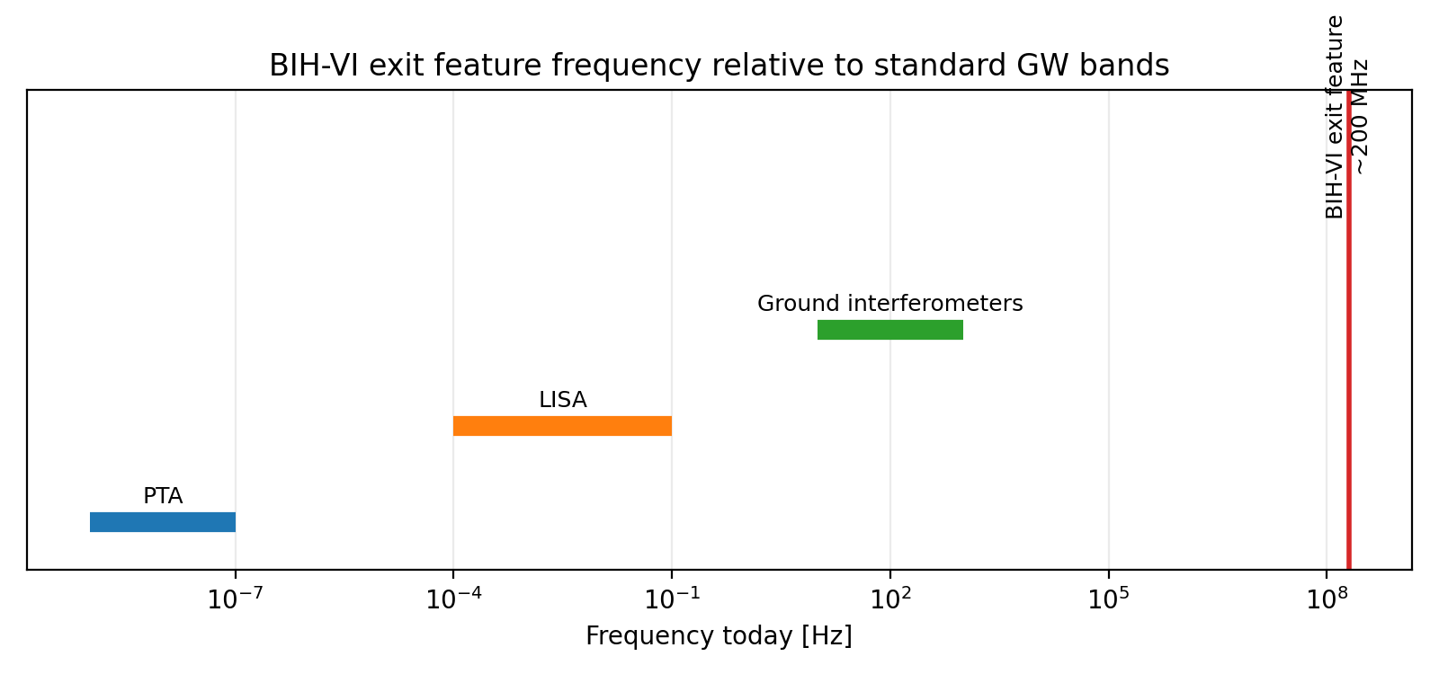
Figure. Present-day UHF frequency mapping for the exit relic.

5. Late-universe diagnostic gate
The Sqrt-Reg shield fades in the infrared and does not replace Lambda by itself. The late-universe sector is therefore a separate observational gate, not a retuning of the frozen early branch.

5.1 Metric-lapse rejection
H_obs(z) = nu(z) H_geom(z) [rejected as universal distance deformation]
D_C(z) = c int_0^z dzprime/[nu(zprime) H_geom(zprime)]
Diagnostic scans show the required local uplift generates either SN-shape strain or BAO-geometry strain. This branch should remain in the paper as a negative result.
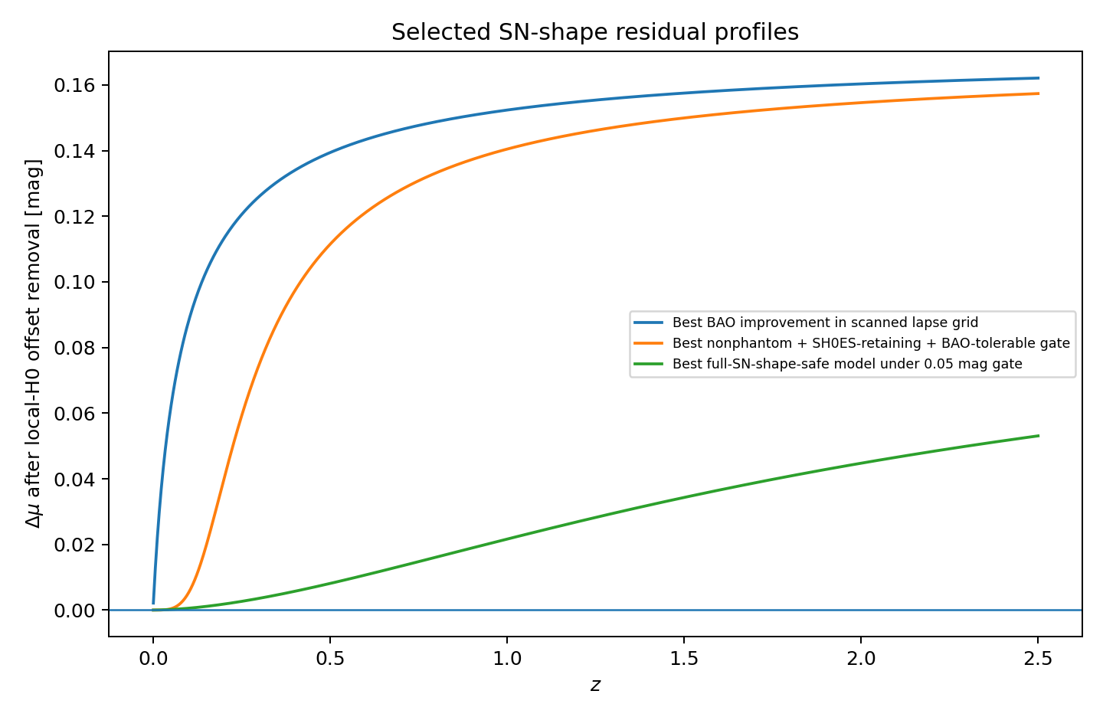
Figure. SN-shape residual diagnostic for the metric-lapse branch.
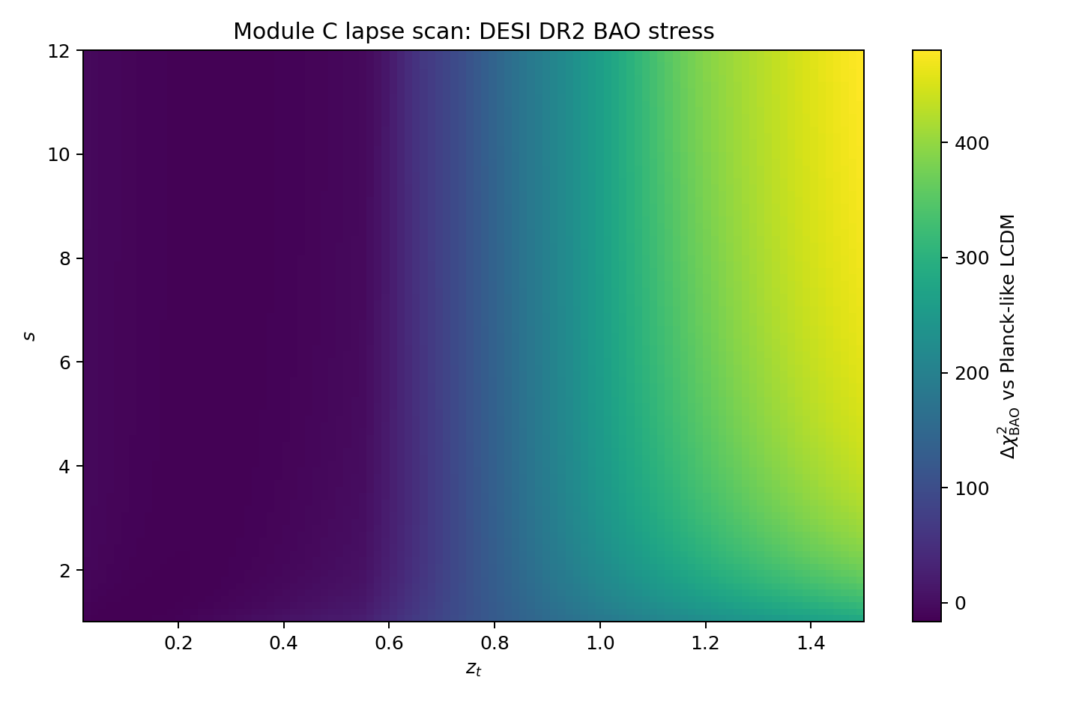
Figure. BAO geometry stress for the metric-lapse branch.

6. C3 calibration-frame extension
nu_metric(z) = 1
H0_ladder = nu_cal H0_geom
Delta M_B = 5 log10(nu_cal)
nu_cal = 73.17/67.36 = 1.08625, Delta M_B = 0.1797 mag
Delta M_B is a calibration-frame target, not yet a first-principles prediction. It must be tested against independent anchors, host-environment systematics, standard sirens, Cepheid metallicity, TRGB, and masers.
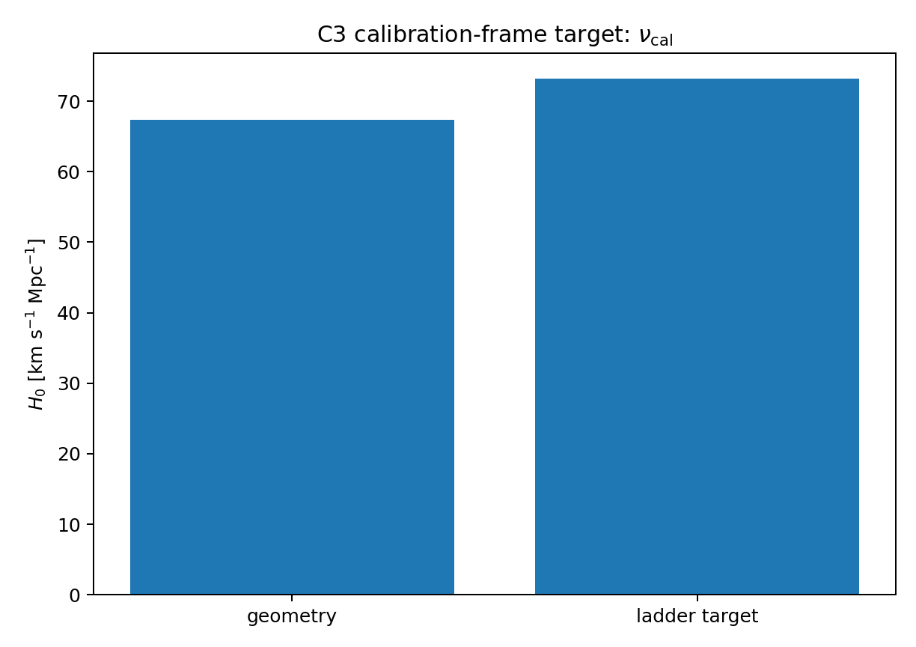
Figure. Calibration-frame target H0_ladder = nu_cal H0_geom.
w_eff(z) = w0 + wa z/(1+z)
E_BIH^2(z) = Omega_r(1+z)^4 + Omega_m(1+z)^3 + Omega_k(1+z)^2 + Omega_DE,0 f_DE(z)
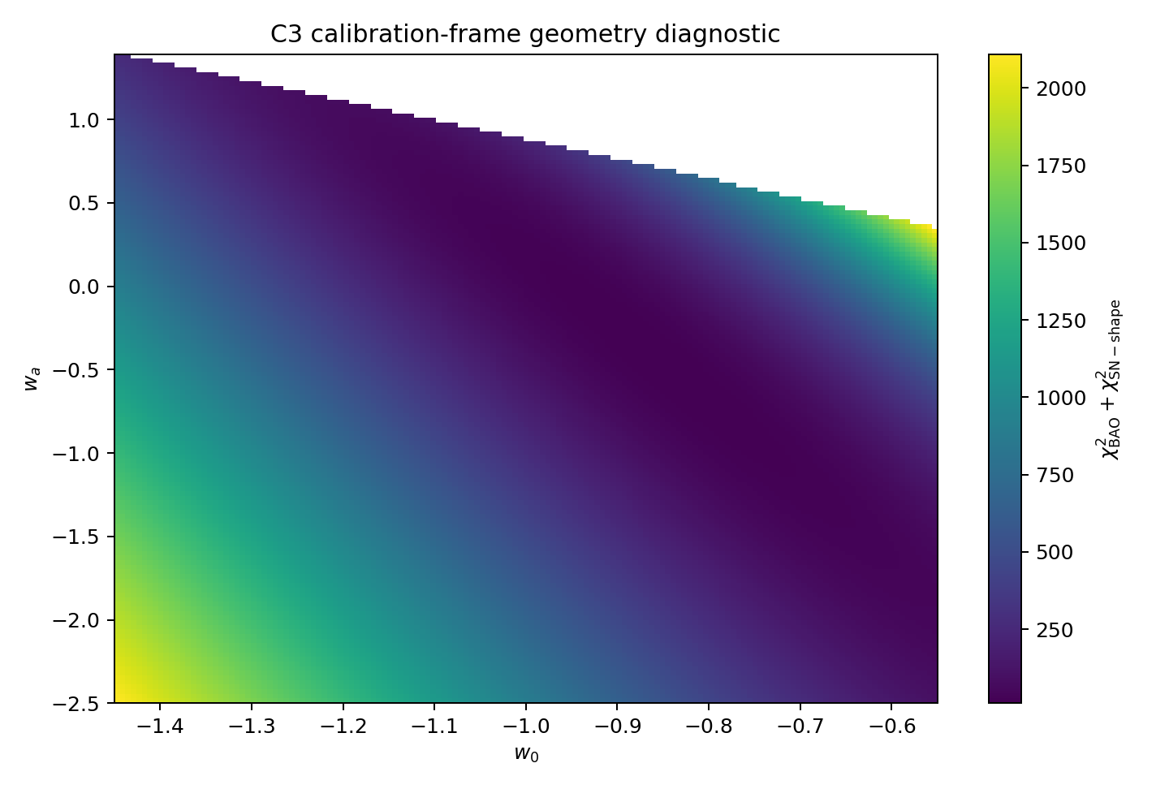
Figure. C3 geometry diagnostic in the CPL scaffold.

7. Likelihood architecture
Theta_C3 = {h, Omega_m, Omega_k, omega_b, w0, wa, M_B^geom, Delta M_B}
Production likelihood must include full Pantheon+SH0ES covariance, DESI DR2 BAO, CMB acoustic-scale priors, and independent calibration-anchor priors. Diagnostic scans should be labeled diagnostic until production chains exist.
Sector | Parameters | Role
Geometry | h, Omega_m, Omega_k, omega_b, w0, wa | BAO/SN/CMB distances
Calibration | M_B^geom, Delta M_B | local readout offset
Falsifier | Q_bulk(z) | thermodynamic consistency

8. Q_bulk reconstruction
dot rho_DE + 3H(1+w_int)rho_DE = Q_bulk
Q_bulk/(H rho_DE) = 3(w_int - w_eff)
For w_int = -1: Q_bulk/(H rho_DE) = -3[1+w_eff(z)]
C3 survives only if the posterior-implied exchange history is smooth, bounded, low-frequency, and physically interpretable. Jagged, discontinuous, or high-frequency sign-flip chatter falsifies the substrate-stress interpretation.
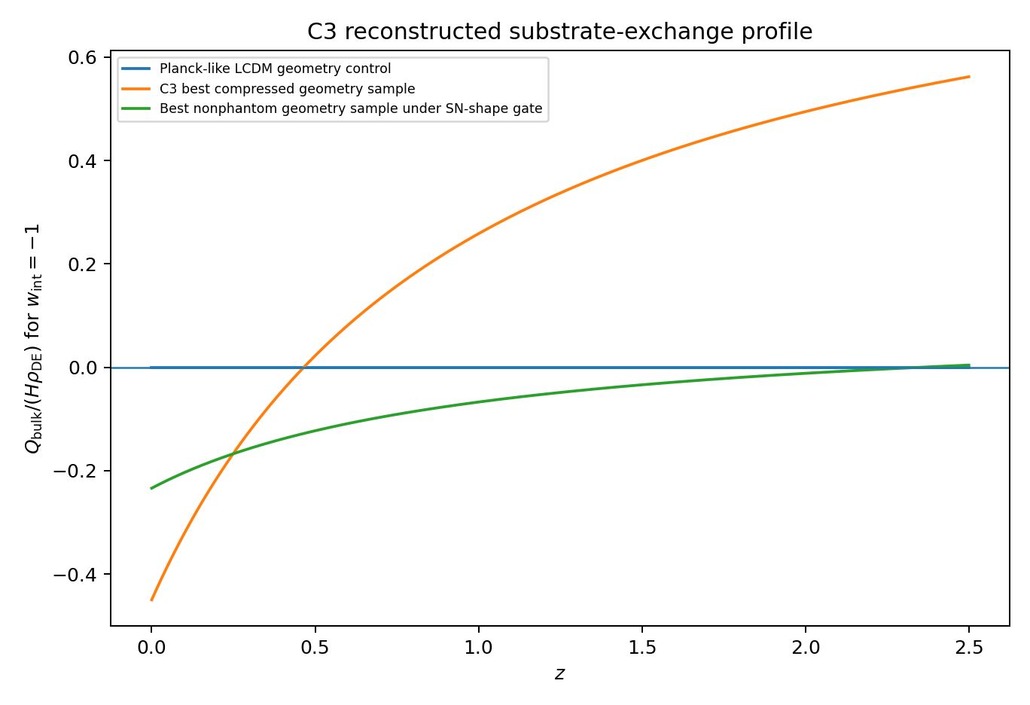
Figure. Selected Q_bulk profiles from the C3 diagnostic scaffold.

9. Falsifiability
- Future tensor limits push well below r ~ 1e-3 without detection and without a viable parameter island.
- Preferred n_s exits the BIH-VI island after nuisance and reheating freedom are included.
- A large or opposite-sign alpha_s is detected.
- Small-scale probes rule out the predicted localized suppression/ringing region.
- Full likelihoods reject Delta M_B ~ 0.18 mag after independent anchors are included.
- Q_bulk(z) reconstruction requires discontinuities, oscillations, or sign-flip chatter.

10. Conclusion
The resulting hierarchy is deliberate: frozen engine, metric-lapse stress test, calibration-frame extension, and Q_bulk falsifier. BIH-VI should therefore be understood as an EFT-level cosmological framework with a frozen early-universe branch and a late-universe validation pipeline. It is not presented as a final microscopic substrate theory, nor as a completed solution to the Hubble tension.

Appendix A. Equation map
Geometric seam: chi = h^{ab} nabla_a R nabla_b R = 1 - 2G E_MS/R
Sqrt-Reg: S_A = 1/[4G sqrt(1-A_c/A)], F(x)=2x_c[1-sqrt(1-x/x_c)]
EFT clock: H^2=H_c^2y(2-y), y_N=-m(y)y, epsilon_H=m(1-y)/(2-y)
C3: nu_metric=1, H0_ladder=nu_cal H0_geom, Delta M_B=5log10(nu_cal)

Appendix B. Rejected branches
- Log-critical entropy: caps H but not density; demoted.
- Pure f(T): scalar/tetrad antisymmetric-constraint pathology.
- Minimal f(T,B): scalar IR recovery failure.
- Analytic f(R): wrong-sign scalaron in analytic IR branch.
- Metric lapse C1/C2: SN/BAO distance-gate failure.

Appendix C. Likelihood implementation
Insert repository link, code version, data requirements, convergence criteria, and production posterior tables after running the full C3 likelihood.

Appendix D. Repository structure
See supplemental/repository_layout.md in the package.

References
Penrose (1965); Hayward (1994, 1998); Cai and Kim (2005); Bousso and Engelhardt (2015); Cheung et al. (2008); Maldacena (2003); Planck 2018 constraints on inflation; BICEP/Keck constraints; Pantheon+; DESI DR2; Riess/SH0ES; entropy-corrected Friedmann literature; horizon-decoherence literature. Verify all metadata before submission.

