BIH-VI Modules A-B Addendum
Bispectrum Stress Test and Transfer-Scale Mapping for the Sqrt-Reg EFT-Clock Branch
Status: technical addendum to the BIH-VI report

Abstract
This addendum extends the BIH-VI technical report by documenting two post-freeze modules. Module A evaluates the non-Gaussianity risk of the BIH-VI exit switch using the dominant switch-enhanced cubic interaction. A high-resolution equilateral in-in estimate confirms that CMB-pivot-side modes remain effectively Gaussian, while exit-scale modes develop a localized, large normalized feature amplitude coincident with a deep scalar-power suppression. Module B maps the exit feature to present-day physical scales and shows that, for N_* = 55, the switch feature lies at ultra-small comoving scales, k_peak ~ 10^23 Mpc^-1, corresponding to a present-day frequency of order 10^8 Hz. The feature is therefore not a CMB or LSS target; the primary CMB-facing BIH-VI predictions remain n_s ~ 0.965, r ~ 10^-3, and alpha_s ~ -6e-4. The exit feature is retained as a secondary ultra-small-scale relic prediction.

1. Executive Summary
- BIH-VI remains a stable EFT-clock realization of the Sqrt-Reg entropy background, not a final microscopic substrate theory.
- The benchmark p=3, mu=1, c_s=1, N_*=55, z_e=1/3 gives n_s=0.9652, r=1.4e-3, alpha_s=-5.8e-4, and H_c=3.8e-6 M_Pl.
- The exit switch with Delta=0.01 is pivot-safe and numerically stable in the Mukhanov-Sasaki stress test.
- The leading equilateral feature-bispectrum estimate gives |f_NL| ~ 3e3 at K ~ 3.58, but only where the two-point power is suppressed by ~3e-5.
- The absolute bispectrum proxy is smooth and finite; the large normalized f_NL mainly reflects the small denominator in the conventional f_NL normalization.
- The exit feature maps to k_peak ~ 1.3e23 Mpc^-1, or f_peak ~ 2e8 Hz; it is not a CMB-scale feature.
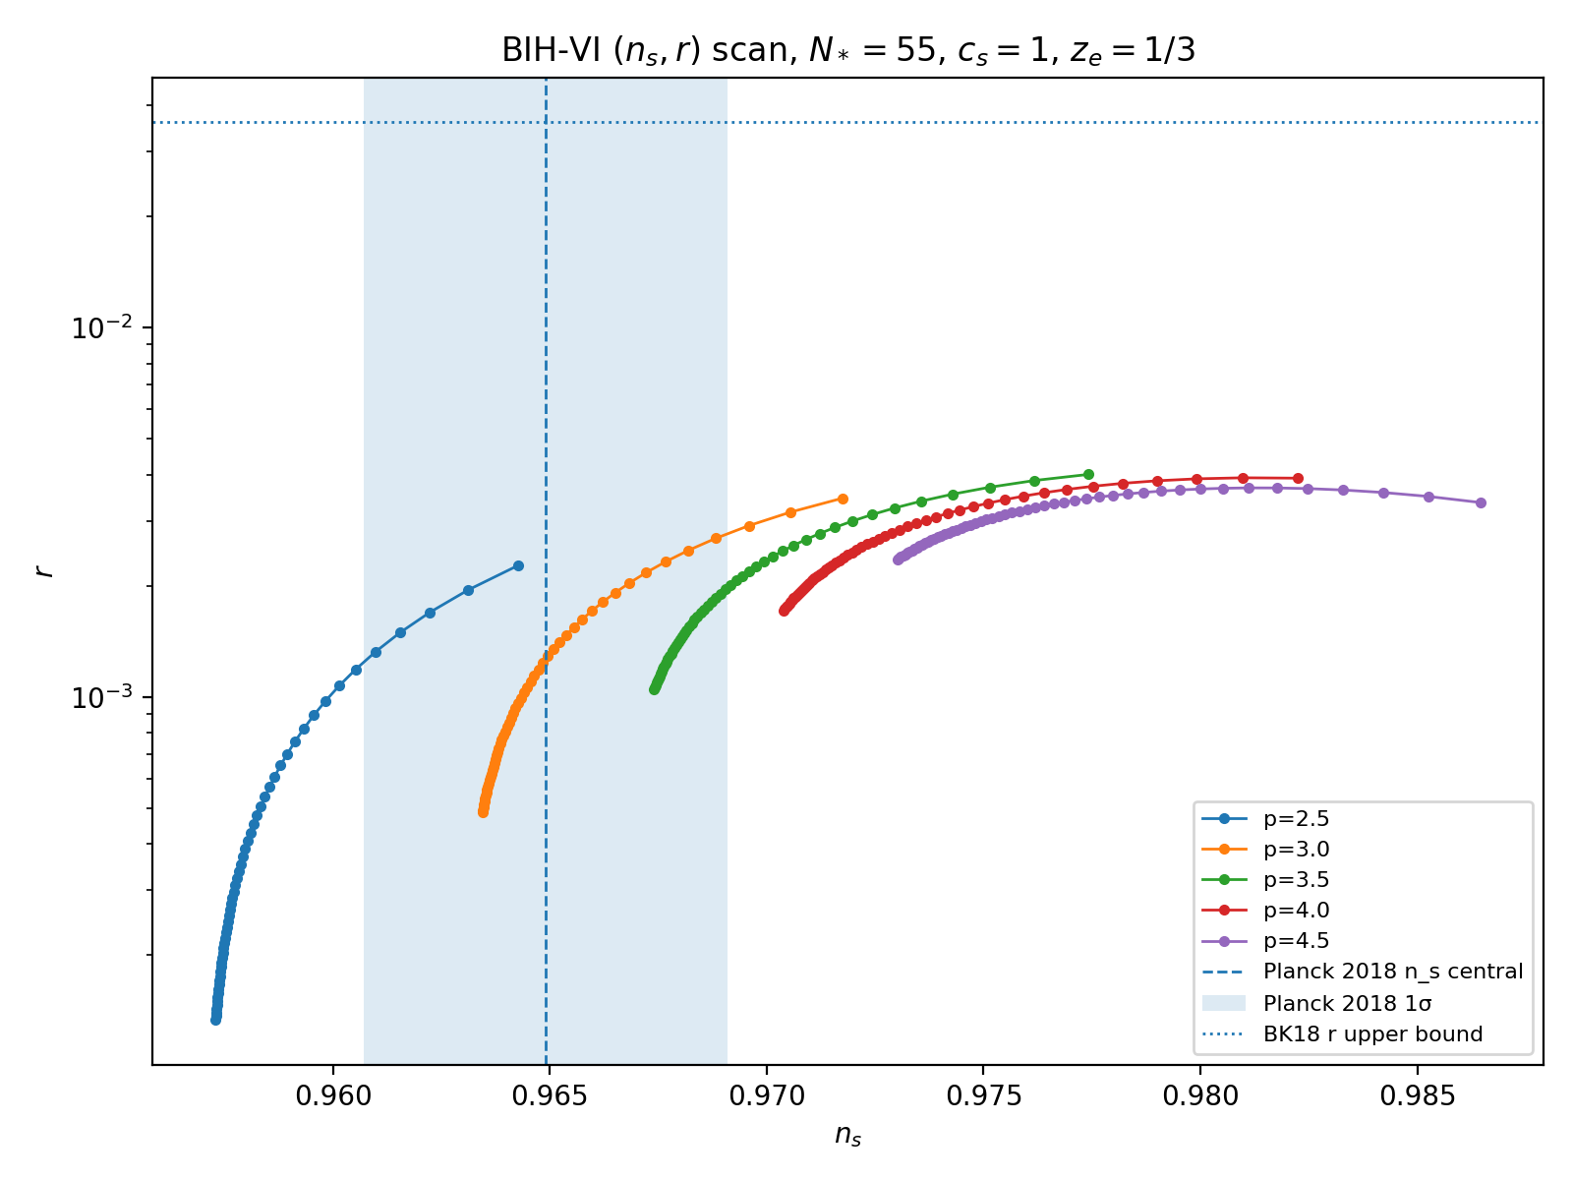
Figure 1. BIH-VI parameter scan in the (n_s, r) plane. The viable island is centered near p=3, mu~1.

2. Core BIH-VI Benchmark Equations
The stable EFT-clock branch is specified by the Sqrt-Reg background and the gear profile:
H^2 = H_c^2 y(2-y), z = 1-y, m(y) = mu z^p.
epsilon_H = m(y)(1-y)/(2-y).
S_zeta^(2) = M_Pl^2 ∫ dt d^3x a^3 [epsilon_H/c_s^2] [ zeta_dot^2 - c_s^2 (grad zeta)^2/a^2 ].
Benchmark: p=3, mu=1, c_s=1, N_*=55, z_e=1/3.
Predictions: n_s=0.9652, r=1.4e-3, alpha_s=-5.8e-4, H_c=3.8e-6 M_Pl.

3. Module A: Exit-Switch Bispectrum and Non-Gaussianity
Module A tests whether the exit switch produces dangerous non-Gaussianity. The calculation isolates the dominant switch-enhanced cubic interaction, which is controlled by the rapid variation of eta_H = d ln epsilon_H / dN during the transition.
S_3^switch ⊃ (M_Pl^2/2) ∫ dt d^3x a^3 epsilon_H H eta_N zeta^2 zeta_dot, eta_N = d eta_H/dN.
H_int^switch ≈ -(M_Pl^2/2) ∫ d^3x a^3 epsilon_H H eta_N zeta^2 zeta_dot.
This is a leading-interaction feature estimate. A full all-operator EFT bispectrum and all triangle configurations remain outside the scope of this addendum.
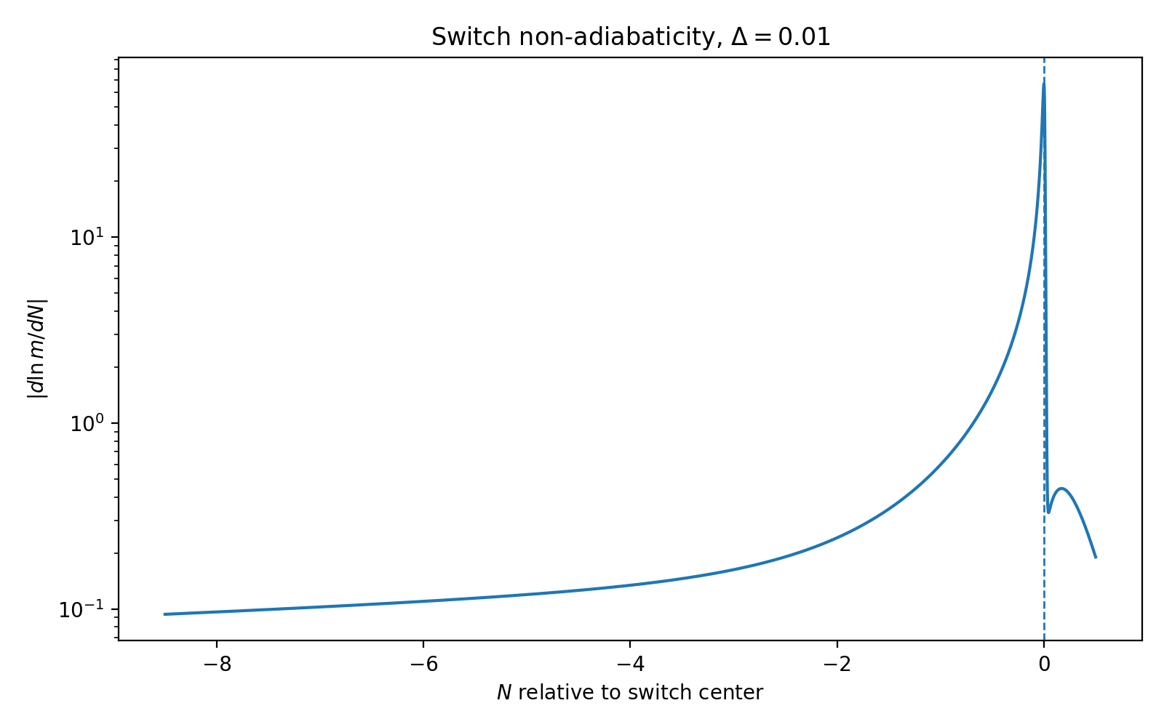
Figure 2. Switch non-adiabaticity for Delta=0.01. The transition is localized and sharp.
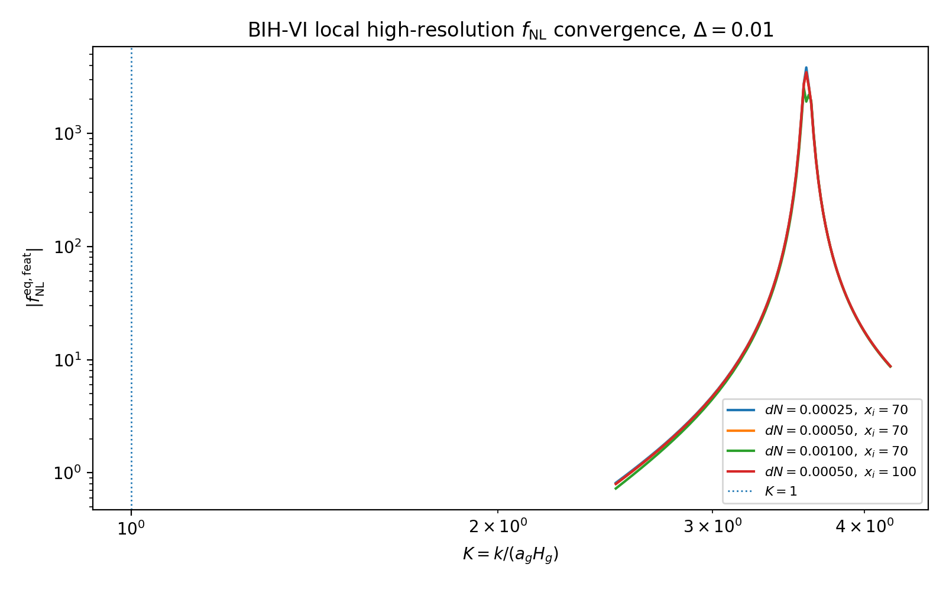
Figure 3. High-resolution local convergence of the equilateral feature f_NL estimate near the exit-scale peak.
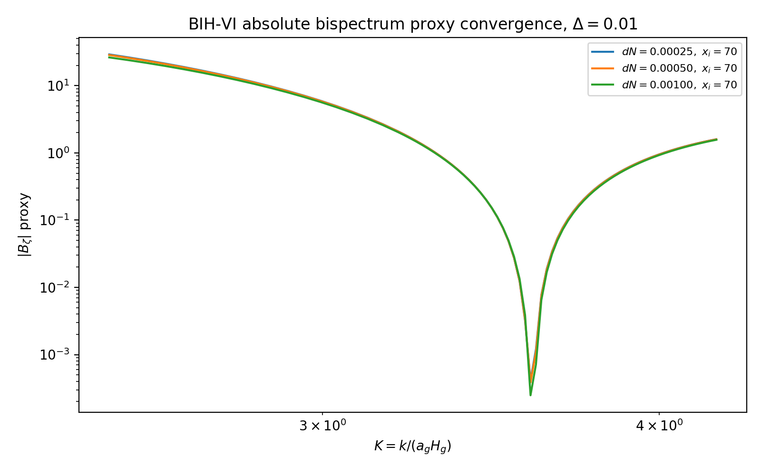
Figure 4. Absolute bispectrum proxy. The proxy remains smooth and finite even where normalized f_NL spikes.
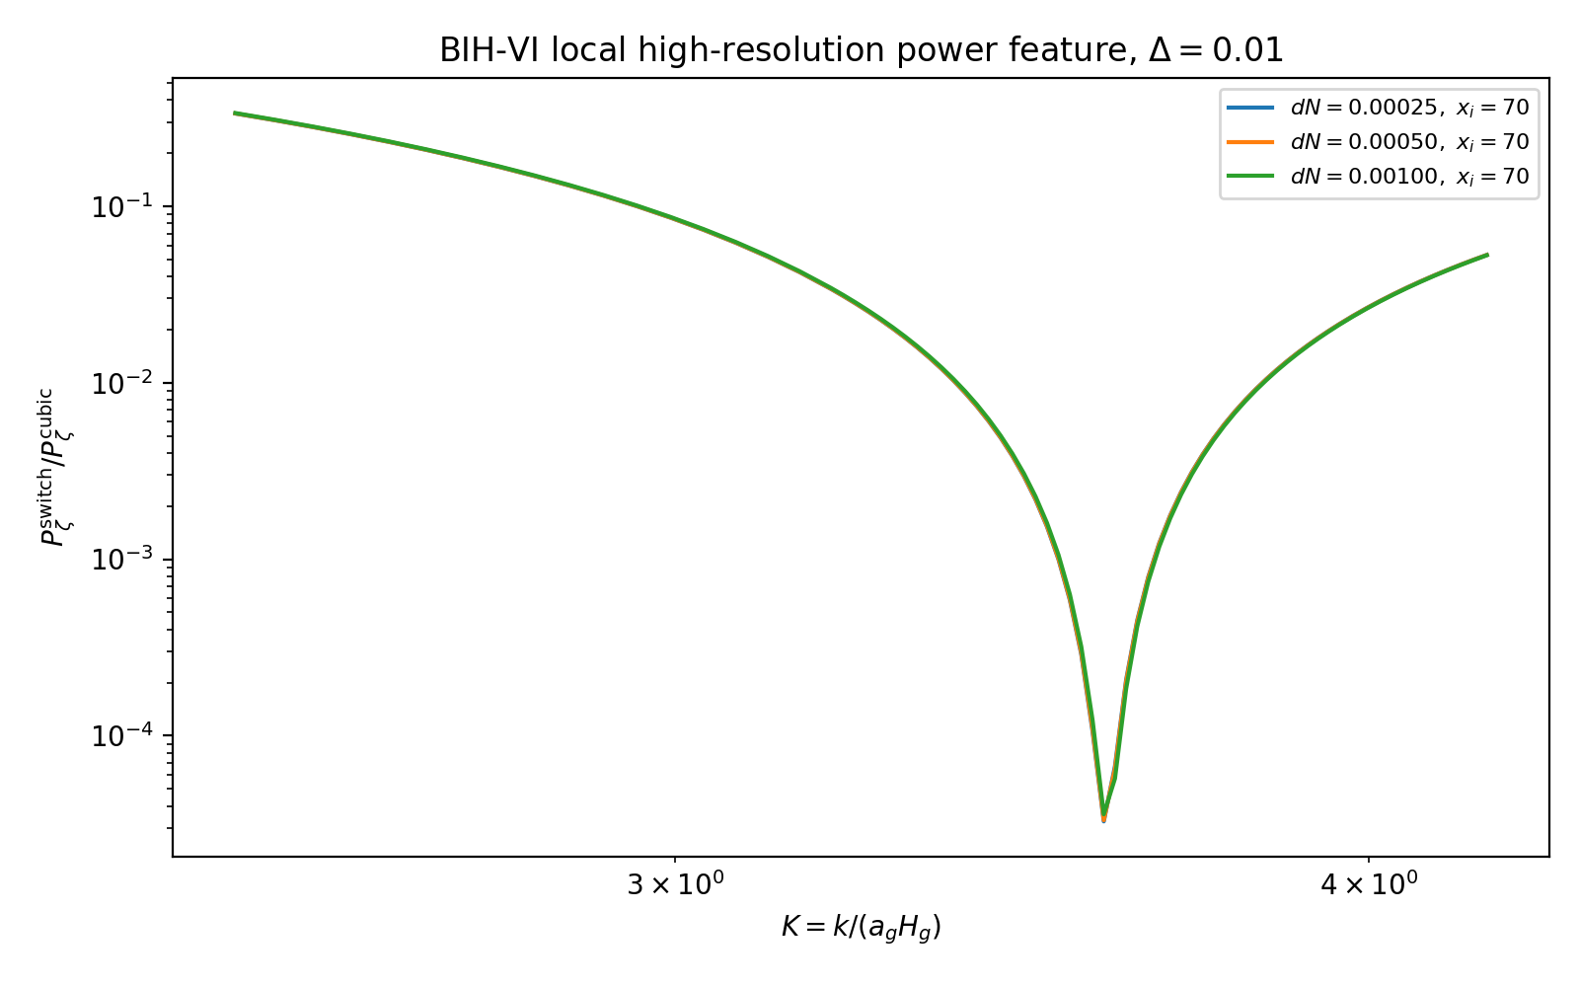
Figure 5. Local high-resolution power feature. The normalized f_NL peak coincides with a deep two-point suppression.

3.1 High-Resolution Feature Result
Quantity | Benchmark Value | Interpretation | Status
K_peak | ~3.58 | Exit-scale feature location | Converged
|f_NL^{eq,feat}|_peak | ~3.1e3 | Large normalized feature amplitude | Feature estimate
P_switch/P_cubic at peak | ~3.3e-5 | Deep scalar-power suppression | Converged
Absolute B proxy | smooth, finite | No absolute blow-up | Pass
K<1 f_NL | O(0.1) or smaller | Pivot side effectively Gaussian | Pass

3.2 Module A Interpretation
The exit switch produces a localized equilateral-type feature. The large normalized feature amplitude occurs only where the power spectrum is deeply suppressed. The absolute bispectrum proxy does not diverge, so the result should be described as a localized exit-scale feature rather than broad-band catastrophic non-Gaussianity.
Report wording: localized exit-scale power suppression + large normalized feature bispectrum; CMB-pivot modes remain effectively Gaussian.

4. Module B: Transfer-Scale Mapping
Module B maps the exit-scale feature to physical comoving wavenumber and present-day frequency. This is the decisive check against over-interpreting the splash as a CMB feature.
K = k/(a_g H_g), k_pivot = 0.05 Mpc^-1, N_*=55.
k_switch ≈ 3.6e22 Mpc^-1, k_peak ≈ 1.3e23 Mpc^-1.
f_today ≈ 1.54e-15 (k/Mpc^-1) Hz, f_peak ≈ 2e8 Hz.
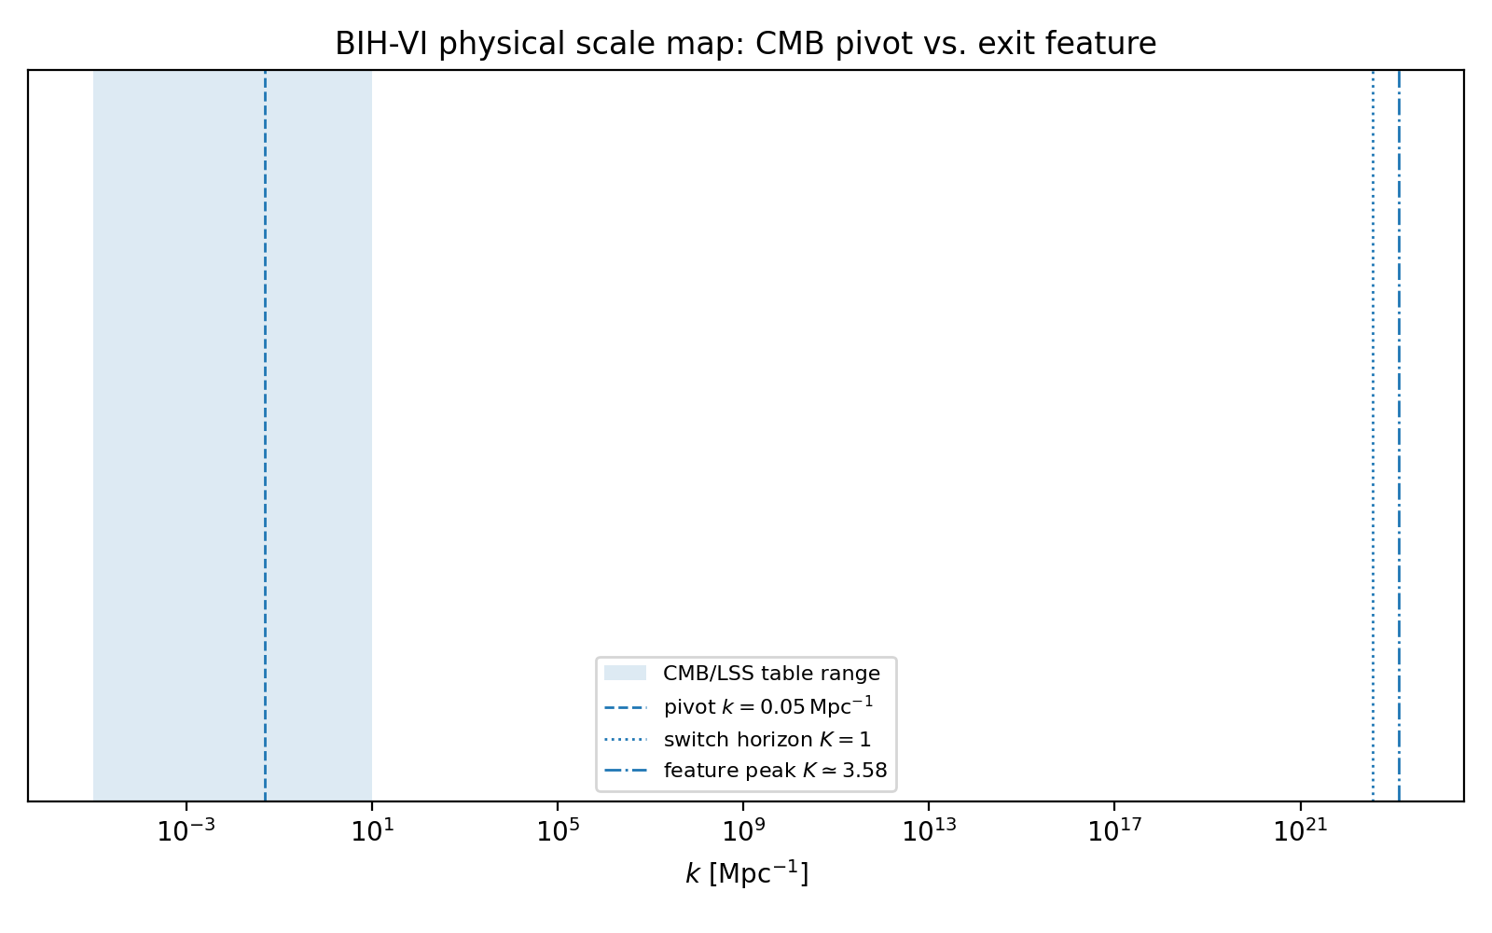
Figure 6. Physical scale map. The exit feature is exponentially far beyond CMB and LSS scales.
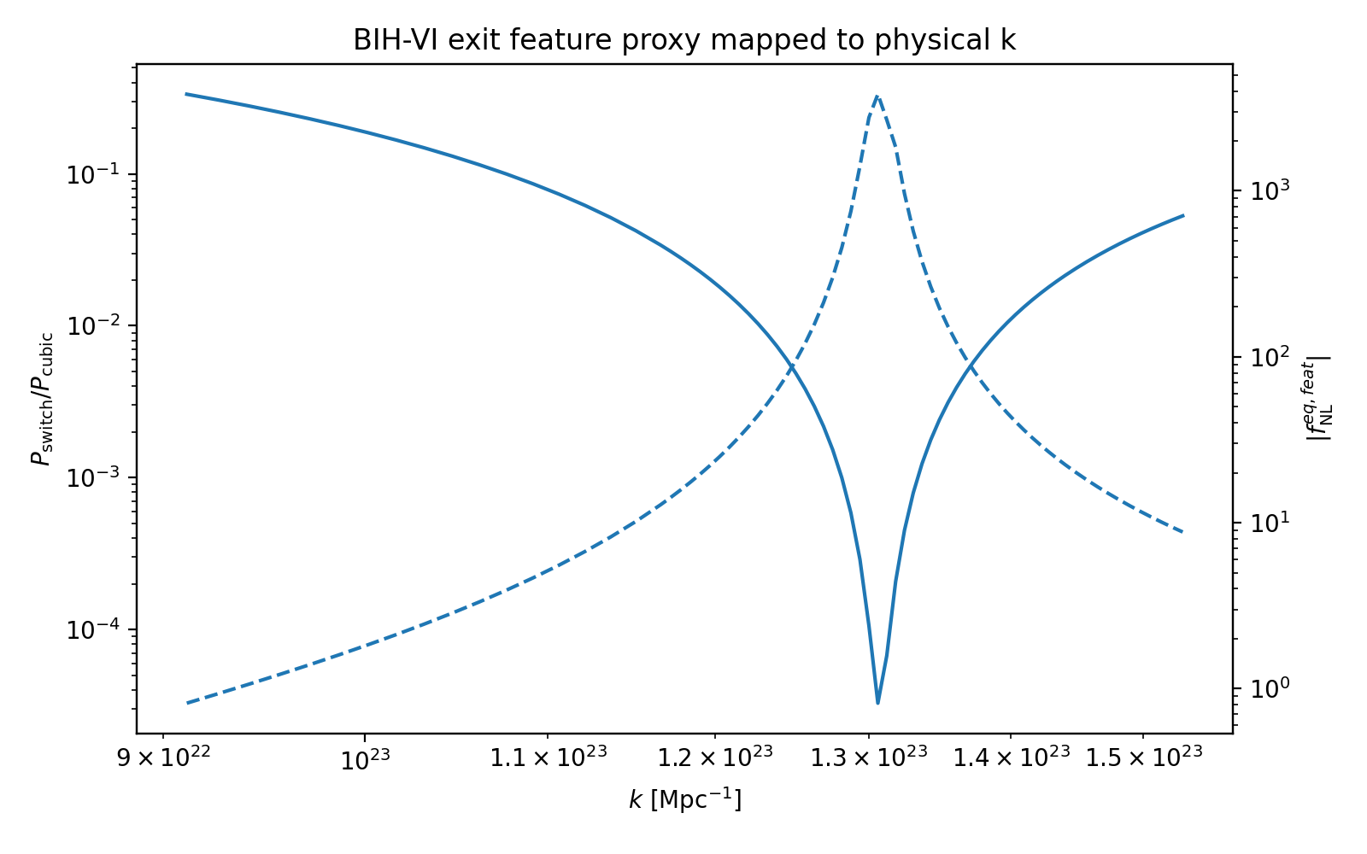
Figure 7. Exit-feature proxy mapped to physical k. The feature lies around k~1e23 Mpc^-1.

4.1 Module B Verdict
- The CMB/LSS range sees the smooth BIH-VI spectrum, not the exit splash.
- The exit feature corresponds to ultra-small comoving scales and present-day frequencies around hundreds of MHz.
- The scalar feature is power-suppressed, so it is unlikely to generate primordial black holes in the benchmark branch.
- The primary observational hooks remain n_s, r, and alpha_s; the exit feature is a secondary relic.

5. Technical Translation of the Black-Oil Intuition
The black-oil image is useful as an engineering metaphor only when translated into EFT terms. The oil is not a literal substance in this report. It represents the single-clock medium defined by the EFT action.
Intuition | Technical Object
black oil / material flow | EFT-clock background trajectory y(N)
surface tension | Sqrt-Reg cap H_c
viscosity | sound speed and EFT operators, including M_2^4
laminar flow | stable, Gaussian pivot-scale perturbations
splash / cavitation | localized exit-scale feature in P_zeta and B_zeta

6. Scope Boundaries and Residual Uncertainties

EFT vs. microscopic completion
BIH-VI proves the existence of a stable EFT branch realizing the Sqrt-Reg background. It does not derive the final UV-complete substrate theory.

Switch-profile sensitivity
Delta=0.01 is pivot-safe and numerically stable, but the transition profile is phenomenological and not yet derived from a microscopic entropy-substrate mechanism.

Single-clock limitation
The present construction is a single-clock EFT realization. Multi-field or isocurvature effects are outside this module.

Bispectrum truncation
Module A uses the dominant switch-enhanced cubic interaction. Full all-operator bispectrum templates remain future work.

Boltzmann transfer
Module B shows the exit feature is outside CMB/LSS scales. A full Boltzmann calculation is unnecessary for the feature at N_*=55 but may still be useful for the smooth pivot spectrum.

7. Updated Prediction Hierarchy
Tier | Prediction | Status
Primary | n_s≈0.965, r≈1.4e-3, alpha_s≈-5.8e-4 | CMB-facing
Secondary | Localized exit-scale power suppression and feature bispectrum | Ultra-small-scale relic
Tertiary | Possible high-frequency induced-GW/transition relics | Speculative; amplitude likely small

8. Conclusion
Modules A and B sharpen the BIH-VI framework without changing the core branch. The CMB-facing predictions remain smooth and pivot-safe. The exit switch produces a genuine localized feature, but it lies at ultra-small scales for the benchmark N_*=55. The correct final framing is therefore: BIH-VI contains a stable Sqrt-Reg EFT-clock branch with a viable CMB parameter island and a controlled ultra-small-scale exit relic.

Appendix: Artifact Index
- bih_vi_fnl_local_highres_convergence.png
- bih_vi_absB_local_highres_convergence.png
- bih_vi_power_local_highres_convergence.png
- bih_vi_fnl_local_highres_scan.csv
- bih_vi_fnl_local_highres_summary.csv
- bih_vi_fnl_local_highres_diffs.csv
- bih_vi_module_b_scale_map.png
- bih_vi_module_b_exit_feature_physical_k.png
- bih_vi_CLASS_primordial_cmb_range.csv
- bih_vi_primordial_exit_feature_scale_map.csv
- bih_vi_module_b_scale_mapping_summary.csv

