BIH-VI Open Work Addendum v2
Modules A and B: Exit-Feature Non-Gaussianity, Scale Mapping, and Scope Boundaries
Prepared as a technical supplement to the BIH-VI EFT-clock report

Executive Summary
This addendum tackles the main open work following the BIH-VI freeze: the exit-switch feature, its leading bispectrum signature, its physical scale mapping, and the residual scope boundaries. The key result is that the model remains pivot-safe while predicting a localized exit-scale feature. The feature is not an ordinary CMB-scale signal for N*=55; it maps to ultra-small comoving scales. Therefore, the primary observational predictions remain ns≈0.965, r≈10^-3, and alpha_s≈-6e-4, while the switch feature is a secondary ultra-small-scale relic of the exit transition.

Scope Boundaries and Residual Uncertainties
EFT vs. microscopic completion: BIH-VI is a stable EFT-clock realization of the Sqrt-Reg background. It is not yet a UV-complete microscopic Lagrangian for the entropy substrate.
Switch-profile sensitivity: The exit profile S(y) and width Delta are phenomenological. Delta=0.01 is pivot-safe and numerically stable, but the substrate mechanism selecting this width is not derived.
Single-clock limitation: The current branch is a single-clock construction. Multi-field, isocurvature, reheating-sector, or entropic-mode effects remain outside the minimal model.
Boltzmann transfer limitation: The Mukhanov-Sasaki spectrum is a primordial proxy. Full CMB temperature/polarization predictions require transfer through a Boltzmann solver. Module B shows the exit feature is far outside standard CMB/LSS scales for N*=55.
Non-Gaussianity limitation: Module A includes the dominant switch-enhanced cubic interaction. Folded and squeezed configurations, all EFT cubic operators, and dedicated feature templates remain future work.

Core BIH-VI Equations
Geometric seam: chi = h^ab ∇_a R ∇_b R = 0, equivalently R = 2 G E_MS.
Sqrt-Reg entropy: S(A) = (1/4G)[sqrt(A(A-A_c)) + A_c arcosh(sqrt(A/A_c))].
Sqrt-Reg background: H^2 = H_c^2 y(2-y), 0 < y <= 1.
Clock gear: dy/dN = -m(y)y, epsilon_H = m(y)(1-y)/(2-y).
EFT-clock action: S = ∫√-g[(M_Pl^2/2)R - Λ(t) - c(t)g^00 + (M_2^4/2)(δg^00)^2 + ...].
Scalar quadratic action: S_zeta^(2) = M_Pl^2 ∫ a^3 (epsilon_H/c_s^2)[zeta_dot^2 - c_s^2(grad zeta)^2/a^2].

Parameter-Island Scan
The viable EFT-clock branch uses m(y)=mu(1-y)^p. The current fiducial branch is p=3, mu=1, c_s=1, N*=55, and z_e=1/3. This gives ns=0.9652, r=1.4e-3, alpha_s=-5.8e-4, and H_c=3.8e-6 M_Pl.
mu | z* | y* | n_s | r | alpha_s | H_c/M_Pl
0.5 | 0.1372 | 0.8628 | 0.9682 | 2.49e-03 | -4.74e-04 | 5.13e-06
0.7 | 0.1176 | 0.8824 | 0.9665 | 1.91e-03 | -5.31e-04 | 4.49e-06
1 | 0.0991 | 0.9009 | 0.9652 | 1.40e-03 | -5.78e-04 | 3.83e-06
1.5 | 0.0811 | 0.9189 | 0.9643 | 9.62e-04 | -6.16e-04 | 3.17e-06
2 | 0.0702 | 0.9298 | 0.9638 | 7.27e-04 | -6.35e-04 | 2.75e-06
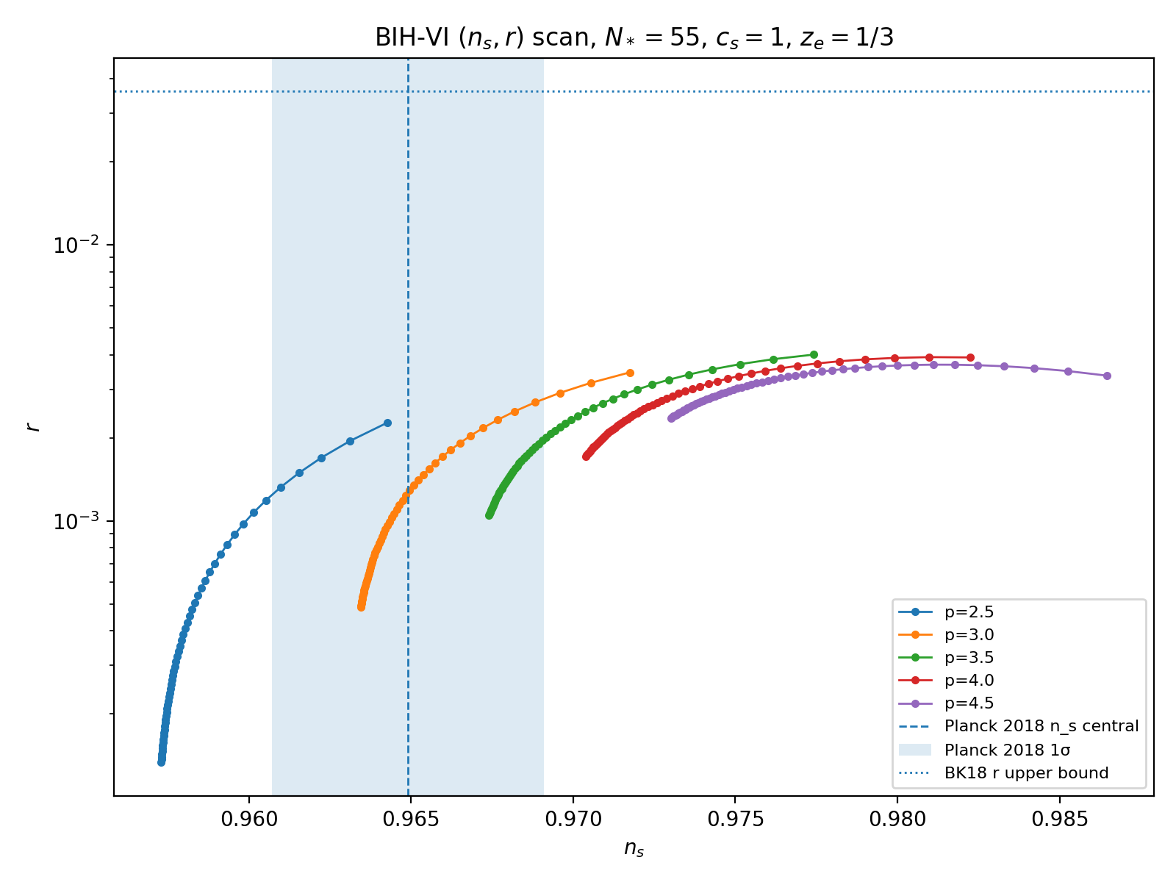
Figure 1. BIH-VI (n_s,r) scan for the EFT-clock branch.
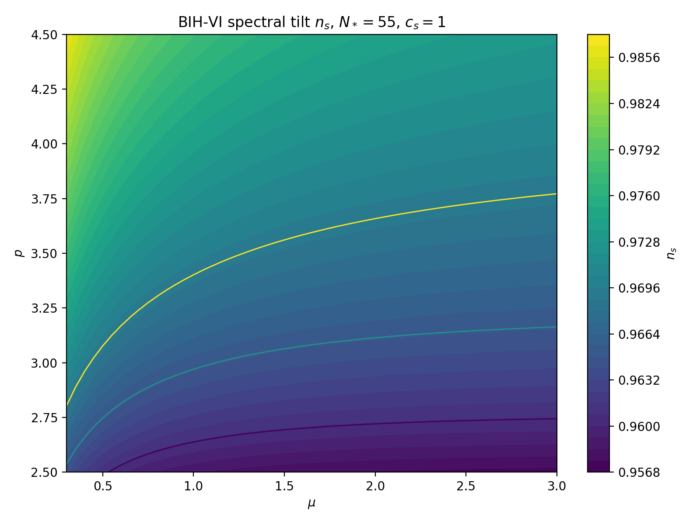
Figure 2. Spectral tilt heatmap over (mu,p).
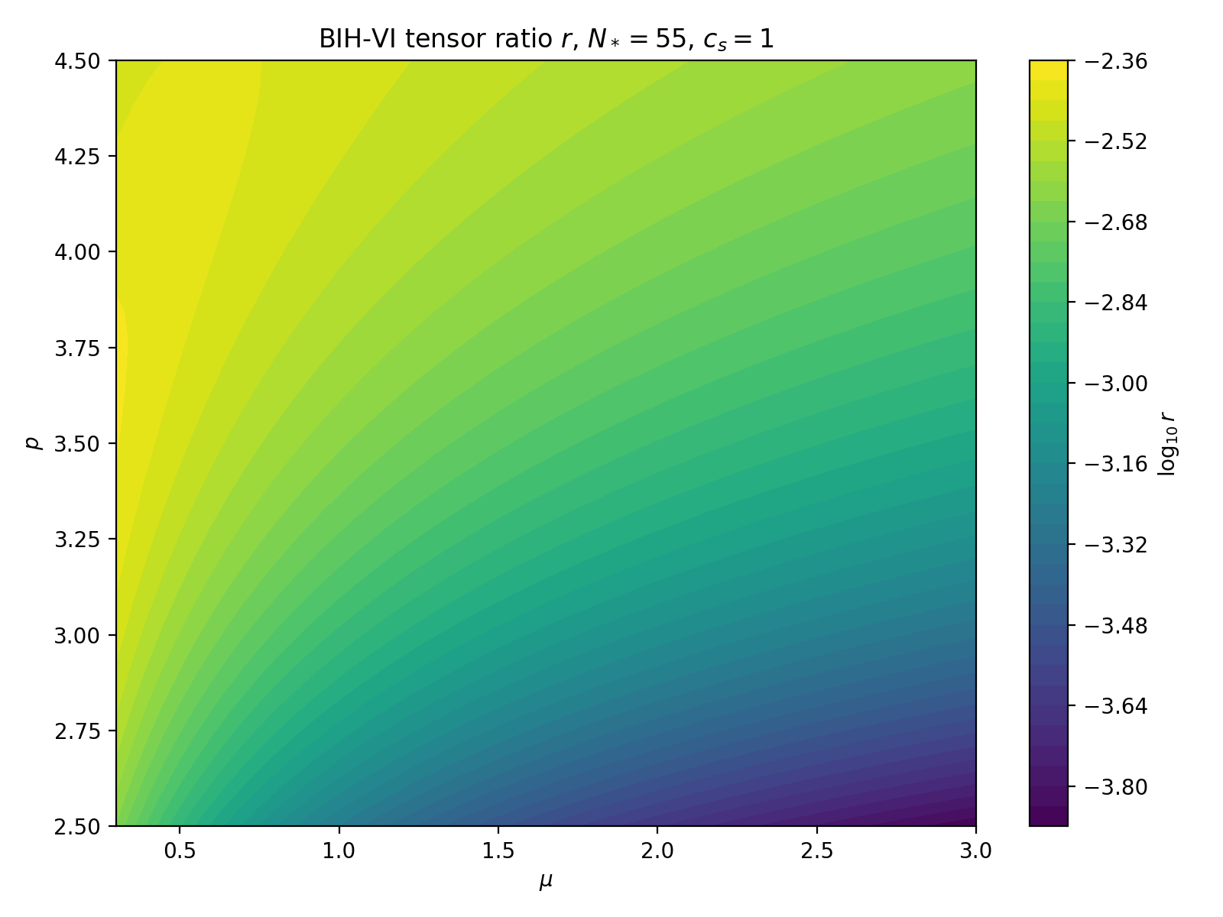
Figure 3. Tensor-ratio heatmap over (mu,p).

Exit Switch and Mukhanov-Sasaki Stress Test
The exit switch is m(y)=mu(1-y)^3 + m_post S(y), with S(y)=1/[1+exp((y-y_g)/Delta)]. For the benchmark y_g=2/3, m_post=4, and Delta=0.01, CMB-pivot modes are effectively uncontaminated while the switch produces a localized exit-scale feature.
Mukhanov-Sasaki equation: v_k" + [c_s^2 k^2 - z_s"/z_s] v_k = 0, z_s = a M_Pl sqrt(2 epsilon_H)/c_s.
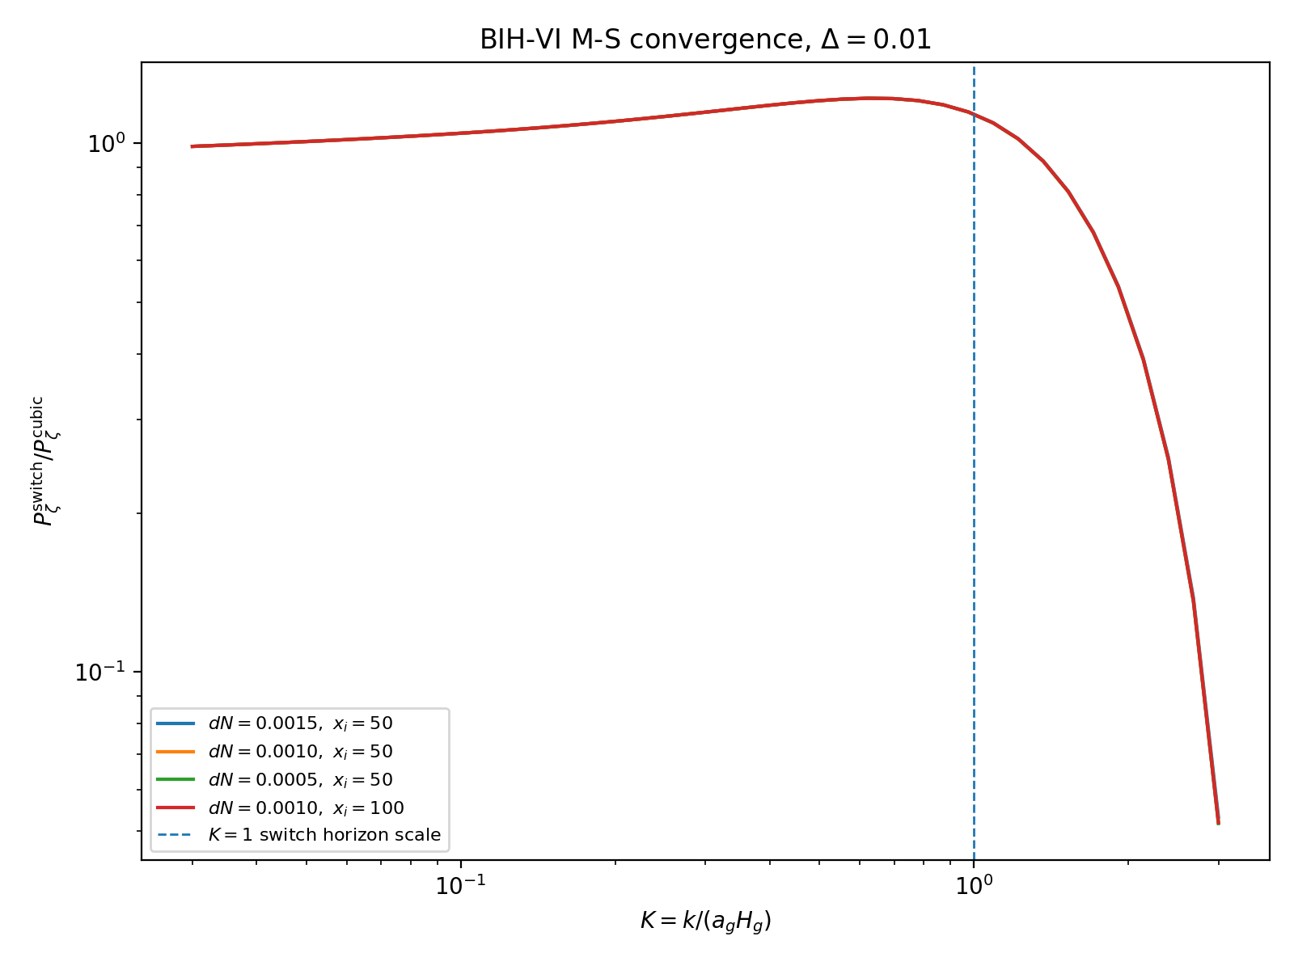
Figure 4. Mukhanov-Sasaki convergence for Delta=0.01.

Module A: Exit-Feature Bispectrum
The leading switch-enhanced cubic interaction was isolated as a feature diagnostic. It is not yet a full all-operator EFT bispectrum calculation, but it is sufficient to test whether the exit switch generates broad CMB-scale non-Gaussianity. It does not: pivot-side modes remain effectively Gaussian. The feature is localized near the exit scale.
S_3^switch ⊃ (M_Pl^2/2) ∫ dt d^3x a^3 epsilon_H dot(eta_H) zeta^2 zeta_dot.
H_int^switch ≈ -(M_Pl^2/2) ∫ d^3x a^3 epsilon_H H eta_N zeta^2 zeta_dot.
dN | x_i | K_peak | |f_NL|_peak | P ratio at peak | |B| proxy
0.00025 | 70 | 3.583 | 3.82e+03 | 3.27e-05 | 4.13e-04
0.00050 | 70 | 3.583 | 3.46e+03 | 3.32e-05 | 3.85e-04
0.00050 | 100 | 3.583 | 3.46e+03 | 3.32e-05 | 3.85e-04
0.00100 | 70 | 3.567 | 2.52e+03 | 1.23e-04 | 3.89e-03
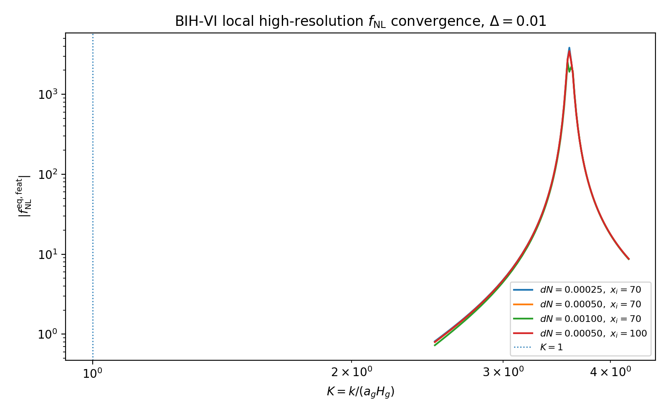
Figure 5. Local high-resolution equilateral feature-bispectrum convergence.
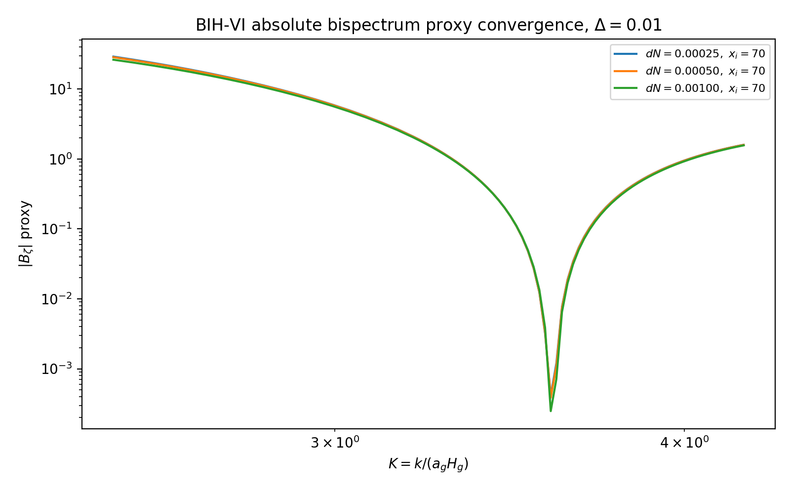
Figure 6. Absolute bispectrum proxy remains smooth and finite across the feature.
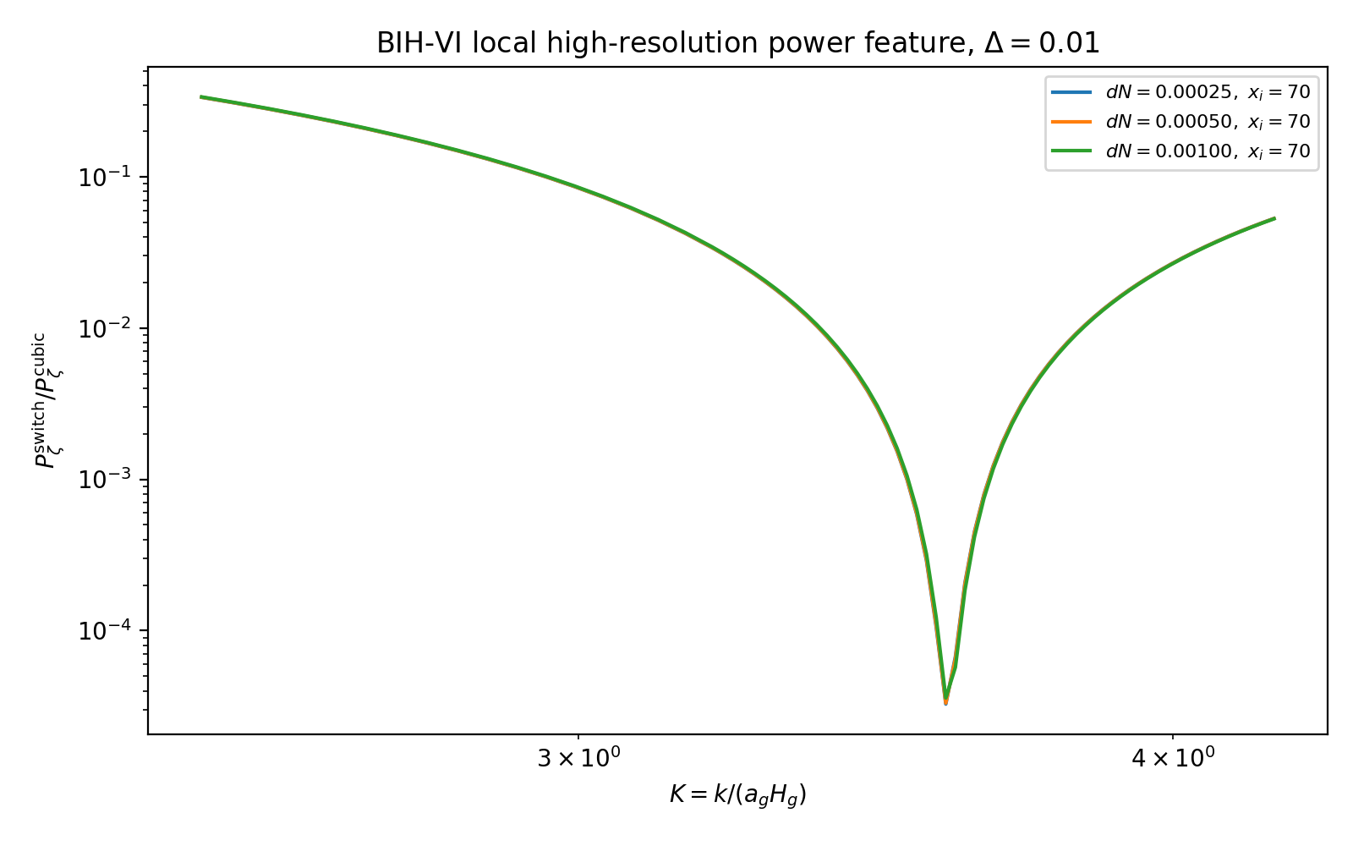
Figure 7. Local high-resolution power suppression associated with the exit feature.
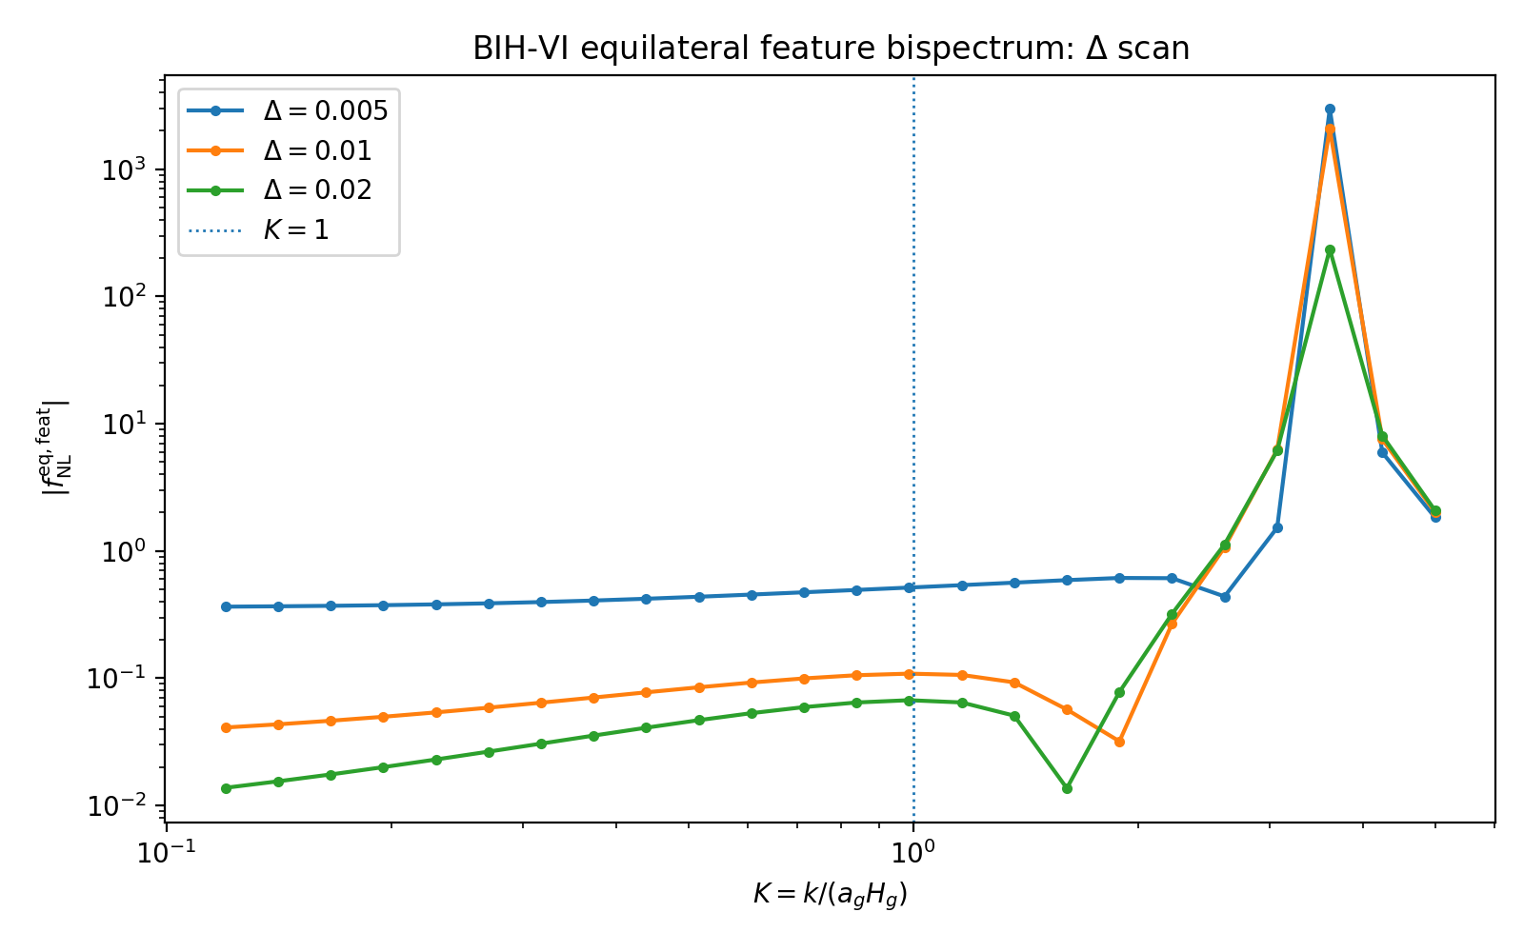
Figure 8. Delta-dependence of the equilateral feature-bispectrum estimate.

Module B: Physical Scale Mapping and Transfer Implication
Mapping the exit feature to present-day comoving scale shows that the feature is exponentially separated from CMB/LSS observables for N*=55. The exit feature is therefore not a LiteBIRD or ordinary CMB angular-spectrum feature; it is an ultra-small-scale relic. The CMB-facing prediction remains the smooth pivot-scale spectrum.
k_pivot [Mpc^-1] | K_pivot | k_switch [Mpc^-1] | k_peak [Mpc^-1] | lambda_peak [m]
0.05 | 1.37e-24 | 3.65e+22 | 1.31e+23 | 1.48
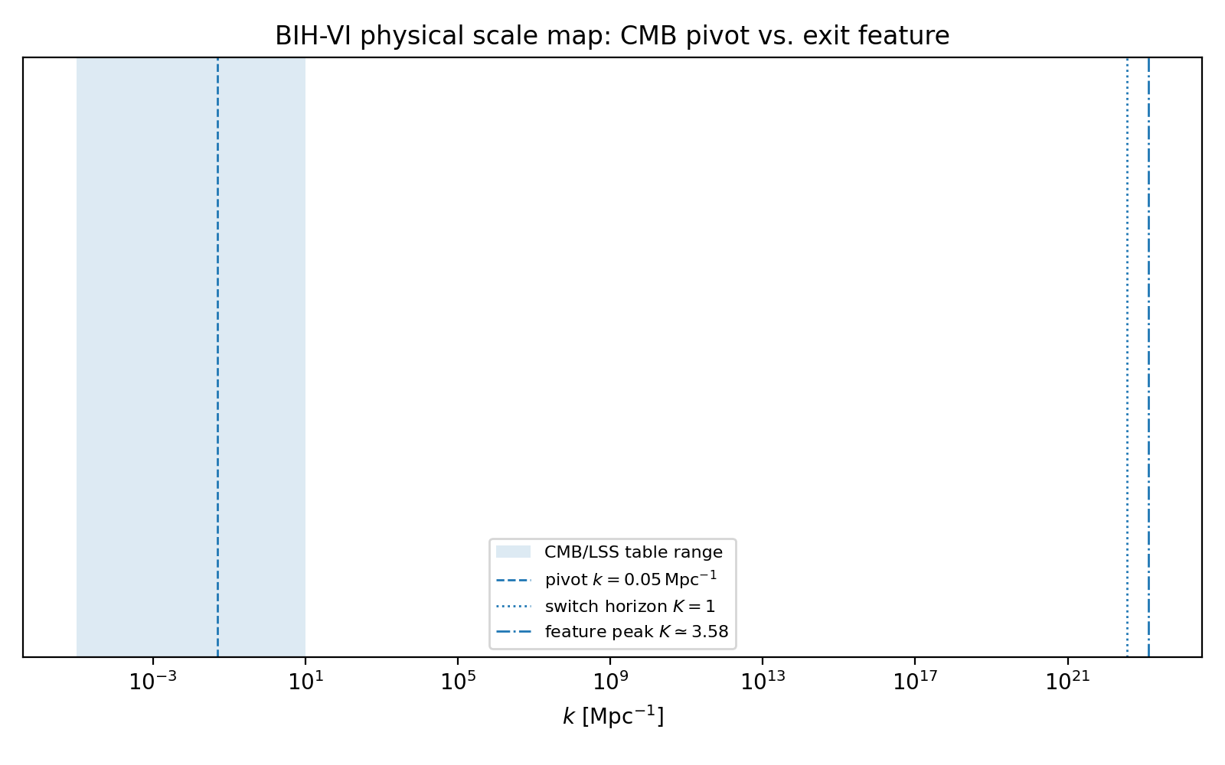
Figure 9. Physical scale map: CMB pivot versus exit feature.
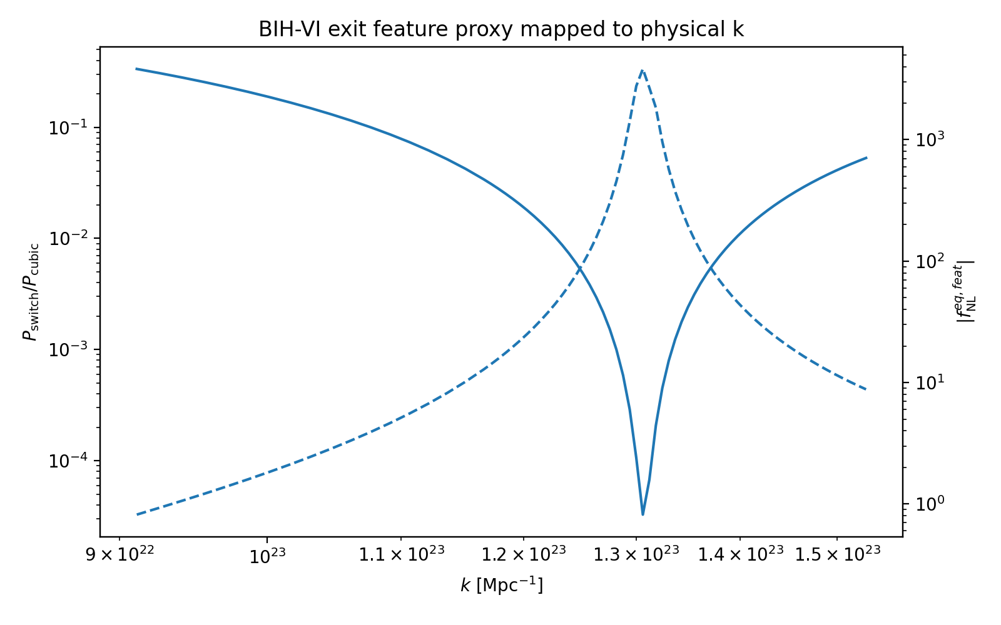
Figure 10. Exit feature proxy mapped to physical wavenumber.

Ultra-High-Frequency Gravitational-Wave Implication
The present-day frequency associated with a comoving wavenumber k is approximately f ≈ 1.54e-15 (k/Mpc^-1) Hz. With k_peak ≈ 1.3e23 Mpc^-1, the feature maps to f_peak ≈ 2e8 Hz, or about 200 MHz. This lies far above standard PTA/LISA/LIGO bands and belongs to the ultra-high-frequency gravitational-wave regime. Because the scalar power is suppressed at the feature, the usual scalar-induced gravitational-wave amplitude is expected to be very small in the benchmark branch.
f_peak ≈ 1.54e-15 * k_peak[Mpc^-1] Hz ≈ 2e8 Hz.

Updated Status and Remaining Work
The BIH-VI EFT-clock branch remains viable. Module A upgrades the exit switch from a power-spectrum feature to a localized non-Gaussian feature, while Module B demotes that feature from a CMB/LSS target to an ultra-small-scale relic. The robust CMB-facing prediction is still ns≈0.965, r≈10^-3, and alpha_s≈-6e-4. The leading remaining work is folded/squeezed bispectrum configurations, all cubic EFT operators, a dedicated feature-template analysis, and a microscopic substrate completion.

Selected References
Hayward, S. A. Unified first law and gravitational energy in spherical symmetry.
Cai, R. G. and Kim, S. P. First law of thermodynamics and Friedmann equations of Friedmann-Robertson-Walker universe.
Cheung, C. et al. The Effective Field Theory of Inflation.
Maldacena, J. Non-Gaussian features of primordial fluctuations in single field inflationary models.
Planck Collaboration. Planck 2018 results. X. Constraints on inflation.
BICEP/Keck Collaboration. Improved constraints on primordial gravitational waves using Planck, WMAP, and BICEP/Keck.
LiteBIRD Collaboration. Probing cosmic inflation with LiteBIRD.

