BIH-VI Open Work Addendum
Residual uncertainties, completed stress tests, and next verification gates
Status: EFT-level completion stable; microscopic substrate not yet derived.

Executive Update
This addendum converts the remaining BIH-VI caveats into engineering-style scope boundaries and test gates. The Sqrt-Reg entropy background and EFT-clock realization remain viable. The project is not yet a UV-complete microscopic theory; it is a controlled, falsifiable EFT branch with a Planck-compatible observable island and a converged Mukhanov-Sasaki switch stress test.
Open work item | Current status | Result / remaining gap
EFT vs microscopic completion | Partly closed | A canonical scalar/EFT-clock realization exists. A UV-complete origin for the Sqrt-Reg entropy functional remains open.
Switch sensitivity | Partly closed | Delta=0.01 is pivot-safe and numerically converged in the M-S test. The switch profile is still phenomenological.
Single-clock limitation | Partly closed | The minimal c_s=1 branch has negligible pivot non-Gaussianity and no isocurvature by construction. Multi-field extensions remain untested.
Numerical splash resolution | Partly closed | The M-S feature is stable under step-size and initial-depth tests. Full Boltzmann transfer is not included.
Backreaction / loops | Preliminary pass | Feature amplitudes are small in absolute power; no PBH-scale enhancement appears in the first M-S stress test.
Curvature / anisotropy | Preliminary pass | Inflationary expansion suppresses shear strongly. Full Bianchi/curved-FLRW dynamics remain future work.

1. Microscopic Completion Gap
The original limitation remains: BIH-VI is not a first-principles UV-complete theory. However, the gap is smaller than before because the stable EFT-clock branch admits a canonical scalar realization. This shows that the Sqrt-Reg background can be carried by an ordinary stable scalar degree of freedom, even though it does not yet derive the entropy law from quantum gravity or holography.
H^2 = H_c^2 y(2-y), z = 1-y, m(y)=mu z^3
dot(phi)^2 = 2 M_Pl^2 H_c^2 m(y) y(1-y)
V(y) = M_Pl^2 H_c^2 [3 y(2-y) - m(y)y(1-y)]
d phi/dy = +/- M_Pl sqrt( 2(1-y) / [m(y)y^2(2-y)] )
For the cubic gear m=mu z^3, the near-cap branch approaches a plateau. The potential is attractor-like: the Sqrt-Reg cap appears as a large-field plateau in canonical variables, while the exit occurs at finite field distance. This is structurally similar to the plateau logic of alpha-attractor models, but here the plateau is selected by the Sqrt-Reg entropy background rather than postulated as a supergravity potential.
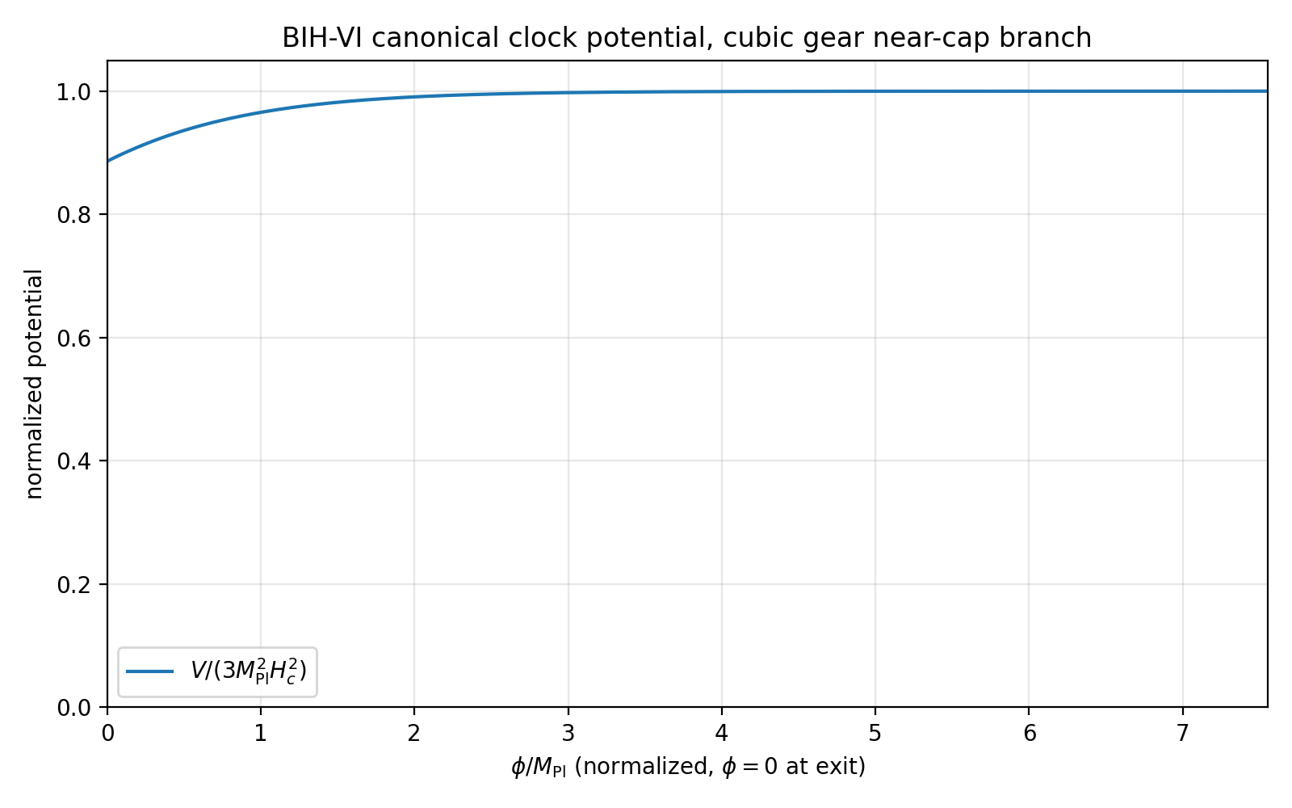
Figure 4. Canonical scalar realization of the cubic-gear BIH-VI clock potential. The plateau is the EFT representation of the Sqrt-Reg cap.

2. Non-Gaussianity Gate
At the CMB pivot, the benchmark branch uses c_s=1 and M_2^4=0. Therefore the leading single-clock non-Gaussianity is slow-roll suppressed. The squeezed-limit consistency estimate gives f_NL^local ~ 5(1-n_s)/12, which is approximately 1.45e-2 for n_s=0.9652. This is far below current Planck constraints.
f_NL^local ~ 5(1-n_s)/12 ~ 1.5e-2
The switch can create feature-type non-Gaussianity near the exit scale. This is not yet computed; it requires cubic EFT terms and/or an in-in calculation through the switch. The M-S stress test shows no large scalar power enhancement, so there is no immediate PBH-like warning sign, but a feature-bispectrum calculation remains future work.

3. Backreaction and Loop Control
The pivot scalar amplitude remains A_s ~ 2.1e-9. The switch feature is localized near the exit. A slow-roll baseline estimate at the switch center gives P_zeta ~ 1.8e-11 before the M-S feature ratio. The converged M-S test found roughly a ~1.1 maximum ratio near K~1 and suppression to ~0.05 in the exit-affected region. Thus the absolute switch-scale power is estimated to stay in the range:
P_zeta^switch ~ 9e-13 to 2e-11 (benchmark estimate)
This is many orders of magnitude below the level usually associated with primordial-black-hole production or large perturbative backreaction. Loop corrections scale with powers of P_zeta and are therefore negligible at the pivot and likely negligible across the switch in this first EFT branch. A full cubic calculation is still required before declaring loop safety at all scales.

4. Curvature and Anisotropy Robustness
BIH-VI is not a contracting bounce; it is an expanding Sqrt-Reg shield followed by an inflationary EFT-clock window. That distinction matters. The usual BKL-style anisotropy danger is most severe in contracting nonsingular-bounce settings, where shear can grow as a^-6. In the BIH-VI expanding branch, shear is diluted during the inflationary window.
rho_shear proportional a^-6, suppression over N e-folds: exp(-6N)
N=55 -> exp(-330) ~ 10^-143
Therefore any subdominant initial shear is exponentially erased during the benchmark window. What remains open is the fully coupled Bianchi-I version of the Sqrt-Reg/EFT-clock background. A future anisotropic calculation should check whether the Sqrt-Reg cap itself is stable to finite initial shear before the inflationary dilution phase.

5. Switch Sensitivity and M-S Convergence
The switch is phenomenological. It is a controlled valve rather than a derived substrate transition. The first stress test found Delta=0.01 to be pivot-safe and numerically stable. The switch remains the most important phenomenological sensitivity because it determines the localized exit-scale feature.
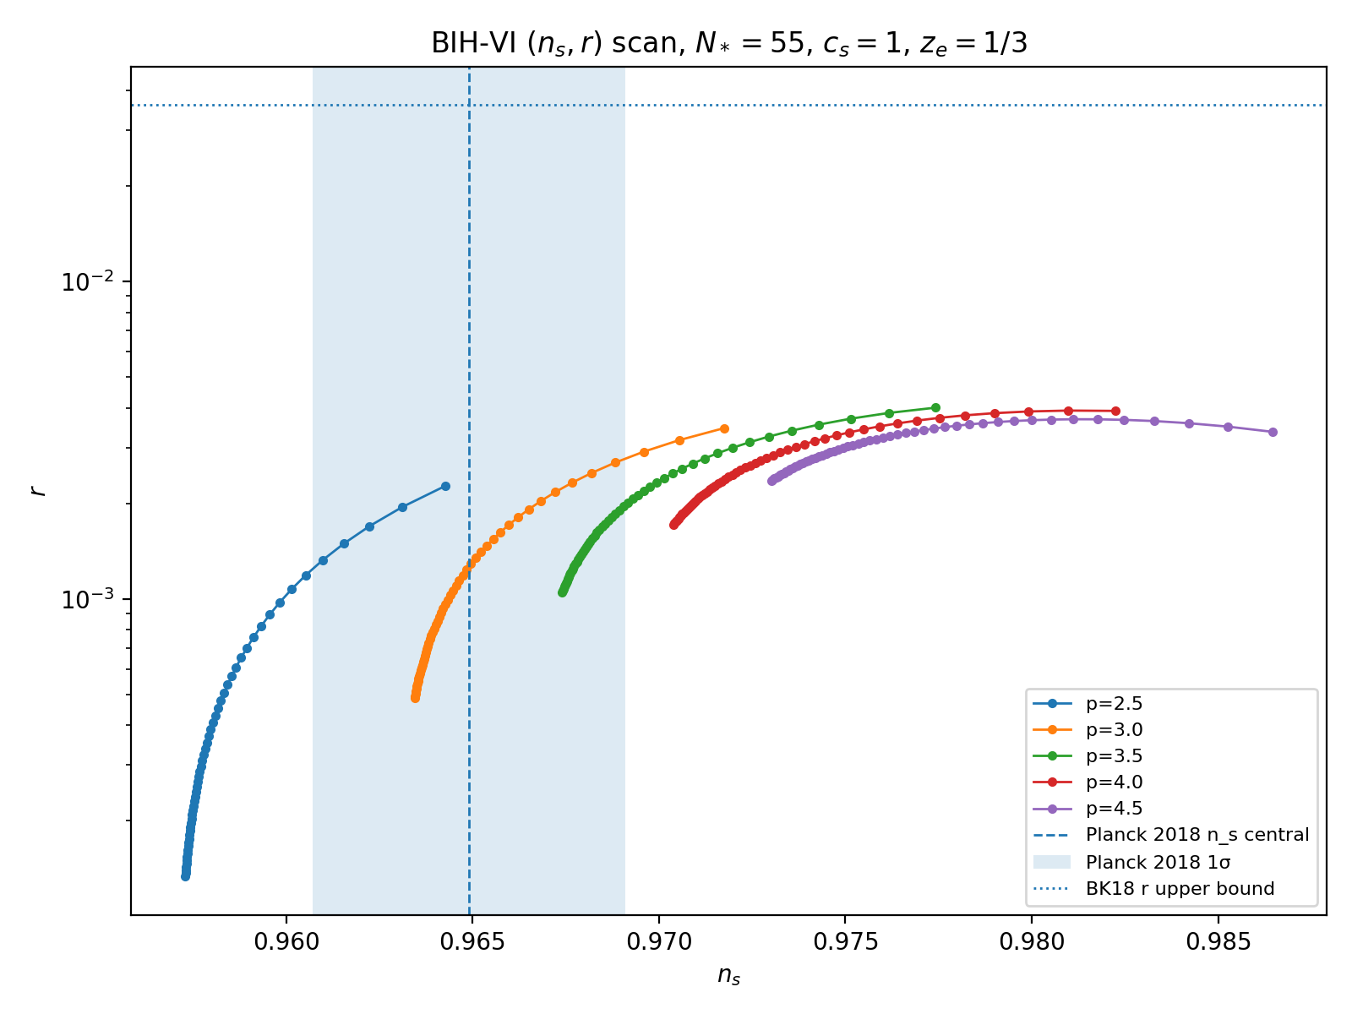
Figure 1. BIH-VI parameter island in the (n_s, r) plane.
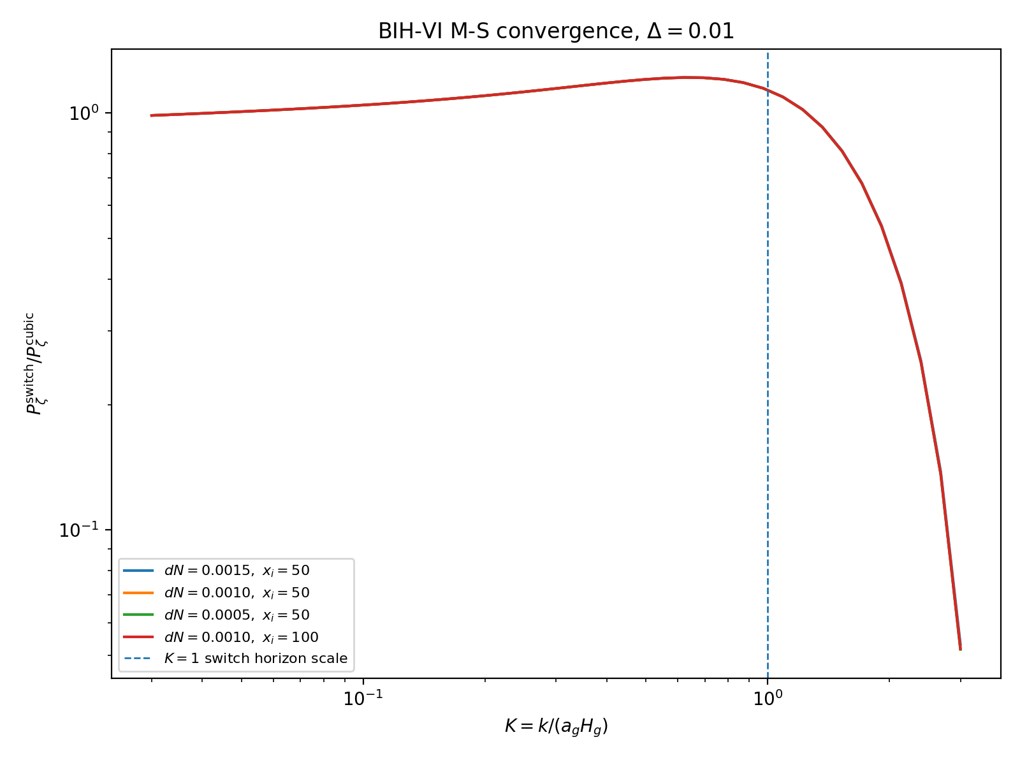
Figure 2. Mukhanov-Sasaki convergence test for the switch feature, Delta=0.01.
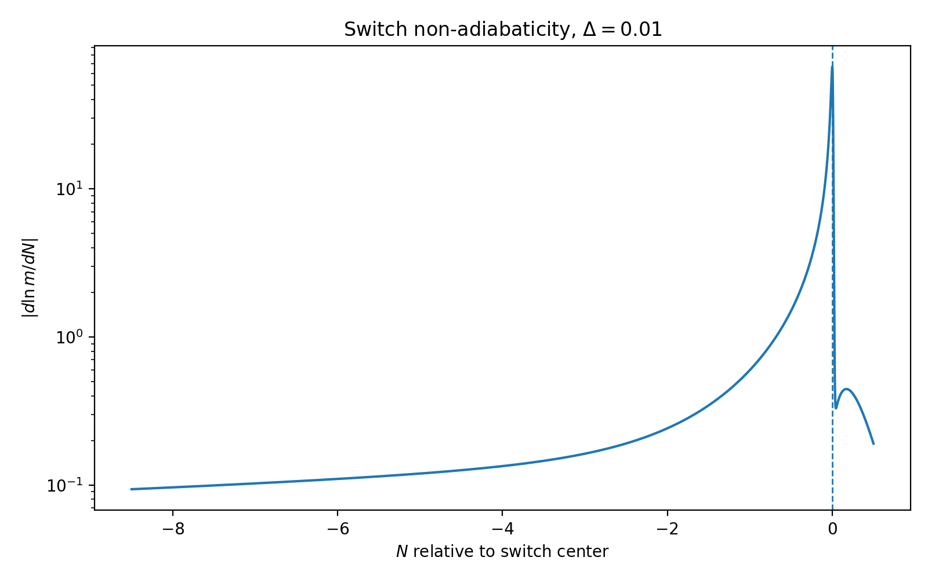
Figure 3. Switch non-adiabaticity, showing localized exit turbulence.

6. Boltzmann Transfer Scope Boundary
The M-S calculation gives the primordial curvature power proxy P_zeta(k). It does not directly generate CMB temperature and polarization spectra. A full CLASS/CAMB-style Boltzmann transfer calculation is required to convert the primordial feature into C_l predictions. This remains outside the present addendum.

7. Scope-Boundary Statement for the Main Report
Recommended wording:
This work establishes an EFT-level stability and phenomenology envelope for the BIH-VI Sqrt-Reg branch. It does not claim a unique microscopic UV completion of the entropy functional, does not treat multi-field/isocurvature dynamics, and does not compute full Boltzmann transfer functions. The contribution is the demonstration that a stable single-clock branch exists, overlaps current CMB constraints, and possesses a controlled exit-scale feature under Mukhanov-Sasaki evolution.

8. Closure Matrix
Question | Current answer
Can BIH-VI be stable at quadratic order? | Yes, in EFT-clock branch with c_s^2>0 and epsilon_H>0.
Does the pivot region match CMB constraints? | Yes, parameter island centered near p=3, mu~1.
Does the exit switch contaminate pivot modes? | No for Delta~0.01.
Does the switch feature converge numerically? | Yes under dN and initial-depth tests performed.
Is UV completion solved? | No. Canonical/EFT realization exists, but microscopic entropy origin remains open.
Is non-Gaussianity solved? | Pivot estimate is safely small; switch bispectrum remains open.
Is full CMB transfer solved? | No. M-S power is a direct primordial proxy only.
Is anisotropy solved? | Inflation dilutes shear strongly; full anisotropic background remains open.

References / Anchors
- Cheung et al., The Effective Field Theory of Inflation, arXiv:0709.0293.
- Maldacena, Non-Gaussian features of primordial fluctuations in single-field inflationary models, arXiv:astro-ph/0210603.
- Planck Collaboration, Planck 2018 Results IX: Constraints on primordial non-Gaussianity, arXiv:1905.05697.
- Kallosh and Linde, Superconformal inflationary alpha-attractors and related alpha-attractor literature.
- BKL/anisotropy caution: anisotropy growth in nonsingular bounce scenarios is a known limitation of contracting bounce models.

Prepared as an addendum to BIH-VI Technical Report.

