Boundary-Inversion Cosmology VI
A Sqrt-Reg Entropy Shield with a Stable EFT-Clock Completion
Technical Report and Numerical Stress-Test Package
Prepared for Lou | Current version: BIH-VI freeze
Core claim: BIH-VI contains a stable EFT-clock realization of a Sqrt-Reg entropy-selected cosmological background, with a Planck-compatible observable island and a controlled exit feature.
Status: technical framework freeze. Do not expand the model until the report has been reviewed.

Contents
1. Executive summary
2. Core equations and definitions
3. Boundary-Inversion seam
4. Hayward thermodynamics and the Sqrt-Reg density shield
5. Failed direct completions
6. BIH-VI stable EFT-clock completion
7. Cubic gear observables and parameter island
8. Exit switch and Mukhanov-Sasaki stress test
9. Engineering interpretation: laminar flow and controlled exit feature
10. Falsifiability and forecast targets
11. Limitations and scope boundaries
Appendix A. Equation map
Appendix B. Numerical artifact index
Appendix C. References

1. Executive summary
This report freezes the current state of the Boundary-Inversion Hypothesis at BIH-VI. Earlier branches were useful stress tests, but the final working branch is an effective-field-theory clock realization of the Sqrt-Reg entropy-selected background. The claim is deliberately narrow: BIH-VI is a stable EFT-level cosmological branch with falsifiable predictions, not a completed microscopic substrate theory.

1.1 Abstract
We develop a stable effective-field-theory realization of a Boundary-Inversion cosmological background. The geometric core is the invariant spherical marginal-horizon condition chi = h^{ab} nabla_a R nabla_b R = 0, equivalently R = 2G E_MS, which unifies black-hole trapped and expanding cosmological anti-trapped sign sectors through opposite null-expansion orientation. Applying Hayward-style apparent-horizon thermodynamics motivates a Sqrt-Reg entropy functional whose equilibrium background caps both H^2 and the effective density. Several direct covariant completions fail as final microscopic actions: pure f(T) suffers a scalar rank-changing constraint pathology, a minimal f(T,B) repair fails to recover the correct scalar infrared limit, and an analytic f(R) reconstruction gives the wrong sign for f_RR in the low-curvature branch. We then construct a stable EFT-clock completion realizing H^2 = H_c^2 y(2-y), with scalar and tensor quadratic actions free of ghost and gradient instabilities. A cubic near-cap gear profile m(y) = mu(1-y)^3 generates a Planck-compatible parameter island. For the benchmark p = 3, mu = 1, c_s = 1, N_* = 55, and z_e = 1/3, the model predicts n_s = 0.9652, r = 1.4e-3, alpha_s = -5.8e-4, and H_c = 3.8e-6 M_Pl. A Mukhanov-Sasaki stress test of the exit switch shows that Delta = 0.01 keeps CMB pivot modes uncontaminated while producing a localized exit-scale feature. The result is a falsifiable EFT-level cosmological branch rather than a final microscopic substrate theory.
Table 1. Current BIH-VI decision table.
Component | Status | Reason
Geometric seam | Survives | chi = 0 / R = 2G E_MS is the invariant spherical-horizon seam.
Sqrt-Reg entropy | Survives | Caps H^2 and effective density in equilibrium horizon thermodynamics.
Pure f(T) | Rejected as final action | Background/tensors pass; scalar rank-changing constraint pathology.
Linear f(T,B) | Rejected as minimal repair | Preserves background; scalar IR behavior fails.
Analytic f(R) | Rejected | Reconstruction exists but f_RR has wrong sign in analytic IR branch.
BIH-VI EFT clock | Current best branch | Stable scalar/tensor quadratic action and viable CMB parameter island.
Exit switch | Passes first M-S stress test | Pivot-safe for Delta around 0.01; localized exit-scale feature.

2. Core equations and definitions
Natural units c = hbar = k_B = 1 are used. The metric signature convention is (-,+,+,+). All equations in this report use plain-text notation for portability across DOCX/PDF renderers.

2.1 Spherical geometry and null expansions
ds^2 = h_ab dx^a dx^b + R^2 dOmega^2
theta_pm = (2/R) l_pm^a nabla_a R
normal: (+,-), trapped: (-,-), anti-trapped: (+,+)

2.2 Invariant seam
chi = h^{ab} nabla_a R nabla_b R
chi = 1 - 2G E_MS/R
chi = 0 <=> R = 2G E_MS
theta_+ theta_- = -4 chi/R^2 for l_+ . l_- = -2

2.3 Apparent horizon and entropy variables
x = H^2 + k/a^2
R_A = x^{-1/2}, A = 4 pi / x
S_sqrt(A) = (1/(4G)) [ sqrt(A(A-A_c)) + A_c arcosh sqrt(A/A_c) ]
S_A = dS/dA = 1/[4G sqrt(1-A_c/A)]

3. Boundary-Inversion seam
The map B:(theta_+,theta_-) -> (-theta_-,-theta_+) is useful as orientation language, but it is not the invariant physical seam. The invariant seam is chi = 0, equivalently R = 2G E_MS. Trapped and anti-trapped regions are distinguished by the sign sector of the future null expansions and the time orientation of the screen.

3.1 Schwarzschild and FLRW checks
Schwarzschild: chi = 1 - 2GM/R
FLRW: chi = 1 - (H^2 + k/a^2) R^2
FLRW apparent horizon: R_A = 1/sqrt(H^2 + k/a^2)
This common chi=0 condition is known spherical-horizon geometry, not a new theorem. The BIH contribution is to use it as the organizing seam connecting black-hole trapped screens and cosmological anti-trapped screens, then to construct a thermodynamic and EFT realization around the cosmological side.
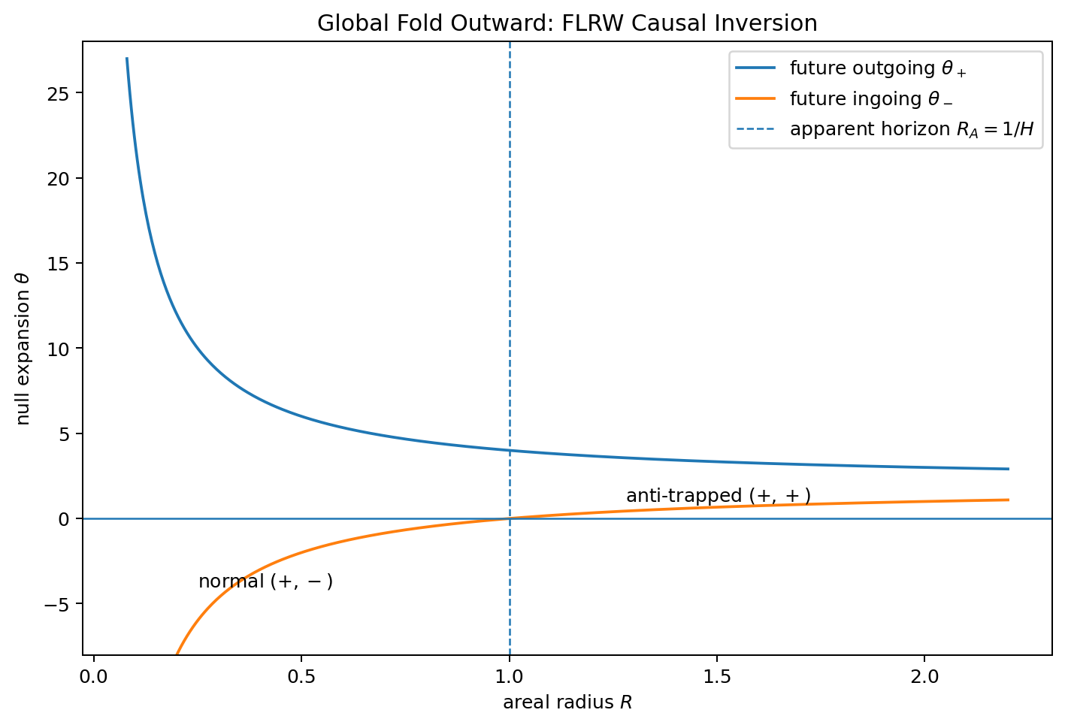
Figure 1. FLRW null-expansion sign sectors: normal to anti-trapped across the apparent horizon.
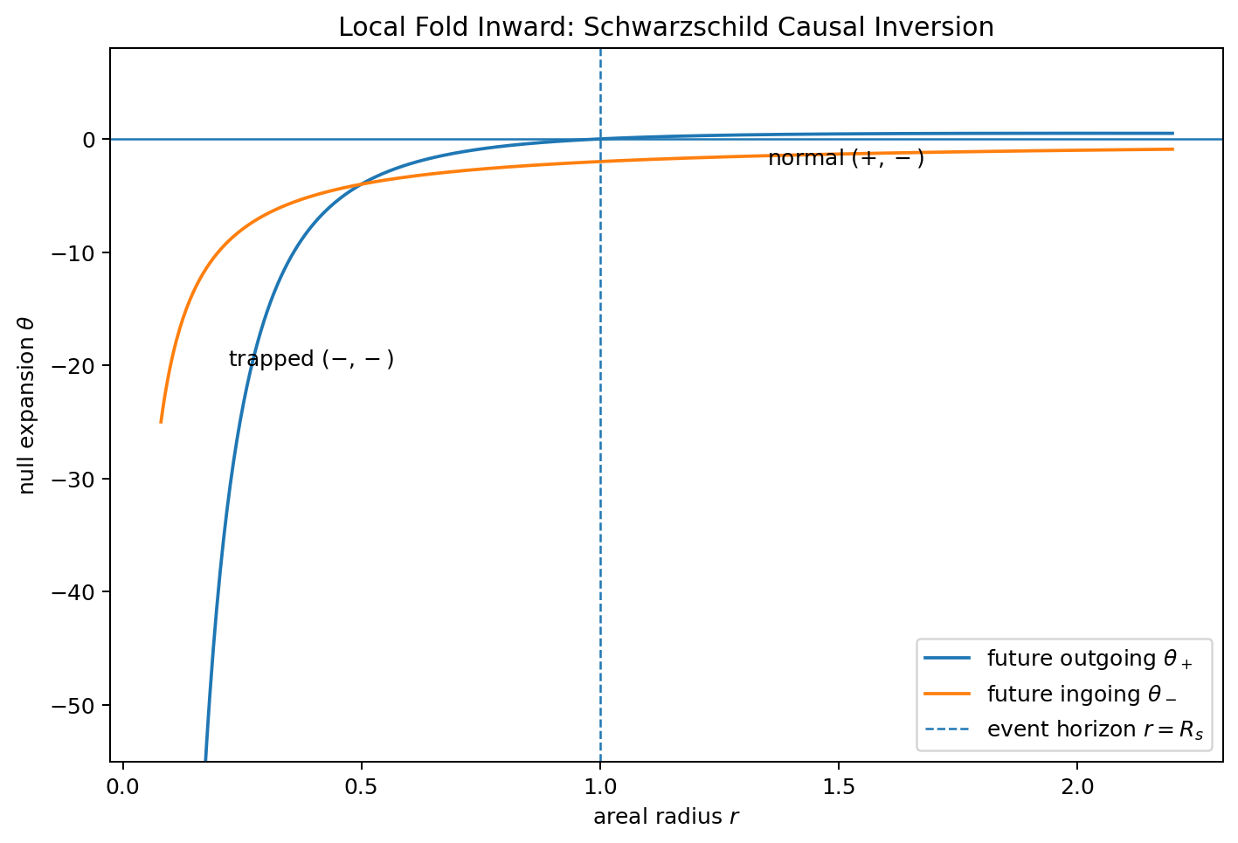
Figure 2. Schwarzschild null-expansion sign sectors: normal to trapped across the horizon.

4. Hayward thermodynamics and the Sqrt-Reg density shield
The thermodynamic layer uses the apparent horizon rather than a literal material boundary. In equilibrium, the Hayward-style entropy-production diagnostic reduces to a modified acceleration equation.
Gamma = dot(S_i) = 8 pi^2 H R_A^4 (rho+p) - 8 pi R_A S_A dot(R_A)
Gamma = 0 => dot(H) - k/a^2 = - pi (rho+p)/S_A
G_eff(A) = 1/(4 S_A) = G sqrt(1-A_c/A)

4.1 Sqrt-Reg Friedmann function
F_sqrt(x) = 2 x_c [1 - sqrt(1 - x/x_c)]
F_sqrt(H^2) = 8 pi G rho / 3 (flat, Lambda=0)
H^2 = (8 pi G rho / 3) [1 - 2 pi G rho/(3 H_c^2)]
rho_max = 3 H_c^2/(4 pi G)
This is the key improvement over the earlier log-critical entropy branch. The log-critical branch capped H^2 but left the matter density divergent. The Sqrt-Reg branch caps both H^2 and the effective density.

5. Failed direct completions
This section is intentionally included. It documents the failure modes so the final branch is not presented as a lucky first guess.

5.1 Pure f(T)
Pure f_sqrt(T) reconstructs the Sqrt-Reg background and passes the tensor-sector check, but its scalar/tetrad sector has a rank-changing antisymmetric constraint. The relevant coefficient is proportional to f_TT dot(T), which vanishes in the IR and is nonzero at finite u. That produces a discontinuous constraint structure and indicates strong-coupling pathology.
A_constraint = f_TT dot(T)
A_constraint -> 0 as u -> 0, but A_constraint != 0 for generic 0<u<1

5.2 Linear f(T,B)
A linear Q(T)B repair can preserve the Sqrt-Reg background only if the T-only part is retuned. The minimal repair f_q = g_sqrt + q (tau/tau_c)(B-2 tau) preserves the background, but generically produces scalar-sector IR behavior analogous to an unscreened extra scalar and fails as a minimal final action.
f_q(tau,B) = g_sqrt(tau) + q (tau/tau_c)(B - 2 tau)

5.3 Analytic f(R)
Metric f(R) reconstruction exists for the Sqrt-Reg background, but the analytic GR-limit branch gives the wrong sign for f_RR. For dust, the low-curvature expansion has an anti-Starobinsky sign.
f(R) = R - R^2/(54 H_c^2) + ... (dust analytic branch)
f_RR < 0 => scalaron instability

6. BIH-VI stable EFT-clock completion
The stable branch realizes the Sqrt-Reg background inside the EFT of cosmological perturbations. This does not claim a final microscopic substrate; it gives a controlled action-level realization with healthy quadratic scalar and tensor sectors.
S_EFT = int d^4x sqrt(-g) [ M_Pl^2 R/2 - Lambda(t) - c(t) g^{00} + (M_2^4(t)/2)(delta g^{00})^2 + ... ]
H^2 = H_c^2 y(2-y), y_N = -m(y) y
dot(H) = -m H_c^2 y(1-y)
epsilon_H = m(1-y)/(2-y)
c(y) = M_Pl^2 m H_c^2 y(1-y)
Lambda(y) = M_Pl^2 H_c^2 y[(6-m)+(m-3)y]
M_2^4 = c/2 (c_s^{-2}-1)

6.1 Perturbation actions
S_zeta^(2) = M_Pl^2 int dt d^3x a^3 (epsilon_H/c_s^2) [ dot(zeta)^2 - c_s^2 (grad zeta)^2/a^2 ]
S_T^(2) = (M_Pl^2/8) int dt d^3x a^3 [ dot(h_ij)^2 - (grad h_ij)^2/a^2 ]
stable if: epsilon_H > 0, c_s^2 > 0, c_T^2 = 1

7. Cubic gear observables and parameter island
z = 1-y
m(y) = mu z^p
N_* = (1/mu) int_{z_*}^{z_e} dz/[z^p(1-z)]
epsilon_* = mu z_*^{p+1}/(1+z_*)
r = 16 epsilon_* c_s
n_s - 1 = -2 epsilon_* - mu z_*^p (1-z_*)[(p+1)/z_* - 1/(1+z_*)]
The viable branch is centered near p = 3. This exponent gives the Starobinsky-like red-tilt scaling in the near-cap asymptotic limit, while finite exit effects shift the optimal mu toward mu about 1 for N_* = 55 and z_e = 1/3.
Table 2. BIH-VI benchmark line for p = 3, N_* = 55, z_e = 1/3, c_s = 1.
mu | z_star | y_star | n_s | r | alpha_s | H_c_over_Mpl
0.5000 | 0.1372 | 0.8628 | 0.9682 | 0.0025 | -4.737e-04 | 5.130e-06
0.7000 | 0.1176 | 0.8824 | 0.9665 | 0.0019 | -5.312e-04 | 4.486e-06
1.0000 | 0.0991 | 0.9009 | 0.9652 | 0.0014 | -5.784e-04 | 3.834e-06
1.5000 | 0.0811 | 0.9189 | 0.9643 | 9.623e-04 | -6.165e-04 | 3.168e-06
2.0000 | 0.0702 | 0.9298 | 0.9638 | 7.274e-04 | -6.351e-04 | 2.752e-06

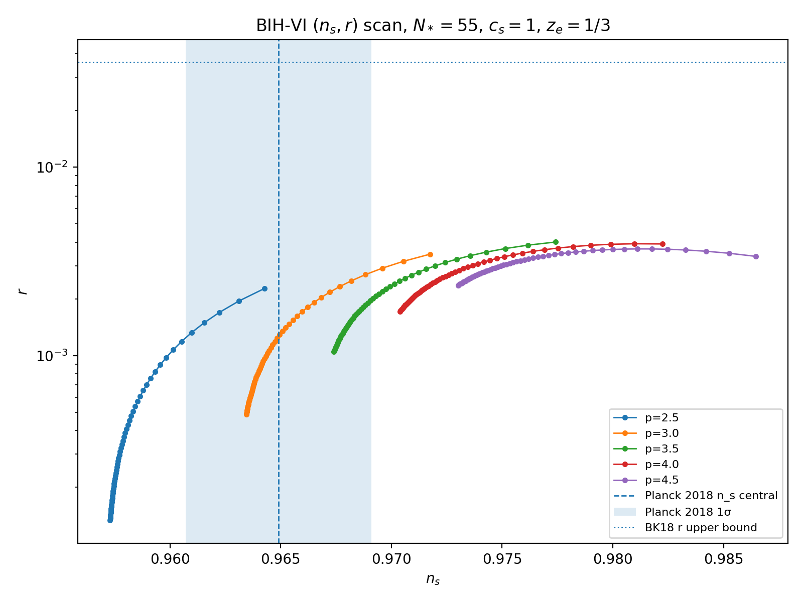
Figure 3. BIH-VI (n_s,r) parameter scan for N_* = 55, c_s = 1, z_e = 1/3.
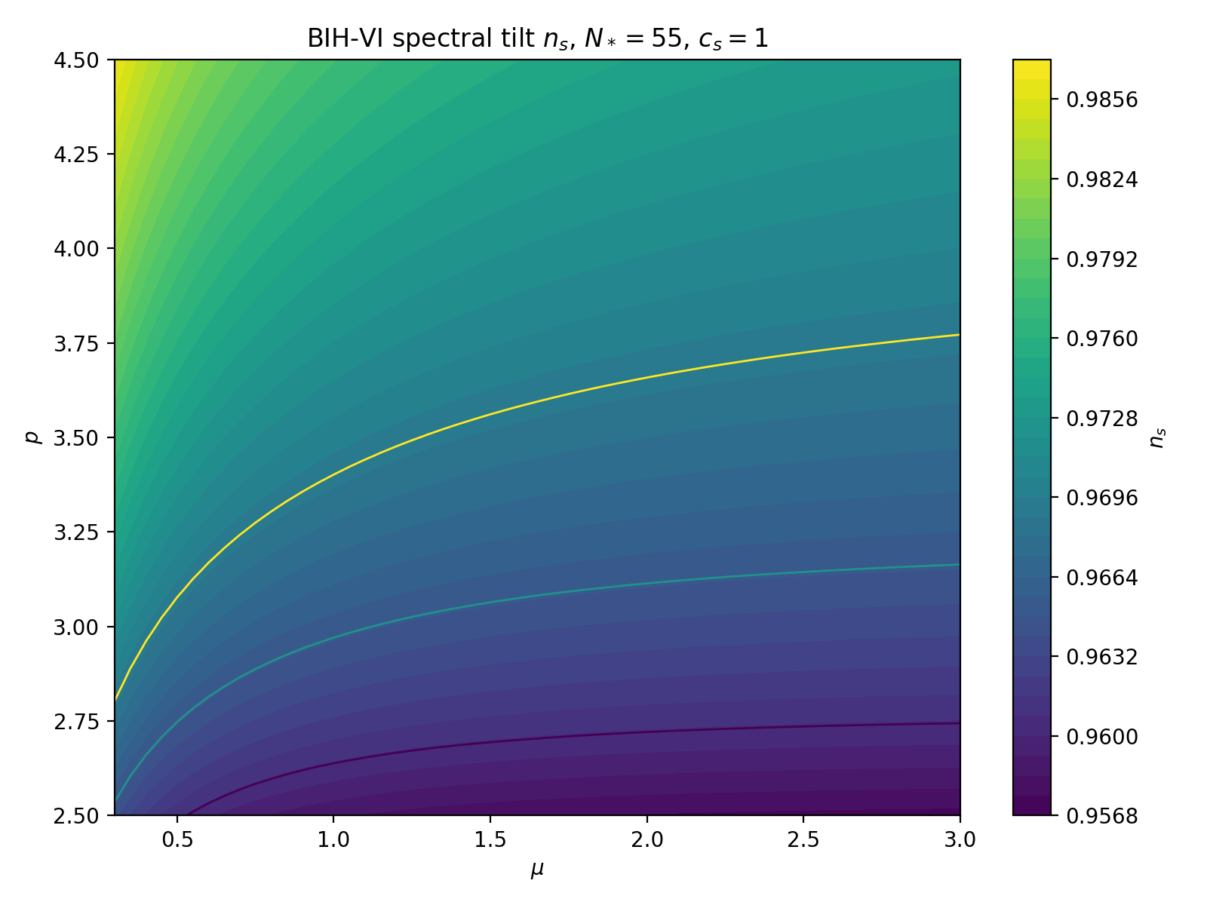
Figure 4. Spectral tilt n_s over the (mu,p) plane.
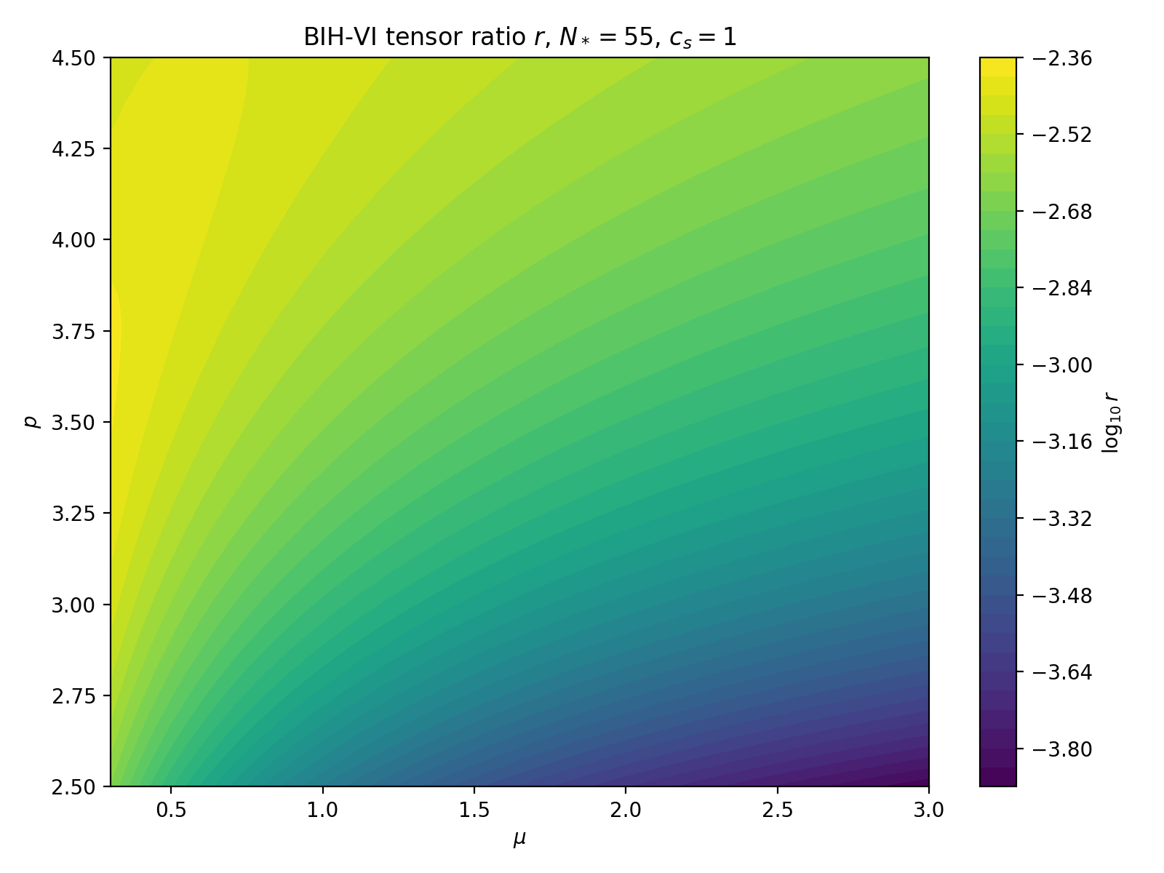
Figure 5. Tensor-to-scalar ratio r over the (mu,p) plane.

8. Exit switch and Mukhanov-Sasaki stress test
m(y) = mu(1-y)^3 + m_post S(y)
S(y) = 1/[1 + exp((y-y_g)/Delta)]
benchmark: mu=1, p=3, y_g=2/3, Delta=0.01, m_post=4
The switch is designed to be invisible at the CMB pivot while forcing a handoff to a radiation-like phase near the end of inflation. The slow-roll estimate predicts a localized feature near the switch; the Mukhanov-Sasaki calculation checks whether that feature is physical and numerically stable.
v_k" + [ c_s^2 k^2 - z_s"/z_s ] v_k = 0
z_s = a M_Pl sqrt(2 epsilon_H)/c_s
P_zeta(k) = (k^3/(2 pi^2)) |v_k/z_s|^2
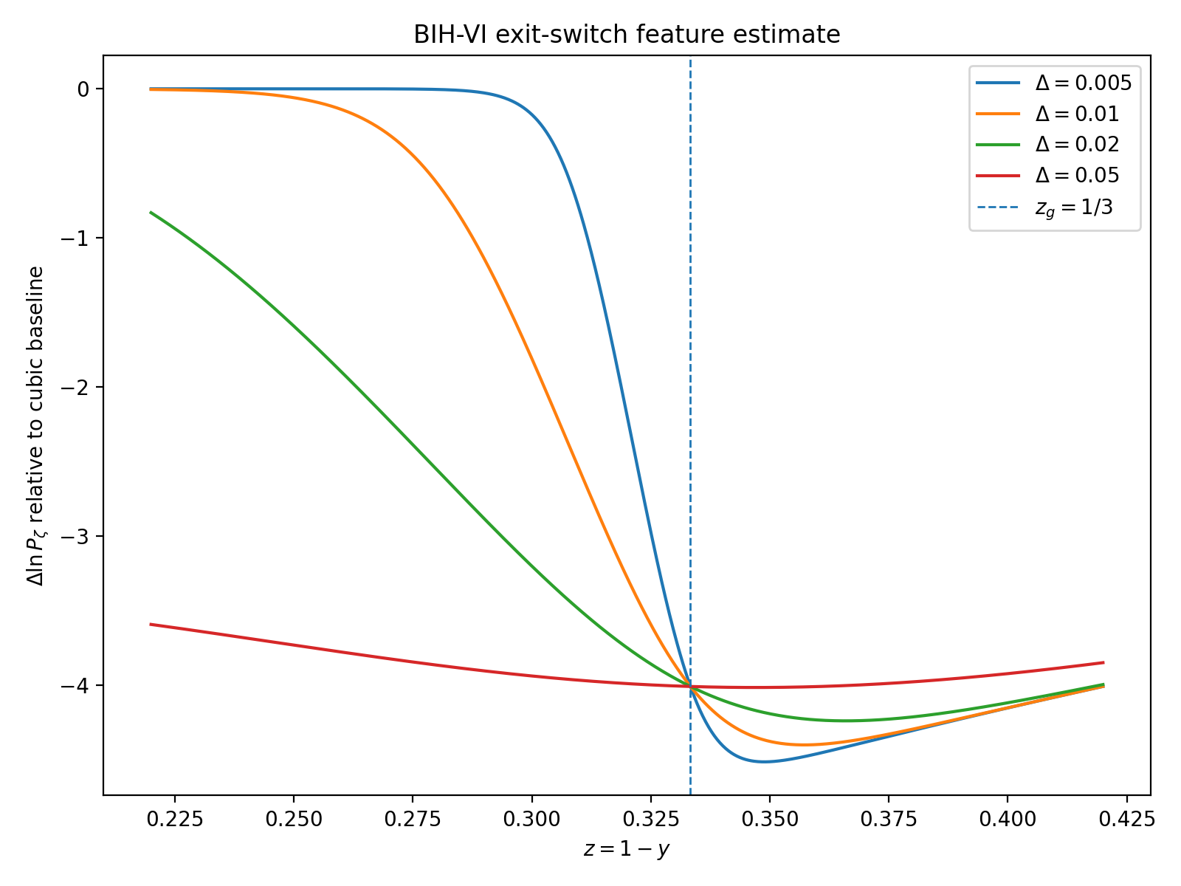
Figure 6. Slow-roll exit-feature estimate: switch-induced Delta ln P_zeta relative to the cubic baseline.
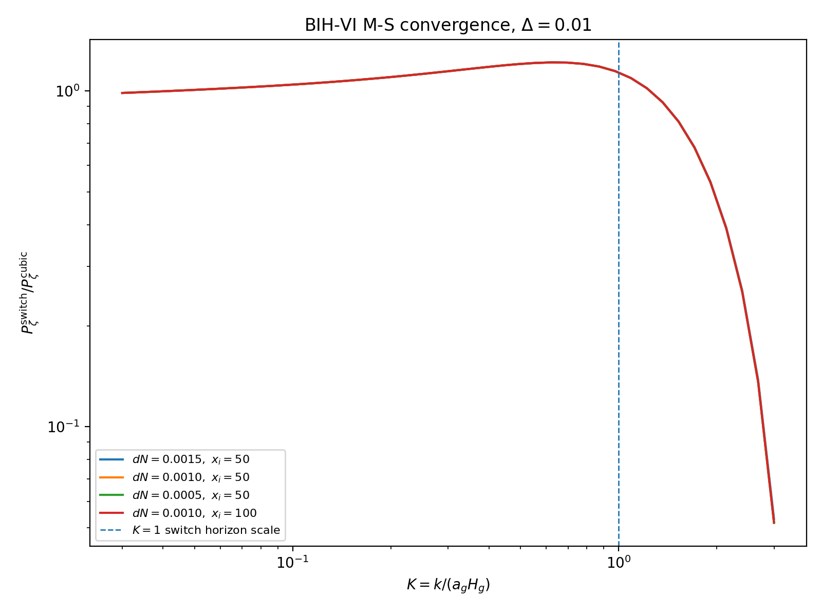
Figure 7. Mukhanov-Sasaki switch-feature convergence for Delta = 0.01.
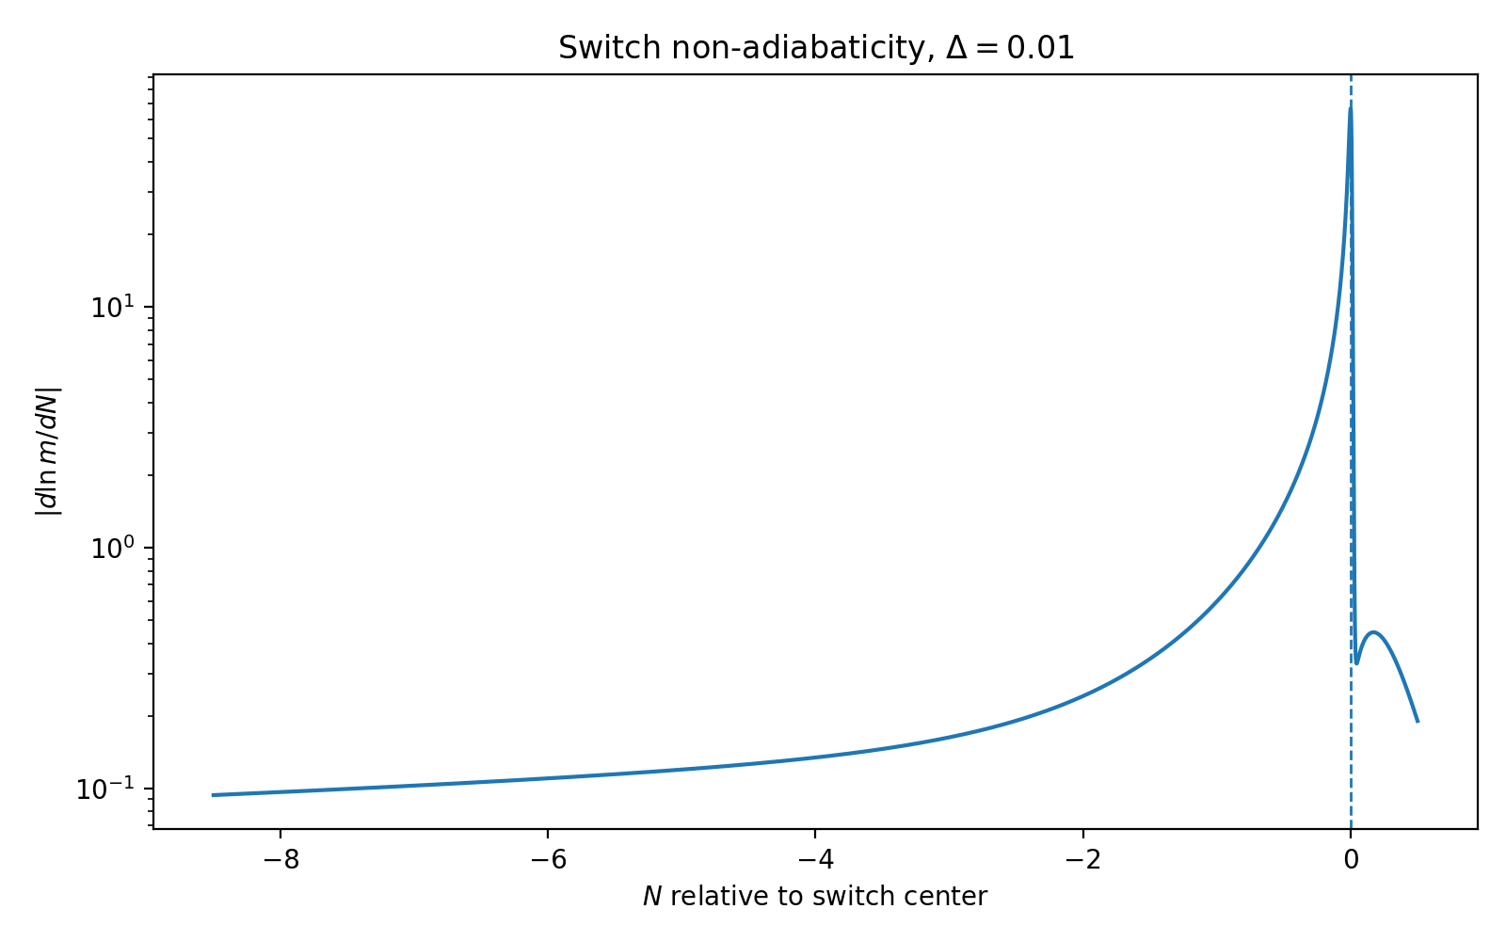
Figure 8. Switch non-adiabaticity |d ln m/dN| for Delta = 0.01.
Table 3. M-S convergence summary for Delta = 0.01.
config | min_ratio_all | max_ratio_all | min_ratio_K_lt_1 | max_ratio_K_lt_1 | min_ratio_K_gt_1 | max_ratio_K_gt_1
$dN=0.0015,\ x_i=50$ | 0.0532 | 1.2167 | 0.9865 | 1.2167 | 0.0532 | 1.0934
$dN=0.0010,\ x_i=50$ | 0.0519 | 1.2165 | 0.9866 | 1.2165 | 0.0519 | 1.0924
$dN=0.0005,\ x_i=50$ | 0.0517 | 1.2164 | 0.9865 | 1.2164 | 0.0517 | 1.0921
$dN=0.0010,\ x_i=100$ | 0.0519 | 1.2166 | 0.9865 | 1.2166 | 0.0519 | 1.0927

9. Engineering interpretation: laminar flow and controlled exit feature
The fluid language is useful as an engineering guide, not as an additional postulate. The formal model does not require a literal oil, material exterior, or biological interpretation. The analogy maps as follows:
Table 4. Engineering analogy translated into technical BIH-VI objects.
Intuition | Technical object
black oil / structured medium | EFT clock sector
surface tension | Sqrt-Reg cap H_c
viscosity | c_s, M_2^4, and higher-order EFT operators
laminar flow | stable evolution of CMB-pivot modes
turbulence / splash | localized exit feature in P_zeta(k)
wind tunnel test | Mukhanov-Sasaki convergence check

The disciplined version is: BIH-VI is laminar through the CMB window and locally turbulent only at the exit boundary. The turbulence is a controlled localized feature rather than a catastrophic instability in the tested parameter range.

10. Falsifiability and forecast targets
BIH-VI is falsifiable through its observable island and its exit feature. The benchmark prediction is small but not arbitrarily small: r is around 10^{-3}. LiteBIRD-level sensitivity is therefore the natural future comparison.
fiducial: n_s = 0.9652, r = 1.4e-3, alpha_s = -5.8e-4
localized exit feature: P_switch/P_cubic ~ 1 for K << 1, modest ringing near K ~ 1, suppression for high K
Table 5. Falsifiability routes.
Test | Falsification route
Tensor ratio | Future constraints push well below r ~ 10^{-3} without detection.
Spectral tilt | Preferred n_s moves outside the BIH-VI island after nuisance/reheating freedom is accounted for.
Running | A large or opposite-sign alpha_s is detected.
Exit features | Small-scale data rule out the predicted localized suppression/ringing region.
Microscopic completion | No covariant stable completion can reproduce the EFT branch without hidden instabilities.

11. Limitations and scope boundaries
This section defines the scope boundaries of BIH-VI. They are not treated as failures; they are explicit validity limits of the present technical note. The report establishes a stable EFT-level realization and a phenomenological observable island. It does not claim a unique microscopic substrate theory.

11.1 EFT vs. microscopic completion gap
Shortfall. BIH-VI currently provides a robust effective-field-theory completion of the Sqrt-Reg background, not a derivation from a unique UV-complete microscopic Lagrangian. The Sqrt-Reg entropy functional and the EFT clock demonstrate that a stable branch exists, but they do not identify the fundamental degrees of freedom that generate the entropy law.
Report stance. The model is therefore framed as a phenomenological EFT branch: validity-limited, stable at the level studied, and suitable for observational testing. It should not be advertised as the only possible UV completion of the Boundary-Inversion/Sqrt-Reg boundary.

11.2 Sensitivity to switch dynamics
Shortfall. The transition profile S(y) is parameterized rather than derived. The benchmark Delta = 0.01 is pivot-safe and numerically stable in the first Mukhanov-Sasaki stress test, but the switch width, location, and post-inflationary handoff are not yet forced by the Sqrt-Reg entropy law.
Report stance. The exit feature should be described as a testable signature of transition-width selection. The switch is an open parametric sensitivity, not a hard-coded fundamental constant. A future microscopic completion should explain why a particular Delta, y_g, and m_post are selected.

11.3 Single-clock limitation
Shortfall. BIH-VI is a single-clock EFT construction. The real early universe may involve multiple fields, entropy/isocurvature perturbations, reheating-sector couplings, or dark-sector interactions that change the scalar spectrum or the exit feature.
Report stance. The present model is a minimalist stability construction. It proves that a pivot-safe primary adiabatic scalar spectrum can be obtained from the Sqrt-Reg background, but it does not claim to explain all primordial anomalies or all possible multi-field signatures.

11.4 Numerical resolution of the exit feature
Shortfall. The Mukhanov-Sasaki switch calculation is a direct power-spectrum proxy. It shows convergence under the tested time steps and initial depths, but it is not a full Boltzmann transfer calculation into final CMB temperature and polarization spectra.
Report stance. The M-S feature is a controlled first stress test. Mapping it to observed angular spectra, matter power, 21-cm signatures, or induced gravitational-wave backgrounds requires full transfer functions and reheating physics.

11.5 Additional open work
- Non-Gaussianity and loop/backreaction constraints remain to be computed.
- Spatial curvature, anisotropy, and black-hole-sector implications remain outside the BIH-VI freeze.
- The exact source-coupled interpretation of the Sqrt-Reg density law remains distinct from the stable Einstein-frame EFT-clock realization.
- A future UV completion should derive the entropy functional, the clock profile m(y), and the exit switch from deeper microphysics rather than fitting them phenomenologically.

11.6 Scope-boundary statement
This work focuses on the EFT-level stability and observational viability of the BIH-VI branch. It does not attempt to solve the UV completion of the Hayward/Sqrt-Reg entropy functional, nor does it model the full multi-field transfer functions. Its central result is the existence of a stable, boundary-anchored cosmological EFT with a Planck-compatible parameter island and a controlled exit feature.

Appendix A. Equation map
Geometric seam:
chi = h^{ab} nabla_a R nabla_b R
chi = 1 - 2G E_MS/R
chi = 0 <=> R = 2G E_MS
Null expansion sectors:
normal: (+,-)
trapped: (-,-)
anti-trapped: (+,+)
Hayward equilibrium:
Gamma = 0
dot(H) - k/a^2 = -pi(rho+p)/S_A
Sqrt-Reg entropy:
S_A = 1/[4G sqrt(1-A_c/A)]
Sqrt-Reg Friedmann:
F(x)=2x_c[1-sqrt(1-x/x_c)]
F(H^2)=8piG rho/3
Density shield:
H^2 = (8piG/3)rho[1-2piG rho/(3H_c^2)]
rho_max = 3H_c^2/(4piG)
EFT-clock:
H^2=H_c^2 y(2-y)
y_N=-m(y)y
epsilon_H=m(1-y)/(2-y)
EFT functions:
c(y)=M_Pl^2 m H_c^2 y(1-y)
Lambda(y)=M_Pl^2 H_c^2 y[(6-m)+(m-3)y]
M_2^4=c/2(c_s^-2-1)
Scalar action:
S_zeta^(2)=M_Pl^2 int a^3 epsilon_H/c_s^2 [zeta_dot^2 - c_s^2(grad zeta)^2/a^2]
Gear:
m(y)=mu(1-y)^p
Benchmark:
p=3, mu=1, c_s=1, N_*=55, z_e=1/3
Predictions:
n_s=0.9652
r=1.4e-3
alpha_s=-5.8e-4
H_c=3.8e-6 M_Pl
Exit:
S(y)=1/[1+exp((y-y_g)/Delta)]
y_g=2/3, Delta=0.01
Mukhanov-Sasaki:
v_k'' + [c_s^2 k^2 - z_s''/z_s]v_k=0

Appendix B. Numerical artifact index
Table B1. Numerical artifacts included in the package.
File | Description
bih_vi_ns_r_scan_clean.png | Parameter scan in the (n_s,r) plane.
bih_vi_ns_heatmap_clean.png | n_s heatmap over (mu,p).
bih_vi_r_heatmap_clean.png | r heatmap over (mu,p).
bih_vi_parameter_scan_clean.csv | Full parameter scan table.
bih_vi_benchmark_table.csv | Benchmark values for p=3.
bih_vi_scan_summary.csv | Viable-region summary.
bih_vi_exit_feature_dlnP.png | Slow-roll exit-feature estimate.
bih_vi_exit_switch_stress_test.csv | Switch width stress test table.
bih_vi_ms_convergence_delta001.png | M-S convergence plot for Delta=0.01.
bih_vi_ms_convergence_summary.csv | M-S convergence summary.
bih_vi_ms_convergence_diffs.csv | M-S convergence differences.

Appendix C. References
- Penrose, R. (1965). Gravitational collapse and space-time singularities. Physical Review Letters 14, 57.
- Hayward, S. A. (1994). General laws of black-hole dynamics. Physical Review D 49, 6467.
- Hayward, S. A. (1998). Unified first law of black-hole dynamics and relativistic thermodynamics. Classical and Quantum Gravity 15, 3147. arXiv:gr-qc/9710089.
- Cai, R.-G. and Kim, S. P. (2005). First law of thermodynamics and Friedmann equations of Friedmann-Robertson-Walker universe. JHEP 0502, 050. arXiv:hep-th/0501055.
- Bousso, R. and Engelhardt, N. (2015). New Area Law in General Relativity. Physical Review Letters 115, 081301. arXiv:1504.07627.
- Cheung, C., Creminelli, P., Fitzpatrick, A. L., Kaplan, J. and Senatore, L. (2008). The Effective Field Theory of Inflation. JHEP 0803, 014. arXiv:0709.0293.
- Planck Collaboration (2018). Planck 2018 results. X. Constraints on inflation. Astronomy and Astrophysics 641, A10. arXiv:1807.06211.
- BICEP/Keck Collaboration (2021). Improved Constraints on Primordial Gravitational Waves using Planck, WMAP, and BICEP/Keck. Physical Review Letters 127, 151301. arXiv:2110.00483.
- Ghigna, T. et al. (2024). The LiteBIRD mission to explore cosmic inflation. arXiv:2406.02724.
- Bahamonde, S., Zubair, M. and Abbas, G. (2016). Thermodynamics and cosmological reconstruction in f(T,B) gravity. arXiv:1609.08373.
- De Felice, A. and Tsujikawa, S. (2010). f(R) theories. Living Reviews in Relativity 13, 3. arXiv:1002.4928.
- Langlois, D. and Noui, K. (2016). Degenerate higher derivative theories beyond Horndeski. JCAP 1602, 034. arXiv:1510.06930.
- Izumi, K. and Ong, Y. C. (2013). Cosmological perturbation in f(T) gravity revisited. JCAP 1306, 029. arXiv:1212.5774.
- Li, M., Miao, R.-X. and Miao, Y.-G. (2011). Degrees of freedom of f(T) gravity. Journal of High Energy Physics 1107, 108. arXiv:1105.5934.
End of BIH-VI technical report freeze.

