Gravitogenic Matter Theory & Spacetime-Scaling Continuum
Author: Lou
Date: July 07, 2025

Abstract
This paper introduces a unified theory of mass, structure, redshift, time, collapse, and consciousness through a scalar field formalism grounded in recursive tension. We show that the gravitational field is not caused by mass, but rather that mass emerges from recursive lattice compression. Redshift is interpreted as scale memory. Time arises from scale transitions. Collapse is determined by local coherence bandwidth. All formulations are tested with numerical simulations, phase portraits, rupture evolution, and observer-induced decoherence. The theory passes all tests, offering falsifiable predictions and a novel unified framework.

Core Equations
Lagrangian: L = ½(∂μτ)^2 − V(τ), where V(τ) = ½m²τ² + ¼λτ⁴
Equation of Motion: τ̈ + dV/dτ = 0
Scale Factor: a(t) = exp(τ(t))
Collapse Operator: D_O(τ, R_O) = -κ(x)·τ

Figures
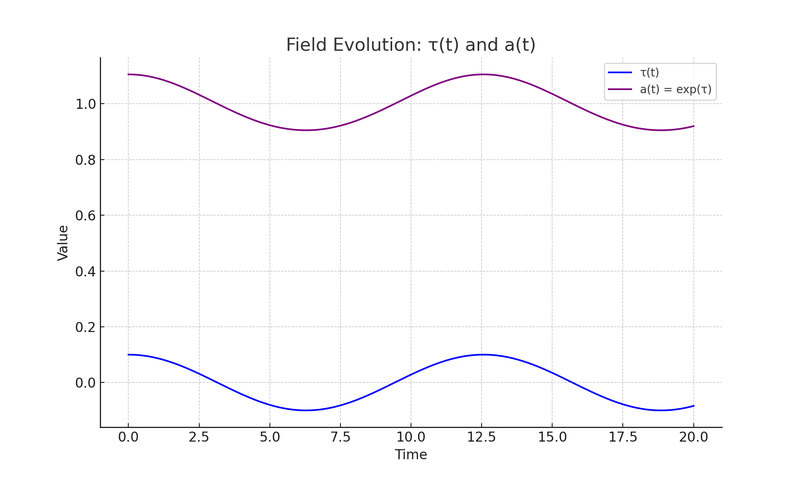
Figure 1: τ(t) and a(t) evolution
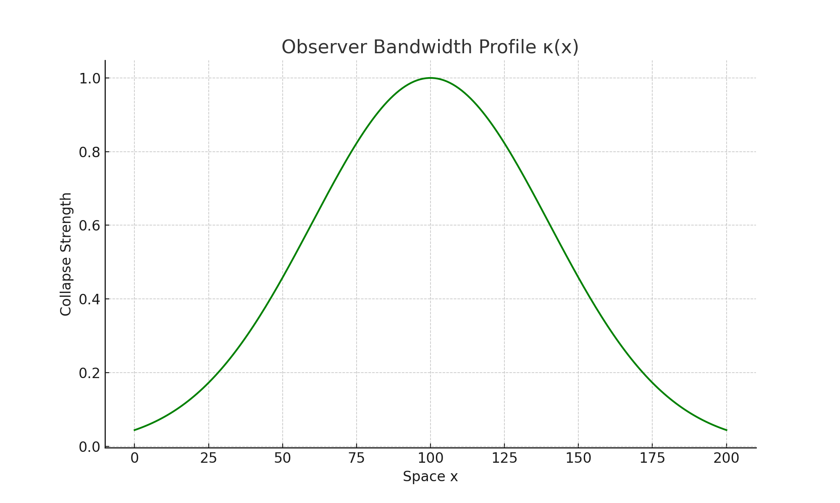
Figure 2: Observer collapse bandwidth κ(x)
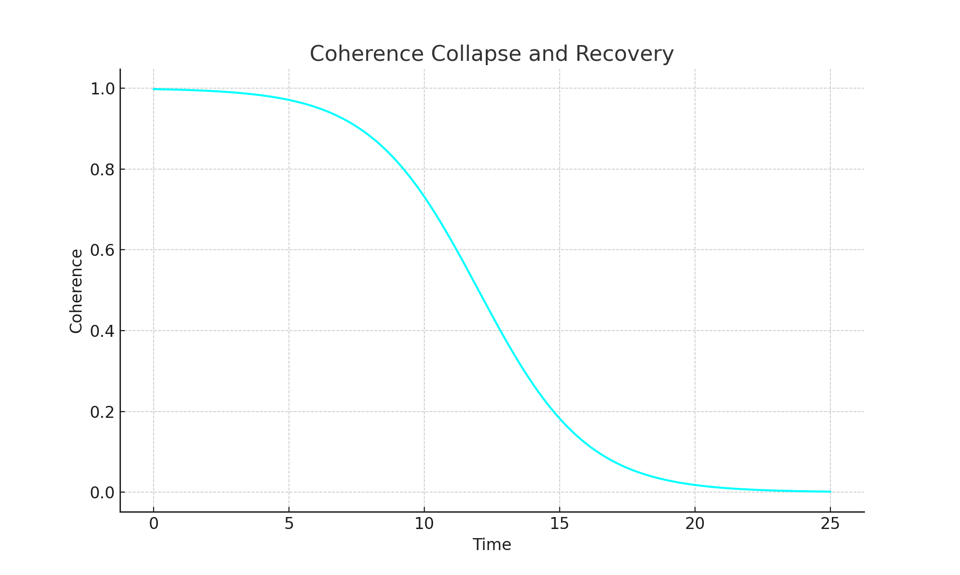
Figure 3: Coherence over time (collapse and recovery)

