Andrii Fedorenko a1349252

**Chapter 1 "Model":**

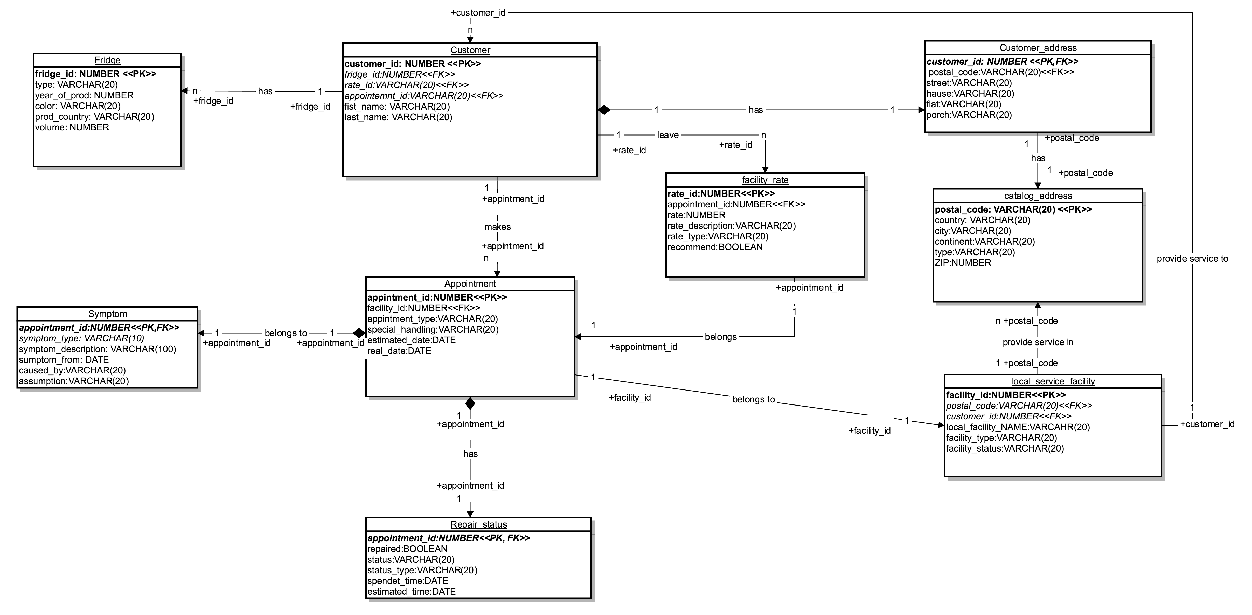

**Chapter 2 "Entities":**

* Fridge – strong entity. Means Fridge with additional attributes like color, type, volume etc.
  + PK choosed by id of each fridge.
* Customer – strong entity. The person who own fridge(s), which has typical data like name and address which is references on table “Customer_address”
  + PK choosed by auto generated id.
  + FK fridge_id references on “Fridge”
  + FK rate_id references on “Facility_rate” – means the Rate which customer left after appointment
  + FK appointment_id – refererncess on specific “Appointment”
* Custommer_address – weak entity. 3rd normal form dividing of tables, removing dependency from “Customer”
  + PK,FK customer_id defined by “Customer”
* Catalog_address – strong entity. 3rd normal form, removing from “Customer_address”. Has typical attributes for address plus additional sometimes zip and postal code are different.
  + PK choosed by postal code
* Local_service_facility – strong entity. Facility which provide repair service. Has attributes like Name, type and status if Facility still active.
  + PK choosed by auto generated id
  + FK postal_code - it means how many addresses specific facility can serve
  + FK custome_id - means which customer they have my default.
* Appointment – strong entity. Specific appointment from Customer.
  + PK auto generated id
  + FK facility_id show which facility going to take this appointment.
* Symptom – weak entity. Means symptom of fridge, why it’s broke and what’s assumptions customer can give.
  + PK,FK appointment_id defined by “Appointment”
* Repair_status – weak entity. Means status of current appointment namely repair, if it’s repaired than it’s ok if not customer need new appointment.
  + PK,FK appointment_id defined by “Appointment”

**Chapter 3 "Relations":**

* Fridge

No relation from this entity

* Customer
  + FK fridge_id ONE TO MANY to “Fridge” ON fridge_id
    - *Customer has n Fridges*
  + FK rate_id ONE TO MANY to “facility_rate” ON rate_id
    - *Cusomer can leave facility rates*
  + FK appointment_id ONE TO MANY to “Appointment” ON appointment_id
    - *Customer can make n Appointments*
* Custommer_address
  + FK customer_id reference ONE TO ONE to “Customer” ON customer_id
    - *Customer has one address*
  + FK postal_code reference ONE TO ONE to “Adresses” postal_code
    - *Customer address has postal code*
* Catalog_address

No relation from this entity

* Local_service_facilities:
  + FK postal_code ONE TO MANY “Adresses”
    - *Local service facility provide service in n Addresses*
  + FK customer_id ONE TO MANY reference to “Customer”
    - *Local service facility provide service to n Customers*
* Appointment
  + FK facility ONE TO ONE “Local_service_facilities”
    - *One Appointment belongs to one local service facility*
* Symptom – weak entity
  + Defined by FK appointment_id from “Appointment” ONE TO ONE
    - *One symptom belongs to one appointment*
* Repair_status
  + Defined by FK appointment_id from “Appointment” ONE TO ONE
    - *Appointment has one repair status*
* Facility rate
  + FK appointment_id reference ONE TO ONE to Appointment ON appointment_id
    - *One facility rates belongs to one appointment*

**Chapter 4 "Examples":**

*Table: Fridge*

|  |  |  |  |  |  |
| --- | --- | --- | --- | --- | --- |
| Fridge_id  <<PK>> | Type | Year_of_prod | Color | Prod_country | Voulme |
| 90823 | BK | 2015 | RED | CHINA | 20 |
| 23509 | MK | 2015 | BLACK | CHINA | 20 |
| 90234 | TO | 2014 | BLUE | CHINA | 40 |
| 32498 | MK | 2016 | SILVER | CHINA | 30 |
| 23980 | MK | 2017 | BLACK | GERMANY | 25 |

*TABLE: CUSOMER*

|  |  |  |  |  |  |
| --- | --- | --- | --- | --- | --- |
| Customer_ID  <<PK>> | Fridge_id  <<FK>> | Rate_id  <<FK>> | Appointment_id  <<FK>> | First_name | Last_name |
| 1 | 90823 | 10 | 100 | Dick | Pickle |
| 2 | 90823 | 20 | 200 | Hans | Fill |
| 3 | 90234 | 30 | 300 | Banna | Man |
| 4 | 32498 | 40 | 400 | Bat | Man |
| 5 | 23980 | 50 | 500 | Fat | Man |

*TABLE: Customer_address*

|  |  |  |  |  |  |
| --- | --- | --- | --- | --- | --- |
| Customer_ID  <<PK,FK>> | street | hause | Flat | Porch | Postal_code  <<FK>> |
| 1 | ApplePie | 123 | 41 | Null | 5432 |
| 2 | Trambon | 1 | 1 | 1 | 9999 |
| 3 | Hell | 66 | 666 | 66 | 6666 |
| 4 | Haven | 33 | 333 | 33 | 3333 |
| 5 | Katchup | 12 | 231 | 23 | 1111 |

*TABLE: Addresses*

|  |  |  |  |  |  |
| --- | --- | --- | --- | --- | --- |
| Postal_code  <<PK>> | Country | City | Continent | Type | ZIP |
| 5432 | United Kingdom | London | Antarctica | C | 5432 |
| 9999 | New Zealand | Nelson | Antarctica | C | 9999 |
| 6666 | France | Paris | Antarctica | W | 6666 |
| 3333 | Norway | Bergen | Antarctica | C | 3333 |
| 1111 | Chile | Santiago | Antarctica | W | 1111 |

*TABLE: Local_service_facilities*

|  |  |  |  |  |  |
| --- | --- | --- | --- | --- | --- |
| Facility_id  <<PK>> | Postal_code  <<FK>> | Cosumer_id  <<FK>> | Local_facility_name | Facility_type | Facility  _status |
| 21 | 5432 | 1 | FACILITY 1 | General | ACTIVE |
| 22 | 9999 | 2 | FACILITY 2 | General | ACTIVE |
| 23 | 6666 | 3 | FACILITY 3 | General | ACTIVE |
| 24 | 3333 | 4 | FACILITY 4 | General | ACTIVE |
| 25 | 1111 | 5 | FACILITY 5 | General | ACTIVE |

*TABLE: Facility_rate*

|  |  |  |  |  |  |
| --- | --- | --- | --- | --- | --- |
| Rate_id  <<PK>> | Appointment_id  <<FK>> | Rate | Rate_description | Rate_type | reccoment |
| 10 | 71 | 10 | All good | Positive | TRUE |
| 20 | 72 | 9 | All good | Positive | TRUE |
| 30 | 73 | 8 | All good | Neutral | TRUE |
| 40 | 74 | 9 | All good | Positive | TRUE |
| 50 | 75 | 9 | All good | Positive | TRUE |

*TABLE: Appointment*

|  |  |  |  |  |  |
| --- | --- | --- | --- | --- | --- |
| Appointment_id  <<PK>> | Facility_id  <<FK>> | Appointment  _type | Special  _handling | Esimated  _date | Real  _date |
| 71 | 21 | Private | (Null) | 2017-03-03 10:00 | 2017-03-03 10:00 |
| 72 | 22 | Corporate | Take a key from door | 2017-03-03 10:00 | 2017-03-03 10:00 |
| 73 | 23 | Private | (Null) | 2017-03-03 10:00 | 2017-03-03 10:00 |
| 74 | 24 | Private | (Null) | 2017-03-03 10:00 | 2017-03-03 10:00 |
| 75 | 25 | Private | (Null) | 2017-03-03 10:00 | 2017-03-03 10:00 |

*TABLE: Symptom*

|  |  |  |  |  |  |
| --- | --- | --- | --- | --- | --- |
| Appointment  _id  <<PK,FK>> | Symptom  _type | Symptom  _description | Symptom_from | Caused_by | assumtion |
| 71 | NO SIGNAL | No signal when turn on | 2017-01-01 10:01 | (null) | (null) |
| 72 | DEMAGE | Scrateches on delievery | 2017-01-01 10:01 | DELIEVERY | Cargo issue |
| 73 | NO FRIDGE | No cold | 2017-01-01 10:01 | (null) | (null) |
| 74 | NO SIGNAL | No signal when turn on | 2017-01-01 10:01 | (null) | (null) |
| 75 | NO SIGNAL | No signal when turn on | 2017-01-01 10:01 | (null) | (null) |

*TABLE: Repair_status*

|  |  |  |  |  |  |
| --- | --- | --- | --- | --- | --- |
| Appointment  _id  <<PK,FK>> | Repaired | Status | Status_type | Spendet_time | Estimated_time |
| 71 | TRUE | Repaired and ready to use | REPAIRED | 00:01:00 | 00:02:00 |
| 72 | TRUE | Repaired and ready to use | REPAIRED | 00:01:00 | 00:02:30 |
| 73 | TRUE | Repaired and ready to use | REPAIRED | 00:01:00 | 00:01:00 |
| 74 | TRUE | Repaired and ready to use | REPAIRED | 00:01:00 | 00:01:30 |
| 75 | TRUE | Repaired and ready to use | REPAIRED | 00:01:00 | 00:02:00 |