User roles:

Every user has some specific area within he works. For example just registered user does not need to know the current environment monitoring information. These restrictions were motivation to create some user roles in order to restrict of grand some functionality of N2Sky.

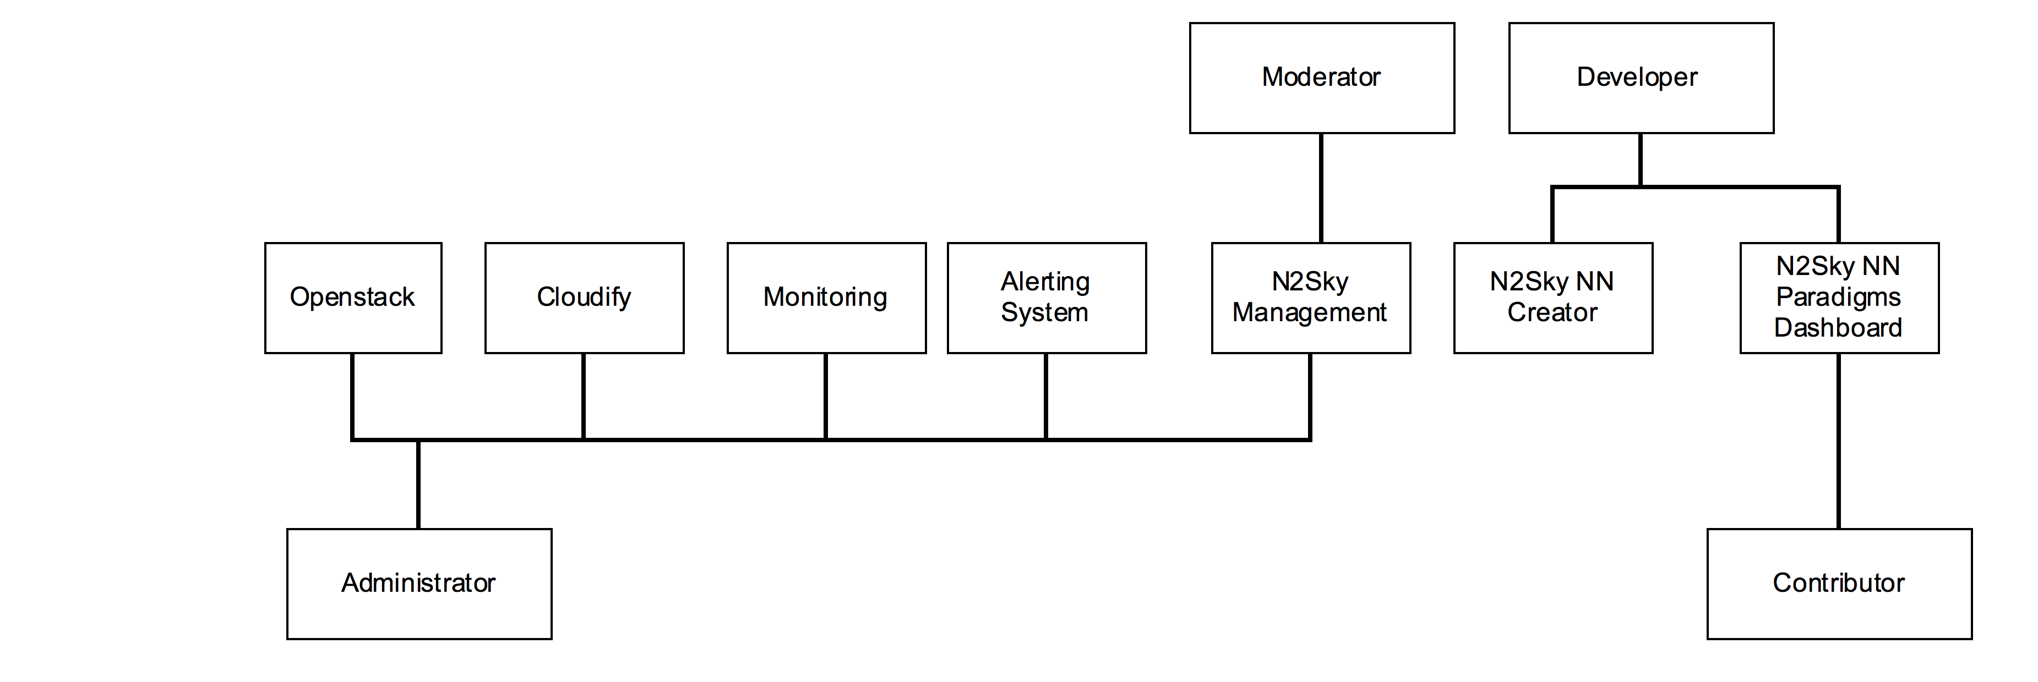

N2Sky user roles:

* Administrator
* Moderator
* Contributor
* Developer

Administrator is a user who has a full access to application including environment management, monitoring and alerting features. Administrator can manage Openstack and Cloudify instances. He also can shadow any N2Sky user to see what actually shadowed user doing. Administrator has access to all dashboards.

Moderator is a user who has access to N2Sky. Moderator can shadow all users except users with a role Administrator. He cannot see or manage environmental features of the application. Moderator has access only to N2Sky dashboards.

Contributor is an arbitrary user. This is does not has to have a deep knowledge in neural network field or know any programming language. The main goal of arbitrary user is to study neural networks within N2Sky. Contributor has access only to own dashboard and other public available dashboards on main application module. Contributor can perform sematic search for available neural network paradigms and use it. He can train neural network objects and test them. This user also can share his trained neural network making it public.

Developer is an expert user, which has enough knowledge and experience to create his own neural network. This user can create neural network paradigm using ViNNSL schema and publish it on N2Sky. Developer can deploy neural network as well on N2Sky environment as on his own environment and provide training and testing endpoints. The goal of developer to study how his network behave with a different neural network structure, input parameters and training data which was provided by other users.

User groups:

During project management of N2Sky was decided to divide all user on the groups. User group is a set of users with same concerns, goals and interests. Each group has either restriction on some functionality of the application of some granted features.

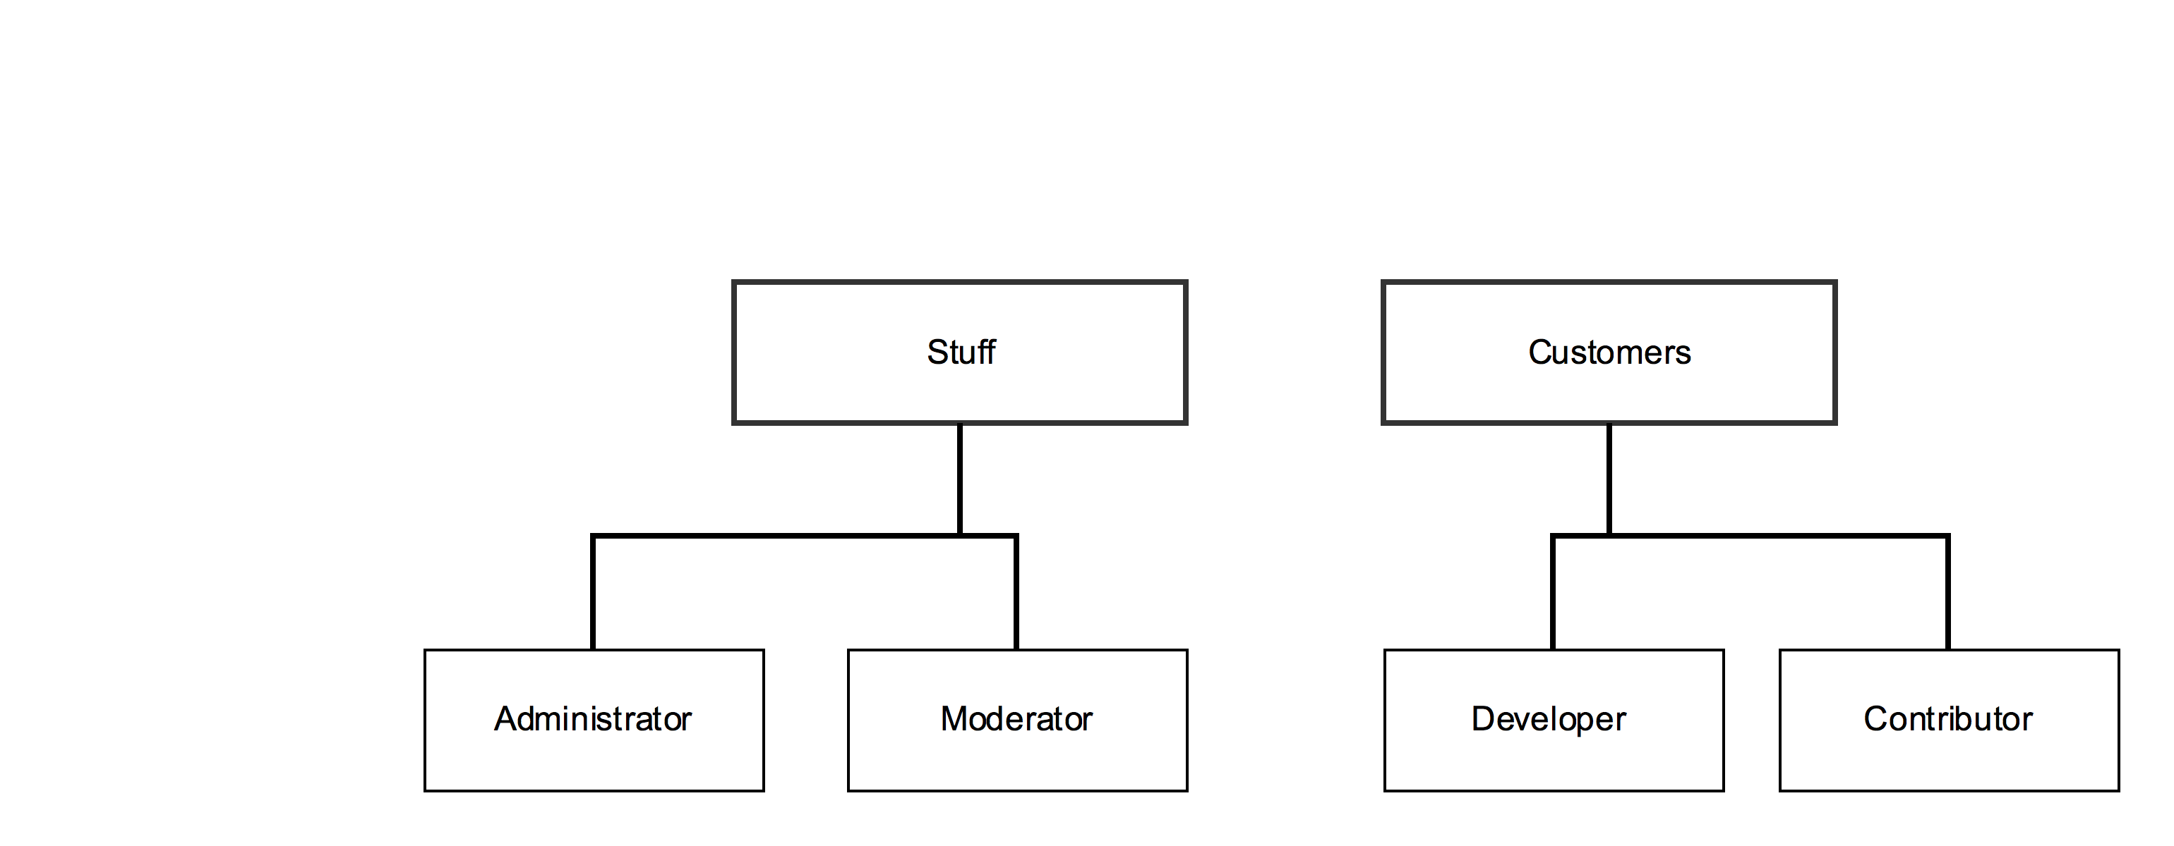

Following groups were created:

|  |  |
| --- | --- |
| User group | Affected user roles |
| Stuff | * Administrator * Moderator |
| Customers | * Contributor * Developer |

This deviation was made because of the functional permission restriction. One of the typical way how to reuse this kind of permissions is to set some constrains on N2Sky functionality using only user groups without roles. It is more secure, because it encapsulate sensitive data. This approach also makes permission functionality more flexible, because it can be extended by user roles or additional restriction can be applied on higher permission level.