GUÍA 3 - TAREAS ASINCRÓNICAS
- Lee el texto y responde las consignas a continuación.

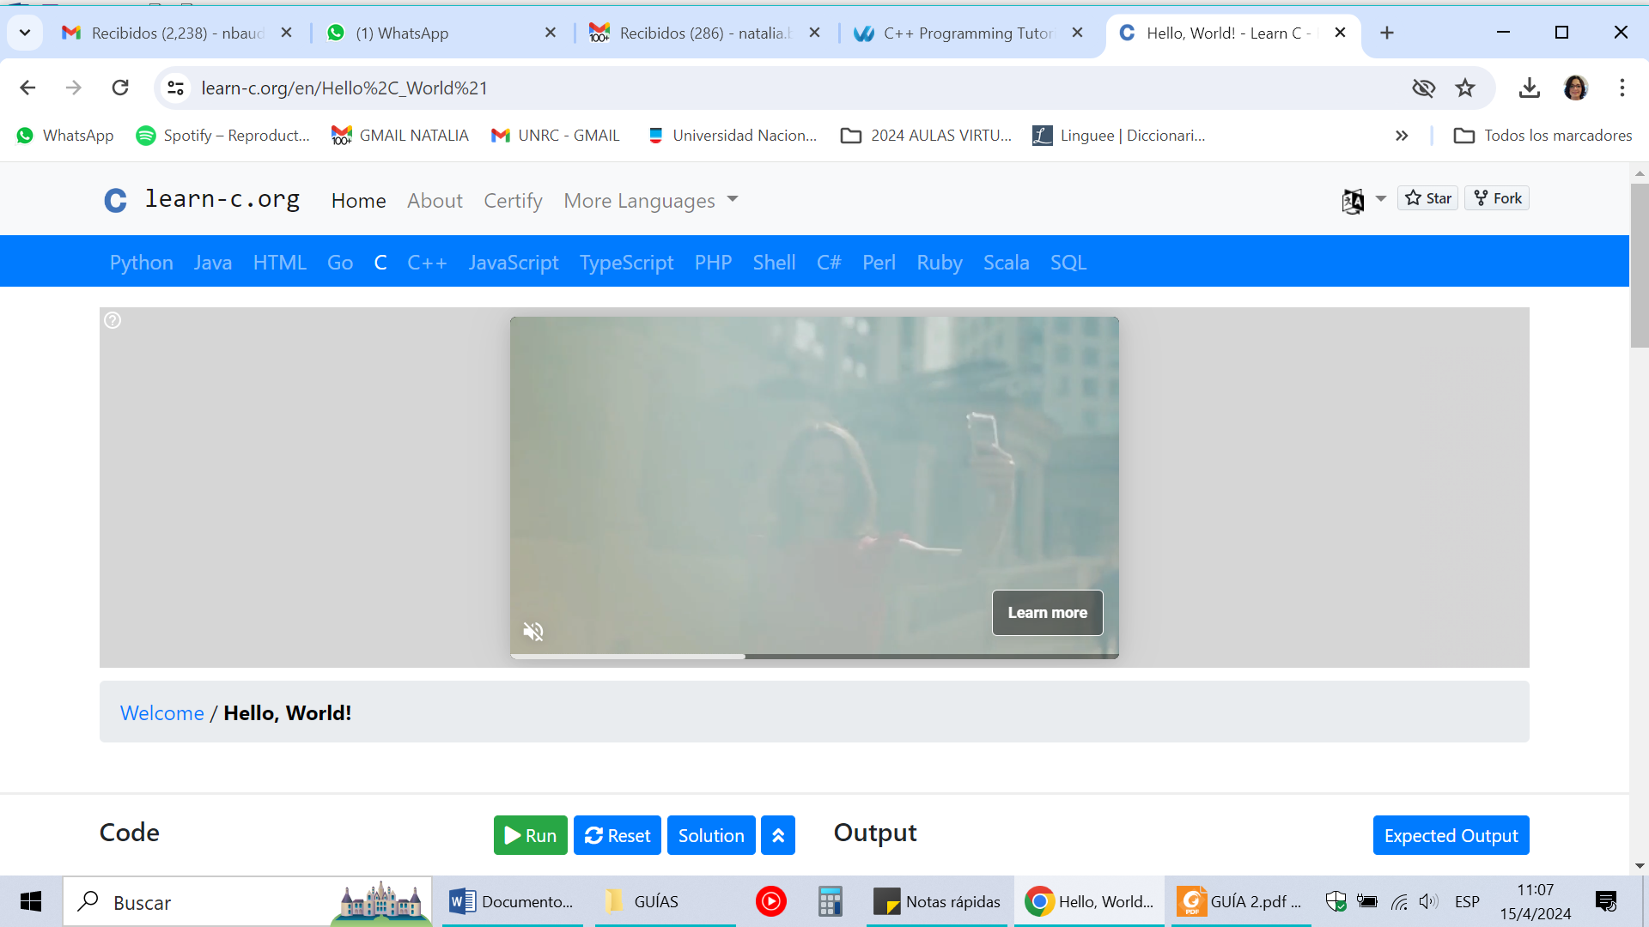
Hello, World!
Introduction
The C programming language is a general purpose programming language, which relates closely to the way machines work. Understanding how computer memory works is an important aspect of the C programming language. Although C can be considered as "hard to learn", C is in fact a very simple language, with very powerful capabilities.
C is a very common language, and it is the language of many applications such as Windows, the Python interpreter, Git, and many many more.
C is a compiled language - which means that in order to run it, the compiler (for example, GCC or Visual Studio) must take the code that we wrote, process it, and then create an executable file. This file can then be executed, and will do what we intended for the program to do.
Our first program
Every C program uses libraries, which give the ability to execute necessary functions. For example, the most basic function called printf, which prints to the screen, is defined in the stdio.h header file.
To add the ability to run the printf command to our program, we must add the following include directive to our first line of the code:
#include <stdio.h>
The second part of the code is the actual code which we are going to write. The first code which will run will always reside in the main function.
int main() {
... our code goes here
}

Consignas

- Identifica y menciona la fuente del texto.
- Busca en el diccionario los significados de las palabras resaltadas, y escribe en la tabla el significado exacto a cada palabra (es decir, el significado según el contexto específico).
Palabra | Equivalente en español
Programming
Understanding
Works
Means
Run
Actual

- Identifica en el texto, 5 palabras con sufijos y completa la siguiente tabla:

Palabra en inglés | Sufijo | Equivalente en español

- Identifica en el texto 3 frases nominales con pre y/o pos modificador.
- Transcribe las frases
- Subraya el sustantivo núcleo
- Escribe el equivalente de la frase en español

- Identifica en el texto una definición y una descripción. Transcríbelas y escribe una interpretación de cada una en español.

