Rest Service Documentation

Team_06 Soccer Appl

# RestService Tipps:

Die Url bestimmt nicht die Aktion, sondern auf welche Ressource zugegriffen wird.

z.B. /matches, /players und NICHT /getPlayers /deletePlayers

Die Art wie mit der Ressource interagiert wird, muss durch die HTTP Methode bestimmt werden.

Alle Matches holen -> GET auf /matches, 1 Match holen -> GET /matches/1 🡪 Id eines Objektes in der Collection matches.

Manchmal gelingt das aber nicht, dann müssen Kompromisse gemacht werden ->/checkPlayer die Interaktion kann nicht so einfach durch HTTP Methoden eindeutig beschrieben werden =(

Nachfolgend werden unsere Services, mit Tabellen und jeweils einem Bild zur Erklärung der Verwendung, beschrieben.

# Generelle Anmerkungen

Statt Date als Key wurde ein künstlicher Schlüssel genommen und ein Check Constraints auf das Date eingefügt, damit nicht 2 am selben Tag gespielt.

Match heißt soccer_match weil Match ein reserved keyword des SQL Standards ist, das nächste Mal bitte keine reserved keywords verwenden, hat ein wenig Zeit gekostet! Da der Fehler nicht wirklich ausgegebn wird, sondern eine komischer generische Exception auftritt

https://i.gyazo.com/4f133d41c84d7ce4bb5d20e81cc3e188.png

Contents

RestService Tipps: 1

Generelle Anmerkungen 1

Get Methoden 2

GetAll Player 2

GetAllMatches 4

GetAllStatistics 6

GetPlayerStatisticsByMatch 7

GetPlayerStatistics 8

Add Methods 9

AddPlayer 9

AddMatch 10

AddStatistics 11

Remove Methods 12

RemovePlayer 12

RemoveMatch 13

Update Methods 14

UpdatePlayer 14

UpdateMatch 15

UpdateStatistics 16

Unique Methods 17

CheckPlayer 17

# Get Methoden

## GetAllPlayers

|  |  |
| --- | --- |
| **Title** | *GetAllPlayers* |
| **URL** | */players* |
| **Method** | **GET** |
| **URL Params** | *NONE* |
| **Data Params** | *NONE* |
| **Success Response** | **Example:** **Code:** 200  **Content:** Siehe Example |
| **Error Response** | **Example:**  **Code:** 400 Bad Request  **Content:** { error : SQL Exception }  **Code:** 500 Internal Server Error  **Content:** { error : Exception } |

Example:

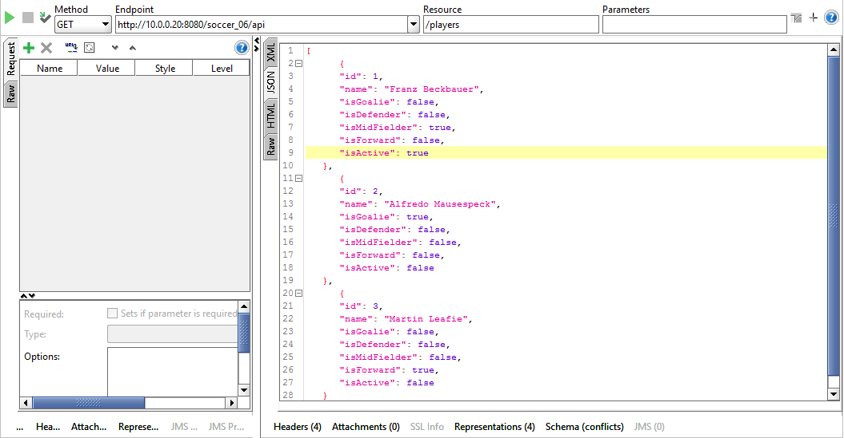

## GetAllMatches

|  |  |
| --- | --- |
| **Title** | *GetAllMatches* |
| **URL** | */soccerMatches* |
| **Method** | **GET** |
| **URL Params** | *NONE* |
| **Data Params** | *NONE* |
| **Success Response** | **Example:** **Code:** 200  **Content:**  Siehe Example |
| **Error Response** | **Example:** **Code:** 400 Bad Request  **Content:** { error : SQL Exception }  **Code:** 500 Internal Server Error  **Content:** { error : Exception } |

Example:

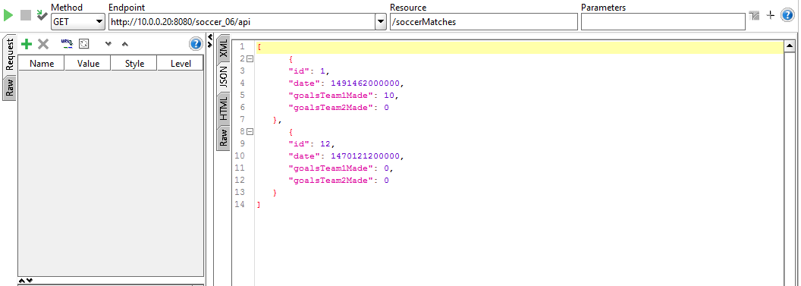

## GetAllStatistics

|  |  |
| --- | --- |
| **Title** | *GetAllStatistics* |
| **URL** | */statistics* |
| **Method** | **GET** |
| **URL Params** | *NONE* |
| **Data Params** | *NONE* |
| **Success Response** | **Example:** **Code:** 200  **Content:**  Siehe Example |
| **Error Response** | **Example:** **Code:** 400 Bad Request  **Content:** { error : SQL Exception }  **Code:** 500 Internal Server Error  **Content:** { error : Exception } |

Example:

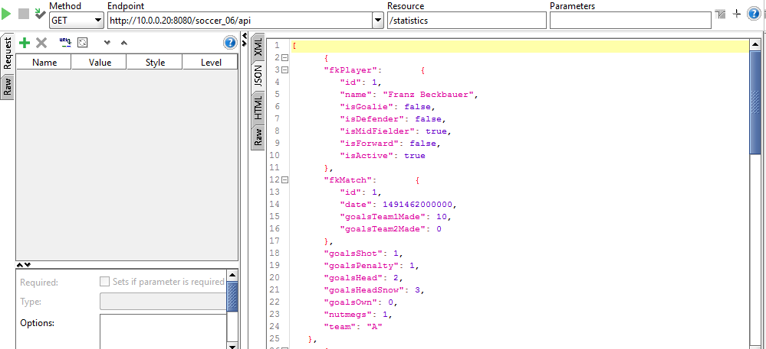

|  |  |
| --- | --- |
| **Title** | *GetPlayerStatisticsByMatch* |
| **URL** | */statistics/:id/:match_id* |
| **Method** | **GET** |
| **URL Params** | *:id Id is the id of the player*  *:match_id is the id of the match* |
| **Data Params** | *NONE* |
| **Success Response** | **Example:** **Code:** 200  **Content:**  Siehe Example |
| **Error Response** | **Example:** **Code:** 400 Bad Request  **Content:** { error : SQL Exception }  **Code:** 500 Internal Server Error  **Content:** { error : Exception } |

## GetPlayerStatisticsByMatch

Example:

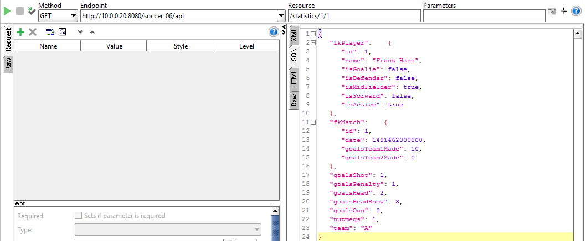

|  |  |
| --- | --- |
| **Title** | *GetPlayerStatistics* |
| **URL** | */statistics/:id* |
| **Method** | **GET** |
| **URL Params** | *:id Id of the player* |
| **Data Params** | *NONE* |
| **Success Response** | **Example:** **Code:** 200  **Content:**  Siehe Example |
| **Error Response** | **Example:** **Code:** 400 Bad Request  **Content:** { error : SQL Exception }  **Code:** 500 Internal Server Error  **Content:** { error : Exception } |

## GetPlayerStatistics

Example:

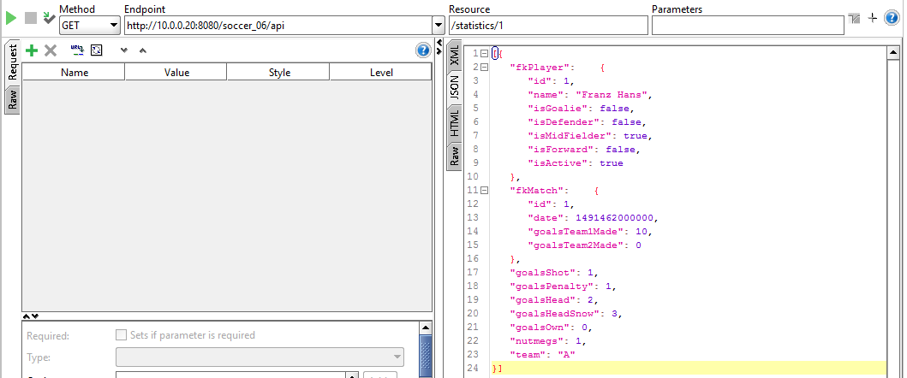

# Add Methods

|  |  |
| --- | --- |
| **Title** | *AddPlayer* |
| **URL** | */players* |
| **Method** | **POST** |
| **URL Params** | *NONE* |
| **Data Params** | *Player Class* |
| **Success Response** | **Example:** **Code:** 200  **Content:** { } |
| **Error Response** | **Example:** **Code:** 400 Bad Request  **Content:** { error : SQL Exception }  **Code:** 500 Internal Server Error  **Content:** { error : Exception } |

## AddPlayer

Example:

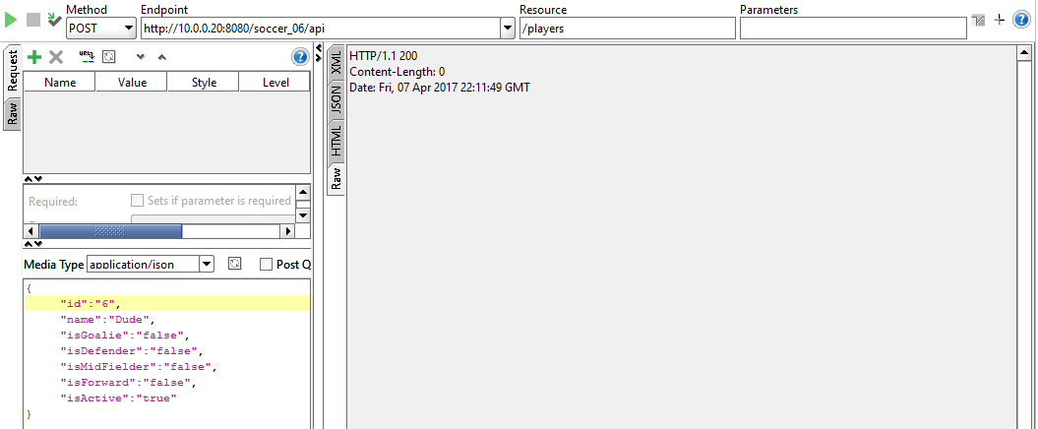

|  |  |
| --- | --- |
| **Title** | *AddMatch* |
| **URL** | */matches* |
| **Method** | **POST** |
| **URL Params** | *NONE* |
| **Data Params** | *Player Class* |
| **Success Response** | **Example:** **Code:** 200  **Content:** { } |
| **Error Response** | **Example:** **Code:** 400 Bad Request  **Content:** { error : SQL Exception }  **Code:** 500 Internal Server Error  **Content:** { error : Exception } |

## AddMatch

Example:

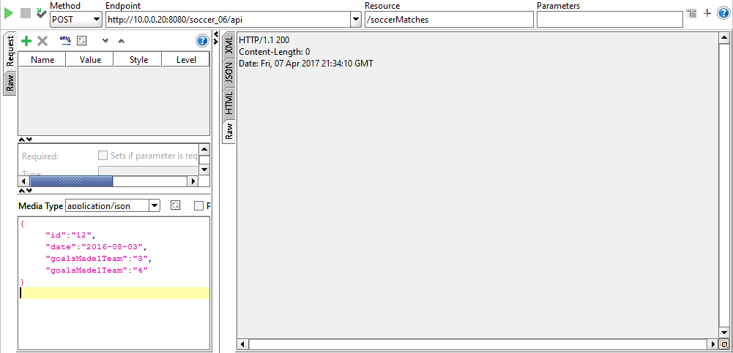

|  |  |
| --- | --- |
| **Title** | *AddStatistics* |
| **URL** | */statistics* |
| **Method** | **POST** |
| **URL Params** | *NONE* |
| **Data Params** | *Player Class* |
| **Success Response** | **Example:** **Code:** 200  **Content:** { } |
| **Error Response** | **Example:** **Code:** 400 Bad Request  **Content:** { error : SQL Exception }  **Code:** 500 Internal Server Error  **Content:** { error : Exception } |

## AddStatistics

Example:

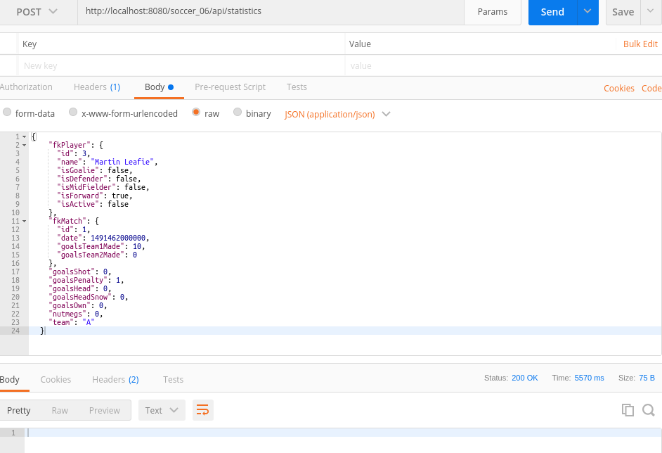

|  |  |
| --- | --- |
| **Title** | *RemovePlayer* |
| **URL** | */players/:id* |
| **Method** | **DELETE** |
| **URL Params** | *:id ist the ID of the player* |
| **Data Params** | *NONE* |
| **Success Response** | **Example:** **Code:** 200  **Content:** {} |
| **Error Response** | **Example:** **Code:** 400 Bad Request  **Content:** { error : SQL Exception }  **Code:** 500 Internal Server Error  **Content:** { error : Exception } |

# Remove Methods

## RemovePlayer

Example:

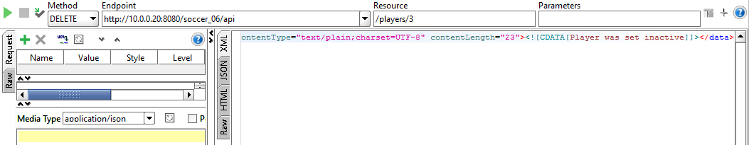

|  |  |
| --- | --- |
| **Title** | *RemoveMatch* |
| **URL** | */soccerMatches/:match_id* |
| **Method** | **DELTE** |
| **URL Params** | *:match_id ist the id of the match* |
| **Data Params** | *NONE* |
| **Success Response** | **Example:** **Code:** 200  **Content:** { } |
| **Error Response** | **Example:** **Code:** 400 Bad Request  **Content:** { error : SQL Exception }  **Code:** 500 Internal Server Error  **Content:** { error : Exception } |

## RemoveMatch

Example:

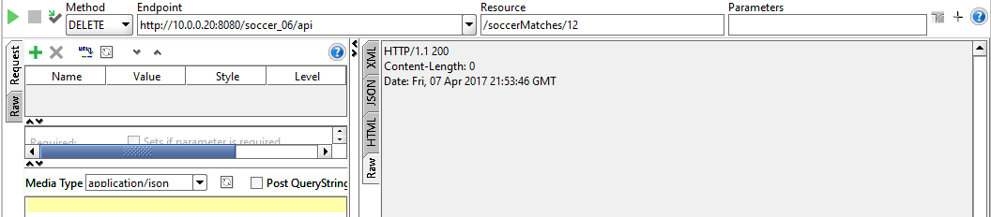

|  |  |
| --- | --- |
| **Title** | *UpdatePlayer* |
| **URL** | */players* |
| **Method** | **PUT** |
| **URL Params** | *NONE* |
| **Data Params** | *Player Class* |
| **Success Response** | **Example:** **Code:** 200  **Content:** { } |
| **Error Response** | **Example:** **Code:** 400 Bad Request  **Content:** { error : SQL Exception }  **Code:** 500 Internal Server Error  **Content:** { error : Exception } |

# Update Methods

## UpdatePlayer

Example:

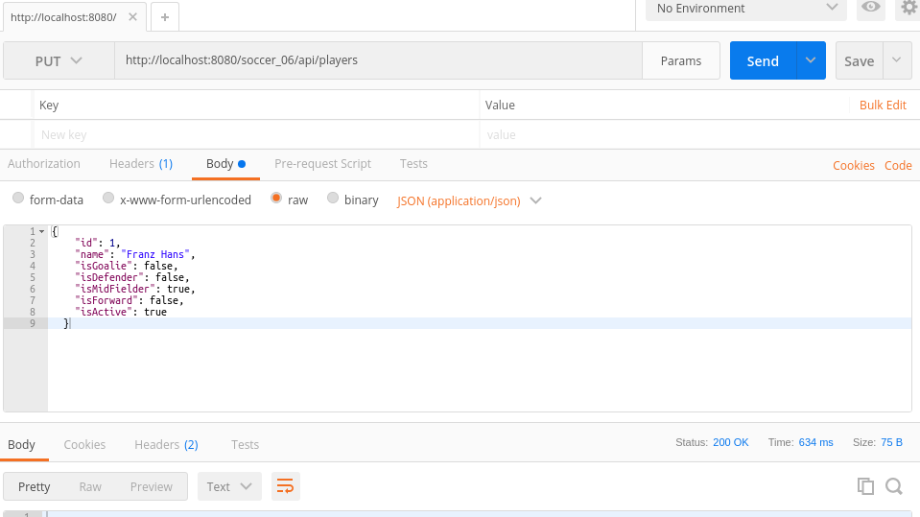

|  |  |
| --- | --- |
| **Title** | *UpdateMatch* |
| **URL** | */players* |
| **Method** | **PUT** |
| **URL Params** | *NONE* |
| **Data Params** | *Match Class* |
| **Success Response** | **Example:** **Code:** 200  **Content:** { } |
| **Error Response** | **Example:** **Code:** 400 Bad Request  **Content:** { error : SQL Exception }  **Code:** 500 Internal Server Error  **Content:** { error : Exception } |

## UpdateMatch

Example:

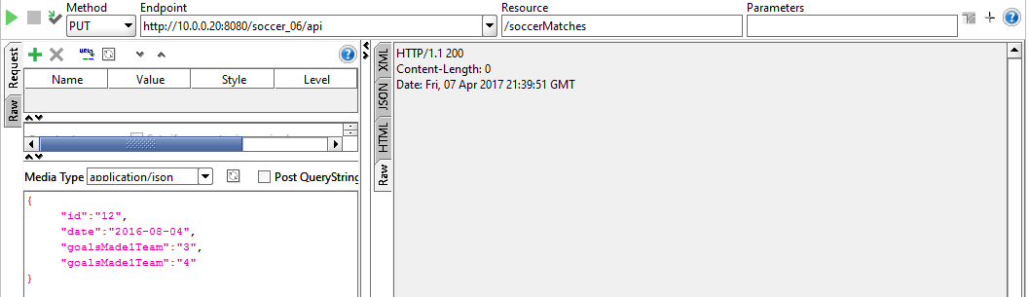

|  |  |
| --- | --- |
| **Title** | *UpdateStatistics* |
| **URL** | */statistics* |
| **Method** | **PUT** |
| **URL Params** | *NONE* |
| **Data Params** | *Statistics Class* |
| **Success Response** | **Example:** **Code:** 200  **Content:** { } |
| **Error Response** | **Example:** **Code:** 400 Bad Request  **Content:** { error : SQL Exception }  **Code:** 500 Internal Server Error  **Content:** { error : Exception } |

## UpdateStatistics

Example:

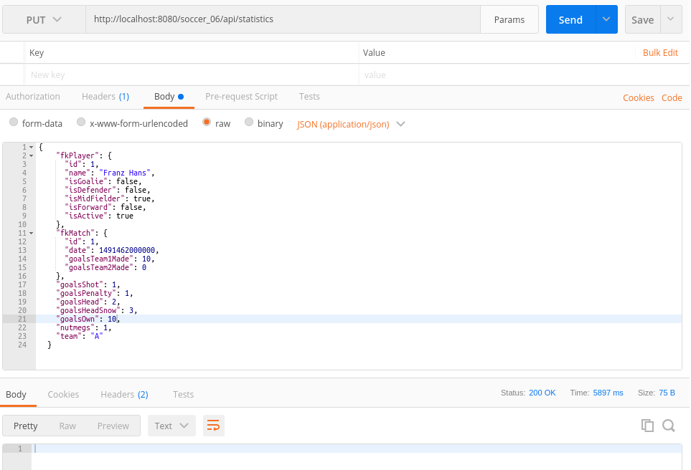

# Unique Methods

## CheckPlayer

|  |  |
| --- | --- |
| **Title** | *CheckPlayer* |
| **URL** | */players/check/:id* |
| **Method** | **GET** |
| **URL Params** | *:id of the player you want to check* |
| **Data Params** | *NONE* |
| **Success Response** | **Example:** **Code:** 200  **Content:** { id : 12 } |
| **Error Response** | **Example:** **Code:** 400 Bad Request  **Content:** { error : SQL Exception }  **Code:** 500 Internal Server Error  **Content:** { error : Exception } |

Example:

