**205CDE**

**Game Matching** | **PlayTGT**

[**https://github.com/lauchimannn/205CDE-56237747.git**](https://github.com/lauchimannn/205CDE-56237747.git)

**Lau Chi Man**

**56237747**

Content

Introduction 3

Design 4

Database structure 4

Tables 5

Structure of PlayTGT 9

Recommendation browsers 22

Evaluation 22

Conclusion and Future Development 23

Reflection 24

Reference 25

# Introduction

Play TGT is a free game matching website. Anyone can access to the website to find someone to play video games with. The purpose of the website is to help players that do not have many friends to find game partners. Target customers are video games players.

As a gamer, I realize that some games have good player matching system while some do not. Once you enter the game, teammates are settled for you already if you play alone. If I want to play with local players, it requires me to search for and enter related Discord servers, then ask people to join my game. To me, it is quite troublesome and awkward. So, PlayTGT offers a platform for players to find game partners with the highest degree of freedom. Players can even stay in the room forever unless they are kicked by the host or the host deleted the room. Thus, the same group of people can enjoy playing together ever time they come back to the website. If not, creating room is also easy and simple, it takes only around 1 minute, so players can do quick matches.

# Design

## Database structure

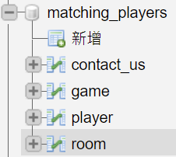

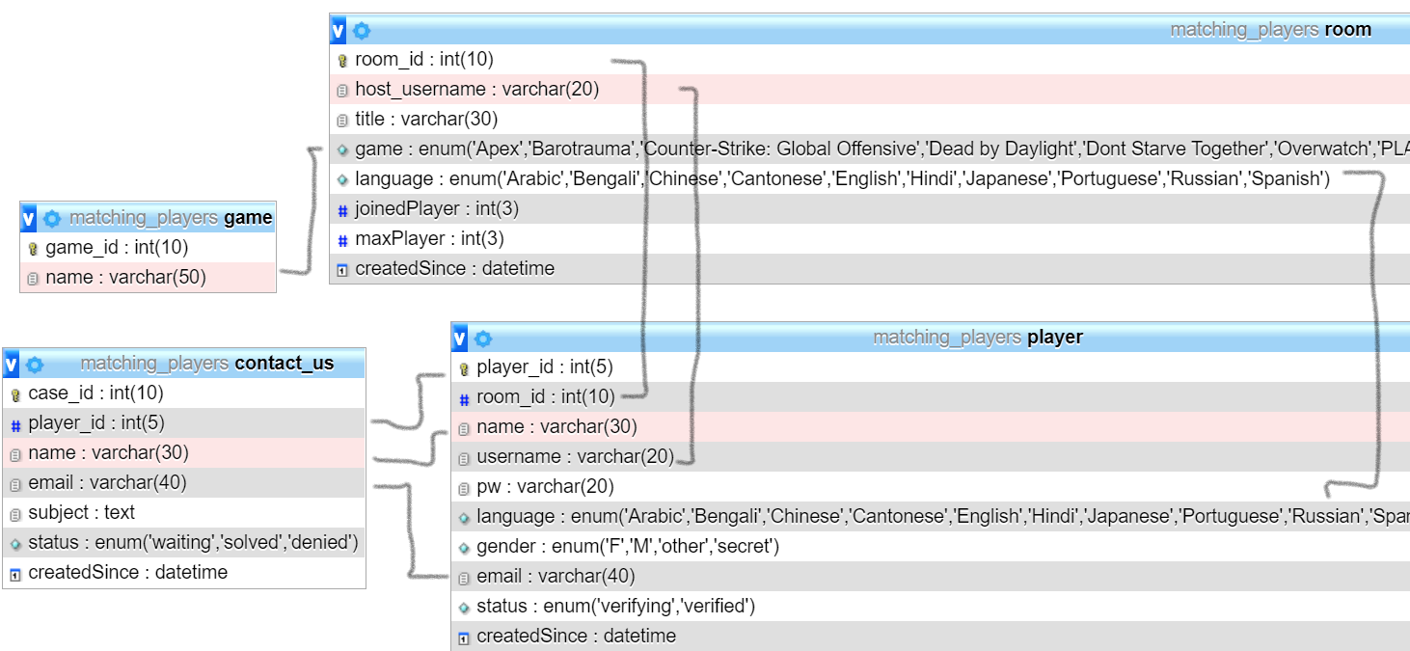

### Tables

#### room

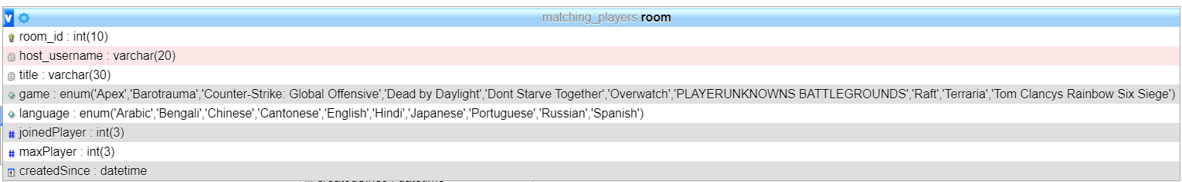

|  |  |  |
| --- | --- | --- |
| **#** | **Name** | **Assigned by (Admin/Host)** |
| 1 | room_id | Admin |
| 2 | host_username | Admin |
| 3 | title | Host |
| 4 | game | Host |
| 5 | language | Host |
| 6 | joinedPlayer | Admin |
| 7 | maxPlayer | Host |
| 8 | createdSince | Admin |

Data example

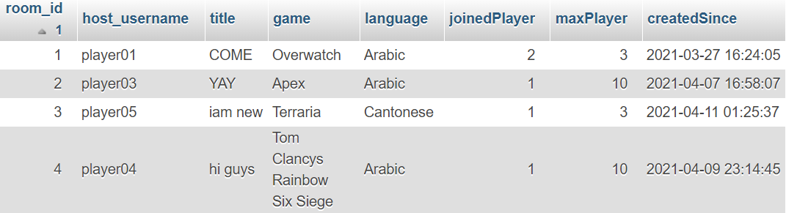

#### player

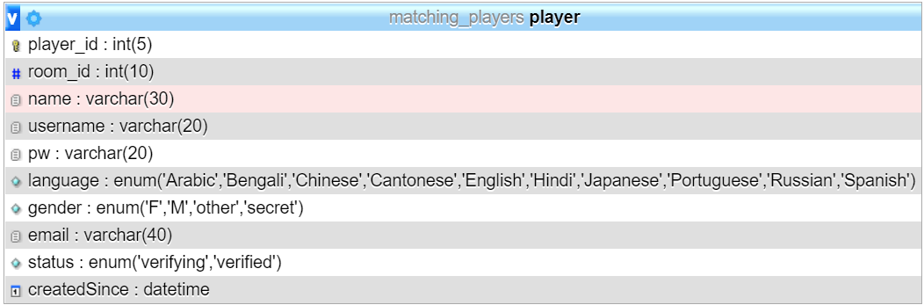

|  |  |  |  |
| --- | --- | --- | --- |
| **#** | **Name** | **Description** | **Assigned by (Admin/Player)** |
| 1 | player_id | / | Admin |
| 2 | room_id | assigned when player joins or creates a room [0 = no room] | Admin |
| 3 | name | no numbers and special char allowed | Player |
| 4 | username | 6-20 char, no space & no special char except _ allowed | Player |
| 5 | pw | 8-20 char | Player |
| 6 | language | / | Player |
| 7 | gender | / | Player |
| 8 | email | requires verifying when create account | Player |
| 9 | status | if email verified, status changes from “verifying” to “verified” | Admin |
| 10 | createdSince | / | Admin |

Data example

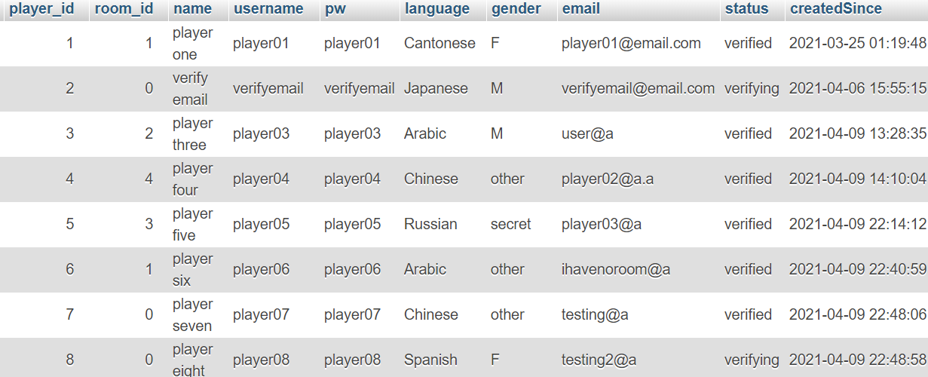

#### game

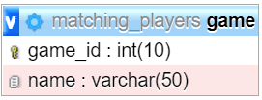

|  |  |  |
| --- | --- | --- |
| **#** | **Name** | **Assigned by** |
| 1 | game_id | Admin |
| 2 | name | Admin |

Data example

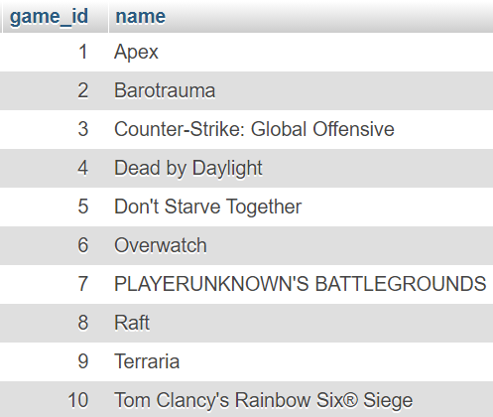

#### contact_us

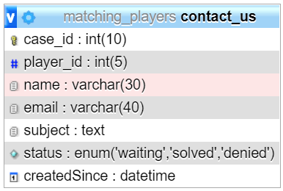

|  |  |  |  |
| --- | --- | --- | --- |
| **#** | **Name** | **Description** | **Assigned by (Admin/Player)** |
| 1 | case_id | / | Admin |
| 2 | player_id | if player is not logged in, sets to 0 | Admin [when player logged in] / Player |
| 3 | name | / | Admin [when player logged in] / Player |
| 4 | email | / | Admin [when player logged in] / Player |
| 5 | subject | / | Player |
| 6 | status | once the form is submitted, status sets to “waiting”, then can be changed by admin, and reply through email | Admin |
| 7 | createdSince | / | Admin |

Date example

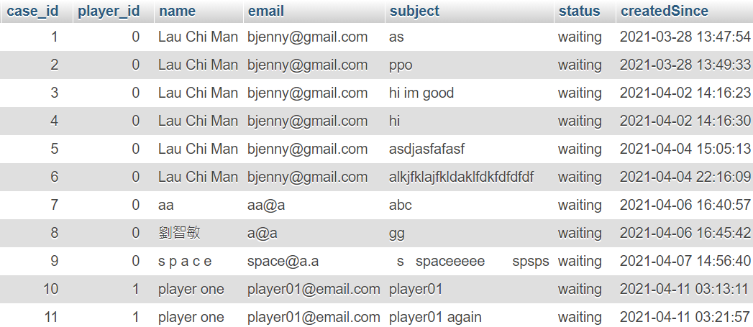

## Structure of PlayTGT

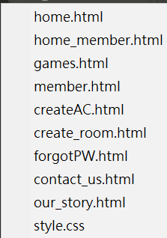

1. Guest
   1. Once entered, home page displays. Message flashes as to ask player to login.

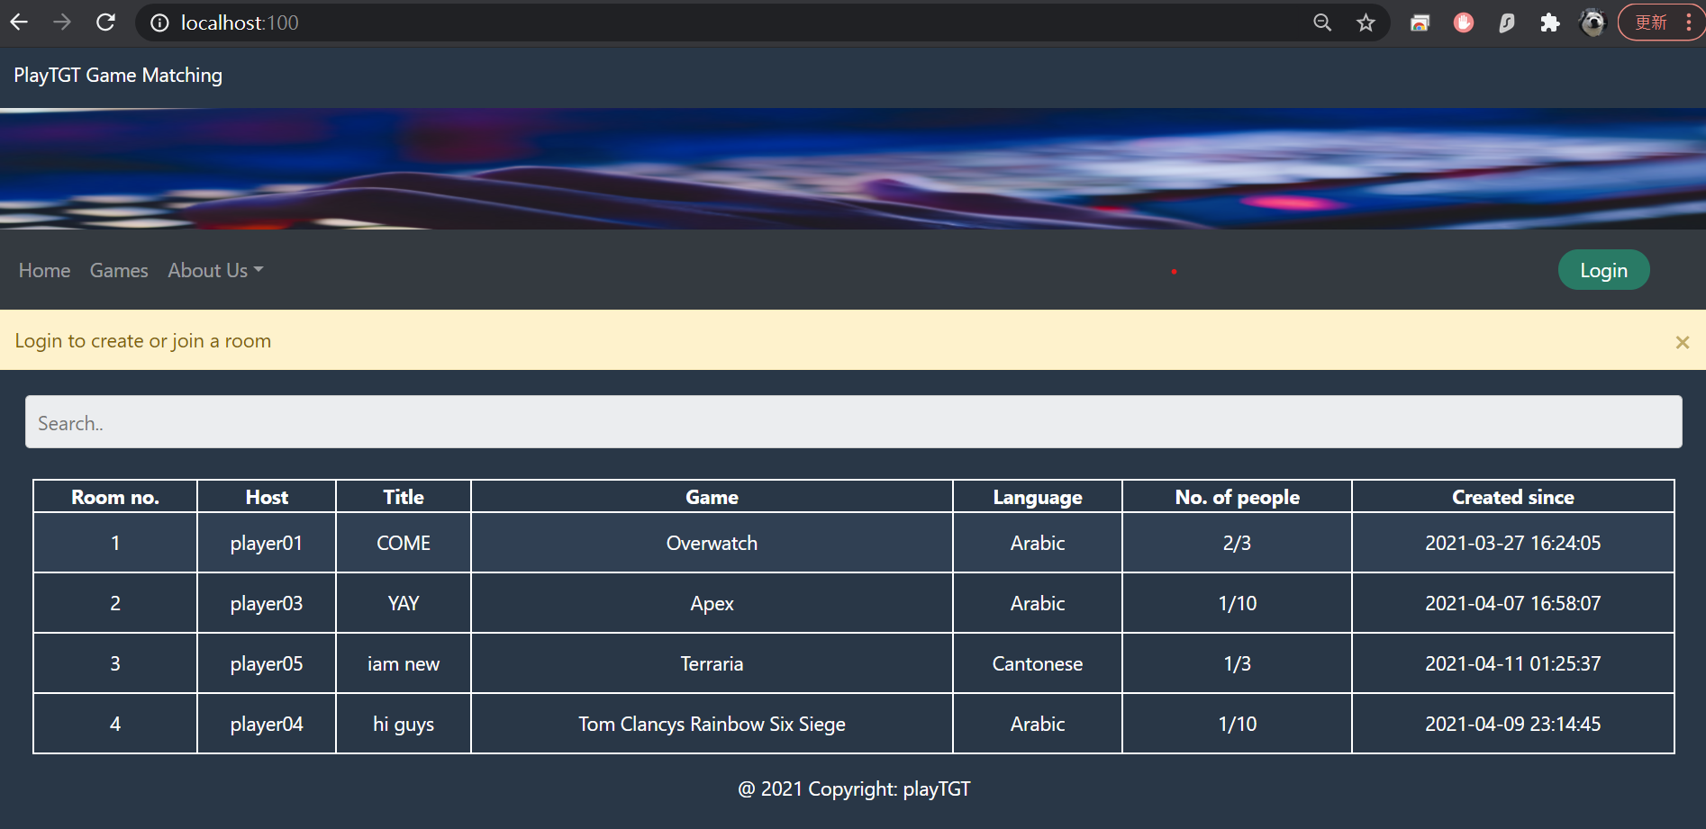

* 1. The search and filter bar supports searching the 1st to 5th column of room table.

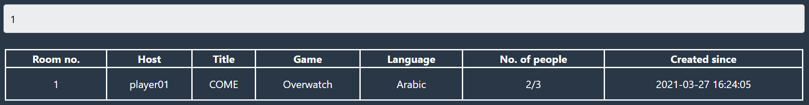

* 1. Clicking “Games”.

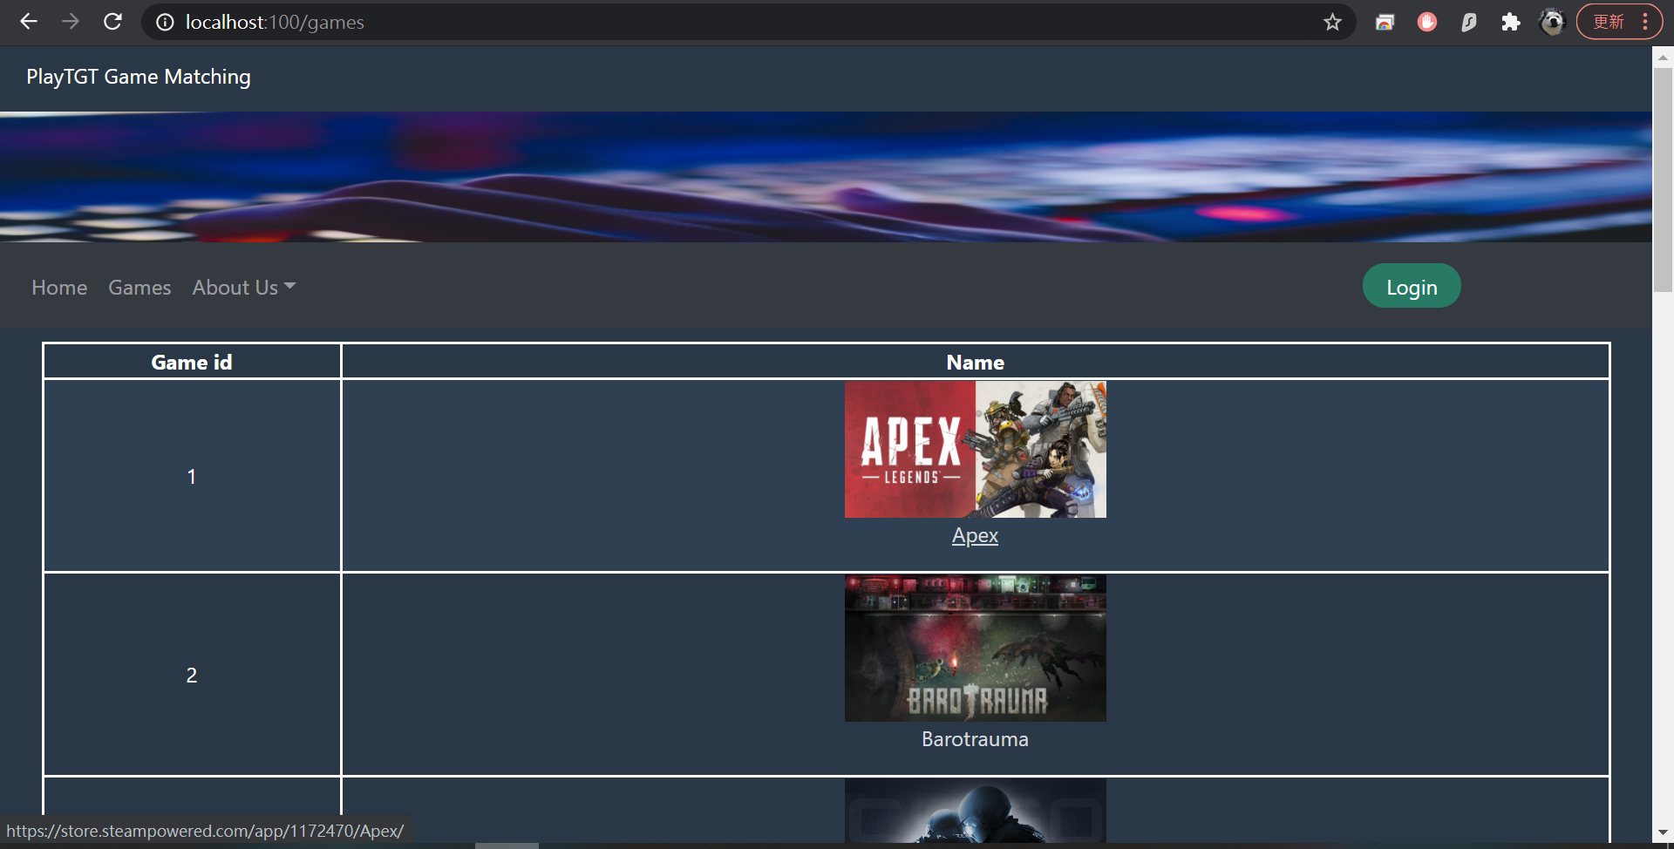

* 1. By clicking Contact Us.

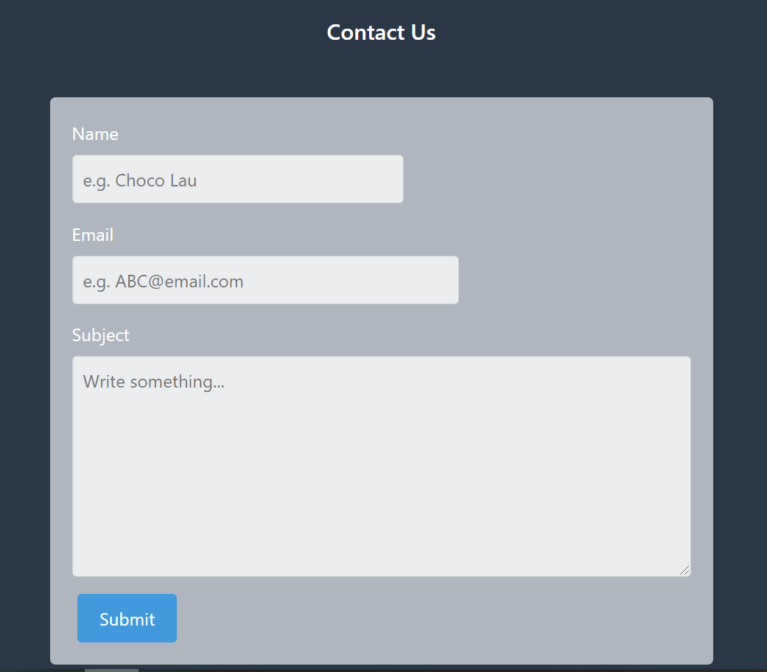

* + 1. As the Name input has key block, no special char and numbers can be typed.

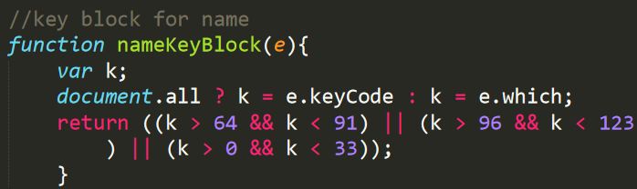

* + 1. As email input’s type = “email”, this input must contains @, and there must be letter after @.

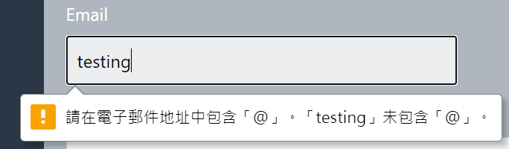

* + 1. Once submitted, data uploads to contact_us table in SQL. Player ID sets to 0 as the player is a guest.



* 1. By clicking Login, login modal popped up.

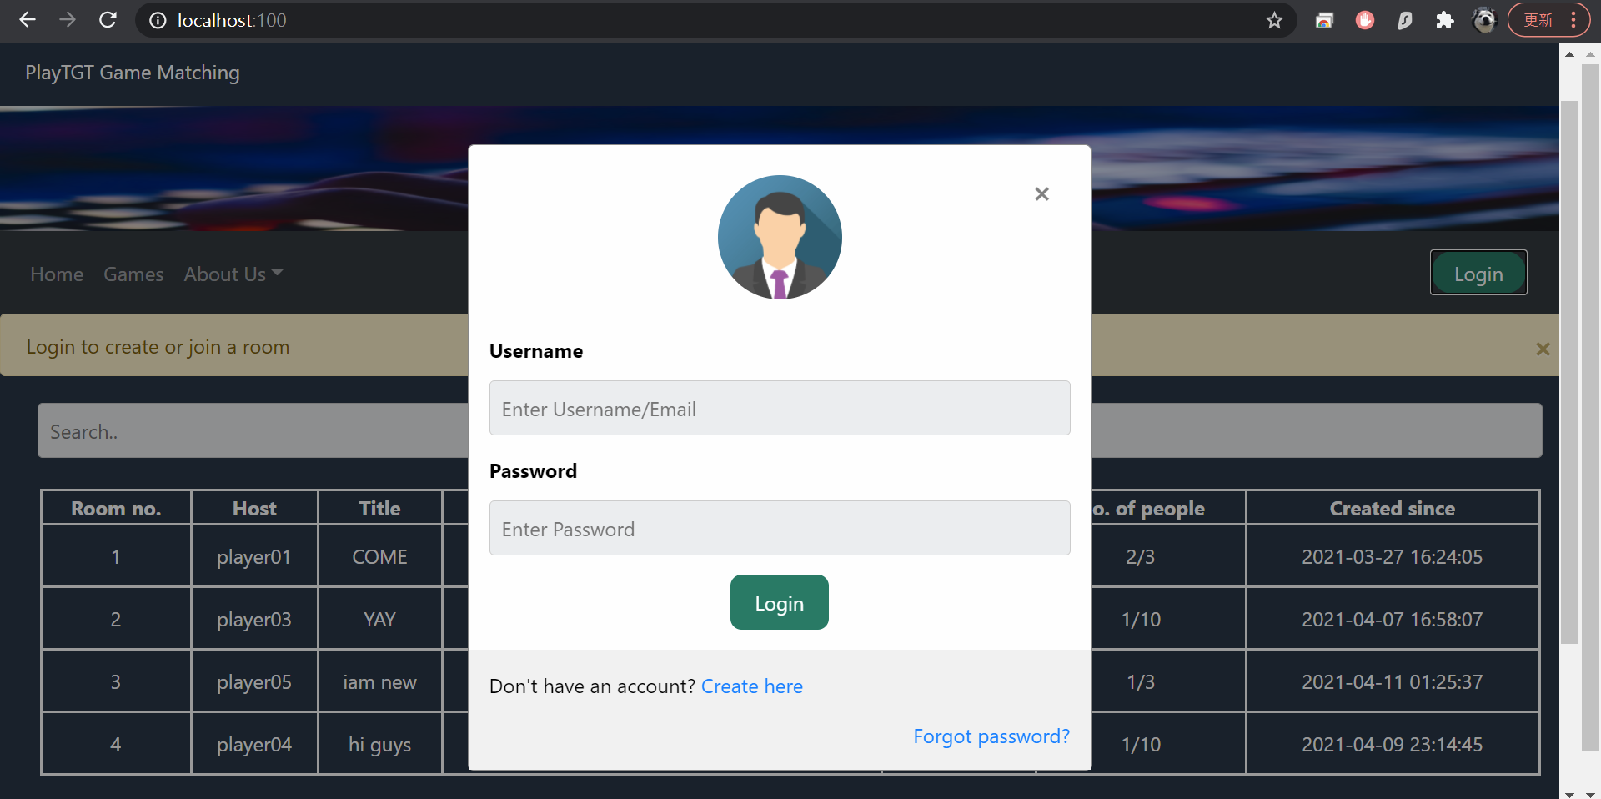

* + 1. If player tries to login with an unverified account, warning message flashes.

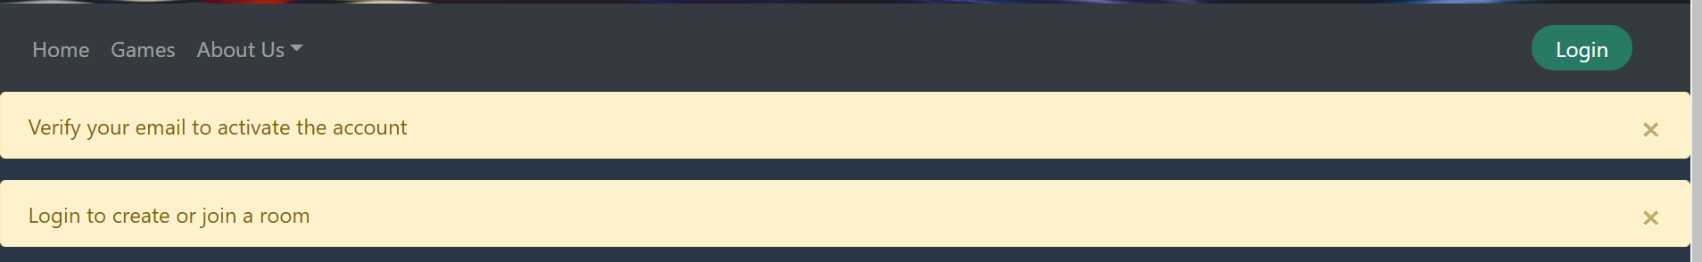

* 1. By clicking create here in login modal, it directs to create account page.

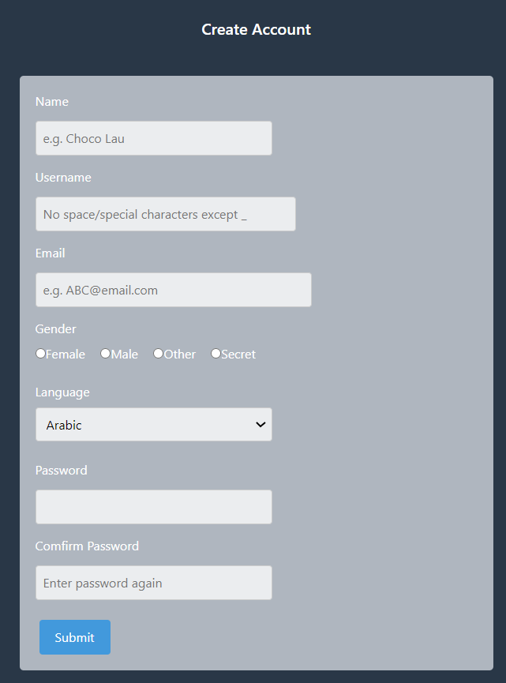

* + 1. As username has key block, player cannot type space or special char other than _ in username input.

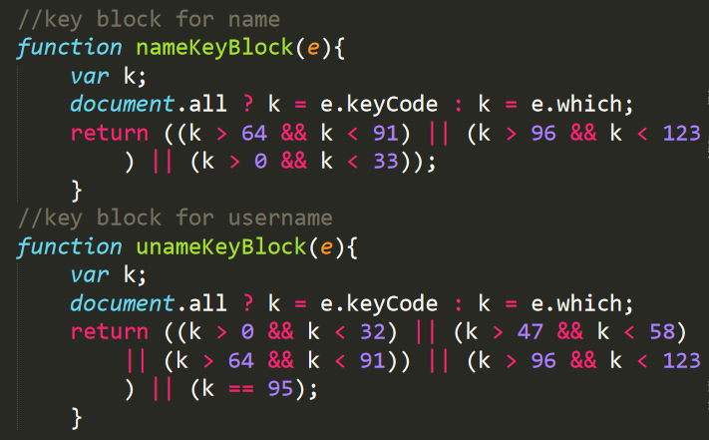

* + 1. If player insists to copy and paste invalid char to the input, error appears.

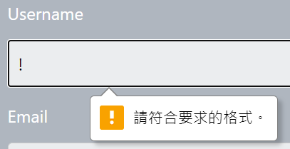

* + 1. Error messages flashes if username or email exists.





* + 1. Alert pops up if confirm password is incorrect.

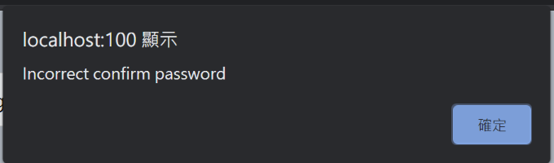

* + 1. If player types name input like “ testing one ”, JS trims it to “testing one”.

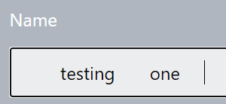



* + 1. Player uploaded to player table in SQL.



1. Login
   1. Login as “player01”.

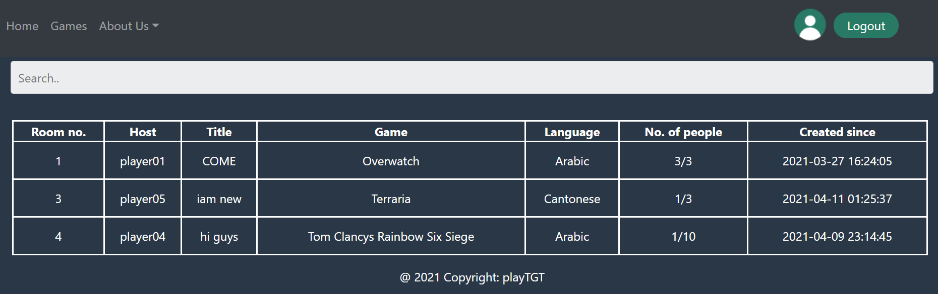

* + 1. If login other account that has not entered a room yet, create room & join buttons appear. If the room is full, join button does not appears.

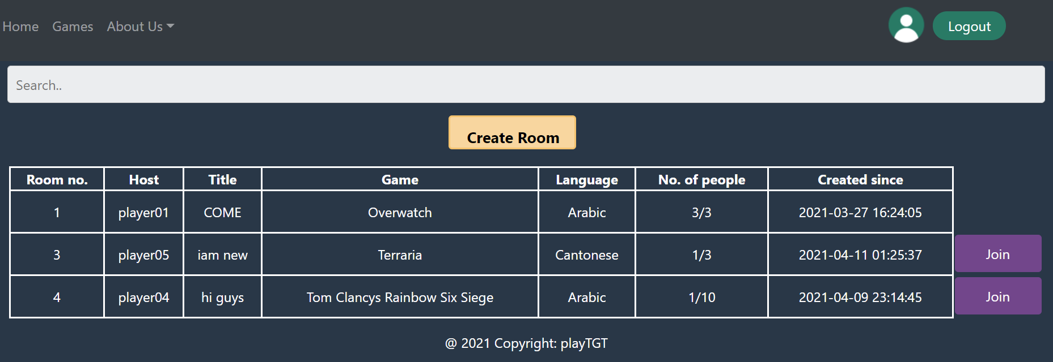

* 1. Name and email input do not appear in Contact Us form once player logged in.

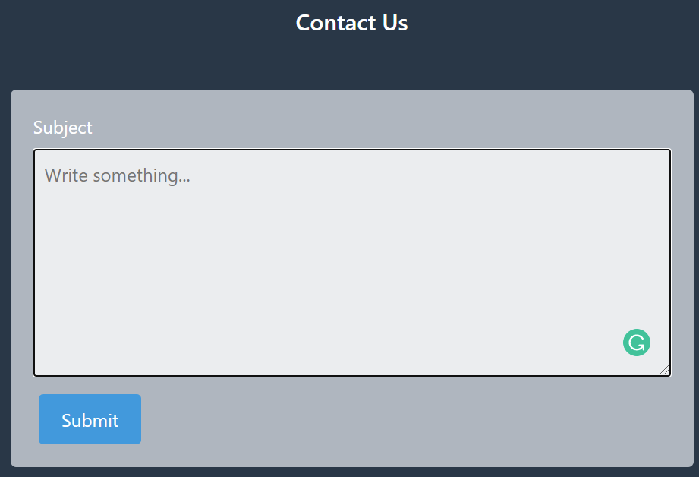

* + 1. Player ID, name and email of the player automatically upload to SQL.



* 1. By clicking member icon.
     1. If player has not entered a room.

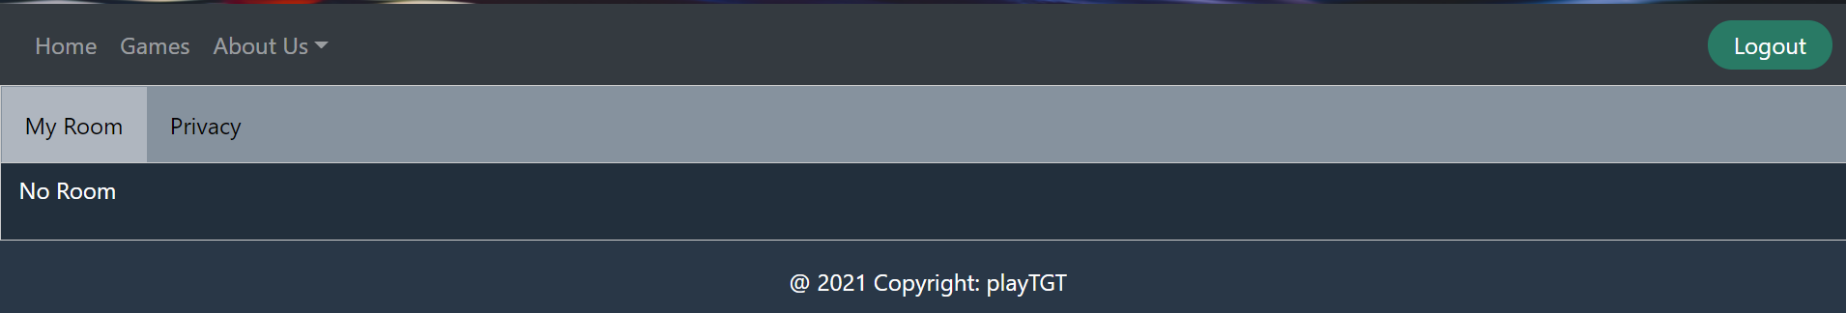

* + 1. If player01 [host] opens a room,

and player06 and 07 joined the room.

[Chat box is not functionable yet.]

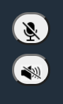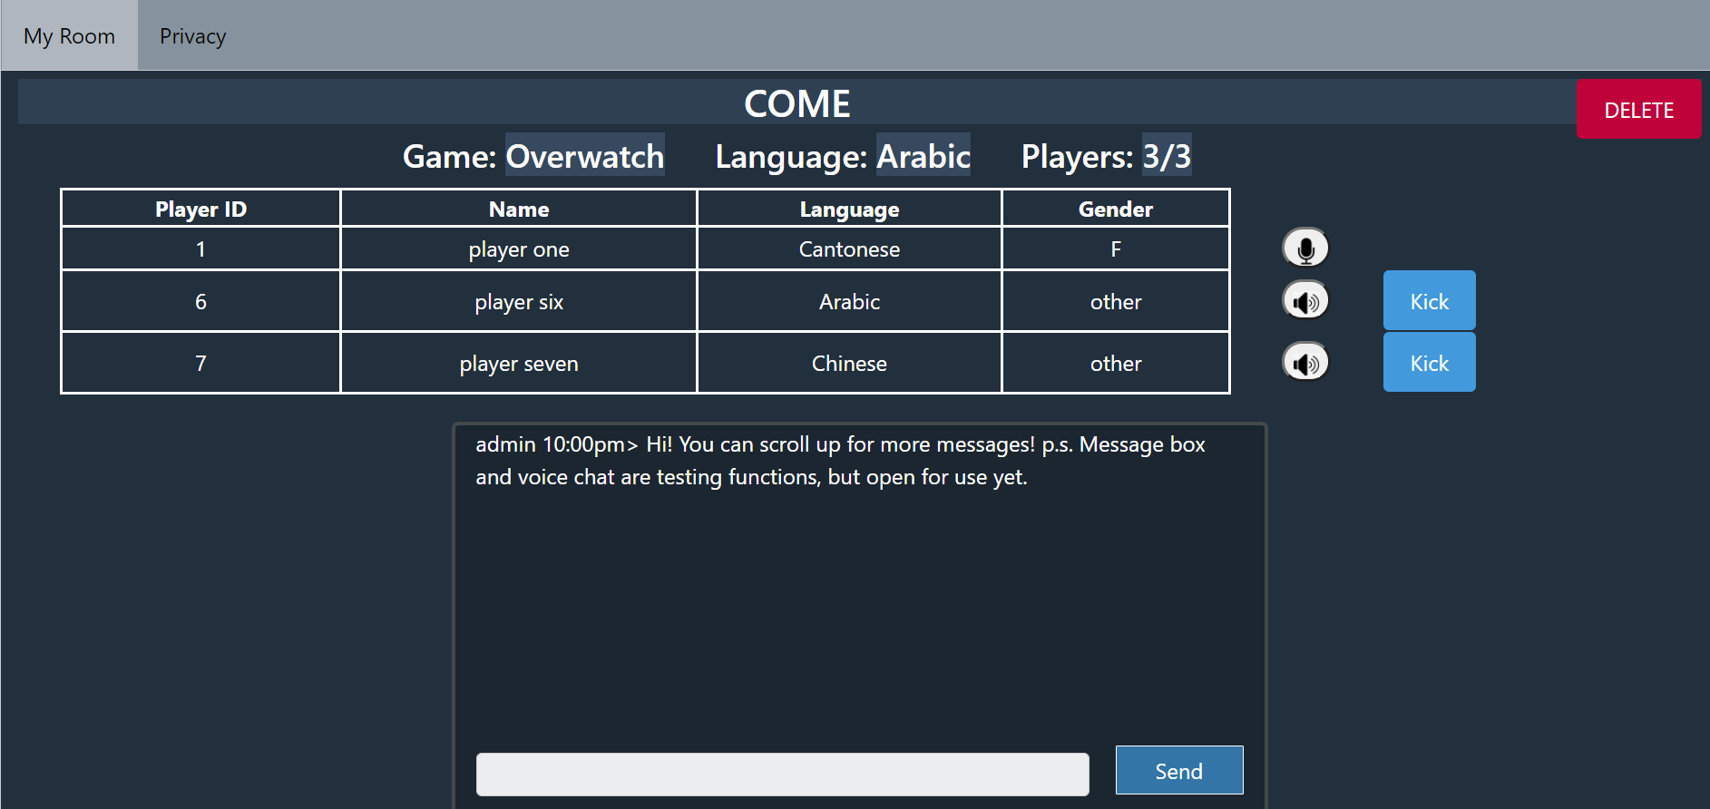

* + - 1. By clicking the speaker and mic buttons, the image changes to mute or unmute. [Only image changes, voice chat is not functionable yet.]
    1. Perspective of player07 [not the host] entering player01’s room.

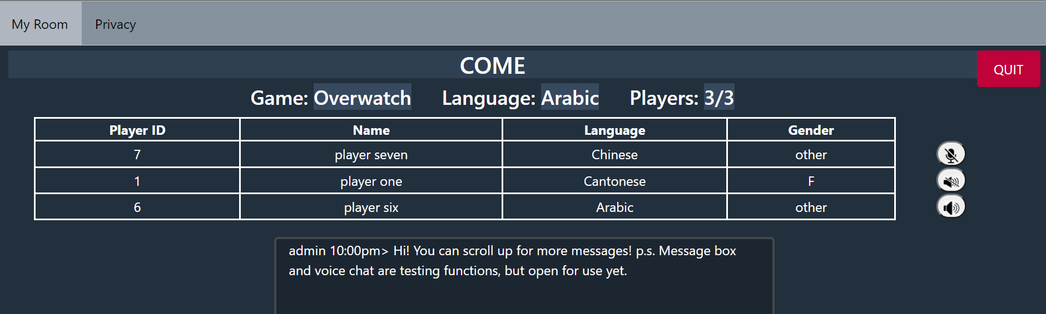

* + - 1. By clicking QUIT, no. of people in room 1 changes from 3/3 to 2/3.

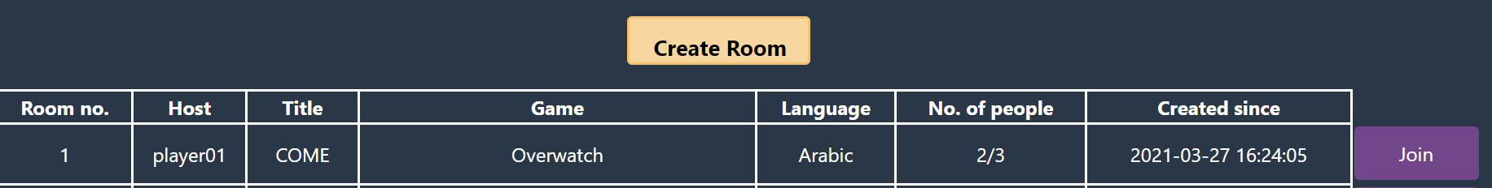

* + 1. Back to player01[host], if kicks player07.

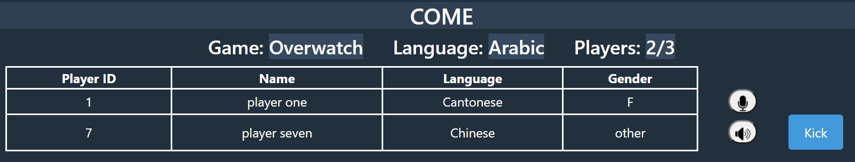

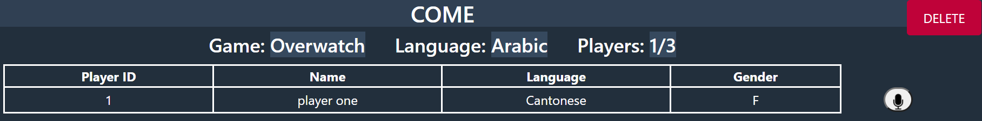

* + - 1. Room_id of player07 changes from 1 to 0. [0 means no room]



* + - 1. By clicking DELETE, the room is gone, and is deleted in room table in SQL.
    1. We can now Create Room.

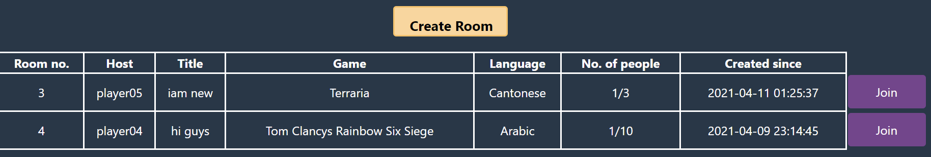

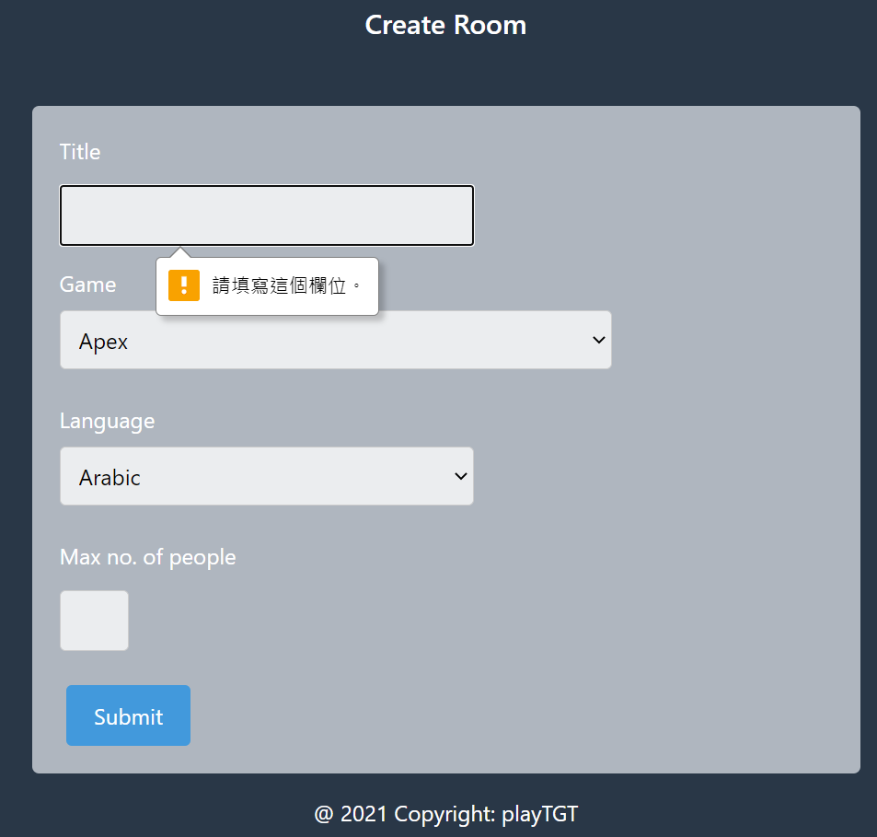

* + - 1. Max no. of people has key block, player can type numbers only.

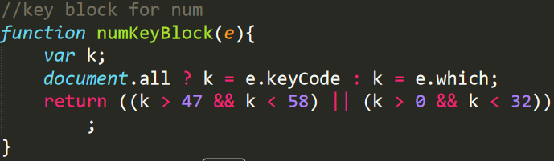

* + - 1. If player insists to copy and paste other char, error appears.

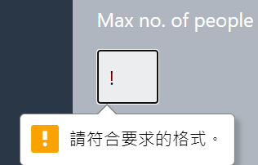

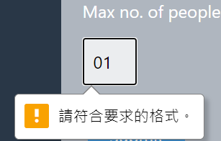

* + 1. Opened room successfully.

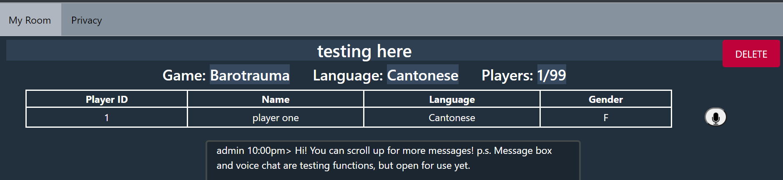

* + - 1. Since the previous room with room_id 1 is deleted in SQL, filling up these empty room_id is priority. So, room_id is 1 again.

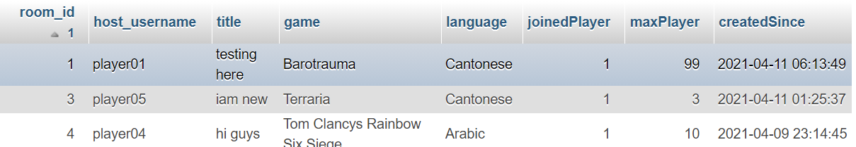

# Codes

Uses session to login in Python.

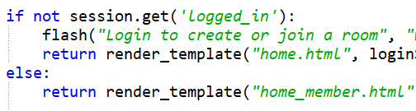

Python to check if room_id followed by sequence. If not, new created room_id fills it up. If yes, the id follows the last room_id.

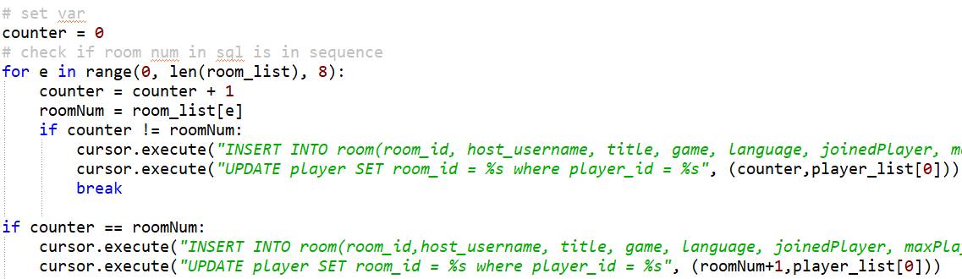

Jinja and JS used in home_member.html to display room table.

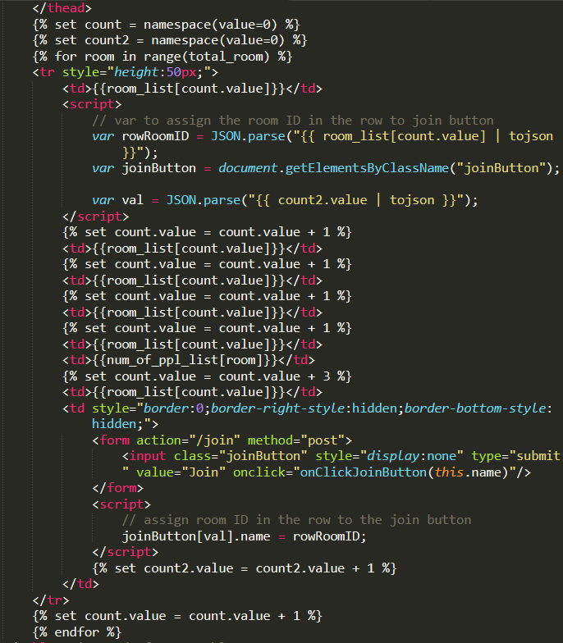

JS to hide and show login, member icon, logout buttons.

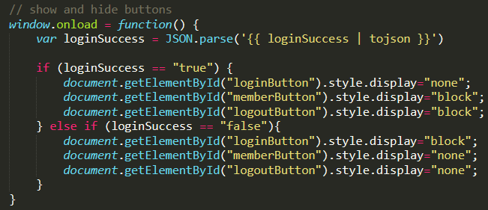

# Recommendation browsers

|  |  |
| --- | --- |
| **Browsers [latest version if possible]** | **Reason** |
| Google Chrome [>=10] | Some functions like html input validation are not supported in old versions |
| Safari [>=10.1] |
| Firefox [>=4] |

# Evaluation

Testing on functions in different versions of browsers has been done. Those are the most recommended browsers for PlayTGT to run in. The evaluation will be continued in the future development.

# Conclusion and Future Development

As budget and technical limitations, PlayTGT is still in beta, and can be improved. In the future, we would like to make chat box and voice chat in room functionable. Also, static emojis and GIF emojis will be added. Then, message board and friend list will be added, so players can add friends in room, or add them by searching their username or id. If possible, I would also love to make every player a little character in pixel, so they can move around in the room. The background of the room maybe the host’s or vote to decide. Players are allowed to customize their character. So that we may gain benefit from selling special skins or pets in the future. We would also like to further add little games in room, like board games, or maybe some games that can be related to the customized character idea I mentioned above, like fighting in the room. So that players can enjoy these little games when waiting for the game start. These games allow pause since we cannot decide when the game will be matched. To convenience players, we will try to cooperate with big game platforms like Steam in the future. Thus, we can add “Start Game” buttons that allow users to open their game applications from whatever platform, or their own PC with only one click. As there is no similar website online, I am sure that PlayTGT will have market once published.

# Reflection

Although I got familiar with Python a lot in last year, variable related problem still appears many times. I found out that I do not assign var in the best way since I use global all the time. It becomes harder and harder to change previous var assignments as codes are piling up. Thus, I will be more careful in assigning var next time, and make sure things go step by step so I do not have to go back to check error that often.

On the other hand, I learnt JavaScript, CSS, and html this year so I’m not that familiar with them. Luckily, they are all famous languages, so I can nearly get all answers I want from the Internet. However, Flask is not as famous as other languages do, so there’s not much online resources. Eventually, I found out that I do not need to use Flask that much, and the simple functions like “set”, “if”, “for” are easy to learn and use. In conclusion, I think my work ends up pretty well, and I have not encountered unsolvable question yet!

# Reference

HTML5Pattern (2021). *WELCOME…* [online] available from <https://www.html5pattern.com/> [9 April 2021]

Stack Overflow (2021). *Filtering table multiple columns* [online] available from <https://stackoverflow.com/questions/43622127/filtering-table-multiple-columns> [9 April 2021]

W3Schools (2021). *How TO - Tabs* [online] available from <https://www.w3schools.com/howto/howto_js_tabs.asp> [9 April 2021]

W3Schools (2021). *How TO - Login Form* [online] available from <https://www.w3schools.com/howto/howto_css_login_form.asp> [9 April 2021]