Lec 2

**Variable amounts of data**

p = malloc(size in bytes)

to free: free(p)

Local variables and function arguments are placed on the stack

■ deallocated after the variable leaves scope

■ do notreturn a pointer to a stack-allocated variable!

■ do not reference the address of a variable outside its scope!

Memory blocks allocated by calls to malloc/calloc are placed on the heap

Insertion

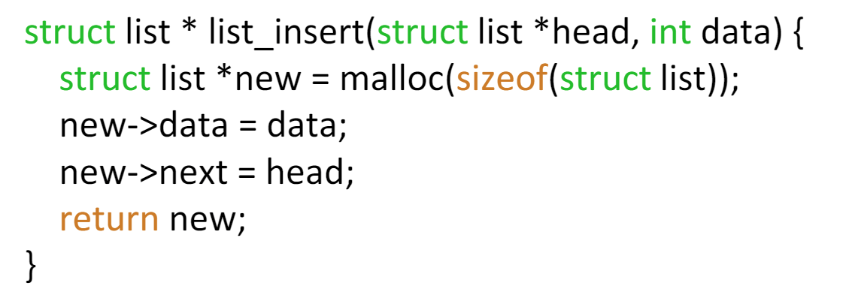

**string.h**

prefixes: *str*-> strings, *mem*-> arbitrary memory blocks

