* **Notes**

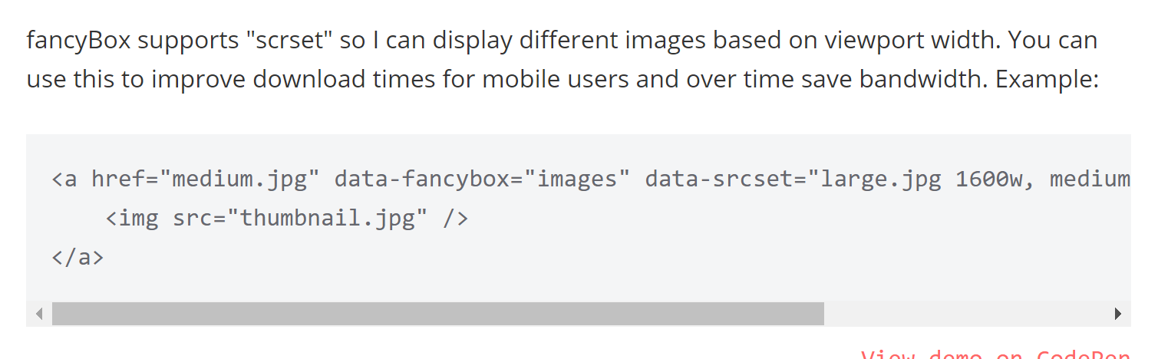

* Image resizing – thumbnails for preview, small/medium/large size images for mobile->high-res displays
* Display: table 🡪 basically like placing a table/div between 2 elements
* 