**Face Verification**

*Hao-Hsin Shih*

*Hs2762@columbia.edu*

***Abstract***

In this report, I will detail the implement of this classifier and how I select the features. The purpose for this assignment to build a face verification system to determine whether the two face images given are of the same person or not. The dataset we use is the Labeled Face in the Wild (LFW) benchmark of the Massachusetts, which includes 13233 images of 579 people. The experiment is use the benchmark given to do a 10-fold cross validation by the classifier and features of the images we choose and then have mean of accuracy rates, standard deviations of the accuracy rates and ROC. And the best result of accuracy is 72.7%

1. ***Introduction***

In this Assignment, two convenient and powerful tools allowed to be used in our program are vfeat and libsvm. Both of them have external library for matlab. So we could call the function in them directly to implement this program. To extract features on face image, vfeat could put multiple windows on the image with coordinates and size we set to extract the information that we could use in our classifier. For selection of classifier, due to the strongly recommendation in the requirement of assignment 5, support vectors machine is obviously a good option for us, and we could just easily implement it by the function offered by libsvm.

1. ***Feature extraction***

The function ‘vl_sift()’ could us extract the information we want from on the image, hoe to use this function is described clearly on its online tutorial. For each frame we use to catch the information on image, it would return a matrix, which is a 128 x 1 vector, and the difference between two vectors by the same frame on the two image compared is their feature, which we use as input for our classifier. The frames I select (use ‘Aaron_Eckhart_0001’ as example):

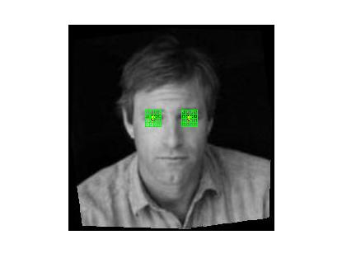 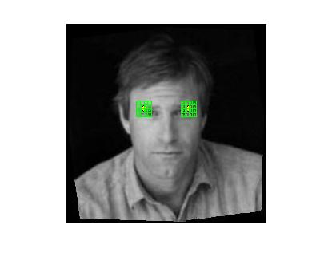

Fig.1 Eyes (2 frames) Fig.2 Eyebrow (2 frames)

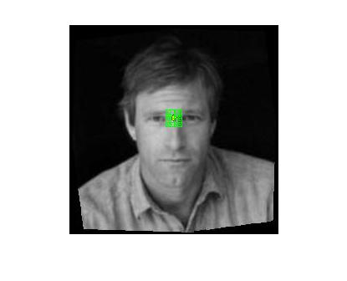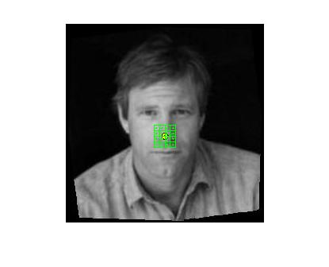

Fig.3 Area between eyebrows (a frame) Fig.4 Bridge of nose (a frame)

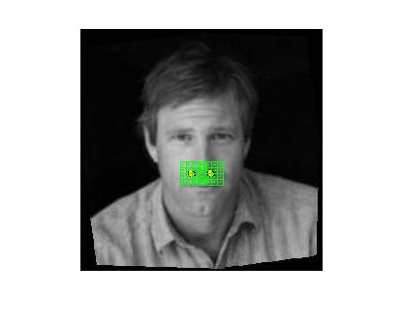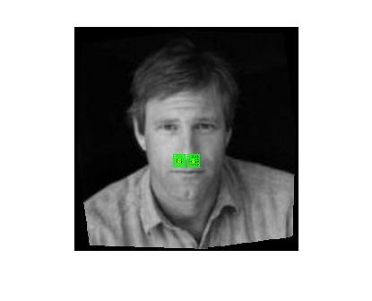

Fig.5 Both sides of cheek (2 frames) Fig.6 Both sides of nose (2frame)

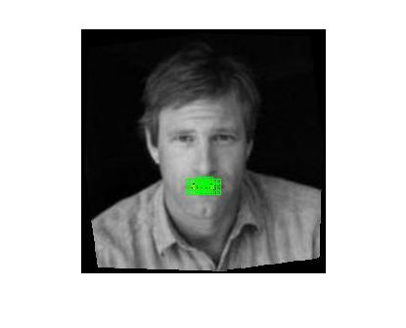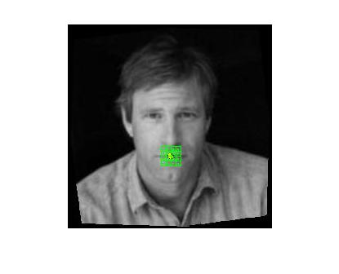

Fig 7 Center and both side of lip (3frames) Fig. 8 Entire mouth (a frame)

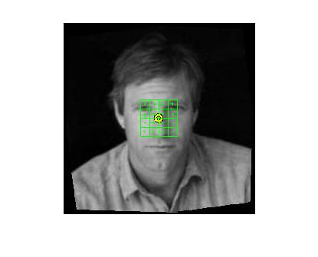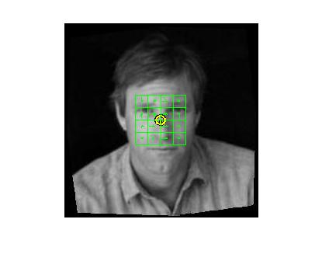

Fig. 9 window with size 48/12 Fig. 10 window with size 64/12

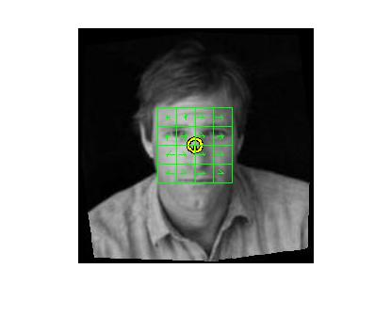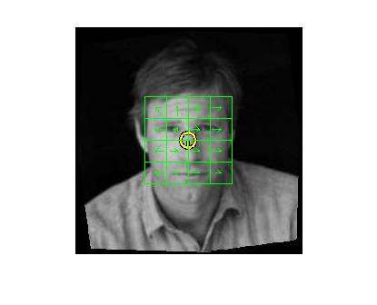

Fig. 11 window with size 80/12 Fig. 12 window with size 96/12

1. ***Feature selection***

In this part, because the dataset is so huge that it took a long time for each experiment, we decide to find some paper [1] to help me get an appropriate accuracy at beginning and used the frame from Fig.1 to Fig. 8. That’s really helpful to reach 68% at first experiment. But the result still not quite good enough to convince myself, so I start to try to add some new frames not mentioned in the [1] and dumped some frames to get better features for classifier to work. But the frames suggested by [1] almost include every characters on face, so it seems that we could add some frame include big area on the image. And as suggestion from the assignment requirement, we could also use different scale with the same center point to be the new features. So I get the result below: (showed with ROC (all of them look similar) and all of them are with the same default svm-type classifier supported by libsvm.)

1. Features including Fig. 1 to Fig. 8 (totally 14 frames):

The mean of accuracy rates: 70.7667(%)

The standard deviations of the accuracy rates: 2.1917

ROC:

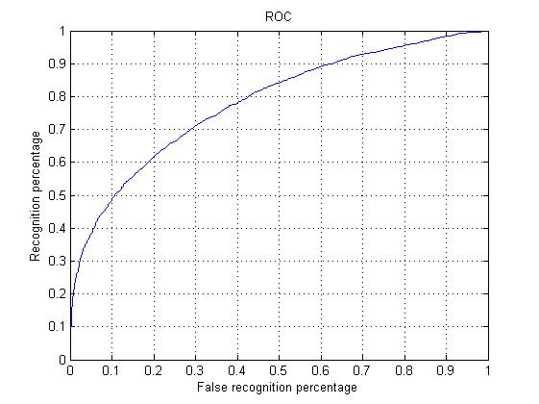

1. Features including Fig. 1 to Fig. 11 except center of mouth in Fig. 7 and Fig.6 (totally 14 frames):

The mean of accuracy rates: 72.4667(%)

The standard deviations of the accuracy rates: 1.3352

ROC:

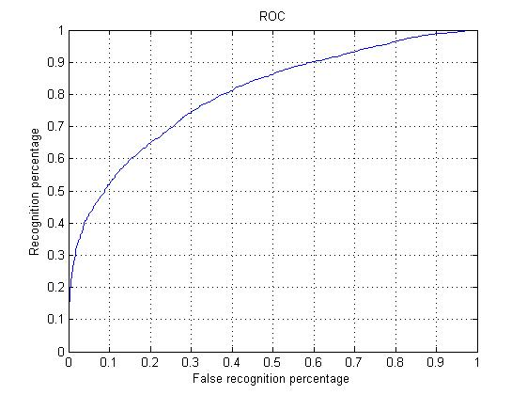

1. Features including Fig. 1 to Fig. 11 (totally 17 frames):

The mean of accuracy rates: 72.18337(%)

The standard deviations of the accuracy rates: 1.8500

ROC:

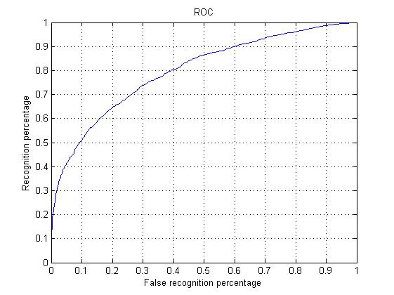

1. Features including Fig. 1 to Fig. 8 except center of mouth in Fig. 7 and Fig.6 (totally 10 frames):

The mean of accuracy rates: 72.2500(%)

The standard deviations of the accuracy rates: 1.6316

ROC:

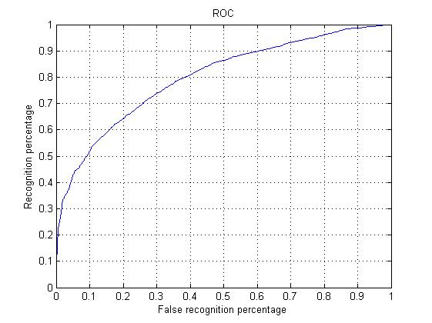

1. Features including Fig. 1 to Fig. 12 except center of mouth in Fig. 7, Fig.6, Fig. 9 and Fig. 11 (totally 13 frames):

The mean of accuracy rates: 72.7000 (%)

The standard deviations of the accuracy rates: 1.4094

ROC:

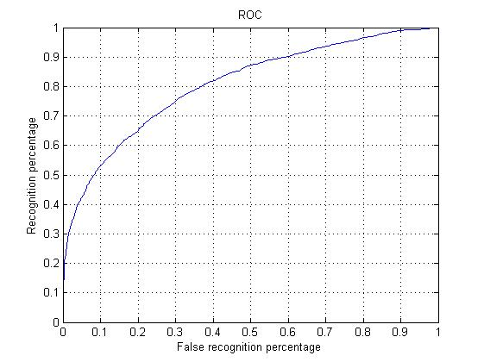

1. ***Classifier***

By the function offered by libsvm, we could build our svm classifier easily with different parameter. There are two type of classifier support by libsvm: svm type and kernel type. I just used svmtrain() by the default setting in the libsvm, because after several trying, it just doesn’t seem that I could make the accuracy better by fix the parameters.

1. ***Conclusion***

By the experiments above, we could know that the most important part for this assignment is features selection. Just keeping the frames on details or huge area would not work at all. We should put the frame on both of them in the meantime to improve the accuracy. Extracting better features are, in general, able to do better than creating a more sophisticated classifier. However, to extract useful features, one has to incorporate prior knowledge. In this lab, there are too many choice and combination of features for us to use. After some experiment with result returning, we still could figure out some clue to approach a better performance. But when we extract some new features, we get new noise in the meanwhile, so that’s the most difficult part we have to conquer in this field.

***Reference***

[1] Jennifer Huang, Volker Blanz, and Bernd Heisele, Face Recognition Using Component-Based SVM Classification and Morphable Models