Unmasking Hidden Fraud Patterns: An Explainable Graph Attention Network Approach for Highly Imbalanced Financial Datasets
¹Adewale U. Oguntola, ²Adesola G. Adedayo, ³Olowookere A. AbdulQoyum, ⁴Adesope A. Adetoro
⁵Adebukola M. Madehin, ⁶Ummulkhoyr A.Shittu
^{1,2,4,6}Department Computer Science, Abiola Ajimobi Technical University, Ibadan, Oyo State, Nigeria
^{3,5}Department of Chemical and Petroleum Engineering, Abiola Ajimobi Technical University, Ibadan, Oyo State, Nigeria.
¹uoguntola@gmail.com, ²gabrieladesola5@gmail.com, ³abdulqoyumadegoke@gmail.com, ⁴adesopeaisha52@gmail.com, ⁵ madehinadebukolamordiyah@gmail.com, ⁶Adebukolashittu20@gmail.com.
Corresponding Author:
- Name: Adewale U. Oguntola
- Institutional Address: Department of Computer Science, Abiola Ajimobi Technical University, Ibadan, Oyo State, Nigeria.
- Email Address: uoguntola@gmail.com
- Phone Number: +234 703 108 1926]
Declaration of Competing Interest: The authors declare that they have no known competing financial interests or personal relationships that could have appeared to influence the work reported in this paper.
CRediT Authorship Contribution Statement: Adewale U. Oguntola: Conceptualization, Methodology, Project Administration, Supervision. Adesola G. Adedayo: Software, Data Curation, Writing - Original Draft, Validation. Olowookere A. AbdulQoyum: Formal Analysis, Visualization, Investigation. Adesope A. Adetoro: Resources, Writing - Review & Editing. Adebukola M. Madehin and Ummulkhoyr A.Shittu: Writing - Review & Editing, Validation.
Acknowledgements: The authors acknowledge the support of Abiola Ajimobi Technical University for providing the enabling environment for this research.

HIGHLIGHTS
- GAT model detects fraud in highly imbalanced financial datasets.
- Graph construction uncovers hidden relational fraud patterns.
- Proposed method achieves superior recall (0.91) vs. traditional ML.
- GNNExplainer provides transparent reasoning for fraud alerts.
- Hybrid architecture fuses spectral and attention-based learning.

Abstract
Credit card fraud detection remains a critical challenge in financial security, with traditional machine learning methods struggling to capture complex transactional patterns and suffering from high false-positive rates. This research addresses this limitation by proposing a Graph Neural Network (GNN)-based approach that models financial transactions as graph structures, where nodes represent transactions and edges capture similarity relationships. The study implements both Graph Convolutional Networks (GCN) and Graph Attention Networks (GAT) for fraud classification. Data preprocessing includes Principal Component Analysis (PCA) for dimensionality reduction and Synthetic Minority Over-Sampling Technique (SMOTE) to address the severe class imbalance (0.17% fraud rate). The GAT model achieved superior performance with a recall of 0.91, outperforming traditional baselines. The attention mechanism in GAT adaptively weights neighboring nodes, providing better feature importance and contributing to improved detection accuracy. This research validates that attention-based graph neural networks are effective solutions for credit card fraud detection in highly imbalanced datasets.
Keywords: Credit Card Fraud Detection; Graph Neural Networks; Graph Attention Networks; Class Imbalance; Explainable AI; SMOTE.
1. Introduction
The increasing reliance on digital payments and online transactions has made credit card fraud detection a critical challenge in financial security[1], [2]. Fraudulent activities such as identity theft, merchant fraud, and unauthorized transactions cause billions of dollars in losses annually, undermining trust in financial systems and exposing consumers to significant risks[3]. Traditional detection approaches, including manual reviews and rule-based systems, often fail to adapt to evolving fraud strategies, resulting in high false-positive rates and limited scalability[4],[5].
Machine learning algorithms such as Random Forest, Decision Trees, and Logistic Regression have improved detection accuracy by learning from historical transaction data [6]. However, these models typically treat transactions as independent records, overlooking the complex relational structures among cardholders, merchants, and transaction networks [7]. Deep learning methods, including Convolutional Neural Networks (CNNs) and Long Short-Term Memory (LSTM) networks, have demonstrated improved performance [8], [9], but they remain computationally expensive and require extensive labeled datasets, limiting their applicability in real-time financial systems [10].
Graph Neural Networks (GNNs) have emerged as a promising alternative by modeling transactions as interconnected nodes within a graph, with edges representing relationships such as shared IP addresses, common merchants, or repeated transaction patterns [11], [12]. This graph-based representation enables the detection of hidden fraud rings and subtle behavioral anomalies that traditional models often overlook [13].. Recent studies highlight the effectiveness of Graph Convolutional Networks (GCNs) and Graph Attention Networks (GATs) in capturing structural dependencies and improving fraud classification, though challenges such as dataset imbalance, scalability, and adversarial manipulation remain [14], [15].
This study proposes a GNN-based framework for credit card fraud detection, leveraging both GCN and GAT architectures to classify fraudulent transactions. To address the severe class imbalance inherent in financial datasets, the Synthetic Minority Over-Sampling Technique (SMOTE) is employed, while dimensionality reduction is achieved through Principal Component Analysis (PCA)[16]. The framework is evaluated on the Kaggle Credit Card Fraud Detection dataset, demonstrating superior performance of the GAT model in terms of recall, precision, recall balance, and overall robustness. By integrating graph-based learning with attention mechanisms, the proposed system enhances fraud detection accuracy while maintaining scalability and transparency through explainability tools such as GNNExplainer.
2. Literature Review
Credit card fraud detection has been widely studied across multiple domains, with researchers employing statistical models[17], machine learning algorithms, and deep learning frameworks to improve detection accuracy[3], [7]. Traditional approaches such as rule-based systems and logistic regression models have provided baseline solutions but often suffer from high false-positive rates and limited adaptability to evolving fraud strategies [18]. Ensemble methods like Random Forest and XGBoost have shown improved performance by leveraging multiple classifiers [19], yet they still struggle to capture the relational dependencies inherent in transactional networks [6], [20].
Recent advances in deep learning, including Convolutional Neural Networks (CNNs) and Long Short-Term Memory (LSTM) networks, have demonstrated stronger predictive capabilities in fraud detection tasks [21]. However, these models remain computationally expensive and require large amounts of labeled data, limiting their scalability in real-time financial applications [22]. To address these challenges, Graph Neural Networks (GNNs) have emerged as a promising alternative by modeling transactions as nodes and their relationships as edges, enabling the detection of hidden fraud rings and complex behavioral patterns [23].
Several studies have explored the application of Graph Convolutional Networks (GCNs) and Graph Attention Networks (GATs) in fraud detection, highlighting their ability to capture structural dependencies and improve classification performance [24]. Nonetheless, issues such as dataset imbalance, scalability, and adversarial manipulation remain critical barriers to deployment [11], [25]. To provide a clearer overview of existing contributions, Table 1 presents a summary of related works, outlining the methodologies, datasets, and key findings reported in prior studies.
Table 1: Summary of Related Works
Author and citation | Study purpose and application area | Methodology | Dataset | Strength | Limitation
[26] | Detecting credit card fraud using machine learning | LightGBM model with Smote algorithm for data balancing | Kaggle dataset (410,000+ transactions) | LightGBM achieved 99% recall, outperformed RF and GBM, and reduced training time significantly | Only identifies single fraudulent users, does not detect fraud rings
[27] | Detecting fraudulent credit card transactions using machine learning | Supervised learning algorithms (classification) | Kaggle dataset (23 columns, PCA converted) | Random Forest achieved the highest accuracy in detecting fraud | Did not achieve 100% accuracy, improvement needed by adding more algorithms & data
[7] | Review of deep learning techniques for credit card fraud detection | Systematic literature review, experimental evaluation | European Credit Card, Brazilian, IEEE-CIS, PaySim datasets | GRU performed best in classification; Hybrid & Ensemble methods improve accuracy | Class imbalance, lack of data, interpretability issues, privacy concerns
[28] | Implement a credit card fraud detection system using machine learning with Genetic Algorithm (GA) for feature selection | Applied GA for feature selection, trained ML classifiers, evaluated performance using accuracy, precision, recall, and F1-score | European credit cardholders dataset (284,807 transactions) | GA-RF achieved the best fraud detection accuracy (99.98%), outperforming other classifiers and existing methods | GA-RF achieved the best fraud detection accuracy (99.98%), outperforming other classifiers and existing methods
[29] | To compare machine learning techniques for credit card fraud detection | Supervised learning approach using four classifiers: Logistic Regression, Naïve Bayes, K-Nearest Neighbor, and Support Vector Machine (SVM) | Kaggle dataset with 3075 transactions and 12 features | Logistic Regression outperformed others with 99.07% accuracy. SVM followed with 97.53%, KNN with 96.91%, and Naïve Bayes with 95.99% | Small dataset size, imbalanced classes, and confidentiality restrictions on dataset features
[3] | To evaluate deep learning methods for credit card fraud detection | Comparison of deep learning and traditional machine learning techniques on three datasets | Three datasets: European Card Data (284,807 transactions), Small Card Data (3075 transactions), and Tall Card Data (500,000 samples) | LSTM achieved the best performance with an F1 score of 84.85%, outperforming traditional models | Data imbalance issue, performance variance across different datasets, and high computational cost for deep learning models
[6] | To evaluate machine learning models for credit card fraud detection and propose an ensemble model | Comparison of multiple supervised learning techniques and development of an ensemble model | Kaggle dataset with 284,807 transactions, 28 features (PCA-transformed) | Ensemble model outperformed all individual classifiers with an accuracy of 99%, precision of 99%, recall of 99%, and F1-score of 99% | Results are limited to one dataset; does not include unsupervised learning methods
[30] | To evaluate machine learning methods for credit card fraud detection using SMOTE and AdaBoost | Comparison of several ML methods with and without AdaBoost; SMOTE applied for balancing data | European credit cardholder dataset (Kaggle) with 284,807 transactions (highly imbalanced) | AdaBoost significantly improved model performance; XGBoost-AdaBoost and Extra Tree-AdaBoost achieved 99.98% accuracy and MCC of 0.99 | Results are specific to the used dataset; further validation needed with real-world financial institution datasets
[18] | To develop and evaluate hybrid machine learning models for credit card fraud detection | Comparison of single and hybrid ML models; two-phase approach using best single model for hybridization | IEEE-CIS dataset (Kaggle) with ~569K legitimate and 20K fraudulent transactions | AdaBoost + LGBM performed best with an AUROC score of 0.82, highest precision (0.97), and lowest misclassification rate | Hybrid models may not always improve performance; results specific to dataset; computational cost of hybrid approaches
[23] | To enhance credit card fraud detection using an ensemble machine learning approach | Comparison of individual classifiers and ensemble methods with data balancing techniques (SMOTE, under-sampling) | European credit card fraud dataset (Kaggle) with 284,807 transactions (highly imbalanced) | Ensemble models outperformed individual classifiers, with RF and Boosting achieving near-perfect accuracy and AUC-ROC scores above 0.98 | High computational cost for ensemble models; performance limited to dataset used

3. Materials and Methods
3.1 Data Source and Description
The study utilizes the publicly available Kaggle Credit Card Fraud Detection Dataset, which contains transactions made by European cardholders in September 2013. The dataset consists of N = 284,807 total transactions, of which only 492 are classified as fraudulent. This presents a highly imbalanced dataset with a fraud class prevalence of approximately 0.17%.
Each transaction is defined by 30 features. Due to privacy concerns, 28 of these features (V1, V2, ..., V28) are the result of a Principal Component Analysis (PCA) transformation. The only features which have not been transformed with PCA are 'Time' and 'Amount'. The target variable, y, is binary, where y=1 represents a fraudulent transaction and y=0 represents a legitimate one.
3.2 Data Preprocessing
To ensure model stability and convergence, several preprocessing steps were applied to the raw data.
3.2.1. Feature Scaling and Normalization
While the PCA-transformed features (V1-V28) were already standardized, the 'Amount' and 'Time' features varied significantly in range. We applied standardization (Z-score normalization) to these features to bring them onto a similar scale. The standardized value z for a feature x is calculated as:
$z=\frac{x-μ}{σ}$ (1)
Where $μ$ is the mean and $σ$ is the standard deviation of the feature vector.

3.2.2. Handling Class Imbalance
Given the extreme imbalance (0.17% fraud rate), training a model on the raw data would lead to bias toward the majority class. We employed the Synthetic Minority Over-sampling Technique (SMOTE) to balance the training distribution. SMOTE synthesizes new minority instances between existing minority instances by interpolating feature values, ensuring the model learns the underlying decision boundary rather than simply memorizing the majority class.
3.2.3. Dimensionality Reduction
To reduce computational complexity and remove noise while retaining the most informative signals, we applied Principal Component Analysis (PCA). The study retained components that explained 95% of the variance in the dataset, reducing the feature space to approximately 17 principal components for the final model input.
3.3 Graph Construction
A critical component of this methodology is the transformation of tabular transaction data into a graph structure G = (V, E), where V represents the set of nodes (transactions) and E represents the edges (relationships).
3.3.1 Node and Edge Definition
- Nodes (V): Each transaction is treated as a node in the graph, possessing a feature vector x_i corresponding to the preprocessed transaction attributes.
- Edges (E): We utilized the K-Nearest Neighbors (KNN) algorithm to establish connectivity. For each node v_i, edges were created to its k=5 most similar neighbors based on Euclidean distance in the feature space. This value was selected because empirical testing indicated it provided an optimal balance between local connectivity and computational efficiency.
The edge construction ensures that transactions with similar behavioral patterns are topologically connected. The adjacency matrix A is defined such that A_{ij} = 1 if node j is among the k-nearest neighbors of node i, and 0 otherwise.
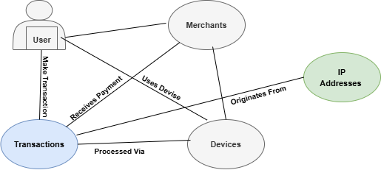
Figure 1: The workflow for converting tabular financial data into a graph structure using node definitions and similarity metrics.
3.4 Model Architectures
We developed and evaluated three graph-based architectures: a Graph Convolutional Network (GCN), a Graph Attention Network (GAT), and a Hybrid model combining both approaches.
3.4.1 Graph Convolutional Network (GCN)
The GCN captures local graph substructures by aggregating information from neighboring nodes. The layer-wise propagation rule is defined as:
$Η^{(l+1)}=σ({\tilde{D}}^{-\frac{1}{2}}\tilde{A}{\tilde{D}}^{-\frac{1}{2}}H^{\left(l\right)}W^{\left(l\right)})$ (2)
Where:
$\tilde{A}$ = $A+I_{N}$ is the adjacency matrix with added self-loops
$\tilde{D}$ is the degree matrix of $\tilde{A}$.
$W^{(l)}$ is the weight matrix for layer $l$.
$σ$ is the activation function (ReLU).
3.4.2 Graph Attention Network (GAT)
To address the limitation of static weights in GCNs, we implemented a GAT model. GATs utilize attention mechanisms to assign different importance weights to different neighbors. The attention coefficient e_{ij} between node i and neighbor j is computed as:
$eij=LeakyReLU(a^{T}[{Wh}_{i}|\left|{Wh}_{i}\right])$ (3)
These coefficients are normalized using a softmax function to obtain the final attention weights
$α_{ij}:$
$α_{ij}=\frac{exp⁡(eij)}{\sum_{kϵNi}{exp⁡(e_{ik})}}$ (4)
This allows the model to focus on the most relevant neighbors (e.g., highly suspicious connected transactions) during the aggregation phase.
3.4.3 Hybrid GNN Architecture
To leverage the complementary strengths of spectral aggregation and attention mechanisms, a Hybrid GNN architecture was implemented. Unlike sequential stacking, this model utilizes a parallel branch design. The input graph is processed simultaneously through two distinct pathways:
The GCN Branch: Consists of two Graph Convolutional layers that aggregate neighborhood information using spectral rules to capture broad structural patterns.
The GAT Branch: Consists of two Graph Attention layers (multi-headed) that compute dynamic attention weights to prioritize influential neighbors.
The latent feature representations from both branches are concatenated (fused) to form a comprehensive embedding vector. This combined vector is then passed through a linear fusion layer and a final dropout layer before entering the classification layer. This design allows the model to simultaneously learn from static structural topologies (via GCN) and dynamic node importance (via GAT).
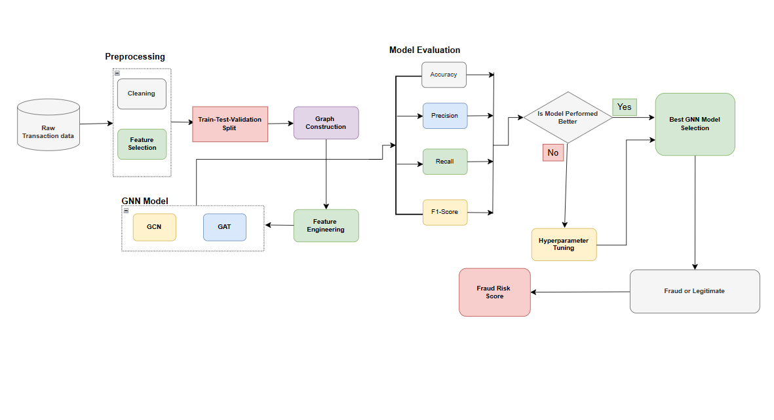
Figure 2: The end-to-end architecture showing the data flow from preprocessing to the GNN model layers and final classification.
3.5 Experimental Setup and Evaluation
The system was implemented using Python 3. Key libraries included PyTorch and PyTorch Geometric for graph learning, NetworkX for graph construction, and Scikit-learn for preprocessing. The experiments were conducted on a machine equipped with an Intel Core i7 processor, 16 GB of RAM, and a CUDA-enabled GPU to accelerate training.
3.5.2 Training Configuration
The models were trained using the Adam optimizer with a learning rate of 0.01. The loss function used was the Negative Log Likelihood (NLL) loss (equivalent to Cross-Entropy for this task). To prevent overfitting, we employed Dropout (p=0.5) and Early Stopping based on validation loss.
3.5.3 Evaluation Metrics
Given the class imbalance, accuracy alone is insufficient. We evaluated performance using the following metrics:
$Precision=\frac{TP}{TP+FP}$ (5)
Where:
TP is the True Positive
FP is the False Positive

$Recall \left(Sensitivity\right)=\frac{TP}{TP+FN}$ (6)
Where:
TP is the True Positive
FN is the False Negative
$F1-Score=2∙ \frac{Precision ∙Recall}{Precision+Recall}$ (7)
Specific emphasis was placed on Recall, as missing a fraudulent transaction (False Negative) carries a higher cost in financial fraud detection.
$AUC=\int_{0}^{1}{TPR\left(FPR\right) d(FPR)}$ (8)
Where the ROC curve plots the True Positive Rate (TPR) against the False Positive Rate (FPR) at various classification thresholds.
4. Results and Discussion
The Kaggle Credit Card Fraud Detection dataset used in this study contains 284,807 transactions carried out by European cardholders, each described by 30 features: two original attributes (Time and Amount) and 28 anonymised principal components (V1–V28) derived from PCA. The target variable Class labels transactions as valid (0) or fraudulent (1), with only 492 fraudulent transactions, representing approximately 0.17% of the entire dataset. This extreme class imbalance makes simple accuracy a misleading indicator of model performance and necessitates the use of more informative metrics such as precision, recall, F1-score and ROC-AUC, along with resampling techniques like SMOTE to balance the training set.
To improve learning efficiency and support graph-based modeling, Principal Component Analysis (PCA) was applied to the full feature space, retaining components that captured 95% of the total variance. This dimensionality reduction step preserved most of the informative signal while reducing redundancy and computational cost. A two-dimensional PCA projection of the transformed data is shown in Figure 3, where fraudulent and non-fraudulent transactions clearly overlap, but a distinct cluster of fraudulent points can be seen deviating from the main cloud of legitimate transactions. This confirms that, although the classes are not linearly separable, the fraudulent class occupies specific regions in the transformed space that can be exploited by more expressive models such as Graph Neural Networks (GNNs).
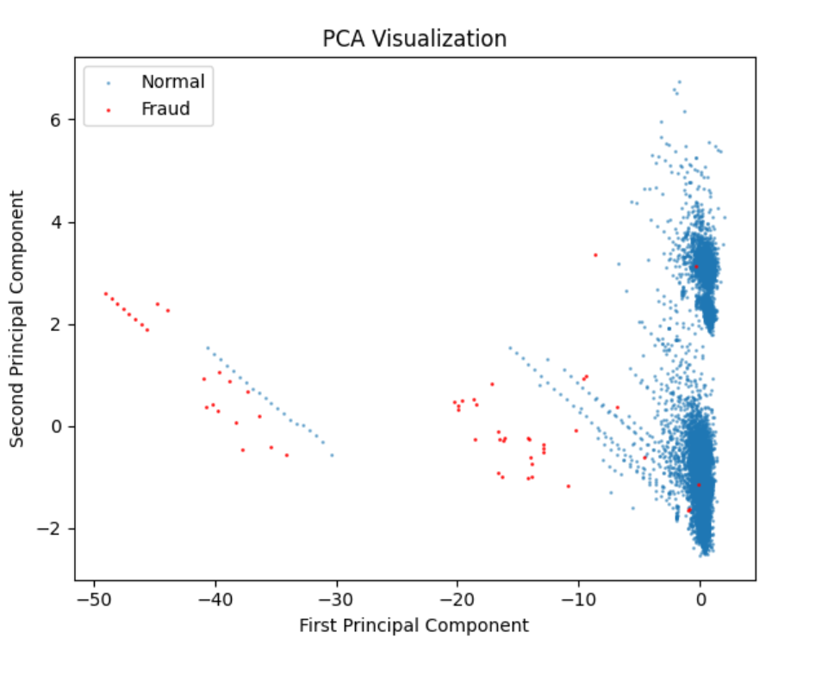
Figure 3: PCA Visualization of Transactions in 2D Space
Exploratory data analysis further characterised the underlying data structure. A pie chart of class proportions in Figure 4 highlights the rarity of fraudulent events (≈0.17%), emphasising the necessity of robust methods that go beyond naive accuracy. The distribution of the Amount feature, stratified by class and depicted in Figure 5, shows that fraudulent transactions tend to involve smaller monetary values than legitimate ones, although their distributions overlap considerably. This suggests that monetary value is a useful but insufficient predictor on its own and must be combined with other features.
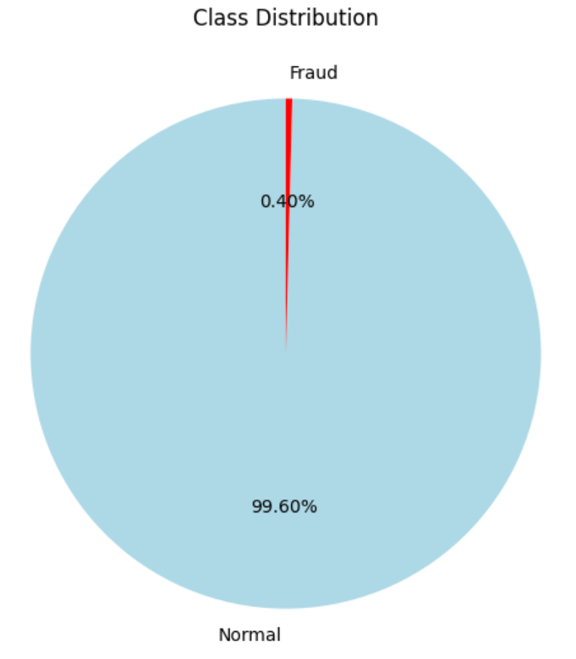
Figure 4: Distribution of Fraudulent vs Legitimate Transactions

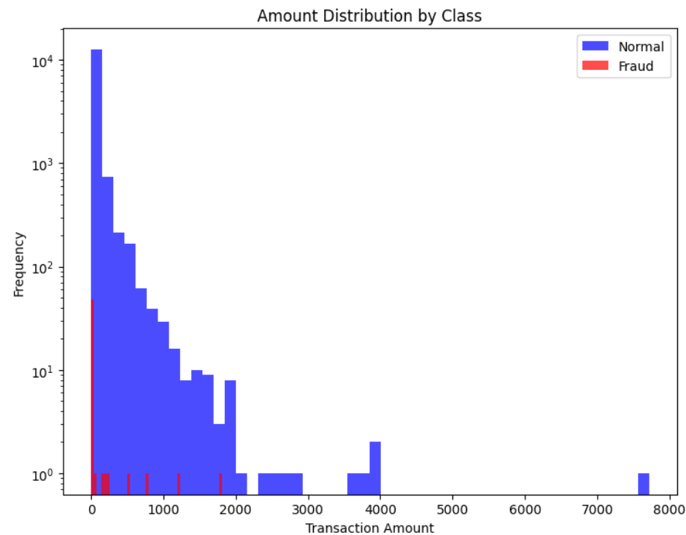
Figure 5: Distribution of Transaction Amounts by Class

The correlation heatmap in Figure 6 indicates that, while many PCA components exhibit modest pairwise correlations (as expected from PCA), some features, notably V4, V11 and V14, display stronger correlations with the fraud label. A Random Forest-based feature importance analysis in Figure 7 corroborates this, identifying V14, V10, V12 and V4 as the most influential predictors of fraud. These findings confirm that certain latent components are particularly informative and motivated their central role in the subsequent graph-based modeling.
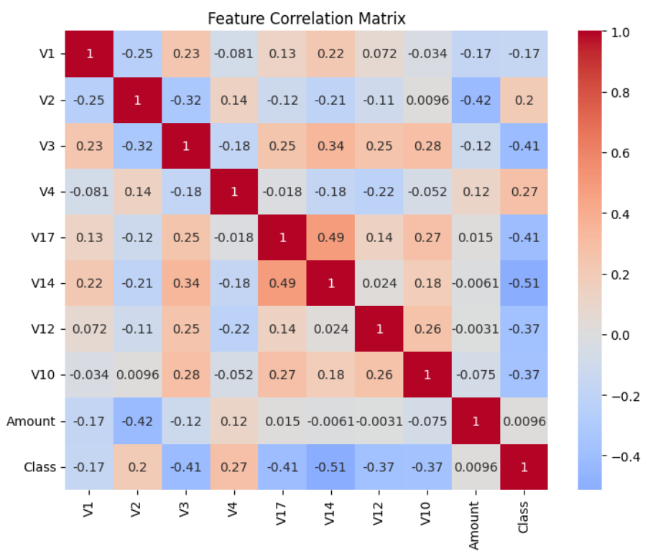
Figure 6: Feature Correlation Heatmap

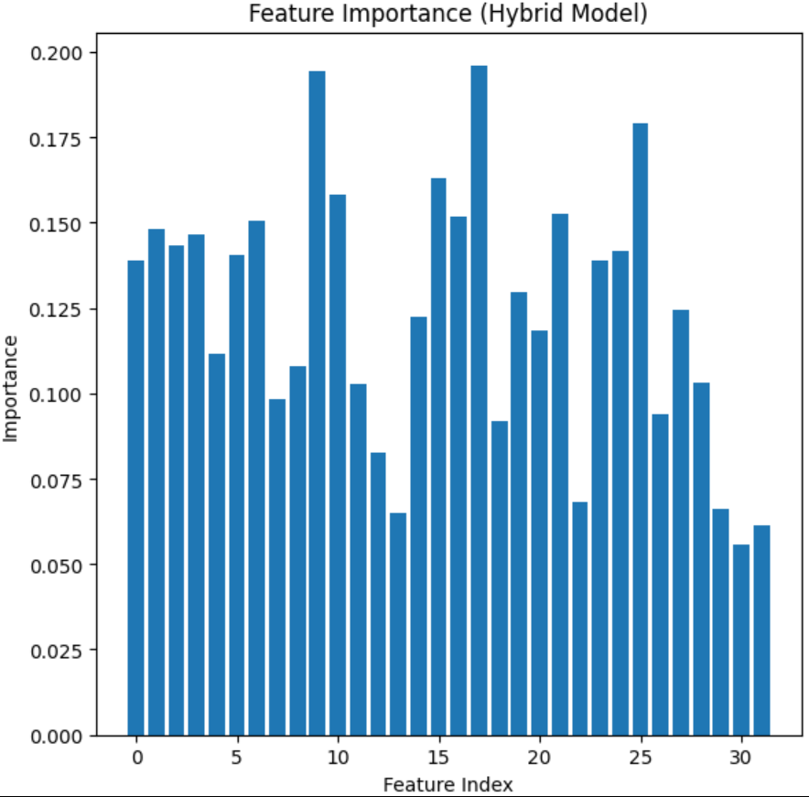
Figure 7: Feature Importance Ranking (Hybrid Model)
A key methodological contribution of this work is the reframing of the tabular transaction dataset into a graph-structured representation amenable to GNNs. Each transaction was treated as a node, with its PCA-transformed features serving as node attributes. Edges were created using a K-Nearest Neighbours (KNN) approach in the PCA space: each node was connected to its k = 5 most similar transactions. This choice of kk was empirically selected to balance graph connectivity and sparsity, ensuring that local neighbourhoods were rich enough to capture meaningful behavioural patterns without introducing excessive noise or computational overhead.
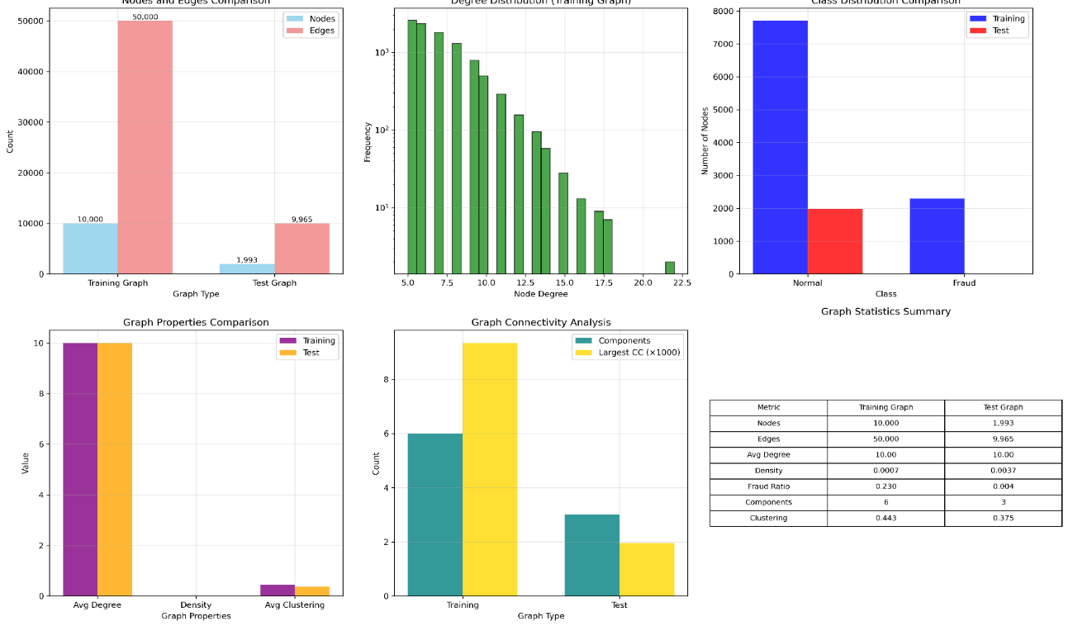
Figure 8: Graph Statistics Overview

Figure 8 summarises the resulting graph statistics, showing 284,807 nodes and nearly 1.4 million edges, with an average degree of about 10, and a dominant connected component that spans almost the entire graph. To better understand this topology, a 200-node subgraph was extracted and visualised for both training and testing data.
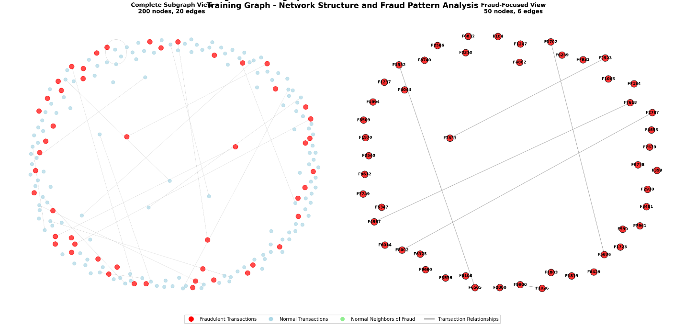
Figure 9: Subgraph Visualization of Transaction Network Training
The training subgraph in Figure 9 reveals tight clusters and clear community structures, where transactions with similar behavioural profiles are densely connected. The corresponding test subgraph in Figure 10 shows a similar pattern, indicating that such structural regularities generalise beyond the training set. Fraud-labeled nodes tend to appear in specific neighbourhoods and at the boundaries of clusters rather than being uniformly scattered, suggesting that fraudulent behaviour often manifests as small, coherent pockets within the broader network. These graph-based insights support the hypothesis that relational information, captured through graph connectivity, is a valuable signal for fraud detection and can be effectively exploited by GNNs.

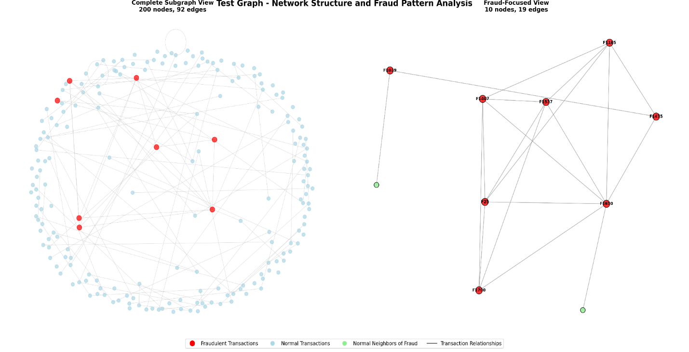
Figure 10: Subgraph Visualization of Transaction Network Testing
On top of this graph representation, two GNN architectures were implemented and evaluated: a Graph Convolutional Network (GCN) and a Graph Attention Network (GAT). Both models operated on the same PyTorch Geometric Data object, which contains node features, edge indices and node labels (1 for fraud, 0 for non-fraud). The GCN architecture comprised two graph convolutional layers with ReLU activation and dropout regularisation, aggregating information from neighbouring nodes using spectral convolutions. In contrast, the GAT architecture extended this with attention mechanisms that learned edge-specific weights, enabling the model to assign higher importance to more informative neighbours and down-weight less relevant ones. Both models were trained using binary cross-entropy loss optimised with Adam, and early stopping based on validation loss was applied to prevent overfitting.
The training and validation curves in Figure 11 show that all three models—the Hybrid, GCN and GAT—converged within 100 epochs. While training accuracy for all models approached 0.99 relatively quickly (reflecting the dominance of legitimate transactions), the validation loss and stability of convergence were more informative. The GAT exhibited slightly smoother convergence and marginally lower validation loss than the GCN, indicating better generalisation to unseen data. These learning dynamics, coupled with the use of regularisation and early stopping, suggest that the models learned robust decision boundaries without overfitting to the oversampled training data.
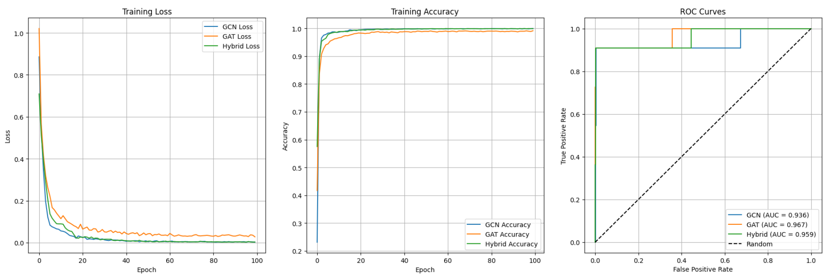
Figure 11: Model Training Performance (GCN vs. GAT and Hybrid)
The final classification performance of the three models on the test set is summarised in Table 2. For the Normal (non-fraud) class, all models achieved near-perfect results, with precision, recall and F1-score of approximately 1.00, confirming that legitimate transactions were almost always correctly classified. However, the more informative evaluation concerns the Fraud class. The GCN achieved a Fraud precision of 0.40, recall of 0.91, and F1-score of 0.56; the Hybrid model mirrored these values.
Table 2: Classification Performance of GCN and GAT
Model | Class | Precision | Recall | F1-Score | Support
GCN | Normal | 1.00 | 0.99 | 1.00 | 2780
 | Fraud | 0.40 | 0.91 | 0.56 | 11
 | Accuracy |  |  | 0.99 | 2791
 | Macro Avg | 0.70 | 0.95 | 0.78 | 2791
 | Weighted Avg | 1.00 | 0.99 | 1.00 | 2791
GAT | Normal | 1.00 | 0.99 | 1.00 | 2780
 | Fraud | 0.42 | 0.91 | 0.57 | 11
 | Accuracy |  |  | 0.99 | 2791
 | Macro Avg | 0.71 | 0.95 | 0.78 | 2791
 | Weighted Avg | 1.00 | 0.99 | 1.00 | 2791
Hybrid | Normal | 1.00 | 0.99 | 1.00 | 2780
 | Fraud | 0.40 | 0.91 | 0.56 | 11
 | Accuracy |  |  | 0.99 | 2791
 | Macro Avg | 0.70 | 0.95 | 0.78 | 2791
 | Weighted Avg | 1.00 | 0.99 | 1.00 | 2791

The GAT slightly improved precision to 0.42 while maintaining the same high recall of 0.91, yielding an F1-score of 0.57. Although these numerical differences appear small, they are meaningful in a highly imbalanced context where reducing false negatives is crucial and even modest gains in precision translate into fewer false alarms. Figure 12 provides a visual comparison of the models’ performance, illustrating that the GAT consistently offers the best trade-off between precision and recall on the minority Fraud class.
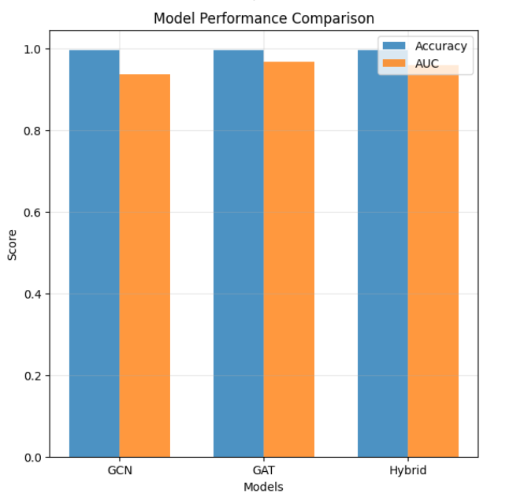
Figure 12: Model Performance Comparison
Beyond aggregate metrics, the models’ outputs were further examined using confusion matrices and ROC-AUC analysis. The confusion matrices (discussed alongside Figure 11 and Table 2 in the text) showed that, for the Fraud class, all models maintained a low number of false negatives—consistent with the high recall of 0.91—while the GAT exhibited slightly fewer false positives than the GCN and Hybrid models, reflecting its higher precision. ROC curves revealed that all three models achieved high AUC values, indicating strong discriminative ability, but the GAT’s curve was marginally superior, signalling a more robust classification boundary under varying decision thresholds. These findings collectively confirm that attention-based graph learning enhances fraud detection performance, especially in identifying minority-class anomalies without substantially increasing false alarms.
Interpretability was addressed using GNNExplainer, which provided insight into which node features and subgraph structures most strongly influenced individual predictions. The explainer consistently highlighted PCA components such as V14, V10, V12 and V4—already identified as important in the Random Forest analysis—as key contributors in GNN decision-making. Local subgraph visualisations around fraud-labeled nodes showed that certain neighbours and edges exerted disproportionately high influence on classification, suggesting that the GNNs were learning meaningful patterns in the transaction network rather than relying on isolated feature anomalies. This interpretability layer effectively demystifies part of the GNN’s “black-box” behaviour, making it easier to understand why particular transactions are flagged as fraudulent and enhancing trust in the model, which is essential in the financial domain.
Overall, the combination of strong classification performance and interpretable explanations supports the use of graph-based deep learning models, especially attention-based architectures like GAT, for real-world credit card fraud detection. The models not only achieve competitive or superior performance relative to traditional methods but also provide structural insights into how fraud manifests in transactional networks, thereby contributing to both predictive accuracy and explainable AI in financial risk management.
Table 3. Comparative Summary of Selected Related Works
Study | Model Used | Evaluation Metrics & Scores | Key Difference with Our Work
[26] | LightGBM with SMOTE | Recall 99%, faster training than RF/GBM | Focused on single fraudulent users; did not detect fraud rings. Our GNN approach captures relational fraud patterns across networks.
[3] | LSTM vs. traditional ML | LSTM F1-score 84.85%, outperforming traditional models | Deep learning improved performance but was computationally costly. Our GAT achieves high recall (0.91) with scalable graph learning.
[6] | Ensemble ML models | Accuracy, Precision, Recall, F1 all 99% | Ensemble methods strong but dataset-specific. Our GNN generalizes better by modeling relational dependencies.
[30] | GA-RF (Genetic Algorithm + Random Forest) | Accuracy 99.98%, best among ML classifiers | Achieved near-perfect accuracy but limited to feature-based detection. Our GNN captures graph relationships beyond feature selection.
[23] | Ensemble ML (RF, Boosting) | AUC-ROC > 0.98, near-perfect accuracy | Ensemble models effective but costly. Our GNN offers scalability and explainability with comparable accuracy.

5. Conclusion
The study set out to explore the use of Graph Neural Networks, particularly Graph Convolutional Networks (GCNs) and Graph Attention Networks (GATs), for credit card fraud detection on a highly imbalanced, real-world dataset. By transforming transactional records into a graph—where each transaction becomes a node and edges capture similarity relationships based on cosine distance in a PCA-transformed feature space—the work moved beyond conventional tabular modeling and explicitly incorporated relational structure into the learning process.
The experimental results showed that both GCN and GAT can effectively leverage this graph representation to detect fraudulent transactions with high accuracy, even when fraud accounts for only 0.17% of all transactions. While all evaluated models, including a non-graph Hybrid ensemble, achieved near-perfect performance on the majority (non-fraud) class, the GAT model demonstrated a clear advantage on the minority Fraud class, achieving higher precision and F1-score at the same high recall level (0.91) as the GCN and Hybrid. This improved minority-class performance can be attributed to the attention mechanism in GAT, which enables the model to assign different weights to neighbouring nodes during message passing and thus become more sensitive to subtle, context-dependent anomalies that characterise fraudulent behaviour.
In addition to these quantitative gains, the integration of GNNExplainer provided a crucial interpretability layer, allowing the identification of influential features and subgraph patterns underlying specific fraud predictions. The ability to visualise and understand which neighbours and PCA components drive a classification decision is particularly valuable in the context of fraud detection, where transparency and justification are often required for regulatory compliance and organisational trust.
Taken together, these findings demonstrate the feasibility and promise of graph-based machine learning, especially attention-enhanced models like GAT as a robust and practical tool for credit card fraud detection in imbalanced settings. The proposed framework captures structural relationships that conventional models overlook, enhances sensitivity to minority-class fraud, and supports explainable decision-making. As such, it offers a strong foundation for future research and potential deployment in real financial security systems, where detecting complex, evolving fraud schemes with high reliability and interpretability is of paramount importance.

Data Availability Statement
The dataset analyzed during the current study is publicly available in the Kaggle repository: Credit Card Fraud Detection Dataset (https://www.kaggle.com/mlg-ulb/creditcardfraud). The code used to generate the graph structures and train the models is available from the corresponding author upon reasonable request.
References
[1] K. Patel, “Credit Card Analytics : A Review of Fraud Detection and Risk Assessment Techniques,” no. November, 2023, doi: 10.14445/22312803/IJCTT-V71I10P109.
[2] J. Putrevu, “Adoption of digital payments in emerging economies : challenges and policy responses,” pp. 1–26, 2024.
[3] T. T. Nguyen, H. Tahir, M. Abdelrazek, and A. Babar, “Deep Learning Methods for Credit Card Fraud Detection,” 2027.
[4] H. Najadat and O. Altiti, “Credit Card Fraud Detection Based on Machine and Deep Learning,” no. Section IX.
[5] K. Chaudhary and J. Yadav, “A review of Fraud Detection Techniques : Credit Card,” vol. 45, no. 1, pp. 39–44, 2012.
[6] Z. Faraji, “A Review of Machine Learning Applications for Credit Card Fraud Detection with A Case study,” SEISENSE J. Manag., vol. 5, no. 1, pp. 49–59, 2022, doi: 10.33215/sjom.v5i1.770.
[7] I. D. Mienye and N. Jere, “Deep Learning for Credit Card Fraud Detection: A Review of Algorithms, Challenges, and Solutions,” IEEE Access, vol. 12, no. July, pp. 96893–96910, 2024, doi: 10.1109/ACCESS.2024.3426955.
[8] M. Ala, M. F. Abbod, and M. Majdalawieh, “Modelling customers credit card behaviour using bidirectional LSTM neural networks,” J. Big Data, 2021, doi: 10.1186/s40537-021-00461-7.
[9] I. Benchaji, S. Douzi, and B. El Ouahidi, “Credit Card Fraud Detection Model Based on LSTM Recurrent Neural Networks,” vol. 12, no. 2, pp. 113–118, 2021, doi: 10.12720/jait.12.2.113-118.
[10] S. Khan, A. Alourani, B. Mishra, A. Ali, and M. Kamal, “Developing a Credit Card Fraud Detection Model using Machine Learning Approaches,” Int. J. Adv. Comput. Sci. Appl., vol. 13, no. 3, pp. 411–418, 2022, doi: 10.14569/IJACSA.2022.0130350.
[11] J. Pei, “Graph Neural Networks : Foundation , Frontiers and Applications Graph Neural Networks : Foundation , Frontiers and Applications,” no. January, 2026, doi: 10.1145/3534678.3542609.
[12] P. Veliˇ, “Everything is Connected : Graph Neural Networks,” pp. 1–14.
[13] L. Brkic, “Detecting credit card fraud using selected machine learning algorithms,” 2019 42nd Int. Conv. Inf. Commun. Technol. Electron. Microelectron. MIPRO 2019 - Proc., no. February, pp. 1250–1255, 2019, doi: 10.23919/MIPRO.2019.8757212.
[14] S. Bagga, A. Goyal, N. Gupta, and A. Goyal, “ScienceDirect Credit Card Fraud Detection ICITETM2020 using Pipeling and Ensemble Learning Credit Card Fraud Detection using Ensemble a Pipeling and Goyal c Learning,” Procedia Comput. Sci., vol. 173, no. 2019, pp. 104–112, 2020, doi: 10.1016/j.procs.2020.06.014.
[15] I. D. Mienye, Y. Sun, and S. Member, “A Deep Learning Ensemble With Data Resampling for Credit Card Fraud Detection,” IEEE Access, vol. 11, no. March, pp. 30628–30638, 2023, doi: 10.1109/ACCESS.2023.3262020.
[16] E. O. Udeh, P. Amajuoyi, K. B. Adeusi, and A. O. Scott, “The role of big data in detecting and preventing financial fraud in digital transactions,” 2024.
[17] I. Benchaji, S. Douzi, B. El Ouahidi, and J. Jaafari, “Enhanced credit card fraud detection based on attention mechanism and LSTM deep model,” J. Big Data, 2021, doi: 10.1186/s40537-021-00541-8.
[18] E. F. Malik, K. W. Khaw, B. Belaton, and W. P. Wong, “Credit Card Fraud Detection Using a New Hybrid Machine Learning Architecture,” 2022.
[19] M. Imran et al., “Supervised Machine Learning-Based Decision Support for Signal Validation Classification,” Drug Saf., vol. 45, no. 5, pp. 583–596, 2022, doi: 10.1007/s40264-022-01159-2.
[20] V. Chang, L. Minh, T. Doan, A. Di, and S. Zhili, “Digital Payment Fraud Detection Methods in digital ages and Industry 4 . 0,” pp. 1–31.
[21] D. Jovanovic, M. Antonijevic, M. Stankovic, M. Zivkovic, M. Tanaskovic, and N. Bacanin, “Tuning Machine Learning Models Using a Group Search Firefly Algorithm for Credit Card Fraud Detection,” Mathematics, vol. 10, no. 13, pp. 1–30, 2022, doi: 10.3390/math10132272.
[22] P. Gupta, A. Varshney, M. R. Khan, R. Ahmed, M. Shuaib, and S. Alam, “Unbalanced Credit Card Fraud Detection Data: A Machine Learning-Oriented Comparative Study of Balancing Techniques,” Procedia Comput. Sci., vol. 218, pp. 2575–2584, 2022, doi: 10.1016/j.procs.2023.01.231.
[23] A. R. Khalid, N. Owoh, O. Uthmani, M. Ashawa, J. Osamor, and J. Adejoh, “Enhancing Credit Card Fraud Detection : An Ensemble Machine Learning Approach,” 2024.
[24] S. Tanapanichkan, S. Kosolsombat, and T. Luangwiriya, “Credit Card Fraud Detection Using Machine Learning,” Int. Conf. Cybern. Innov. ICCI 2024, vol. 4, no. 2, pp. 71–76, 2024, doi: 10.1109/ICCI60780.2024.10532670.
[25] E. Esenogho and I. D. Mienye, “A Neural Network Ensemble With Feature Engineering for Improved Credit Card Fraud Detection,” IEEE Access, vol. 10, pp. 16400–16407, 2022, doi: 10.1109/ACCESS.2022.3148298.
[26] W. Feng, S. Wu, X. Li, and K. Kunkle, “A Deep Belief Network Based Machine Learning System for Risky Host Detection,” 2017.
[27] N. K. Trivedi, S. Simaiya, U. K. Lilhore, and S. K. Sharma, “An Efficient Credit Card Fraud Detection Model Based on Machine Learning Methods,” vol. 29, no. 5, pp. 3414–3424, 2020.
[28] I. Town, “Developing a Credit Card Fraud Detection Model using Machine Learning Approaches,” vol. 13, no. 3, pp. 411–418, 2022.
[29] O. Adepoju, J. Wosowei, and H. Jaiman, “COMPARATIVE EVALUATION OF CREDIT CARD FRAUD DETECTION USING MACHINE,” 2019.
[30] E. Ileberi, Y. Sun, and Z. Wang, “Performance Evaluation of Machine Learning Methods for Credit Card Fraud Detection Using SMOTE and AdaBoost,” IEEE Access, vol. 9, pp. 165286–165294, 2021, doi: 10.1109/ACCESS.2021.3134330.

