BUILDING SPECIFICATIONS: {BuildingWidth} W X {BuildingLength} L X {CeilingHeight}H
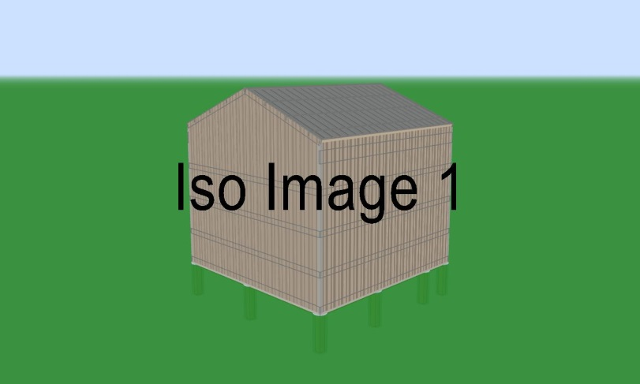
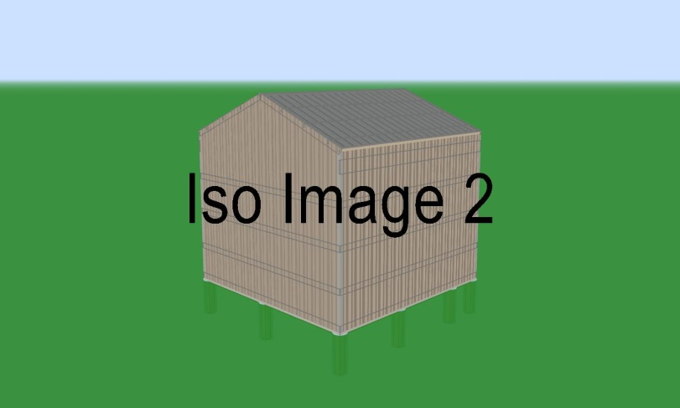
- To be built on customer’s level lot
- Customer to pull permit if needed
- 1 Year Builders Warranty

Payment Schedule as FOLLOWS:
{PaymentSchedule}

- {BuildingWidth} Pre-engineered Wood Trusses {TrussSpacing} O.C.
- {Overhang} Overhang with {SoffitMaterial}
- {FoundationStyle} {FoundationDepth}D X {FoundationWidth}W with {FoundationBase} {FoundationUplift}
- {PostMaterial} (Eaves {EaveSpacing} O.C.) (Gables {GableSpacing} O.C.)
- {TrussCarrierMaterial} {TrussCarrierStyle} Truss Carrier
- {PurlinType} {PurlinMaterial} {PurlinSpacing} O.C. Roof Purlins and {GirtMaterial}
- {GirtSpacing} O.C. Wall Girts
- {SkirtBoardMaterial} Skirtboard
SIDING AND ROOF:
- {RoofColor} {RoofSheathing} Roof
- {RidgeCapMaterial}
- {WallColor} {WallSheathing} Walls
- Wainscote Not Applied
- {TrimColor} Siding Trim
- Wall Liner Not Applied
- Ceiling Liner Not Applied
ATTACHED BUILDING DETAIL:
{AttachedBuildingList}
DOOR, WINDOW AND CUPOLA DETAIL:
{DoorWindowList}
SEE MODEL IN 3D!
{ViewerLink}

