Systematic Trading Strategies on the NSE F&O Universe
Intraday and Daily Cross-Sectional & Time-Series Strategies, with Walk-Forward Validation, Realistic Cost / Market-Impact Modelling and Capacity Analysis
Research & Methodology Report
Framework: QuantResearch.py
Capstone Project — Group 7132
June 2026

Contents
Contents 1
1. Executive Summary 1
2. Data and Universe 1
2.1 Instrument classification 1
2.2 Contracts, frequencies and features 1
2.3 Data-quality issue discovered and fixed 1
3. Framework Architecture 1
4. Strategy Library 1
4.1 Time-series strategies (per instrument) 1
4.2 Cross-sectional strategies (equity universe) 1
5. Methodology 1
5.1 Backtesting 1
5.2 Walk-forward validation 1
5.3 Performance metric suite 1
5.4 Transaction cost and market-impact model 1
5.5 Turnover controls and liquidity sizing 1
6. Results 1
6.1 Daily strategies (full universe, 15% vol target, walk-forward OOS) 1
6.2 The horizon effect 1
6.3 The frictionless illusion and cost sensitivity 1
6.4 Turnover controls 1
6.5 The alpha–liquidity conflict and liquidity-weighted sizing 1
6.6 Capacity analysis 1
7. Key Findings 1
8. Limitations 1
9. What Else Could Be Most Useful to Explore 1
9.1 Highest priority 1
9.2 Signal and regime research 1
9.3 Robustness and infrastructure 1
10. Reproducibility 1

1. Executive Summary
This report documents a complete, dependency-light research framework (QuantResearch.py) built on a two-year minute-level dataset of NSE single-stock and index futures, and the empirical conclusions it produced. The framework spans the full pipeline: ticker classification, cached data loading and resampling, a library of cross-sectional and time-series strategies, a look-ahead-safe backtester with volatility targeting and end-of-day flattening, anchored walk-forward validation, a realistic transaction-cost and market-impact model, turnover controls, liquidity-weighted sizing, a full performance-metric suite, persisted results, and capacity analysis.
The central finding is a clean horizon effect that survives scrutiny. At intraday frequencies, short-horizon cross-sectional mean reversion dominates; at the daily frequency, time-series momentum dominates and reversion loses. However, the two regimes differ enormously in implementability:
- Intraday mean reversion posts spectacular frictionless Sharpe ratios (50+ at one-minute bars) but is almost entirely an artefact of microstructure / bid-ask bounce: it turns the book over ~200,000 times a year and is annihilated by realistic transaction costs and market impact. Its realistic capacity is tiny — on the order of ₹130–160 million (~US$1.5–1.9 million).
- Daily time-series momentum earns a far more modest but believable Sharpe (~0.9 out-of-sample, net of costs), turns over only ~80–225 times a year, and remains profitable to a book size of roughly ₹100 billion (~US$1.2 billion) — about 600× the capacity of the best intraday strategy.
The practical conclusion: the genuinely deployable, scalable strategy is daily time-series momentum on index and single-name futures, while the intraday reversal edge is a high-Sharpe, very-low-capacity niche whose profitability hinges entirely on execution cost.

2. Data and Universe
The dataset is intraday (one-minute) OHLCV+OI bars for NSE futures, organised as one CSV per ticker-contract-month across 24 monthly folders spanning January 2022 to December 2023.

2.1 Instrument classification
Four symbols are index futures — BANKNIFTY, FINNIFTY, MIDCPNIFTY, NIFTY — and the remaining ~200 are single-name equity futures. TickerClassifier encodes this split and routes time-series strategies to the index universe and cross-sectional strategies to the equity universe.

2.2 Contracts, frequencies and features
- Contracts: F1 (front month, used throughout), F2, F3.
- Frequencies: native one-minute, resampled on demand to 5-minute, 15-minute, hourly, daily, weekly or monthly with correct OHLC / summed-volume / last-OI aggregation.
- Features: Open, High, Low, Close, Volume, Open Interest.

2.3 Data-quality issue discovered and fixed
The vendor files mix date conventions: most months use MM/DD/YYYY with slashes, but the August–December 2023 files use DD-MM-YYYY with dashes. A single hard-coded parser silently dropped every day after the 12th and scrambled the rest, making the history look truncated to ~10 weeks. A per-file auto-detecting parser fixed this; the corrected F1 minute series spans 2022-01-03 to 2023-12-29 — 24 months, 493 trading days, ~184,000 bars per ticker. All results in this report use the corrected data.

3. Framework Architecture
QuantResearch.py is a single, self-contained module (numpy / pandas / scipy only) exposed through a QuantLab facade. Its components:
Component | Responsibility
TickerClassifier | Index vs single-name equity classification
MarketData | Discover, load, resample OHLCV+OI; parquet caching
Strategy library | Cross-sectional & time-series signal generators
Backtester | Look-ahead-safe P&L, vol targeting, EOD flat, costs, impact, turnover controls, liquidity sizing
WalkForwardValidator | Anchored/rolling parameter optimisation, stitched OOS
performance_metrics | Full return/risk metric suite (frequency-aware)
execution_stats | Leverage, turnover, realised cost, cost drag
save_run / compare_runs | Persist & track results across runs
plot_dashboard / plot_capacity_frontier | 2×3 dashboard and capacity charts

Performance: reading ~4,900 minute CSVs and resampling the full universe takes ~80 seconds; the resampled per-ticker frames are cached to parquet, so subsequent loads take ~0.2 seconds (a ~400× speed-up). Results are persisted to timestamped folders plus an always-current latest/ snapshot and a cumulative runs_log.csv.

4. Strategy Library
Strategies are run on F1 contracts. Time-series strategies trade each instrument on its own signal and are run on both the index universe (suffix _index) and the single-name universe (suffix _ss). Cross-sectional strategies rank the equity universe and build dollar-neutral long/short books.

4.1 Time-series strategies (per instrument)
- Momentum — long if trailing return is positive (lookback tunable).
- Mean reversion — fade rolling z-score extremes.
- Seasonality — trade the sign of the expanding-mean return for the current calendar bucket (hour-of-day intraday, day-of-week daily); look-ahead-safe.
- Regime-adaptive (bonus) — switch between momentum and mean reversion based on the rolling Hurst exponent (trend if H>0.5, revert otherwise).

4.2 Cross-sectional strategies (equity universe)
- Momentum — long past winners, short past losers (top/bottom quantile, dollar-neutral).
- Mean reversion — long recent losers, short recent winners.
- Seasonality — rank names by historical mean return in the current calendar bucket.
- Residual momentum (bonus) — momentum on returns residual to a rolling regression on the equal-weight market (market-neutral).

5. Methodology

5.1 Backtesting
The backtester is vectorised and look-ahead-safe: target weights decided on bar t are lagged one bar before being applied to forward returns. Per-asset P&L is retained so it sums exactly to the portfolio return, enabling per-asset Sharpe attribution.
- Volatility targeting — weights are scaled each bar by target_vol / trailing realised vol (using only past data), so strategies run at a constant risk level and are comparable.
- Intraday EOD flattening — the book is forced flat on the last bar of each day, so no overnight gap is earned and no position is carried overnight (verified: last-bar weights are exactly zero).

5.2 Walk-forward validation
The sample is cut into consecutive out-of-sample (OOS) blocks; each strategy's parameters are optimised on the preceding in-sample window and applied to the next OOS block. The stitched OOS streams are scored as one series, giving an honest, overfit-resistant estimate. All headline numbers in this report are walk-forward OOS.

5.3 Performance metric suite
Each run reports: Sharpe, Sortino, Calmar, max drawdown, win rate, profit factor, average win / loss return, CAGR, annualised volatility, skewness and kurtosis. Annualisation is inferred from the bar spacing, so it is correct for daily and any intraday frequency. Execution columns are reported alongside: gross leverage, turnover per bar, annualised turnover, the assumed spread, the realised cost (in bps, derived from gross vs net so it captures impact), and the annualised cost drag.

5.4 Transaction cost and market-impact model
Cost per name per bar = |Δweight| × (spread_bps + impact_coef_bps × √participation) / 10,000, where participation = |Δweight| × capital / ADV_value. The linear spread is the half-spread/slippage always paid; the square-root term is Almgren-style market impact that penalises large trades in thin names. With impact disabled it reduces to a linear cost. ADV is each name's average daily traded value (price × volume).

5.5 Turnover controls and liquidity sizing
- Signal smoothing — EMA the target weights so positions move gradually.
- Rebalance throttle — act only every N bars, holding the target in between.
- No-trade band — hysteresis: only trade a name when its target drifts beyond a relative band (EOD-aware so intraday stays flat overnight).
- Turnover penalty — subtract a penalty × turnover term from the in-sample selection score, so the walk-forward chooses lower-churn parameters.
- Liquidity-weighted sizing — tilt position sizes by ADV^power, rescaling each leg to preserve gross exposure and dollar-neutrality; positive power leans toward liquid names, negative toward less-liquid names.

6. Results

6.1 Daily strategies (full universe, 15% vol target, walk-forward OOS)
Strategy | Sharpe | Calmar | MaxDD | CAGR | Vol
ts_momentum_ss | 0.93 | 1.28 | -14% | 18% | 0.20
ts_momentum_index | 0.87 | 0.84 | -18% | 15% | 0.18
xs_momentum | 0.61 | 0.73 | -11% | 8% | 0.14
xs_mean_reversion | 0.41 | 0.57 | -8% | 5% | 0.13
ts_seasonality_index | 0.32 | 0.26 | -15% | 4% | 0.16
xs_residual_momentum | -0.42 | -0.45 | -14% | -6% | 0.14
xs_seasonality | -0.94 | -0.62 | -18% | -11% | 0.12
ts_mean_reversion_index | -1.15 | -0.88 | -39% | -34% | 0.32
ts_regime_adaptive_index | -1.99 | -0.91 | -33% | -30% | 0.17
Daily momentum (time-series and cross-sectional) is profitable out-of-sample; reversion and seasonality are not.
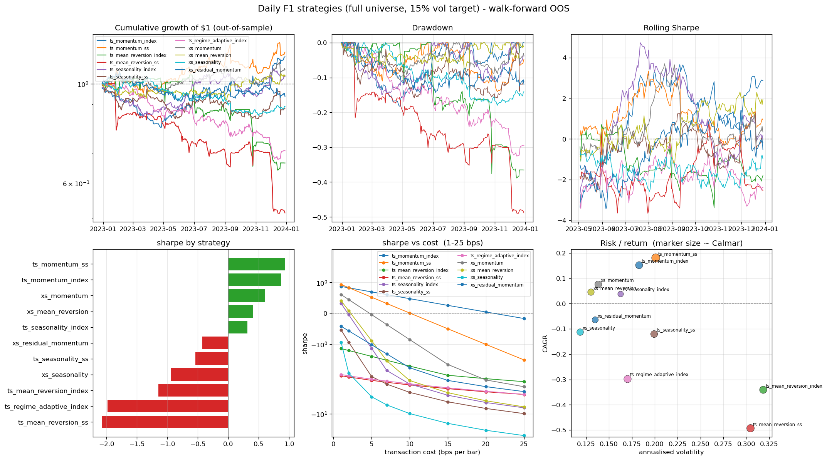
Figure 1. Daily strategy dashboard: equity curves, drawdowns, rolling Sharpe, metric bars, cost-degradation and risk/return map.

6.2 The horizon effect
Running the same library at minute frequency flips the ranking: cross-sectional mean reversion is the dominant intraday strategy, and momentum loses. This is a textbook horizon effect — short-term reversal (overreaction / microstructure) at high frequency, trend at low frequency — and its clean appearance is evidence the framework is capturing real structure rather than artefacts.
Strategy (xs_mean_reversion) | Sharpe | Ann. turnover | Realised cost
1-min, spread-only 0.5bp | 54.4 | ~212,000x | 0.50bp
15-min, spread-only 0.5bp | 3.0 | ~14,800x | 0.50bp
15-min, with sqrt impact (5% ADV) | -5.7 | ~9,400x | 1.69bp
Slowing from 1-min to 15-min strips the microstructure illusion; realistic impact then erases the residual edge.

6.3 The frictionless illusion and cost sensitivity
At one-minute bars the intraday reversal edge is enormous gross but rebalances essentially the entire book every minute (~212,000 turns/year, ~1,060%/year cost drag at 0.5bp). Persisting a Sharpe-vs-cost ladder for every run makes this explicit: the strategy's break-even cost is below ~1bp, far under any realistic all-in cost. The high Sharpe is mostly bid-ask bounce, not tradeable alpha.

6.4 Turnover controls
Applied to intraday xs_mean_reversion, the controls cut turnover sharply but at a roughly one-for-one Sharpe cost, because the alpha itself lives at the high-frequency horizon. Smoothing and throttling are the effective levers; the no-trade band barely helps a fully-rotating basket. The walk-forward turnover penalty also helps: penalising turnover shifts parameter selection to a longer lookback (e.g. 2→10), cutting turnover ~50% for a ~20% Sharpe give-up.

6.5 The alpha–liquidity conflict and liquidity-weighted sizing
Mapping intraday xs_mean_reversion by liquidity quartile shows the alpha is monotonically concentrated in less-liquid names (spread-only Sharpe: most-liquid quartile -2.0 → least-liquid +12.2), while impact cost rises as liquidity falls. The two implementability levers therefore conflict: restricting to the most liquid names removes the alpha. Liquidity-weighted sizing confirms this — at a small book, a mild tilt toward less-liquid names (power = -0.5) maximises OOS Sharpe (3.3 vs 2.0 equal-weight), the opposite of the usual instinct. The decisive lever is trading a smaller book, not trading more liquid names.

6.6 Capacity analysis
Capacity is defined as the book size at which impact-aware OOS Sharpe crosses zero, found by sweeping book size with the impact model.

Intraday xs_mean_reversion (5-min vs 15-min)
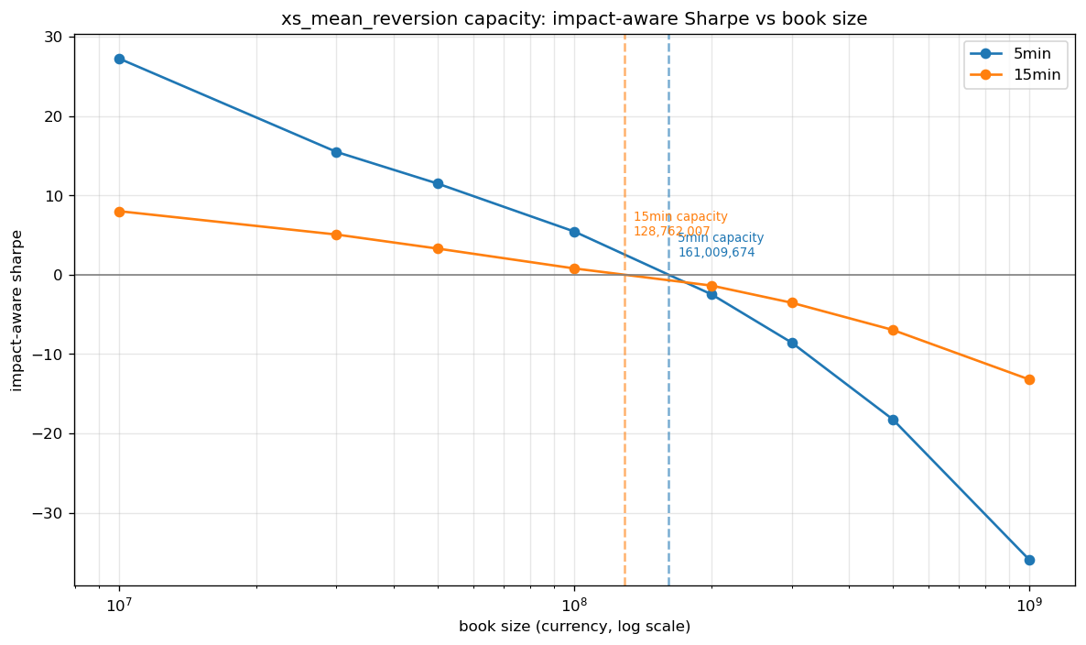
Figure 2. Intraday capacity frontier. 5-min has higher small-book Sharpe but decays faster; curves cross in the capacity zone.
Bar size | Sharpe @ small book | Capacity (INR) | % of median ADV
5-min | ~27 @ ₹10M | ~₹161M | 7.8%
15-min | ~8 @ ₹10M | ~₹129M | 6.2%
Both intraday capacities are tiny (~₹130–160M, ~US$1.5–1.9M).

Daily momentum strategies
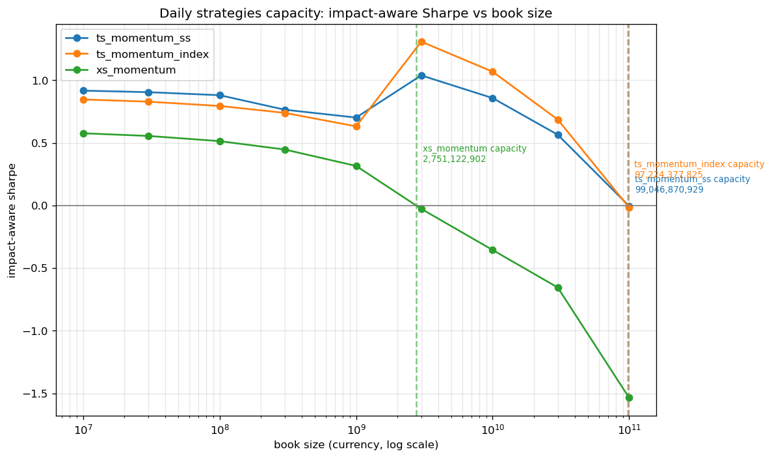
Figure 3. Daily capacity frontier. Sharpe is flat from ₹10M to ~₹1bn because daily turnover makes impact negligible until very large books.
Strategy | Ann. turnover | Capacity (INR) | ≈ USD
ts_momentum_ss | ~205x | ~₹99bn | ~$1.2bn
ts_momentum_index | ~80x | ~₹97bn | ~$1.2bn
xs_momentum | ~225x | ~₹2.75bn | ~$33M
Daily momentum has ~600× the capacity of the best intraday strategy.

7. Key Findings
- Horizon effect is real and clean: reversal wins intraday, momentum wins daily — consistent with overreaction at short horizons and trend at longer horizons.
- Frictionless Sharpe is dangerously misleading intraday: the one-minute reversal Sharpe of ~54 is mostly bid-ask bounce; honest accounting (impact + capacity) is essential.
- Costs, not signals, are the binding constraint intraday: break-even cost is sub-1bp and realistic impact pushes every intraday strategy negative at meaningful size.
- Alpha and liquidity conflict for reversal: the edge lives in less-liquid names, so 'trade only liquid names' destroys it; 'trade smaller' is the lever that works.
- Daily time-series momentum is the implementable winner: modest but believable OOS Sharpe (~0.9), low turnover, and capacity ~₹100bn — roughly 600× the intraday reversal.
- Walk-forward + impact-aware selection self-regularises: when impact bites, the optimiser automatically picks lower-turnover parameters.

8. Limitations
- Two-year sample (2022–2023). A single, fairly trending macro regime; results may not generalise across bull/bear/sideways regimes. No out-of-period (e.g. 2024+) test.
- Idealised execution. Fills are assumed at the bar close; the impact model is a parametric square-root law with assumed coefficients, not calibrated to realised fills. No modelling of queue position, partial fills, adverse selection, latency, or borrow/short availability.
- ADV proxy. Average daily traded value is computed as price × futures volume without lot-size/multiplier normalisation, so participation and absolute capacity figures are approximate (relative comparisons are robust).
- Futures-specific frictions omitted. Roll costs, expiry effects, margin, financing and contract-switching between F1 and the next front month are not modelled; F1 is treated as a continuous series.
- No portfolio-level construction. Strategies are evaluated individually; there is no multi-strategy combination, correlation-aware allocation, or risk-budgeting across signals.
- Simple signals and grids. Each strategy uses one or two parameters over coarse grids; no feature engineering, ensembling, or machine-learning models, and no formal multiple-testing / data-snooping correction.
- Costs assumed symmetric and static. Spread and impact coefficients are constant across names and time, rather than time-varying with volatility or order-book depth.
- Survivorship / universe drift. The universe is taken as the available files; additions, deletions and ban-period exclusions of single-stock futures are not explicitly handled.

9. What Else Could Be Most Useful to Explore

9.1 Highest priority
- Out-of-sample period test (2024+). Re-run the committed daily momentum configuration on fresh data to confirm the edge persists out of the development sample.
- Multi-strategy portfolio. Combine daily ts_momentum (index + single-name) and xs_momentum into one risk-weighted, correlation-aware book and report its impact-aware metrics and capacity — likely the most deployable end product.
- Execution realism. Model fills at next-bar open (or VWAP over a participation schedule), calibrate the impact coefficient to realised slippage, and add a participation cap (e.g. ≤5–10% of ADV) — turning capacity from an estimate into a constraint.

9.2 Signal and regime research
- Regime overlay (the project's original thesis): use the Hurst / volatility regime to switch the whole book between daily momentum and intraday reversion, rather than running each standalone.
- Better intraday alpha: test whether intraday reversion has a longer-horizon, lower-turnover form (e.g. open-to-close overreaction, or signals refreshed a few times per day) that survives impact at larger size.
- Volatility / OI features: the loader already provides Open Interest and volume; OI changes and volume spikes are natural conditioning variables left unused here.
- Cross-frequency blends: daily momentum core with a small intraday reversion satellite sized to its low capacity.

9.3 Robustness and infrastructure
- Parameter-stability and deflated-Sharpe analysis to guard against the coarse-grid overfitting risk.
- Transaction-cost sensitivity as a first-class deliverable per strategy (already persisted) used as a go/no-go gate against measured live costs.
- Walk-forward with rolling (not just anchored) windows and more splits, to test stationarity of the chosen parameters.
- F2/F3 and roll-aware continuous series to study term-structure and reduce expiry noise.

10. Reproducibility
All results are persisted under results/latest/ as committed snapshots, each containing metrics.csv, asset_sharpe.csv (per-name Sharpe), cost_sensitivity.csv (Sharpe vs cost ladder), returns/gross_returns parquet, and meta.json (full run config including cost, impact, turnover and liquidity settings):
- daily/ — full-universe daily strategies (11).
- intraday/ and intraday15/ — 1-minute and 15-minute intraday strategies.
- intraday_lowturn/, intraday_realistic/ — turnover-controlled and impact-aware intraday runs.
- xs_mr_15m_best/ — best implementable intraday reversal config (15-min, small book, liquidity tilt).
- capacity/ and capacity_daily/ — capacity-frontier curves and charts.
Typical usage: lab = QuantLab("Data", target_vol=0.15); lab.load(frequency="daily"); res = lab.run_all(); lab.report(res); lab.plot(res); lab.save(res). Capacity: lab.capacity_frontier("ts_momentum", universe="index").

