Journal of Fluids Engineering – FE-20-1665 – Reply
We thank the editor for handling the manuscript and the reviewers for careful reading of the manuscript and constructive suggestions.

We hope that our arguments will be strong enough to finalize the revision of our paper.
Best regards.

Reviewer 1
Comment #1- fig 3: The authors find a linear regime for voltage values below 15V but the general shape is exponential and linear approximations can be obtained whatever the voltage. ? Could the authors say a little bit more about this comment and specify the underlying mechanism if there is.
Answer: The following text as been added to the manuscript (in bold): The transition between linear and non linear regimes is depicted by the change in breakup length slope and these regimes are predicted by the so-called linear and non-linear theories, respectively. A quasi-linear regime is thus observed for low amplitude stimulation (lower than 15V) and is in agreement with previous observations on drop shapes. As predicted by the theory, the breakup length decreases with the amplitude and seems to reach a minimum length for 62V and although the breakup lengths present an exponential decay, the regime below 15V will then be referred as linear regime hereafter.

Figure 3 has also been redrawn with a log x-axis to give a better insight:
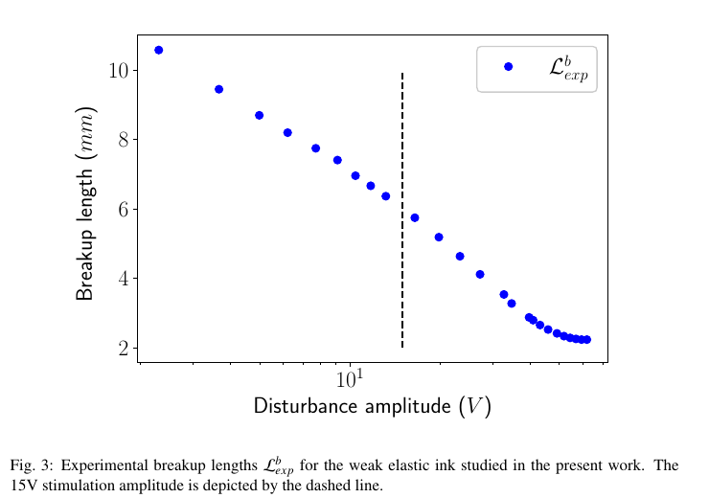

Comment #2 : page 4 : Zimm's regime excludes interactions from entanglement between chains. Did the authors have tried to make measurements of complex dynamic moduli to check this hypothesis rather than steady shear viscosity (fig 4) ?
Answer: Very few devices are able to achieve shear rate and despite a large number of rheological devices at our disposal at the Laboratoire Rhéologie et Procédés, none are able of such measurement. Moreover, if we trust the so call Cox-Merz rule, dynamical measurements should be done for frequencies up to 10⁶rad/s. This last could be done, eventually done, by a time-temperature superposition, that is often encountered for polymer melt solutions, but which seems to be quite unachievable for solutions with a viscosity as low as our. A measure of G’, G’’ of a low viscous fluid with a rheometer which have a minimum torque of 1 to 5 nN.m is a real challenge due to : the inertia of the fluid, the inertia of the oscillating tool and to the surface tension effects.
Comment #3 : Figure 12 : it is quite surprising that the velocity profile for a Newtonian fluid is not parabolic ? please, could the authors comment ?
Answer: As stated in [1], the laminar development length L in a pipe is

with D the diameter of the pipe. In the present case and thus the nozzle is too short to achieve a full development of the velocity with a parabolic profile.

[1] Durst, F., Ray, S., Ünsal, B., & Bayoumi, O. A. (2005). The development lengths of laminar pipe and channel flows.
Comment #4 – table 2 : Are the two decimals (1128,88 kg/m3) on the density of the liquid significant?
Answer: The density has been measured using an Anton Paar DMA4500M which has a precision of 0,000005 g/cm³, i.e. 0,005 kg/m³.
Comment #5 – page 4. spelling error : The unit of absolute temperature is K not °K !
Answer: Corrected
Comment #6 – page 7 :three sentences below the title of section 3.2, a reference to a section is missing " ….to jet the weakly elastic ink in section ??. the density ....". Same issue, page 8 at the beginning of section 4. please correct
Answer: Corrected
Comment #7 – page 9 : spelling error : bottom of the page, the tested relaxation times tau_e are the same (0.75) instead of 0.75 and 0.85. please correct
Answer: Corrected

Reviewer 2: The present study deals with the determination of the relaxation time of a weakly elastic fluid. An original approach is proposed: it is based on the comparison of both capillary breakup length and shapes between numerical simulations and experiments. However, as it is explained by the authors, the accuracy of this procedure depends strongly on the accuracy in the measurements of the surface tension, the solvent and polymer viscosities, the radius of the jet. It would have been interesting to discuss in more details this issue.

Answer: The solvent and polymer viscosities have been added to the manuscript. As for the geometry, the following sentence and image has been added: “Although the nozzle geometry is a property of Markem-Imaje© and can not be disclosed, a complete study of its geometry was carried out using a SEM (see Fig. 11) to get its exact dimensions.”

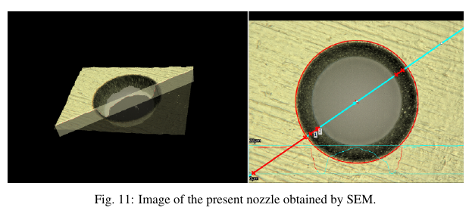

Reviewer 2: The numerical simulation was done using OpenFoam code and the rheological behavior of the fluid is described by the Oldroyd B model. 2D axisymmetric situation is considered. Governing equations and boundary conditions at the inlet and outlet of the domain should be be written.
Answer: Governing equations and boundary conditions have been added

Reviewer 2: Details about the numerical scheme, the mesh grid should be added. A first estimation of the relaxation time is given by Zimm’s theory, which turns out to be a good approximation. The authors should also discuss the influence of the relaxation time on the growth rate of the perturbation.
Answer: The influence of the relaxation time on the growth rate has been widely discussed in [2]. Brenn et al. derived the dispersion curve for an axisymmetric viscoelastic jet using the corotational Oldroyd model as the constitutive equation. Moreover, Keshavarz et al. compared in [3] experimental results of an Oldroyd-B to the model from [2] and showed an excellent agreement (see Fig. 8 in [3]). By comparing their results to the dispersion curve of a Newtonian fluid they also illustrated that the viscoelasticity increased the growth rate. In the present work, the measurement error of the growth rate is higher than the expected influence on the growth rate due to the very low relaxation time.

[2] G. Brenn, Z.B. Liu, F. Durst, Linear analysis of the temporal instability of axisymmetrical non-Newtonian liquid jets, Int. J. Multiph. Flow 26 (10) (2000) 1621–1644.
[3] Keshavarz, B., Sharma, V., Houze, E. C., Koerner, M. R., Moore, J. R., Cotts, P. M., Threlfall Holmes, P., and McKinley, G. H., 2015. “Studying the effects of elongational properties on atomization of weakly viscoelastic solutions using rayleigh ohnesorge jetting extensional rheometry (rojer)”. Journal of Non-Newtonian Fluid Mechanics, 222, pp. 171–189.

