Development of an Online Library Inventory Management System for Maharlika National High School Library Using the Agile Model

A Capstone presented to the
Faculty and Staff of College of Computer Education
Andres Soriano Colleges of Bislig
Mangagoy, Bislig City

In Partial Fulfillment of the
Academic Requirements for the Degree of
Bachelor of Science in Information Technology

Ely Gian A. Ga
Junel M. Sotil
Jems B. Sinday
Mary Jean F. Borja
Sansim I. Basañez

November 2, 2025

APPROVAL SHEET
This thesis is entitled, " DEVELOPMENT OF AN ONLINE LIBRARY INVENTORY MANAGEMENT SYSTEM FOR MAHARLIKA NATIONAL HIGH SCHOOL LIBRARY USING THE AGILE MODEL " has been prepared and submitted by Junel M. Sotil, Ely Gian A. Ga, Jems B. Sinday, Mary Jean F. Borja and Sansim Basañez in partial fulfillment for the degree of Bachelor of Science in Information Technology and Bachelor of Science in Computer Science has been examined and recommended for acceptance and approval for Oral Defense

MR. RONALD N. SURITA
Thesis Adviser

Thesis Committee
GENDA C. NECIO DBM-IS
Chairman

ANREY G. ANTIQUINA, PhD JOEL MILLER GO
Member Member
_____________________________________________________________________
Panel of Examiners
APPROVED by the dissertation committee on oral examination with a grade of
Thesis committee
GENDA C. NECIO DBM-IS
Chairman

ANREY G. ANTIQUINA, PhD JOEL MILLER GO
Member Member
ACCEPTED and APPROVED in partial fulfillment of the requirements for the degree of Bachelor of Science in Information Technology.
Comprehensive Examination.

GENDA C. NECIO DBM-IS
Dean CCE
ACKNOWLEDGEMENTS
We would like to extend my deepest appreciation to all individuals who supported and contributed to the completion of the capstone project, "DEVELOPMENT OF AN ONLINE LIBRARY INVENTORY MANAGEMENT SYSTEM FOR MAHARLIKA NATIONAL HIGH SCHOOL LIBRARY USING THE AGILE MODEL." Above all, we thank our Lord God for His unwavering guidance, strength, and blessings throughout the research process.
Foremost, we express our heartfelt gratitude to MR. RONALD N. SURITA, The group esteemed project adviser, for his invaluable guidance, mentorship, and unwavering support throughout this endeavor. His expertise and encouragement significantly influenced the design and refinement of this project.
We extend a special thanks to our family for their enduring love, understanding, and encouragement, which served as a source of motivation during challenging times.
Lastly, we sincerely appreciate all users and stakeholders who participated in the testing and evaluation phases. Their invaluable insights and feedback played a pivotal role in enhancing the functionality and usability of the “DEVELOPMENT OF AN ONLINE LIBRARY INVENTORY MANAGEMENT SYSTEM FOR MAHARLIKA NATIONAL HIGH SCHOOL LIBRARY USING THE AGILE MODEL.”
All glory and honor belong to God. Thank you all for your contributions.

DEDICATION
This study is wholeheartedly dedicated to our beloved parents, who have been our source of inspiration and strengthened us when we thought of giving up, who continually provide their moral, spiritual, emotional, and financial support.
To our brothers, sisters, relatives, mentors, friends, and classmates who shared their advice and encouragement to finish this study.
And lastly, we dedicated this book to the Almighty God, thank you for the guidance, strength, power of mind, protection, and skills and for giving us a healthy life. All of these, we offer to you.

ABSTRACT
The “Development of an Online Library Inventory Management System for Maharlika National High School Library Using the Agile Model” is designed to enhance the efficiency of library operations by automating inventory Monitoring, book borrowing, and return processes. The system replaces traditional manual record-keeping methods with a digital solution that ensures real-time data accuracy and improved user accessibility.
The system follows a web-based architecture, allowing librarians and students to interact seamlessly through an intuitive user interface. It integrates real-time inventory updates, reducing errors in book Monitoring and minimizing administrative workload. Key features include bulk book imports and exports via Excel, automated transaction logging, and a role-based access system to ensure security and efficiency in managing library resources.
The backend is developed using PHP (MySQL) to ensure data integrity and security, while the frontend utilizes HTML, CSS, JavaScript, Bootstrap, and AdminLTE for an optimized user experience. Real-time notifications keep users informed about book availability and due dates, improving transaction transparency.

Testing and evaluation demonstrate significant improvements in library management efficiency, with reduced processing times for book transactions and enhanced accuracy in record-keeping. User feedback indicates high satisfaction with the system’s usability and reliability, affirming its potential as a scalable solution for digital library management.

In conclusion, this project highlights the application of modern web technologies in library operations, promoting a more structured, user-friendly, and efficient approach to managing book inventory and transactions. The system serves as a model for future enhancements in school-based digital resource management.

TABLE OF CONTENTS
Approval Sheet |  |  | ii
Acknowledgment |  |  | iii
Dedication |  |  | iv
Abstract |  |  | v
List of Tables |  |  | ix
List of Figures |  |  | x
Chapter 1 – INTRODUCTION |  |  | 1
 | Background of the Study |  | 1
 | Objectives |  | 3
 | Documentation of Existing and Seriousness of the Problem |  | 5
 | Scope and Delimitation |  | 8
 | Feasibility Analysis |  | 10
 | Review of Related Literature |  | 17
Chapter 2 - METHODOLOGY |  |  | 24
 | Conceptual Design |  | 24
 |  | System Architecture | 24
 | Process and Data Models |  | 33
 | Entity Relationship (ER) Diagram |  | 34
 | Software Development (SDLC) Model |  | 39
 | Methods |  | 42
 |  | Requirements Gathering and Analysis | 45
 |  | Access Level Analysis | 46
 |  | System Test Plan | 57
 |  | Gantt Chart | 59
 | System Requirements |  | 61
 |  | Functional Requirements of the System | 61
 |  | Non-Functional Requirements | 65
 | Technologies Used |  | 67
 | Production of Prototype and Testing |  | 68
 | Analysis of Assessment Data |  | 70
 | Ethical Considerations |  | 71
 | Deployment and Monitoring |  | 73
Chapter 3 – RESULTS AND DISCUSSION |  |  | 75
Chapter 4 – SUMMARY, CONCLUSION, AND RECOMMENDATIONS |  |  | 97
 | Summary |  | 97
 | Conclusion |  | 98
 | Recommendations |  | 99

REFERENCES 100

APPENDICES 103
Appendixes A Letter Request 104
Appendixes B Survey Questionnaire 105

CURRICULUM VITAE 113

LIST OF TABLES
Table 2.1 | Requirements Gathering and Analysis Overview | 45
Table 2.2 | Testing Plan | 55
Table 2.3 | Interpretation of Ratings | 56
Table 2.4 | Functional Requirements for Principal | 61
Table 2.5  Table 2.6  Table 3.1  Table 3.2  Table 3.3  Table 3.4  Table 3.5  Table 3.6  Table 3.7  Table 3.8  Table 3.9  Table 3.10  Table 3.11  Table 3.12  Table 3.13 | Functional Requirements for Librarian  Function Requirements for Students  Perceived Usefulness (PU)  Perceived Ease of Use (PEU)  Behavioral Intention to Use (BI)  Attitude Toward Using (ATU)  Self-Efficacy (SE)  Perceived System Performance (PSP)  Summary of extended technology acceptance  Testing  System Usability Indicators  Facilities and Resources  Student Support Service  Realtime Generating Report  PHP Unit framework for PHP test | 63  64  80  81  82  82  83  84  85  86  88  91  92  93  94

CHAPTER I
INTRODUCTION
BACKGROUND OF THE STUDY
Maharlika National High School aims to cultivate an environment where students can learn, adapt, and thrive through meaningful educational experiences. The school library plays a critical role in supporting this mission by providing resources necessary for advanced study and research. However, the management of library operations, particularly book borrowing, returning, and inventory updates, has become a growing challenge due to reliance on outdated and labor-intensive processes.
The library currently uses manual methods to record book transactions and manage inventory. Borrowed and returned books are tracked on paper, and newly acquired books are counted and manually added to digital records. These processes often lead to inefficiencies, such as delays in data entry, increased workloads for librarians, and the risk of errors in recording transactions. When books arrive in bulk to meet educational requirements, the time and effort required to update the records significantly hinder workflow, causing delays in making resources available to students.
PURPOSE, DESCRIPTION AND SIGNIFICANCE
The primary purpose of the project is to develop a faster and more efficient method of managing library resources by applying modern technology through a web-based application. It aims to simplify the process of recording, monitoring, and updating the library’s book inventory while ensuring that data remains accurate and easily accessible. The system seeks to assist the librarian and the principal in maintaining reliable records that support effective decision-making regarding book management and library operations.
The project involves the development of a Online Inventory Management System designed to replace the library’s traditional manual process with a digital, automated approach. The system will allow real-time update of book availability, reservations, and transactions. It is divided into three main modules—Principal Module, Librarian Module, and Student Module—each with specific functions that collectively contribute to the smooth operation of the library. The Principal Module enables administrative oversight, the Librarian Module manages book records and transactions, and the Student Module allows users to view, search, and reserve available books.

The implementation of this project is significant as it provides a modernized and systematic approach to library management. By automating inventory and transaction processes, it reduces human error, improves efficiency, and enhances accessibility for users. The system will not only help the librarian manage resources more effectively but also provide the principal with accurate data for administrative evaluation and decision-making. Ultimately, it contributes to the school’s goal of adopting technology-driven solutions that improve educational services and resource management.

OBJECTIVES OF THE STUDY
This study aims to develop a Web-Based Library Inventory Management System for Maharlika National High School that streamlines book borrowing, returning, and inventory management, ensuring efficiency, accuracy, and ease of use for librarians and students.
To address the challenges caused by manual processing and paper-based records, which hinder workflow and increase the risk of human error in which could lead to multiple problems and inaccurate record of data. That will pile with the previous problem.
The specific objectives are as follows:
- To streamline borrowing and returning processes Develop a system that records book transactions in real time, minimizing delays and reducing manual errors.
- To automate bulk book imports and exports Implement functionality for importing large volumes of book data using Excel files, eliminating manual data entry during mass book arrivals. Enable data export to Excel for printing and offline use.
- To integrate QR code functionality Generate QR codes for student borrowing transactions and enable scanning for faster, more accurate book returns.
- To provide accurate and up-to-date inventory records Ensure real-time updates to the inventory database, improving data accuracy and accessibility for informed decision-making.
- To improve the efficiency of library operations. Reduce the time and effort required for librarians to manage book inventories, allowing them to focus on other essential tasks.
- To enhance user experience for students, librarians, and the principal Provide a user-friendly interface that simplifies searching for and accessing library resources.
- To utilize the Agile model for system development. Employ an iterative development process to ensure the system adapts to evolving user needs throughout the project lifecycle.

DOCUMENTATION OF EXISTING AND SERIOUSNESS OF THE PROBLEM
Main Problem

- Inefficient management of Book
- Time consuming process
- Prone to error
- Lack of real time Monitoring

Contributing Factors
- Reliance of Manual Operation/Process
- Lack of Automation
- Fragmented Record-keeping
- Limited access to real-time data

Figure 1.1 Driving Factors in Maharlika National Highschool (MNHS) and Proposed Solutions
The Figure above illustrates the key issues faced by Maharlika National High School’s library in managing resources, including the reliance on manual systems for Monitoring borrowed and returned books and updating inventory records. These manual processes are time-consuming, prone to errors, and lack real-time data monitoring.
The contributing factors to these problems are the heavy reliance on paper-based records, the absence of automation in Monitoring transactions and managing inventory, fragmented record-keeping processes, and limited access to real-time data. These factors exacerbate inefficiencies and contribute to the difficulties in managing library resources. Resulting in increased administrative workload for librarians, and disruptions in the overall library workflow. These challenges result in reduced accessibility for students and faculty, negatively impacting their experience and hindering effective resource management.
These challenges collectively result in increased workload for librarians, who must manually manage book transactions and inventory updates, often under time constraints. The inefficiencies caused by outdated processes disrupt the overall library workflow, leading to delays and inconsistencies in resource availability. As a consequence, students and faculty experience reduced accessibility to library materials, which hinders their ability to engage in timely research and academic activities.
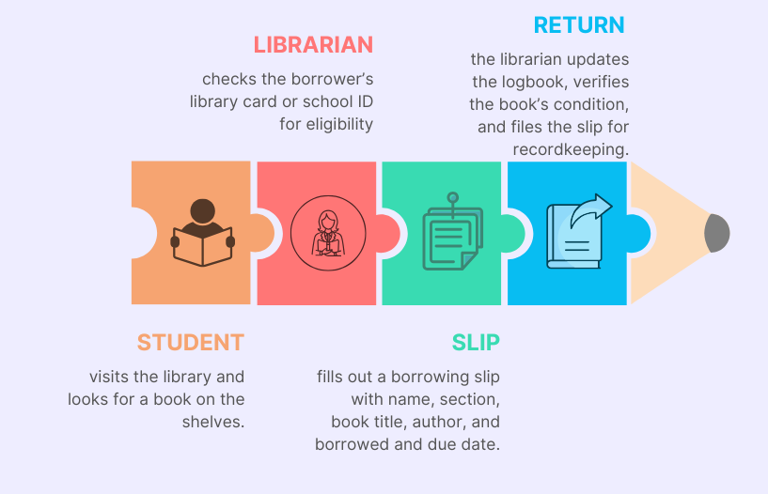
Figure 1.2 Existing Process for Borrowing, updating record and returning Books from the Library
Existing Process for Borrowing, Updating Record, and Returning Books from the Library
This figure illustrates the current manual process followed in the library for borrowing and returning books. The process begins when the student visits the library and selects a book to borrow. The librarian verifies the borrower’s eligibility through a library card or school identification and records the transaction using a borrowing slip containing book details, borrower information, and due dates. Upon return, the librarian checks the book’s condition, updates the record log, and files the slip for proper documentation and accountability.

SCOPE AND DELIMITATION
SCOPE
To address the growing need for efficient library operations at Maharlika National High School, this study proposes the development of a Web-Based Book Library Inventory Management System. The system is designed to streamline book transactions, improve data accuracy, and enhance overall library management. It will primarily serve the Librarian, Principal, and Students, offering a user-friendly interface and automation features tailored to the school's needs.
Core Features of the System
- Bulk Book Data Import
  - Upload book records via Excel file for faster inventory setup
- QR Code Scanning
  - Scan QR codes to process single or multiple book returns efficiently
  - Reduce manual entry and minimize errors
- Excel Export Functionality
  - Export book inventory and transaction logs as downloadable Excel files
- User Role Management
  - Librarian and Principal have administrative access to manage the system
  - Students can view available books and borrowing status
- School-Specific Implementation
  - System tailored exclusively for Maharlika National High School
- Efficiency and Accuracy Focus
  - Automates repetitive tasks to reduce human error and improve work flow

DELIMITATIONS
This study will not include the management of other resources outside of the library's book collection. The system will be web-based only. The scope is specifically limited to Maharlika National High School, and the system will not be designed for use by other schools or institutions. Furthermore, the system will only cater to the library’s primary users: The system will not integrate with other existing school systems, such as student or administrative records, unless further development phases address such integration.

FEASIBILITY ANALYSIS
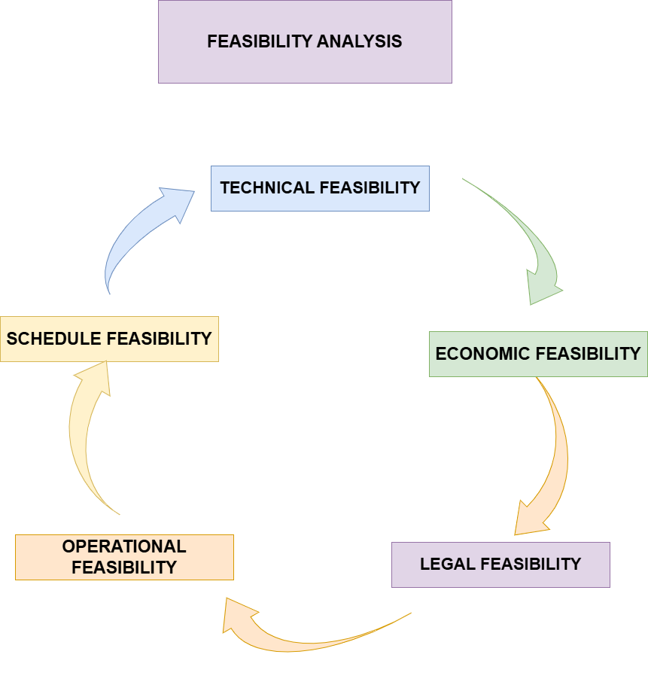

Figure 1.3 Feasibility Analysis of the development of an online library inventory management system for maharlika national high school.
1. Technical Feasibility
The proposed system will be developed using reliable and proven technologies, such as PHP, MySQL, HTML5, CSS3, JavaScript, and Bootstrap. The system will be web-based, ensuring easy access for users via standard web browsers and minimizing the need for complex installations. MySQL will be used to manage data, allowing for real-time updates and accurate Monitoring of borrowed and returned books, as well as inventory management. The system's architecture and design will ensure smooth integration, scalability, and long-term usability.

2. Economic Feasibility
Initial Development Cost: The development of the library management system will be free, as it leverages open-source tools and technologies (PHP, MySQL). The primary cost will involve only hosting and testing.
Operational Cost: There will be ongoing costs for server hosting and system maintenance. However, these costs are expected to remain relatively low due to the affordable hosting services.
Return on Investment (ROI): The system is expected to generate significant ROI over time by reducing the amount of manual labor required for Monitoring books, increasing efficiency in library operations, and providing better service to students and faculty. The automation of processes like book transactions and inventory updates will save both time and resources.
3. Legal and Ethical Feasibility
Data Privacy: The system will comply with applicable data privacy regulations (such as GDPR or local data protection laws). Personal data, including student information, will be securely stored and only accessible by authorized users.
Copyright Issues: The system will ensure that copyrighted materials are handled appropriately. It will not store or distribute copyrighted books without proper authorization from the relevant parties.

4. Operational Feasibility
The system will be designed to be user-friendly, with minimal training required for library staff and students. It will automate the current manual processes, such as book Monitoring and inventory updates, improving the overall efficiency of the library’s operations. The system will be scalable, allowing for future growth, such as adding more books or accommodating more users. It will improve workflow and make it easier for staff to manage resources.
5. Schedule Feasibility
The development of the system will be carried out in three key phases:
Phase 1: Requirement gathering, system design, and initial development. This phase will focus on finalizing the project scope and defining all functional requirements.
Phase 2: Implementation, integration, and testing. During this phase, the system will be built, integrated with MySQL, and thoroughly tested for functionality, usability, and performance.
Phase 3: Deployment, user test, and final refinements. Once the system is deployed, librarians and students will be trained on how to use it effectively.

Conceptual framework

Student information (name, year, section)
Book details (title, author, stock, source)
QR codes for borrowing/returning
Excel files for bulk book import
User roles (Admin, Librarian, Student)

INPUT
OUTPUT

Accurate and updated book inventory
Downloadable Excel reports
Transaction history per user
Improved workflow and reduced manual errors
Enhanced decision-making for Principal and Librarian
Scalable system ready for future enhancements

PROCESS

Real-time monitoring of borrowed and returned books
QR code scanning for fast book returns
Bulk import/export of book data via Excel
Role-based access control (Admin, Librarian, Student)
Inventory updates and transaction logging
Dashboard analytics and report generation
Notifications via MQTT for status update

Figure 1.4 Input Process Output (IPO) Diagram

The Input-Process-Output (IPO) model for understanding how systems or processes work. The IPO model breaks down the system into three distinct stages—Input, Process, and Output—which helps in identifying the flow of data and actions within the system.

Input
The input phase refers to the resources, tools, and requirements that are necessary to start the process. In this study, the inputs include:
- Current Resource Management Practices: These involve manual methods of Monitoring and managing resources, which are inefficient and prone to human error.
- Technological Tools and Platforms: Technologies such as PHP for backend scripting, MySQL for database management, and web-based platforms are integrated to develop the system.
- System Requirements: These are the conditions needed for the system to work effectively, including the existing infrastructure at Maharlika National High School.

Process
The process phase is where the system’s functions take place:
- System Design & Development: Automating inventory management tasks like monitoring borrowed/returned resources, minimizing errors.
- User Interface (UI) and Accessibility: Ensuring the system is intuitive, easy to use, and accessible on both PCs and mobile devices, allowing users to interact with minimal technical expertise.
- Real-Time Inventory Monitoring: Automatically updating inventory data as materials are borrowed or returned, ensuring accuracy and timeliness.
- Import/Export Data: The system will enable seamless data transfer with Excel, allowing for easy reporting and record-keeping.
- QR Code Generator (Student): Students generate QR codes representing their borrowing transactions.
- QR Code Scanner (Librarian): Librarians scan QR codes to return books, ensuring fast and accurate recording.

Output
The output phase represents the outcomes and results that arise from the system:
- Increased Efficiency and Accuracy: The system reduces manual data entry and enhances inventory management.
- Real-Time Information for Decision-Making: The system will provide staff with up-to-date information on resource availability, supporting better decision-making.
- Scalability and Cost-Efficiency: The system is designed to grow and adapt, supporting future expansions and potential use in other schools.

REVIEW OF RELATED LITERATURE
LOCAL
ibrary Management System of Baguio City National Science High School
Automated Library management system is a very efficient software to use by the librarian in managing school library in Baguio City National Science High School. Since the Library management system is not present in school library of Baguio City National Science School. The researchers aims to create the Library management system for the Librarian, students and teachers. The researchers aims to evaluate the effectiveness of the Library management system through the following criteria: security, acceptability of GUI and functionality. The findings of the study implies that the library management system is slightly effective for the use of managing the library of the school. The system is slightly effective because the findings of the study has shown that the level of efficiency in terms of security and GUI has reached the qualified level which is the third and fourth level of their respective likert scale. It is also slightly effective in terms of functionality since the some of the functions of the system is encountering some errors. The researchers recommend for more improvement and expansion of the Library management system so that the system will reach its full potential and it will be effective for the usage of managing the library of the school
Angway, Timothy Jue, Lictao, Reivuhrn Andrie, Magmoyao, Arlene, Tacdoy, Revelation
.https://www.researchgate.net/publication/356219314_Automated_library_management_system_for_public_libraries_in_the_Philippines
Development of Southern Luzon State University Digital Library of Theses and Dissertation
The project developed a digital library of theses and dissertations that would help students, faculty, and researchers of Southern Luzon State University in doing their library work without going to the physical location. Agile Model, a practice-based methodology for effective modeling and documentation of software-based systems was utilized in developing the system. MARC is used in proper cataloguing and XML for sharing information in some catalogues of the theses and dissertations. After project development, it was evaluated and tested by different users – the librarian, researchers and students – based on ISO 25010 software quality standards. The evaluation showed that the users strongly agreed on the system’s usability. However, it is recommended that for hosting a better hardware specification, two (2) CPUs with the speed of 3.8GHz and a minimum of 2048MB of Random Access Memory based on numbers of 8,000 accounts equivalent to 17,000 articles with one terabyte of hard disk drive capacity for storing the database and the theses and dissertation must be used.
Development of Southern Luzon State University Digital Library of Theses and Dissertation
Reynaldo V. Danganan
(99+) Development of Southern Luzon State University Digital Library of Theses and Dissertation.com

Library Systems Development: Utilization, Usability and Impact for Private Schools in Negros Occidental, Philippines
Abstract: This study delves into the development, utilization, and evaluation of a Library Management System (LMS) in private schools within Negros Occidental, Philippines. Recognizing the inefficiencies of traditional manual library systems, a web-based LMS was designed and deployed at Colegio de Sta. Ana de Victorias (CSAV). The system was developed to automate library tasks, optimize information retrieval, and improve overall library operation. The research thoroughly assessed the system's usability through users testing and feedback, and evaluated its impact on library operations, users’ satisfaction, and academic performance. By gathering both quantitative and qualitative data, this study provides a clear understanding of the practical application of LMS in a real-world educational setting. Findings indicate that the LMS significantly improved library functions, reduced processing time, and enhanced accuracy. Librarians reported increased efficiency and more time for user interaction. Students and faculty derive benefit from improved access to library resources and instantaneous retrieval of information. Despite this, implementation challenges to a new method such as resistance to change, technical issues, and inadequate training were identified. The study concludes that the development and implementation of the LMS at CSAV demonstrates the potential of library automation to enhance library services in private schools. This research contributes to the growing body of knowledge on library system
Stephanie L. Lampaza, Mary Joy P. Parrenas, Angele D. Suarez, Kristine T. Soberano

https://ijcsmc.com/docs/papers/January2025/V14I1202503.pdf?utm_source=chatgpt.com

FOREIGN
Developing an integrated library management system with agile methods, the University of Ibadan experience
Babatope, Ihuoma Sandra. Idowu, Oluwatosin Fisayo. Agwu, Patrick Uzodinma. Dumbiri, Rita
Agile methods is the software development methodology and practices used in software industry in which the elements and principles of agile methods are used. Generally, the agile development process is an incremental work process that promotes the importance of customer satisfaction, collaboration, communication, teamwork, good quality and planned follow-up practices. The paper aims to discuss these issues. This paper first presents an overview of agile methods, addresses the most relevant ones for developing library management system then discusses the utilization of these methods in the context of the development of an integrated library management system presenting the case of Kenneth Dike Library, University of Ibadan. The Kenneth Dike Library, University of Ibadan after several attempts at automating its processes since the early 90’s eventually resolved to develop an in-house Library Automation System in 2015 using agile methods. The paper refers to definite initiatives taken to improve development processes as well as discuss the benefits and challenges when applying the agile methods in order to change traditional working culture and encourage end user participation in the building process. The following elements of agility can be considered the most effective and relevant: appreciating the needs of the customers, end-user participation and satisfaction, quality assurance, ability to redesign and make decisions fast and empowering the team, eliminating of waste. The paper finally highlights what the library can achieve by adapting a fresh approach for developing, evaluating and managing its operations and how the library staff can benefit from the agile way of working.
Babatope, Ihuoma Sandra. Idowu, Oluwatosin Fisayo. Agwu, Patrick Uzodinma. Dumbiri, Rita
https://repository.ifla.org/items/5e797538-2c1d-4bdf-a84e-8d6d214ebcb8?utm_source=chatgpt.com
Developing a QR Code-based Library Management System with Case Study of Private School in Surakarta City Indonesia
Heru Supriyono, Muhammad Ramadhan Fitriyan, Muamaroh
Manual library management system used in some private schools in Surakarta city has some drawbacks such as it needs longer time for borrowing process, member and collection checking, as well as report preparation. A QR code based computer information system was proposed to solve these problems. This paper discusses the development process of the system and then followed by the tests conducted and discussion. The objective of the work is to record the borrowing, extension, and returning processes as well as their report preparation using QR code based library management system. The information system was built in web-based environment using Bootstrap framework and the data was managed by using MySQL database management system. A camera connected to the computer was used to read the QR code. The test results showed that the optimum distance between QR code tagged book and camera was between 15 and 30 centimetres. The blackbox testing results showed that all functions of information systems working well as expected. The user acceptance test results showed that the system significant acceptance from the respondents so that the information system could be characterized as easy to use, functions and features provided meet the requirement, and able to increase service to the student. Finally, respondents suggested that they would like to implement the system at their school libraries
Heru Supriyono, Muhammad Ramadhan Fitriyan, Muamaroh
.https://www.mdpi.com/2673-4591/70/1/38?utm_source=chatgpt.com
Evaluation of Library Management System in Nigerian Federal University Libraries
This study asses the efficiency and user-satisfaction of cataloguing module of library management system in federal university libraries in Nigeria, using experimental and survey design. Seventy participants were purposely selected for the study. Observation and questionnaire were used to collect data. Results for efficiency showed that experienced participants was 100 %, while the efficiency of inexperienced participants are 71.08, 53.95, 53.87 and 30.55% for SLAM, Alexandria, New Gen Lib and Koha respectively. The results also revealed that many participants were satisfied with SLAM, Alexandria and New Gen Lib cataloguing module. However, majority of the participants were not satisfied with Koha cataloguing module. The study concludes that SLAM, Alexandria and New Gen Lib cataloguing modules are efficient but Koha cataloguing module is not efficient. The study recommends that SLAM, Alexandria, New Gen Lib and Koha cataloguing interfaces should be improved upon.
S. M. Mohammed, M. Adamu, L. Abubakar, L. Akawu
https://ojs.ibbujournals.com.ng/index.php/lajost/article/view/1253?utm_source=chatgpt.com

CHAPTER II
METHODOLOGY
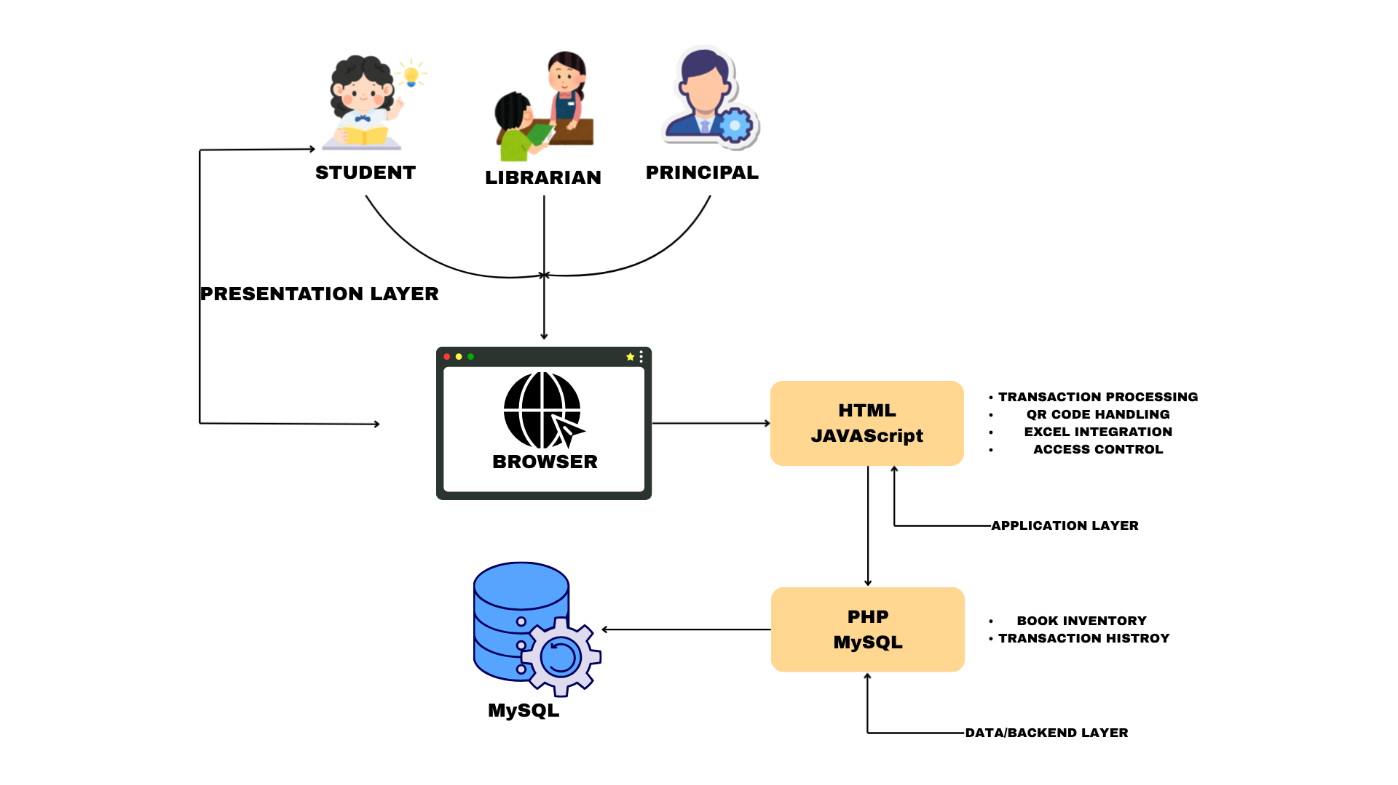
Conceptual Design
System Architecture
Figure 2.1 System Architecture of the development of an online library inventory management system for maharlika national high school

Recognizing these challenges, this study proposes the development of a Web-Based Library Inventory Management System. Using the Agile model as the Software Development Life Cycle (SDLC), the system will streamline library operations and improve overall efficiency. By incorporating features such as real-time Monitoring of borrowed and returned books and bulk data imports through Excel files, the proposed solution aims to reduce the manual workload of librarians while ensuring accurate and up-to-date records.
This system will provide timely access to resources for students and faculty, enabling better decision-making and improving the library's workflow. By modernizing the library’s inventory management, Maharlika National High School can continue to support its students and staff with the tools they need to succeed in a technology-driven world.
The System Architecture shown in figure 4. The Web-Based Library Inventory Management System follows a structured architecture to ensure efficient book monitoring, secure data handling, and user accessibility. The system is hosted on a web server, requiring an active Wi-Fi or mobile data connection for users to access it. Student must request an account creation from a librarian before accessing the system.
- Upon login, users are authenticated based on their roles:
  - Principal (Admin):
    - Has the highest level of control over the system.
    - Can create, modify, manage librarian and students accounts.
    - Has access to all librarian functionalities.
  - Librarians (Co admin):
    - Manage book records (import and export excel file).
    - Track transactions.
    - Create and delete student accounts.
    - Perform system maintenance.
    - Import and Export Excel File
    - Scan QR code
  - Students:
    - Search for books.
    - Borrow and return books.
    - Generate QR code
System Components & Data Management
- All book records, transaction history, and user information are stored in a centralized database, ensuring real-time Monitoring and data integrity.
- The database serves as the backbone of the system, ensuring synchronized updates across all users.
Administrator Dashboard & Reporting
- Admin & Librarians have access to an Administrator Dashboard to:
  - Manage book records.
  - View transaction history.
  - Generate reports.
  - Admin will manage librarian’s accounts.
- Data Management and Reporting Module provides insights into:
  - Book usage patterns.
  - Borrower trends.
  - Library resource demand.
- These insights help optimize book collections and support data-driven decision-making for future acquisitions.

Security Measures
- User authentication requires valid credentials before accessing the system.
- Data encryption ensures that sensitive information is protected.
- Role-based access control (RBAC) prevents unauthorized users from accessing administrative functions.
- Admin authority ensures only trusted personnel manage librarian accounts.

Providing a continuous and streamlined process, the system ensures smooth operations, minimizes errors, and improves resource accessibility, ultimately enhancing the library experience for both students and faculty.
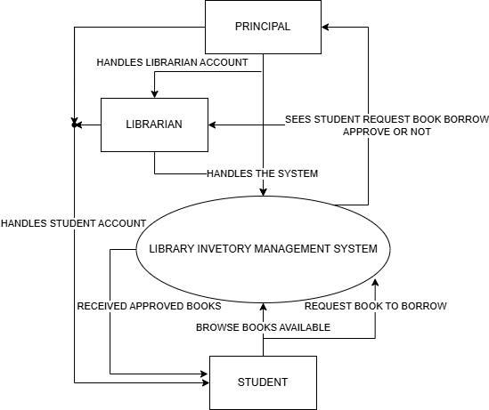
Context Diagram

Figure 2.2 Context Diagram
The diagram represents the high-level interaction between different roles and the Library Inventory System. Each entity has specific responsibilities and interactions within the system:
- Librarian
  - Manages the book inventory (adding, removing, and updating books).
  - Updates the book records in the Library Inventory System to ensure availability and accuracy.
  - Can Scan the provided QR code from the Student to returned Multiple books all at once.
2. Principal
- Oversees the system operations and settings.
- Ensures the proper functioning of the Library Inventory System, handling administrative tasks that manages student and librarian accounts, similar functions as the librarian.
- Can scan the provided QR code from the Student to return multiple books all at once.
3. Library Inventory Management System
- The central system that manages book inventory, borrowing, and returning.
- Provides relevant information to users, such as book availability and transaction history.
- Also shows List of Student that belongs on their year level and section showing their history of borrowed and returned books.
4. Student
- Interacts with the system to borrow and return books.
- Receives information about book availability, due dates, and other library-related queries.

Process Flow Model

1. Student returns the book.
2. System verifies return through Librarian’s acceptance.
3. Book status updates in real time for all users.

Returning Process

1. Student Logs in and searches for a book.
2. System verifies availability.
3. Transaction is recorded, and book status updates in real time.
4. Librarian reviews and approves the borrowing request.
PROCESS FLOW

1. Admin and Librarian and faculty add books or perform bulk imports via Excel.
2. System processes updates and reflects changes in the catalog.
3. Admin and librarian can export books data in system to Excel

Inventory Management

1. System generates reports on borrowing trends, book status, and inventory data.
2. Administrators analyze data for decision-making and library improvements.

Reporting

Figure 2.3 Process Flow Model

Data Model Representation

1. Updated Borrowing Records – Reflects book status changes.
2. Real-Time Inventory Updates – Ensures accurate book Monitoring.
3. Reports & Insights – Monitoring borrowed Books and stocks.

Output

1. System verifies book availability before processing a request.
2. Inventory updates in real-time upon borrowing/returning.
3. Transaction data is securely stored in the database.

Process

1.Borrowing/Returning Requests – Submitted by students.
2.New Book Records – Entered by librarians/admins.
3.Bulk Uploads (Excel) – Large-scale book additions.

4. System Data export to Excel – for printing purposes

Input

Figure 2.4 Data Model Representation

Benefits
- Operational Efficiency: Real-time updates and bulk imports reduce manual workload along with export data for printing work related purpose.
- Accuracy: Secure data storage and processing eliminate errors.
- Scalability: The system can accommodate new books and users as needed.
- Decision Support: Reports and analytics empower administrators to make informed decisions.

Process flow and Data Models
The proposed Library Inventory Management System for Maharlika National High School streamlines the management of borrowed and returned books, as well as inventory updates, through an efficient web-based system. Librarians and students interact with the system via an intuitive interface, simplifying the process of managing library resources.
Students and faculty access the system to search for books, view availability, and initiate borrowing or returning transactions. A built-in bulk import and export feature allows librarians to upload new book inventories using Excel files, significantly reducing manual data entry effort and time. Transactions are recorded in real time, ensuring accurate and up-to-date Monitoring of library resources.
A centralized database securely stores all user, book, and transaction data. This ensures easy retrieval and organization of historical borrowing and inventory records. Administrators can access this data through a dedicated dashboard, which provides tools for viewing reports, monitoring borrower trends, and analyzing resource utilization.

Entity Relationship (ER) Diagram
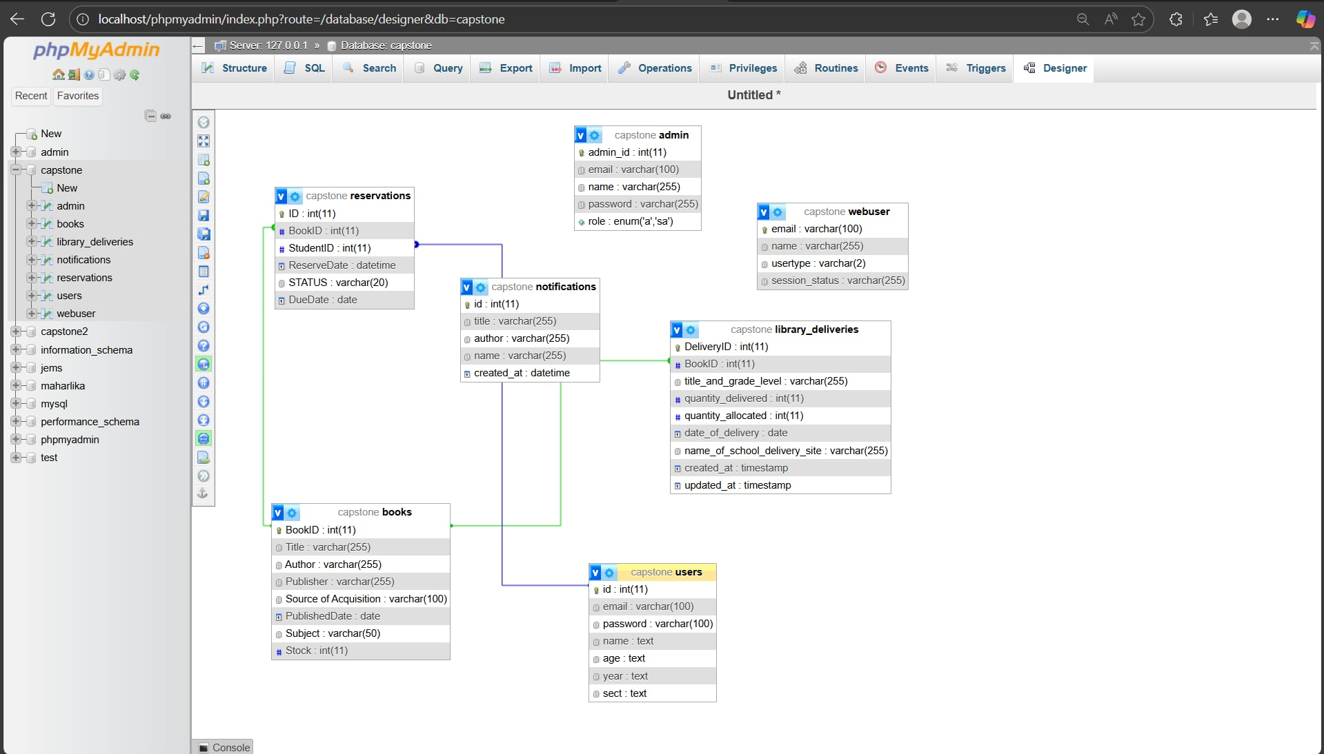

Figure 2.5 Entity-Relationship Diagram for development of an online library inventory management system for maharlika national high school
The provided Entity-Relationship Diagram (ERD) illustrates the core data structure and relationships in the Library Inventory Management System designed for Maharlika National High School. Each entity represents a key component of the library system, ensuring efficient and accurate management of books, transactions, and users. The diagram showcases the relationships between Students, Librarians, Web-users, Books, and Transactions, highlighting how the system operates seamlessly.

Entity-Relationship Diagram (ERD) Analysis
The Library Inventory System consists of multiple entities that define the core functionality of managing books, users, and reservations. The ERD illustrates how these entities interact within the system. The primary entities include books, users, reservations, admin, and web-user. Each entity plays a significant role in ensuring the seamless operation of the inventory system.
- Capstone Books
The capstone book table is a fundamental component of the system, storing for book related data it contains the attribute list such as Title, Author, Publisher, Published Date, Language, Stock, and Source of Acquisition. It serves as repository for book records and is essential for Monitoring book availability
- The Principal and Vice Principal is responsible for managing book records, including adding, updating, and deleting book entries. And the stock attribute is crucial for inventory management ensuring the book status is up to date.
- User Entity
This table represent the student that utilize the Library System, the key attributes are id, email, password, name, age, year, and section. This ensure that the entity has a unique identity within the system and can only access based on their role.
- The email and password field facilitates user authentication to secure access to the system. And relationship user and reservation is established through id which enable student to borrow and return books.

- Reservations Entity
This entity table serves intermediary between users and books, enabling the reservation of books. the key attributes are ID, Student ID, ReserveDate, Due-Date, and STATUS.
- The student id connects with the users table, ensuring the it’s registered can make reservation. And the STATUS field allows the system to track whether a reservation is pending, approved, or completed.
- Admin entity
The admin table purpose is to store administrative user its responsibility is managing the system. The key attributes admin id, email, and password.
- administrators are responsible for performing CRUD (Create, Read, Update, Delete) operations on book records. Even if it’s not shown in the ERD model it does not explicitly define a relationship between admin and books, admins can import book stock using Excel, allowing for bulk additions and updates.
- Web-user Entity
This table entity has an attributes of email, user type, and session status. Related to user authentication and session management.
- In the ERD model may not show any direct relationship between web-user and the other core entities (books, reservations, or users), it is used for session Monitoring rather than core inventory management.

Data Integrity and Operational Benefits:
The Library Inventory System is designed with data integrity and efficiency in mind, ensuring smooth operations and precise management of book reservations and user activities. The structured relationships among entities provide the following key advantages:
- Accuracy
The relationships between books, users, and reservations ensure accurate Monitoring of borrowed and returned books. By eliminating data redundancy and reducing manual errors, the system maintains a consistent and reliable record of book availability. The STATUS field in the reservations table allows real-time monitoring of book reservations, preventing duplicate bookings or lost records.
- Efficiency
By automating inventory and reservation processes, the system optimizes time and resources. Users can efficiently search for available books, borrow them online, and track their borrowing status. Librarians can import large book inventories via Excel, reducing manual data entry efforts. These streamlined workflows enhance overall operational efficiency.
- Scalability
The system's flexible database design allows for easy expansion. As the library grows, The use of relational database principles ensures that the system remains adaptable to future enhancements.
This structured data model aligns with the objectives of the Library Inventory Management System by ensuring smooth operations, reducing manual workloads, and providing robust support for data management and analysis.
Conclusion
The Library Inventory System enhances data accuracy, operational efficiency, and scalability while ensuring secure user management. The structured Entity-Relationship Diagram (ERD) ensures that books, users, and reservations are interconnected logically, minimizing errors and redundancy. These benefits position the system as a robust and scalable solution for library management, supporting future enhancements and increasing efficiency in inventory operations.

Software Development Life Cycle (SDLC) Model
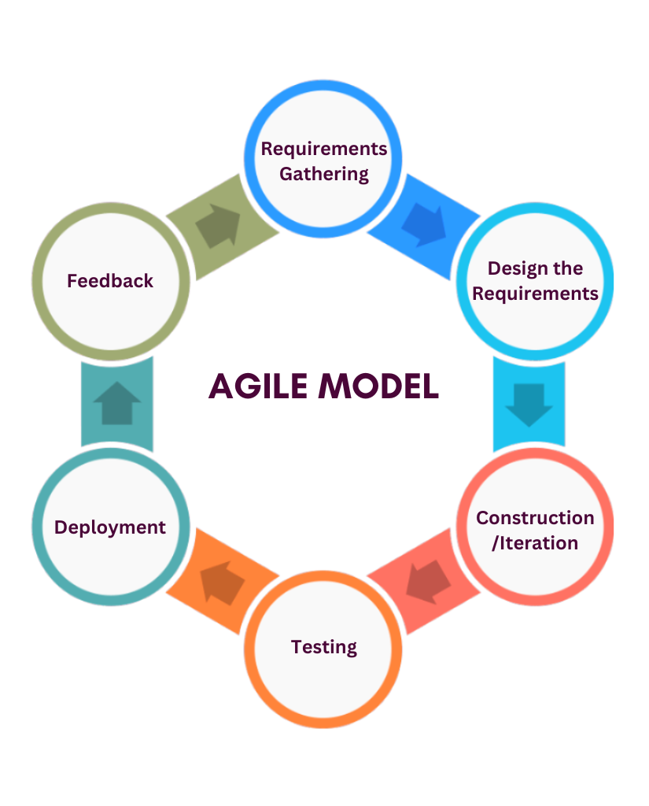

Figure 2.6 Agile Development Model for Online Library Inventory Management System
AGILE MODEL
The Agile model stages for developing the Library Inventory Management System for Maharlika National High School. The development process follows an iterative and incremental approach, ensuring continuous improvement and quick adaptations based on user feedback.
The project is divided into sprints, with each sprint focusing on delivering critical features such as book borrowing and returning functionalities, real-time inventory updates, bulk book imports, and an admin dashboard. The Agile methodology allows for flexible adjustments, reducing risks and ensuring that the system evolves based on librarian and student needs.
The Agile model emphasizes continuous feedback, adaptability, and collaboration, making it well-suited for this project. By incorporating user input throughout each phase, the development team can refine the system to enhance usability and efficiency. The phases of development in the Agile approach include:
- Requirements Gathering – This phase involves identifying the needs of librarians, students, and Admin. Key features such as book reservations, inventory Monitoring, and bulk book imports and export using Excel are outlined, student creation account and librarian creation account, Along with the use of QR Code generation and QR Code Scan.
This phase ensures that the system is tailored to the needs of its primary users: students, librarians, and Principal. By engaging these users through interviews, surveys, and collaborative discussions, the group will gather valuable insights into their current challenges and expectations.
Key pain points identified during this phase include inefficiencies in Monitoring borrowed and returned books, difficulties in managing inventory updates, and the lack of real-time notifications for borrowed and return books or new arrivals. Stakeholders expressed the need for features such as an intuitive interface for Monitoring transactions, automated inventory updates, real-time notifications for book availability, and secure user authentication for both students and librarians.
By analyzing these inputs, the project team defines specific system functionalities, such as a streamlined borrowing and returning process, status updates for each book, and a dashboard for monitoring inventory. Additional user requirements include compatibility with mobile devices, ease of use, and robust data management capabilities. This comprehensive understanding of user needs provides a strong foundation for designing a system that addresses existing challenges while enhancing overall library operations.
- Design the Requirements – Based on the gathered requirements, a structured blueprint of the system is created. This includes database design, user interface layout, and system workflows to ensure efficiency.
- Construction/Iteration – The system is developed in small increments, with each sprint focusing on implementing specific functionalities. Developers work on modules such as book management, user authentication, and reservation monitoring to ensure smooth library operations.
- Testing – Each developed module undergoes rigorous testing to identify and resolve bugs. Functional, usability, and security testing are performed to ensure the system operates seamlessly.
- Deployment – Once the system passes testing, it is deployed for real-world use in the school’s library. At this stage Admin, librarians and students begin utilizing the platform for book reservations, inventory management, and other essential tasks.
- Feedback – Continuous feedback is gathered from users to identify areas for improvement. Issues or additional feature requests are considered, leading to further iterations that enhance system functionality.
As each sprint is describe to the system development the Gantt Figure will explain the timeline of each sprint and development applied to while following the Agile process.
Methods
The development of the Library Inventory Management System for Maharlika National High School follows a comprehensive and iterative approach to ensure that the system meets the needs of students, librarians, Admin. The project begins with the Requirement Gathering phase, where key inputs are collected through consultations with the librarians, school admin, and students. Information on the current challenges, such as manual book Monitoring, inventory updates, and the need for real-time data, is used to define the system’s objectives and functionalities.
Based on these requirements, a System Architecture is designed to establish the interaction between the system's components. The architecture outlines key entities such as students, librarians, books, and transactions, supported by a relational database structure. Additionally, MQTT (Message Queuing Telemetry Transport) is integrated into the architecture to enable real-time communication between system components. MQTT facilitates instant updates, such as reflecting book status changes (borrowed or returned) and notifying users or librarians about new arrivals. This lightweight protocol ensures efficient and fast data transmission, even with limited resources.
To manage the development process, the Agile Model is employed as the chosen Software Development Life Cycle (SDLC) methodology. This iterative approach allows continuous feedback and refinements through multiple sprints. In each sprint, a set of features, such as book borrowing/returning, bulk book import functionality, MQTT-enabled real-time notifications, and a status dashboard, is developed, tested, and reviewed. The agile framework ensures flexibility and responsiveness to user feedback while minimizing risks.
The system’s frontend is developed using HTML5, CSS3, JavaScript, Admin LTE, and Bootstrap 5.3.2 to provide a responsive and user-friendly interface. The backend is built with PHP 8.2, ensuring robust server-side processing for handling user requests and system logic. MySQL is used to implement a secure and scalable database that supports data storage and retrieval for books, users, and transactions. MQTT brokers are implemented to handle real-time data updates between clients, ensuring that all system users (Admin, librarians and students) have access to the most current information. Security measures, such as secure authentication mechanisms and data validation, are implemented to protect sensitive information and maintain system integrity.
After the initial development, the system undergoes Integration and Unit Testing to validate each module’s functionality. Test scenarios include verifying the borrowing and returning process, bulk book imports using Excel, Export data system to excel, accurate inventory updates, MQTT message transmission reliability, and secure login procedures. User Acceptance Testing (UAT) is conducted with librarians and students to assess the system’s usability and performance. Feedback from UAT is used to make refinements and ensure the system meets the expectations.
The system is then deployed to a budget-friendly hosting solution, ensuring accessibility to all users. Training sessions are conducted for librarians to familiarize them with the new system, including how to manage transactions and inventory efficiently. A Maintenance Plan is implemented post-deployment to address any arising issues, apply system updates, and introduce new features based on evolving needs. Routine monitoring is conducted to ensure optimal performance, real-time functionality via MQTT, and security.
This methodical development process ensures that the Library Inventory Management System is reliable, efficient, and scalable, addressing the current challenges of manual processes while preparing for future enhancements. The integration of MQTT further enhances the system by providing real-time communication, streamlining library operations, and improving resource accessibility for students and faculty.

Table 2.1 Requirements Gathering and Analysis Overview
Indicator | Challenges | Cause | Effect | Opportunities
Performance | Delays in book borrowing and returning | Manual recording processes | Increased waiting times and inefficiencies in service | Implement real-time transaction Monitoring with the new system.
Information | Inaccurate or outdated inventory records | Manual data entry and bulk updates | Lost or incomplete data, inaccurate analysis | Automate inventory management and updates using Excel file imports.
Control | Limited real-time monitoring of transactions | Manual Monitoring methods | Errors and inefficiencies in book inventory management | Introduce real-time Monitoring and automated error-checking mechanisms.
Efficiency | Increased workload for librarians | Manual inventory processes | Reduced focus on critical library functions | Streamline workflows with a web-based system for borrowing, returning, and reporting.
Service | Difficulties in finding and accessing resources | Lack of using manual resources. | Poor student and faculty experience | Provide an intuitive search interface for students and faculty to access resources easily.

Access Level Analysis
The Web-Based Library Inventory Management System features a well-defined access hierarchy to ensure efficiency, security, and streamlined library operations:
Admin and Librarian:
  - Full access to the system, including managing user roles, overseeing book inventory, and generating reports.
  - Responsible for configuring system settings such as importing bulk book data via Excel along with data export to via Excel, setting borrowing and returning policies, and monitoring system logs for compliance and accuracy.
  - Can review transaction records in real time, update the database for newly acquired books, and handle system maintenance to ensure smooth operations.
  - Admin will manage the librarian accounts and have a higher authority than librarian along with librarian functions also available to the admin.
Students:
  - Limited access, designed for browsing, borrowing and returning books through the system's user-friendly web interface.
  - Can view the availability of books and search the library catalog.
  - Access is designed for simplicity, ensuring students can interact with the system without additional technical complexities.

System Users:
  - Includes Admin, librarians and students, each with distinct access levels to maintain operational efficiency and data integrity.
  - The access levels are clearly demarcated to prevent unauthorized data manipulation and ensure that sensitive operations remain restricted to authorized personnel.

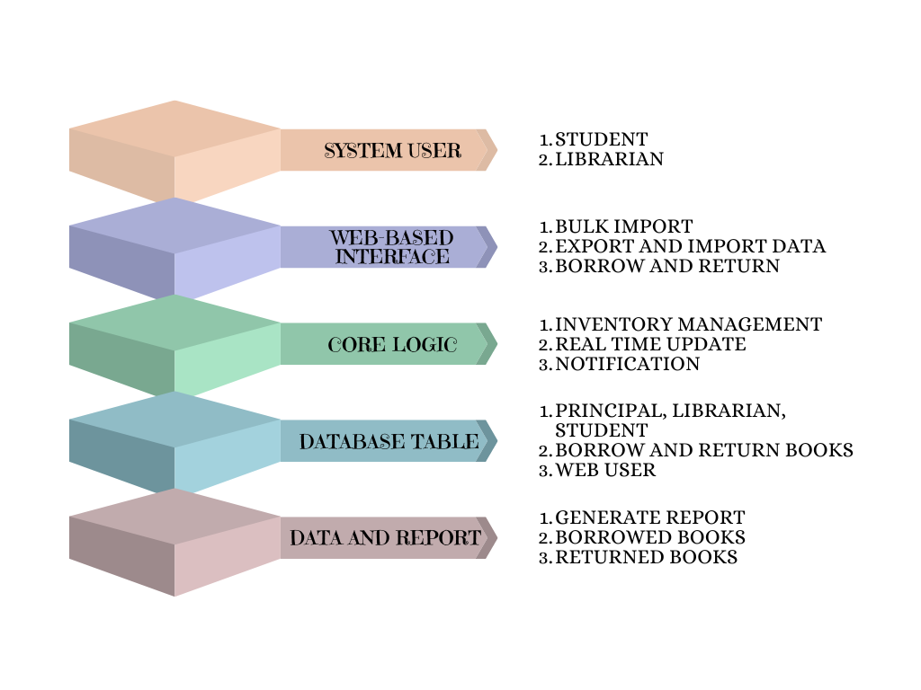
Figure 2.7. Layered architecture of the development of an online library inventory management system for maharlika national high school
Figure 12 layered architecture of the Web-Based Library Inventory Management System. The system is structured into distinct levels, ensuring efficient interactions between system users, application logic, and data management.
System User Layer:
The system is accessed by three primary user roles:
  - Students: Can borrow and return books through an intuitive web-based interface.
  - Librarians: Have access to additional features for inventory management and massive data imports, such as uploading books via Excel.
  - Admin: manages librarian accounts and have all access similar to librarian.
Web-Based Interface Layer:
This layer facilitates user interactions by enabling:
  - Manipulate book status and Bulk import and export of book data by Admin and librarians.
  - Borrowing and returning of books by students.
Core Logic Layer:
This layer is responsible for essential system operations, including:
  - Real-time inventory updates whenever books are borrowed, returned, or added.
  - Notification mechanisms for book status or successful transactions.
  - Inventory management to ensure accuracy in records.
Database Layer:
All data is securely stored in an organized database system, with key tables for:
  - Admin account.
  - Librarian accounts.
  - Student’s information.
  - Books catalog.
  - Borrowed and returned books.
Data and Reports Layer:
This layer provides insights into system activities through:
  - Reports generation (e.g., borrowed and returned books).
  - Real-time monitoring of transactions and system usage.
The design ensures modularity and efficiency in managing library operations, benefiting admin, librarians and students by providing a seamless borrowing, returning, and inventory management experience.

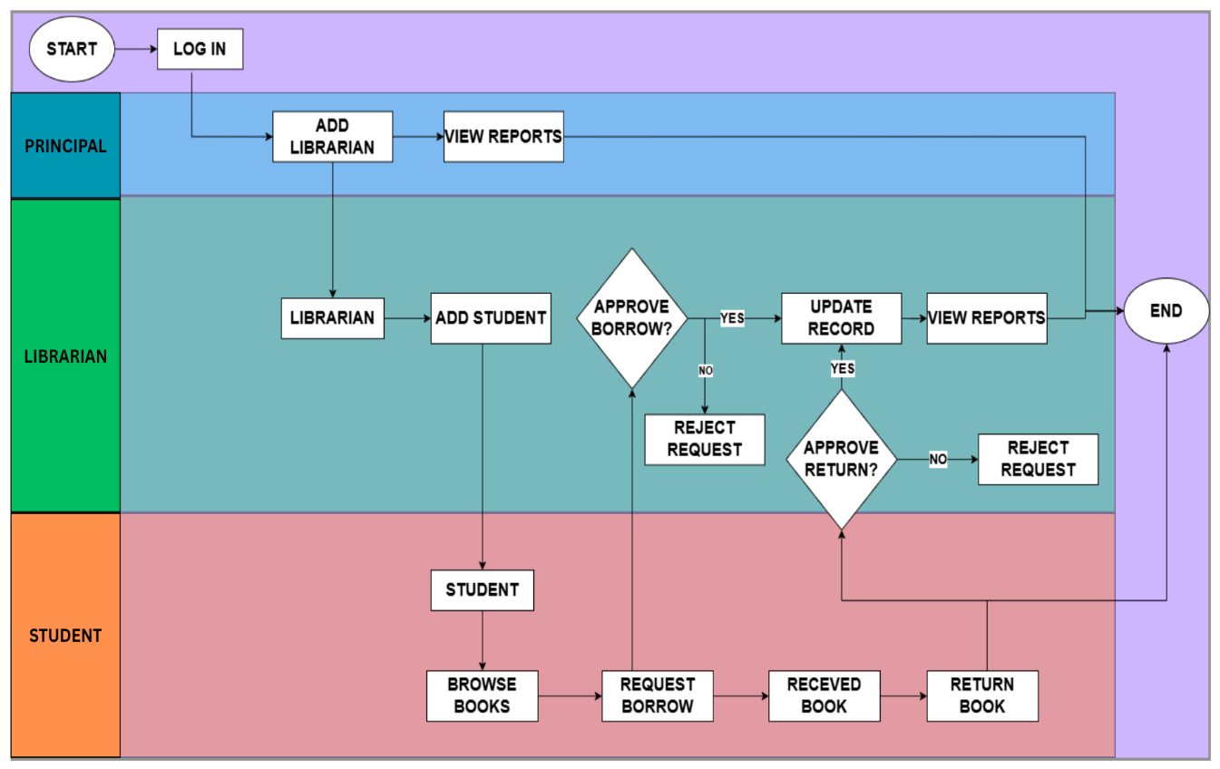
Flow chart
Figure 2.8 Swimlane-Style for the development of an online library inventory management system for maharlika national high school
The flowchart represents the User Login and Role-Based Actions in a Library Management System. It follows a structured process from login to logout while defining the roles and their respective functions.
1️. Login Process
- The system begins with a Login Step (Log In).
- After logging in, users must select their role (Student, Librarian, or Admin).

2️. Role-Based Actions
Once a role is selected, users can perform specific tasks based on their permissions:
Student Role
- Students borrow and return books from the library system.
Librarian Role
Librarians have more management responsibilities, including:
- Importing books into the system.
- Bulk importing books to handle large datasets.
- Exporting data to Excel for record-keeping.
- Managing student accounts (creating, modifying, or deleting student accounts).
Admin Role
Admins have higher authority and can:
- Manage student & librarian accounts (same functions as librarian + additional privileges).
- Perform all librarian functions such as importing/exporting books and managing data.

3️. Logout Process
- After completing their tasks, all users can log out to end their session.
System Test Plan
The System Test Plan ensures the functionality, reliability, and usability of the Library Inventory Management System by covering all aspects of the system's operations:
Unit Testing:
  - Focused on individual modules such as real-time transaction Monitoring, inventory updates, and bulk data imports.
  - Ensures each component performs as expected in isolation.
Integration Testing:
  - Validates the interaction between system components, such as borrowing and returning processes, and their impact on the inventory database.
  - Checks the seamless operation of data flows across modules, including Excel file imports to data export and reporting functions.
System Testing:
  - Comprehensive evaluation of the entire system to ensure all functionalities work together harmoniously.
  - Includes testing for edge cases, such as bulk book imports And data export during peak operational times.
Usability Testing:
  - Evaluates the system from the perspective of Admin, librarians and students.
  - Ensures the interface is intuitive and user-friendly, enabling efficient interactions for all users.
Performance Testing:
  - Tests the system's response time and stability under varying loads, such as high-volume book borrowing or bulk updates.
  - Ensures the system can handle concurrent operations without lag or crashes.
Security Testing:
  - Ensures sensitive data, such as transaction logs and inventory details, are protected against unauthorized access.
  - Validates role-based access control and encryption protocols.
Acceptance Testing:
  - Involves Admin, librarians and selected students testing the system in a real-world scenario to ensure it meets all operational requirements.
  - Final validation before deployment to confirm the system delivers the intended benefits.
Table 2.2 Testing Plan
Level of Testing | Testing Phase | Tester
Unit | Component Development | Developers
Integration | MQTT Integration. | Development Team  Librarian, Students
Integration | QR Code Integration.  Import & Export Excel File. | Development Team  Librarian, Students
System | End-to-End System Testing | QA Team and librarian
Acceptance | User Acceptance Testing | Librarian, Students
Perceived Usefulness (PU) | Usability Testing | Librarian, Students
Perceived Ease of Use (PEU) | Usability Testing | Librarian, Students
Behavioral Intention to Use (BI) | User Feedback Session | Librarian
Attitude Towards Using (ATU) | Feedback Analysis | Librarian
Self-Efficacy (SE) | Training & Feedback | Librarian
Perceived System Performance (PSP) | Performance Testing | QA Team, Librarian, Students
Overall Mean | Final Assessment | Inventory, Librarian

The table above outlines the various testing levels for the Library Inventory Management System, spanning from initial development testing to final evaluations involving users. Each phase is designed to engage specific testers, ensuring a thorough validation process. This structured approach validates the functionality of individual components, ensures seamless system integration, and evaluates overall usability. The testing plan aligns the system’s performance with the needs of students, librarians, and administrators, ensuring reliability, efficiency, and user satisfaction.
Code | Mean Rage | Description
5 | 4.20 – 5.00 | Excellent
4 | 3.40 – 4.19 | Good
3 | 2.60 – 3.39 | Satisfactory
2 | 1.80 – 2.59 | Needs Improvement
1 | 1.00 – 1.79 | Poor

Table 2.3 Interpretation of Ratings
The table above provides an interpretation scale to evaluate user and system feedback gathered during testing. Each rating is assigned a descriptive category based on the mean range, helping testers and stakeholders interpret results with clarity. This scale will be applied to metrics such as usability, ease of use, and perceived system performance, supporting objective analysis of user feedback and overall system effectiveness.
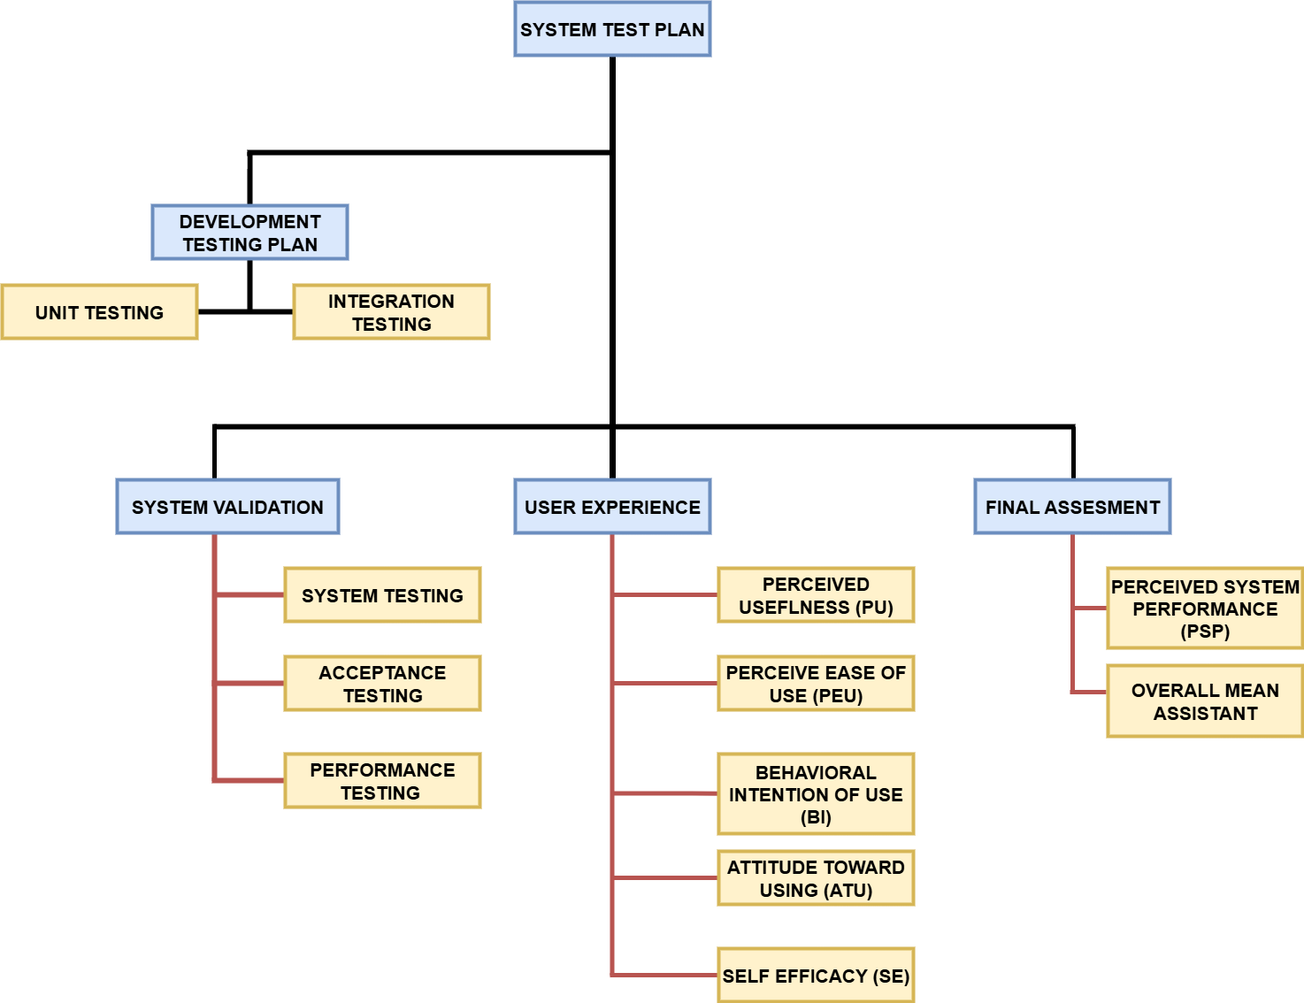
System Test Plan Model

Figure 2.9 Work Breakdown Structure for System Test Plan

Figure 14 illustrates the Work Breakdown Structure (WBS) for the system test plan, detailing the hierarchical tasks for evaluating the Library Inventory Management System. The Development Testing phase involves Unit and Integration Testing to ensure proper functionality of individual modules, such as book borrowing/returning, real-time inventory Monitoring, and user authentication, as well as their seamless integration.
The System Validation phase encompasses System Testing, Acceptance Testing, and Performance Testing to verify the platform’s functionality, stability, and reliability under varying conditions. This phase also includes testing the system’s ability to scale, ensuring that it can handle increasing numbers of transactions and users without significant performance degradation.
The User Experience Evaluation phase assesses usability factors, including Perceived Usefulness, Ease of Use, Behavioral Intention to Use, Attitude Toward Using, and Self-Efficacy among librarians and students. This evaluation will ensure that the system is intuitive and easy to use, providing a positive user experience for all stakeholders.
The Final Assessment focuses on evaluating Perceived System Performance and calculating an Overall Mean Assessment to summarize testing outcomes. This comprehensive assessment will guide any final adjustments and ensure the system is ready for full deployment. This structured approach ensures that all critical aspects of the system are rigorously examined, facilitating its successful deployment and ongoing use in managing library resources efficiently.

No. | Task Name | December |  |  |  | January |  |  |  | February |  |  |  | March
No. | Task Name | Weeks |  |  |  | Weeks |  |  |  | Weeks |  |  |  | Weeks
No. | Task Name | 1 | 2 | 3 | 4 | 1 | 2 | 3 | 4 | 1 | 2 | 3 | 4 | 1 | 2
1.0 | BRAIN STORM
1.1 | Preliminary Investigation
1.2 | Define System Requirements
1.3 | Planning the Methodology
2.0 | DESIGN
2.1 | Design Process Models
2.2 | Design Data Models
2.3 | Design System Architecture
2.4 | Construction CSU Template
3.0 | DEVELOPMENT
3.1 | Coding
3.2 | Test Cases & Scenarios
3.3 | Development Prototype
4.0 | QUALITY ASSURANCE
4.1 | User Initial Review
4.2 | System Evaluation
5.0 | DEPLOYMENT
5.1 | Deployment
5.2 | User Acceptance

Figure 2.10 Gantt of the Proposed System
In the first month, the team initiated Sprint 1, which aligned with the Agile stage of Requirements Gathering. This sprint focused on identifying the core functions of the school library inventory system through brainstorming sessions, feasibility studies, and research. The team investigated existing systems and gathered insights from Maharlika National High School to understand the current challenges and user needs. These activities laid the foundation for defining system requirements and setting realistic goals for development.
In the second month, the project moved into Sprint 2, corresponding to the Agile stage of Designing the Requirements. This sprint emphasized analysis, including data gathering, data analysis, and data interpretation. The team synthesized research findings and user feedback to refine the system scope and functionality. This phase ensured that the proposed features—such as book tracking, QR code integration, and Excel import/export—were grounded in actual user needs and technical feasibility.
By the third month, the team transitioned into Sprint 3, which covered the Agile stages of Construction/Iteration and Testing. The focus shifted to design and development, including the creation of the context diagram, data flow diagram, entity relationship diagram, and data dictionary. Screen layouts were also drafted to ensure intuitive navigation. Coding and debugging followed, bringing the system’s core modules to life. Testing was conducted in layers—unit testing for individual components, integration testing for module interaction, and system testing for overall performance.
In the fourth month, the team entered Sprint 4, which aligned with the Agile stages of Deployment and Feedback. The system was deployed in the school setting, and user acceptance testing was conducted to validate usability and effectiveness. Feedback from librarians and students was collected to refine the system further, ensuring it met real-world expectations for functionality, security, and ease of use.
Each sprint lasted approximately two weeks and concluded with a review and retrospective. This iterative cycle allowed the team to continuously improve the system based on stakeholder input, resulting in a scalable, user-friendly, and secure library inventory solution.
System Requirements
Functional Requirements of the System
Table 2.4 Functional Table Requirements for Principal
Principal | Functional Requirements
Feedback Management | Manage user accounts, set permissions, and oversee the overall library system operations.
Dashboard Analytics | Access a dashboard to visualize inventory, borrowed books, and return books.
MQTT | This version emphasizes the use of MQTT for enabling real-time data updates and notifications
QR Code Scanning | Scan QR codes to quickly process borrowing and returning of multiple books.
Import & Export (Excel)
  Import book records in bulk and export inventory data to Excel for backup and reporting.
Notifications | Receive real-time alerts for books reservations, returned books, and system updates, Excel Import.

These tables outline the key functional requirements necessary for the Library Inventory Management System to operate effectively, catering specifically to the needs of administrators and librarians. Table 4 focuses on the requirements for these tables outline the key functional requirements necessary for the Library Inventory Management System to operate effectively, catering specifically to the needs of librarians. Table 4 focuses on the requirements for librarians, detailing functionalities that support efficient library operations, such as managing book inventory, overseeing borrowing and return transactions, and accessing dashboards for real-time data visualization, Scan Generated QR code. Additionally, the system leverages MQTT to provide real-time notifications, ensuring that librarians are promptly informed about return books, new reservations, and system updates.
These features enhance the ability to streamline library processes and improve the overall user experience for students and faculty. Administrators and librarians, detailing functionalities that support efficient library operations, such as managing book inventory, overseeing borrowing and return transactions, and accessing dashboards for real-time data visualization. Additionally, the system leverages MQTT to provide real-time notifications, ensuring that librarians are promptly informed about returned books, new reservations, and system updates. These features enhance the ability to streamline library processes and improve the overall user experience for students and Librarians.

Table 2.5 Functional Requirements for Librarian
Librarian | Functional Requirements
Feedback Management | Manage user accounts, set permissions, and oversee the overall library system operations.
Dashboard Analytics | Access a dashboard to visualize inventory, borrowed books, and return books.
MQTT | This version emphasizes the use of MQTT for enabling real-time data updates and notifications
QR Code Scanning | Scan QR codes to quickly process borrowing and returning of single or multiple books.
Import & Export (Excel)
  Import book records in bulk and export inventory data to Excel for backup and reporting.
Notifications | Receive real-time alerts for books reservations, returned books, and system updates, Excel Import.

These tables outline the key functional requirements necessary for the Library Inventory Management System to operate effectively, catering specifically to the needs of librarians. Table 4 focuses on the requirements for librarians, detailing functionalities that support efficient library operations such as managing student accounts, maintaining and updating book records, and overseeing borrowing and return transactions. Additionally, the system leverages features like QR code scanning to streamline single or multiple book returns and integrates Excel import/export capabilities to simplify bulk record management. Real-time notifications ensure that librarians are promptly informed about returned books, new reservations, and system updates. These features enhance the librarian’s ability to manage library resources efficiently and improve the overall user experience for students and faculty.
Student | Functional Requirements
Borrowing/Returning Books | Borrow or return books through a user-friendly web-based interface with real-time status updates via MQTT.
Books Search | Search for available books using the system, with detailed information on availability and location
QR Code Generation | Students generate their unique QR codes for borrowing/returning books. When scanned, transactions are automatically logged.
Notifications | Receive MQTT-enabled notifications for, book availability, and reservation confirmations.
Table 2.6 Functional Requirements for Student.

Table 6 highlights the functional requirements for students and librarians, focusing on ease of use and accessibility. Students can borrow or return books through an intuitive, web-based interface, ensuring efficient transactions. The system allows users to search for books with real-time availability updates powered by MQTT, enhancing the user experience. Notifications confirm successful book transactions, such as borrowing, returning, or reserving, ensuring users are informed promptly. These features collectively create a streamlined system designed to improve library operations and support enhanced resource accessibility for all users.

Non-Functional Requirements
The non-functional requirements for the Library Inventory Management System ensure optimal performance, usability, reliability, security, scalability, and maintainability. These requirements support the functional aspects of the system and aim to deliver a seamless user experience, efficient real-time data handling via MQTT, and adaptability to the evolving needs of students, Librarian and admin.
- Performance Requirements:
System should load book search results, borrowing/return interfaces, and dashboards to ensure a seamless user experience. It must support concurrent access by multiple users, including students borrowing or reserving books and librarians managing inventory, with a response time under peak load conditions. The database should be optimized to handle high volumes of transaction records, book data, and real-time MQTT notifications without performance degradation.
- Usability Requirements:
The system interface should be intuitive and user-friendly for both students and librarians. Students should be able to search for books, borrow or return them, and receive notifications without additional assistance. Librarians should easily navigate to manage inventory, view borrowing trends, and analyze system reports with minimal training. Mobile-friendly access is essential to ensure usability for students and librarians using smartphones or tablets.
- Reliability Requirements:
The system must achieve at least 99% uptime to ensure availability, especially during peak usage times such as examination periods or project deadlines. Regular backups of library data, including book inventory and transaction records, should be performed daily, with mechanisms for quick recovery in case of system failure. Error handling should be comprehensive, providing clear and helpful messages to users in case of issues like failed book transactions, system errors, or connectivity problems.
- Security Requirements:
To protect user data and ensure compliance with data privacy standards, the system should implement strong security measures. These include encryption of sensitive data, such as user credentials, book transaction details, and admin access logs, as well as role-based access control to limit access to book data, transactions, and administrative functionalities. Unique book transaction identifiers and secure authentication mechanisms should prevent unauthorized access to specific user data and system features.
- Scalability Requirements:
The system must accommodate growth in library operations, including an increase in the number of books, users, and transactions. It should support modular upgrades, such as adding new features like advanced reporting tools or an expanded user management system, without requiring significant changes to the existing architecture. The system should be able to handle an increasing volume of borrowing, returning, and reservation activities while maintaining optimal performance.
- Maintainability Requirements:
The system should allow for regular updates and maintenance with minimal disruption to users. Comprehensive documentation should be provided for troubleshooting, scaling, and future development. A modular design will facilitate the integration of additional features, such as multi-language support or advanced filtering for book search and transaction analysis. The system should be easy to maintain and extend, ensuring smooth updates and adaptability to future needs.
- Compatibility Requirements:
The system must integrate seamlessly with basic input methods, such as allowing users to manually enter book identifiers (like authors and book titles) to borrow or return books. The system should work on popular web browsers (e.g., Chrome, Firefox, Safari) and mobile operating systems (iOS and Android).
Technologies Used
The Library Inventory Management System is built using modern web development technologies to ensure seamless functionality, security, and user experience for both students and librarians.
The frontend of the system is designed using HTML, Bootstrap, and JavaScript. HTML forms the backbone of the structure, Bootstrap provides component CSS classes for rapid and responsive design development, ensuring a consistent and professional user interface. JavaScript enhances interactivity and improves the overall user experience, enabling smooth navigation and real-time updates on book availability and transactions.
On the backend, PHP is employed as the server-side programming language. PHP enables robust server-side scripting and seamless interaction with the database, ensuring that the library system efficiently processes user requests, manages book inventories, and updates transaction records. The system also integrates real-time communication using MQTT for instant updates on book statuses (borrowed, returned).
For data management, MySQL is used as the database system. MySQL ensures reliable storage and management of critical data, including book records, user information, and transaction details. The database is optimized to handle large volumes of data, ensuring quick retrieval and minimal response time.
To ensure scalability, the system is designed to handle an increasing number of users, books, and transactions. The modular architecture of the system allows for future enhancements and integration of additional features, such as advanced search filters or multilingual support, with minimal disruption.
Production of Prototype and Testing
The production of the prototype and testing phases for the Library Inventory Management System follow a structured process to ensure the development of a user-friendly and efficient platform. The prototype development focuses on creating an initial version of the system that incorporates key features such as book borrowing and returning, real-time inventory updates, a user-friendly dashboard for librarians, and notification alerts for users. This prototype is built using the chosen technologies, allowing the development team to evaluate the system’s core functionalities, including book management, transaction handling, and real-time data updates via MQTT, before integrating more advanced components. Usability, responsiveness, and data accuracy are prioritized to ensure a high-quality user experience that reflects the system's intended final design.
Once the prototype is developed, rigorous testing is conducted at multiple levels to identify and address potential issues before deployment. Unit testing is first applied to individual functions, such as the book borrowing process, inventory management, and database operations, to ensure each component operates correctly in isolation. This is followed by integration testing, where the modules are combined, and their interactions are verified to function seamlessly. Testing scenarios include a variety of use cases to confirm that data flows accurately between system components, ensuring consistency and reliability.
In the next phase, system testing is performed on the complete prototype to validate its compliance with all functional and non-functional requirements. This phase includes performance testing, security evaluations, and scalability assessments to ensure the system performs efficiently under real-world conditions. Lastly, user acceptance testing (UAT) is conducted with actual users, including students and librarians, to gather feedback on the system’s usability, accessibility, and functionality. Feedback collected during this stage is critical for refining the system, addressing any shortcomings, and improving the overall user experience.
By carefully developing and thoroughly testing the prototype, the project ensures that the final Library Inventory Management System is robust, secure, and ready for deployment, providing an effective solution for managing library resources and improving the overall experience for both librarians and students.
Analysis of Assessment Data
The analysis of assessment data for the Library Inventory Management System evaluates information gathered during testing and user feedback phases. This analysis provides insights into the system’s performance, usability, and overall impact on library resource management and book transaction processes. It helps identify areas for improvement and validates the system’s effectiveness in enhancing library operations.
During the testing phase, data was collected on various system metrics, including response times, error rates, and overall functionality. Preliminary assessments focused on functional metrics, where key indicators such as book borrowing success rates, real-time inventory updates, and notification delivery times were measured to ensure a smooth user experience. The analysis of these metrics revealed that the system met its baseline performance goals, with minor adjustments needed to optimize response times during peak usage. This indicates that the system’s architecture is stable and capable of scaling to meet increased demand.
User feedback from acceptance testing was instrumental in evaluating user satisfaction, particularly in terms of usability and the overall experience with the system’s interface. Feedback showed that most users found the borrowing and returning process straightforward and appreciated the simplicity of the web-based interface. However, some users suggested adding more context or instructions in certain areas, such as clearer notifications for books or better organization of the inventory dashboard. The analysis suggests that implementing these enhancements, including more detailed tool tips and a guided tour for new users, will further improve user satisfaction and ease of use.
An assessment of the system’s impact on library operations was conducted by comparing the efficiency of book transactions and inventory management before and after implementing the prototype. Post-implementation data showed a significant increase in transaction processing speed and accuracy, thanks to the real-time inventory updates and automated notification features. These improvements demonstrate the system’s ability to address challenges in managing library resources efficiently, aligning with the project’s goal to improve resource accessibility and streamline library operations.
In conclusion, the analysis of assessment data indicates that the Library Inventory Management System successfully meets its functional objectives, achieves high user satisfaction, and positively impacts library resource management and book transaction processes. Future updates based on user feedback will focus on optimizing user experience and expanding system capabilities, ensuring a robust solution that supports continuous improvement in library operations.
Ethical Considerations
The ethical considerations for implementing the Library Inventory Management System encompass user privacy, data security, informed consent, and equitable access to technology. Given the sensitive nature of user and book transaction data, ensuring the confidentiality and security of all stored information is paramount. The system must adhere to data protection regulations, ensuring that all collected data, including user credentials and book transaction records, is securely stored and accessed only by authorized personnel. Robust data encryption and role-based access controls should be in place to prevent unauthorized access and data breaches.
Informed consent is a critical component of ethical implementation. Users (students and librarians) must be clearly informed about how their data will be collected, stored, and analyzed. This includes transparency regarding the purpose of collecting transaction data, how the data will be used to improve library services, and how long the data will be retained. Users should have the option to delete or modify their data at any point, empowering them to make informed decisions about their participation in the system.
Additionally, ethical considerations extend to ensuring that the system is accessible and inclusive for all users, regardless of their technical proficiency or access to advanced digital tools. The borrowing and returning process should be designed to be user-friendly and straightforward, with clear instructions available to guide users through the process. Special care should be taken to accommodate users who may not be familiar with web-based systems, ensuring that all library patrons can participate equitably in library operations.
Transparency and accountability are also essential for building trust in the Library Inventory Management System. Regular system audits should be conducted to ensure data integrity and compliance with ethical standards. Any updates or changes to data policies must be communicated promptly to stakeholders, including students, librarians, and school administrators. Additionally, transaction data should be anonymized during analysis to protect user identities and prevent misuse of information.
By adhering to this ethical framework, the Library Inventory Management System will foster trust among users, protect their rights, and promote inclusive and secure participation. These considerations are vital to ensuring that the system not only meets its objectives but also upholds the highest ethical standards in its operation.
Deployment & Monitoring
The deployment and monitoring plan for the Library Inventory Management System is designed to ensure a smooth transition from development to live implementation while addressing potential challenges. Once deployed, the monitoring phase begins, encompassing regular system checks, performance analysis, and user feedback collection to maintain system stability and efficiency.
The deployment phase will begin with setting up the system infrastructure, importing the existing inventory data, and training librarians and administrators to use the system effectively. Initial testing will be conducted during the pilot to assess the functionality of key features, such as book borrowing and returning, real-time inventory updates, and the analytics dashboard. User training will emphasize ease of use, ensuring both librarians and students can interact with the system confidently and efficiently. Adjustments will be made based on feedback collected during the pilot phase to address any issues or improve usability before the system is fully deployed.
Once the system is fully operational, monitoring will focus on performance metrics such as response time, database efficiency, and system uptime. Regular checks will be performed to ensure the system remains secure and performs optimally. User feedback will continue to be collected for any potential enhancements, ensuring that the system evolves based on real-world usage.
To ensure the system’s ongoing reliability and functionality, a proactive approach to system maintenance will be implemented. This includes routine software updates, bug fixes, and security patches. Additionally, periodic system audits will ensure that inventory data remains accurate and that all access controls are functioning as intended. This will help maintain the integrity of the system and ensure that library resources are managed efficiently.
By carefully planning deployment and establishing a continuous monitoring framework, the Library Inventory Management System will maintain high levels of performance, security, and user satisfaction post-deployment.

Chapter 3
RESULT AND DISCUSSION
This chapter includes implementations results of the project after the Development testing. The project was implemented and tested at Maharlika National High School, Maharlika, Bislig City, The School Librarian and Two practice Teachers participated in this.
The Online Inventory Management System for Maharlika National High School Library (OIMS) for book inventory Monitoring support system for academic institutions has the following modules: ‘(a) students’ module, which consist of a demographic profile , communication channel, customer satisfaction survey, and exit assessment form; (b) system admin, librarians module that involves student management, borrowing, return and varied reports like interview reasons, interview and survey responses view, user management, and varied reports like satisfaction survey and communication channel this system can be accessed through its domain name. Maharlika Inventory .com

Figure 3.1 The User’s enters his/her login credentials, users also. If unknown log in credentials will show account does not exist and will be ask again to enter valid login credentials. As the user will require to ask the librarian to make an account fort them
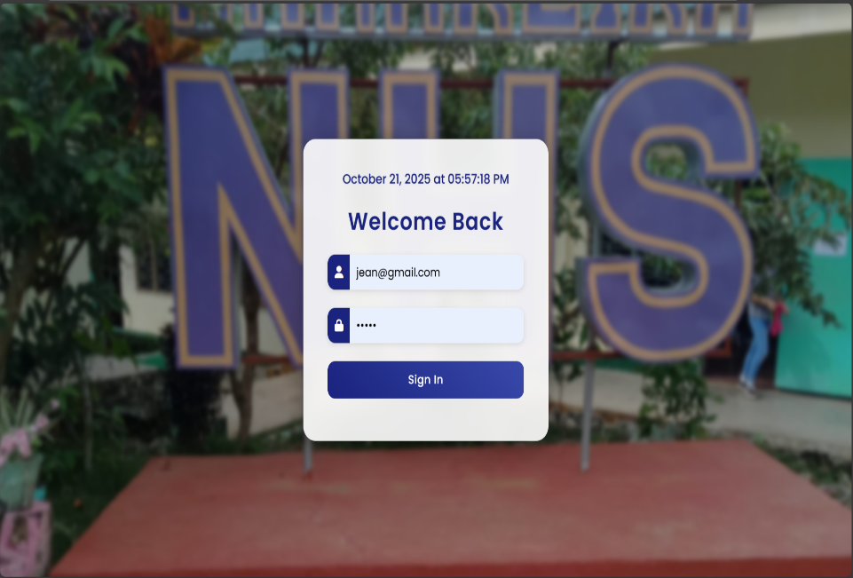

Figure 3.1 Log In Page
Figure 3.2 Student can browse see the its information and then they can Request book. And wait for the librarian approval
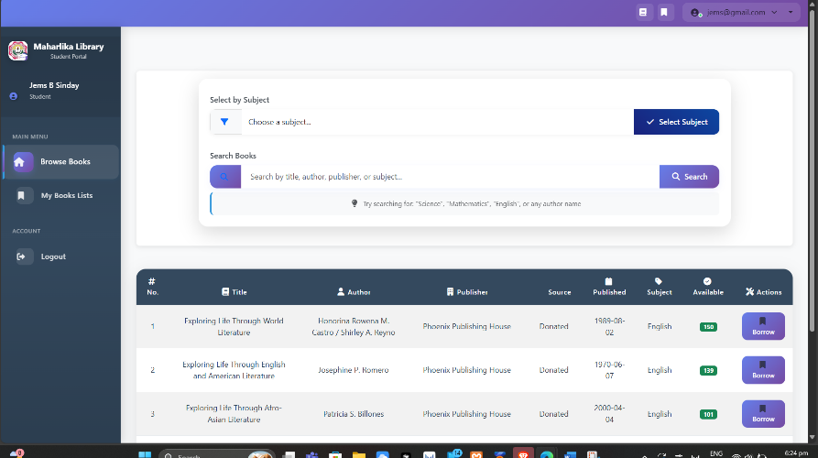

Figure 3.2 Student Dashboard
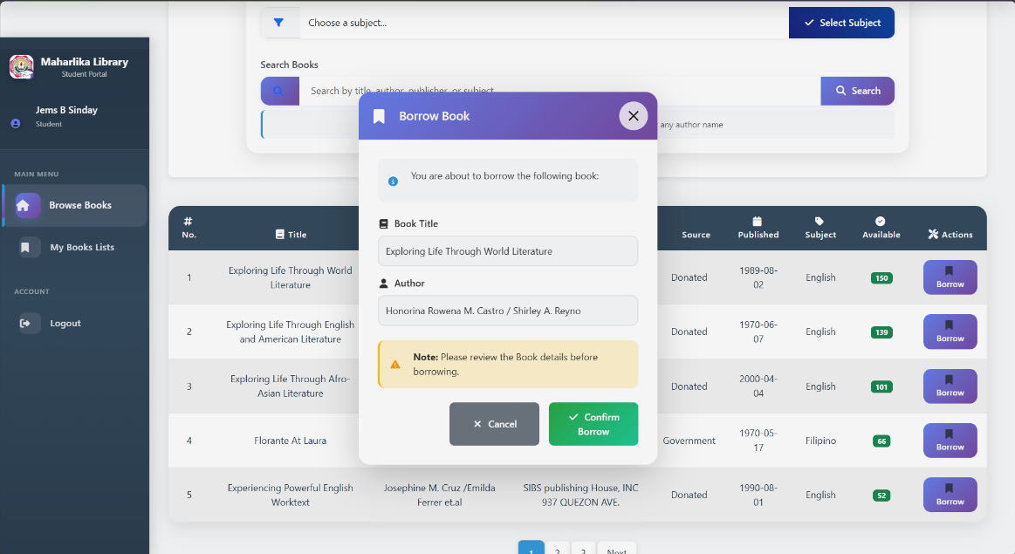
Figure 3.3 they can select the type of book and request to borrow whereas the final approval where will be on the librarian will approve and the principal as this here shows the borrowed books and its information and with the note below to check the requested book before clicking the request.
Figure 3.3 Student Book borrow
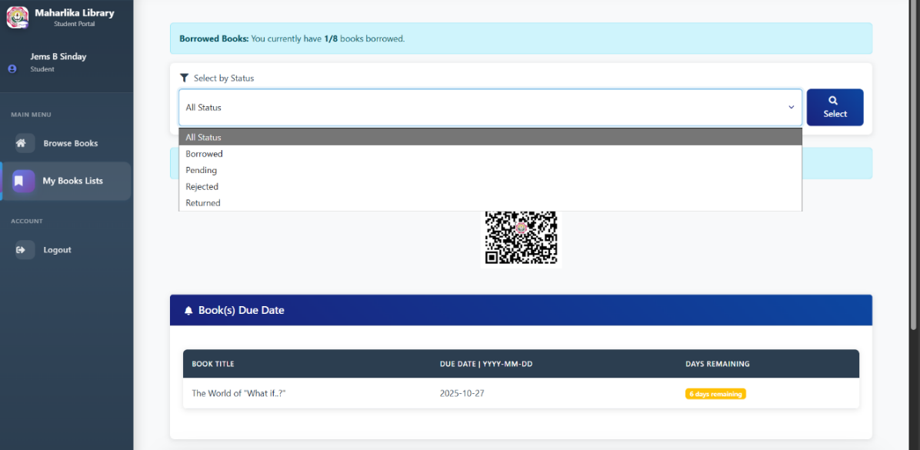
Figure 3.4 Will show the return process that Students may return books through QR Code or through manual depends on the books and users wants. They can use QR Code even if it’s a singular book.
Figure 3.4 Student QR Code to return books
Figure 3.5 Principal & Librarian dashboard can see the list of books and they have access on the specified books to manage.
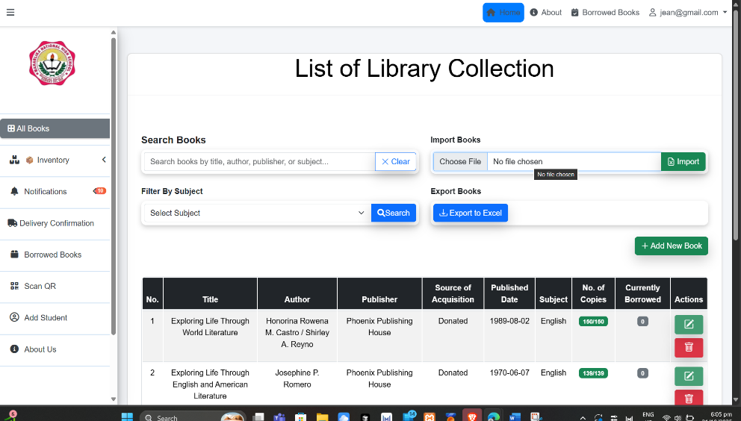

Figure 3.5 Principal & Librarian Dash Board
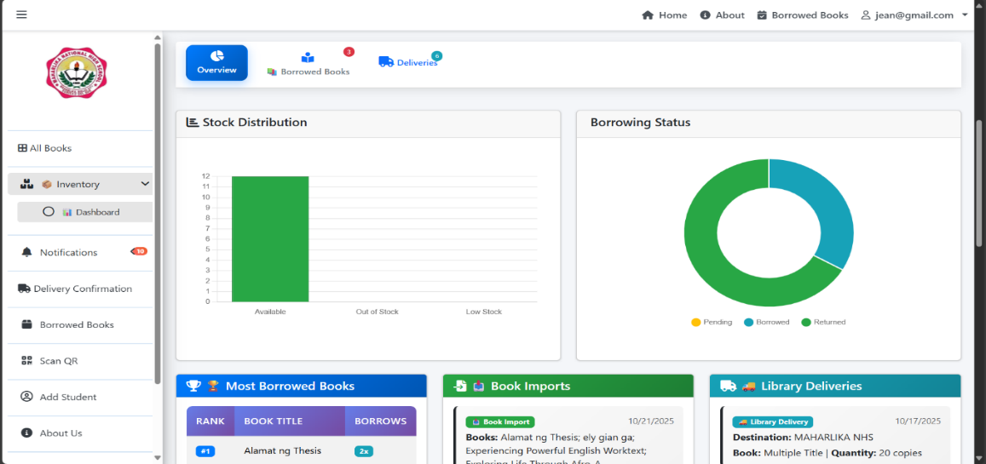
The Generate Report will show graph stock of books availability. where it shows all the borrowed and return, to the most Borrowed Books, Book Import, Library Delivery.
Figure 3.6 Principal & Librarian Inventory status
The figure above shows all the borrowed and return listing on ranking on most borrowed Books. Book Import, Library Delivery
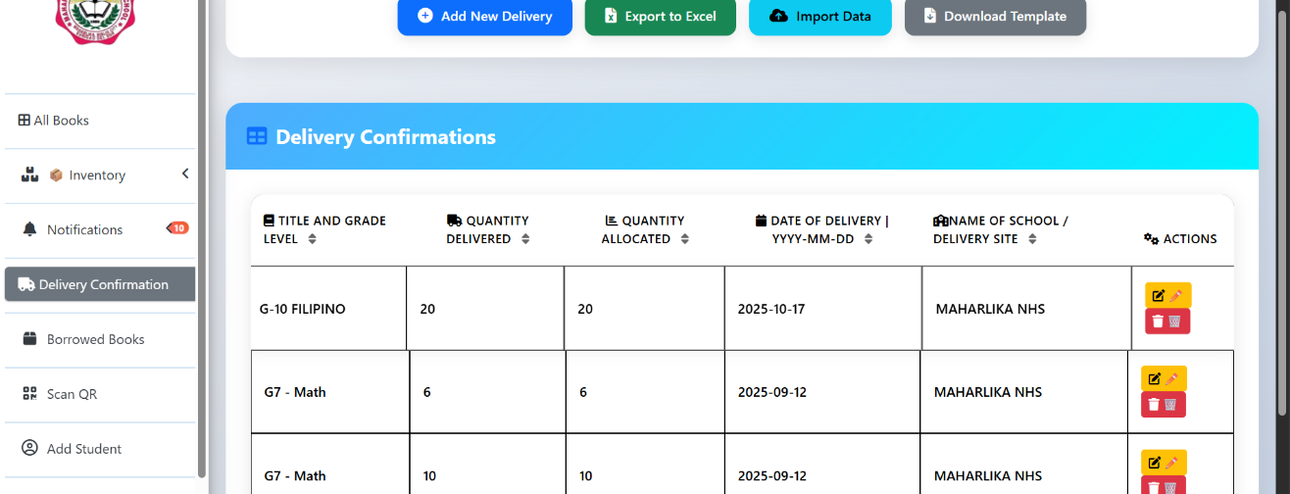
Figure 3.7 Principal & Librarian Can check the Delivery Confirmations by following their table list.
Figure 3.7 Principal & Librarian Delivery Confirmations
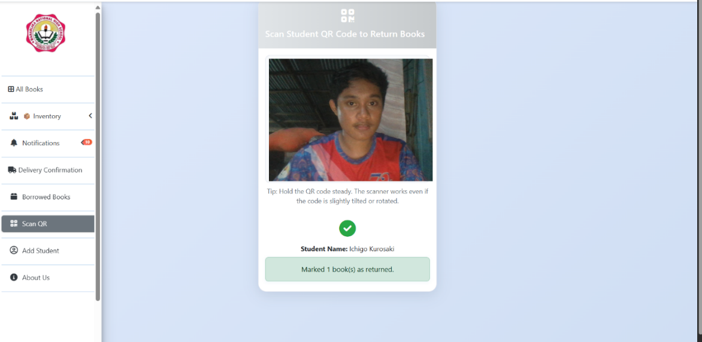
Figure 3.8 Shows where the Librarian Can scan QR code from Students to approve of return on multiple books.
Figure 3.8 QR Code Scanner
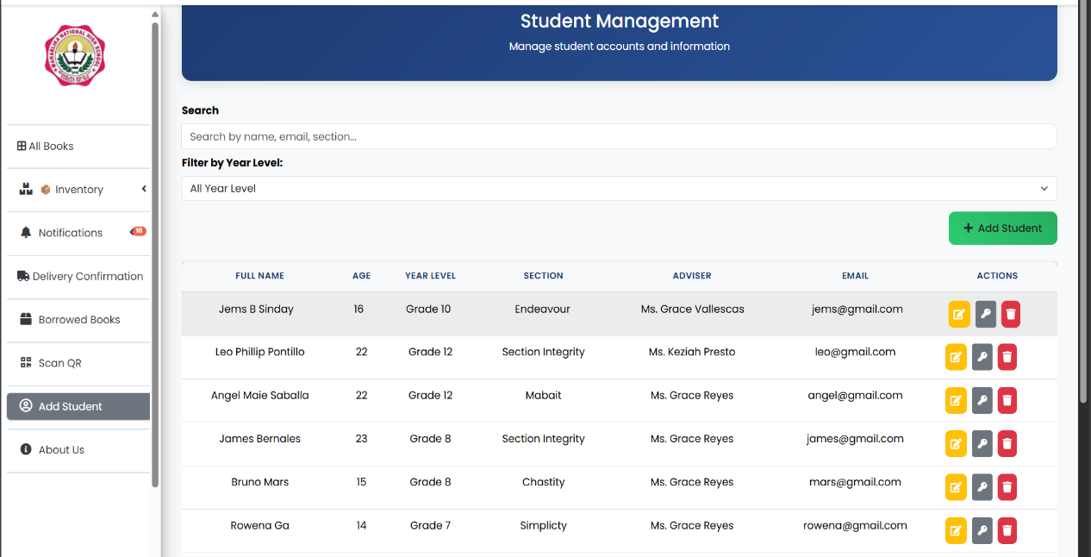
The Librarian and Principal manages students account. Where student can request to account creation to change password or names through librarian and Principal.
Figure 3.8 Students Accounts

Table 3.1 - Perceived Usefulness (PU)
Indicator | Mean | Adjective Rating
- I could do work easily now because of OIMS. | 4.40 | Strongly Agree
- Using the OIMS improves my job performance | 4.35 | Strongly Agree
- Using the OIMS helps my job productivity. | 4.30 | Strongly Agree
- I have found the OIMS useful in my job | 4.60 | Strongly Agree
Overall Mean | 4.41 | Strongly Agree
Legend: 1.00–1.79 = Strongly Disagree 1.80–2.59 = Disagree 2.60–3.39 = Moderately Agree 3.40–4.19 = Agree 4.20–5.00 = Strongly Agree
The perceived usefulness shows the users “Strongly Agree” with an overall mean score of 4.41. This result indicates that the system can improve the work performance and solve the problem.
Table 3.2 - Perceived Ease of Use (PEU)
Indicator | Mean | Adjective Rating
- Learning to Operate the OIMS was easy for me | 4.60 | Strongly Agree
- I found it easy to get the OIMS to do of what I want it to do | 4.50 | Strongly Agree
- My interaction with the OIMS has been clear and understanding | 4.40 | Strongly Agree
- It was easy for me to become skillful at using OIMS | 4.45 | Strongly Agree
Overall Mean | 4.48 | Strongly Agree
Legend: 1.00–1.79 = Strongly Disagree 1.80–2.59 = Disagree 2.60–3.39 = Moderately Agree 3.40–4.19 = Agree 4.20–5.00 = Strongly Agree
The Perceived Ease of Use (PEU) shows that users “Strongly Agree” with an overall score of 4.48. This data indicates that the system is convenient and helpful.

Table 3.3 - Behavioral Intension to use (BI)
Indicator | Mean | Adjective Rating
- I intend to use the system | 4.40 | Strongly Agree
- I will spend less time of applying manual method | 4.49 | Strongly Agree
- I plan to use the system | 4.40 | Strongly Agree
- I will use OIMS in the future | 4.44 | Strongly Agree
Overall Mean | 4.43 | Strongly Agree
Legend: 1.00–1.79 = Strongly Disagree 1.80–2.59 = Disagree 2.60–3.39 = Moderately Agree 3.40–4.19 = Agree 4.20–5.00 = Strongly Agree
The behavioral Intension to use (BI) the system. The data reveals that the user “Strongly Agree” with an overall score of 4.43. This shows that the target users look forward to use the system when it will be implemented.
Table 3.4 - Attitude Toward Using (ATU)
Indicator | Mean | Adjective Rating
- Using the OIMS make work easier | 4.60 | Strongly Agree
- Using the OIMS is a good idea | 4.50 | Strongly Agree
- Using the OIMS improves the quality if the that I do | 4.40 | Strongly Agree
- Using the OIMS enhances the effectiveness of my job | 4.45 | Strongly Agree
- The actual process of the system is pleasant | 4.50 | Strongly Agree
- I am excited about the parts of my job that involve using the system. | 4.65 | Strongly Agree
Overall Mean | 4.52 | Strongly Agree
Legend: 1.00–1.79 = Strongly Disagree 1.80–2.59 = Disagree 2.60–3.39 = Moderately Agree 3.40–4.19 = Agree 4.20–5.00 = Strongly Agree
The Attitude Toward Using (ATU) the system, The data shows that users “Strongly Agree” with an overall of 4.52. This suggest that the system can help the target user make their work easier and enhance their effective on their jobs.

Table 3.5 - Self Efficacy (SE)
Indicator | Mean | Adjective Rating
- I can automatically identify the marketing strategy without anybody interventions | 4.50 | Strongly Agree
- I have no problem classifying strategy | 4.45 | Strongly Agree
- I can handle the process of classifying strategy by watching someone doing it | 4.40 | Strongly Agree
- With simple instruction I can handle the process of classifying strategies on my own | 4.35 | Strongly Agree
Overall Mean | 4.42 | Strongly Agree
Legend: 1.00–1.79 = Strongly Disagree 1.80–2.59 = Disagree 2.60–3.39 = Moderately Agree 3.40–4.19 = Agree 4.20–5.00 = Strongly Agree
The Self Efficacy (SE) of the system data shows that users “Strongly Agree” with an overall mean score 4.42, indicating that they are motivated to perform their task and with ease to do it successfully with the aid of the system.
Table 3.6 - Perceive System Performance (PSP)
Indicator | Mean | Adjective Rating
- I can automatically identify the appropriate inventory management strategy without external assistance. | 4.45 | Strongly Agree
- I have no difficulty classifying inventory management strategies. | 4.50 | Strongly Agree
- I can learn to classify inventory strategies effectively by observing someone else. | 4.45 | Strongly Agree
- With minimal guidance, I can independently classify inventory management strategies. | 4.40 | Strongly Agree
Overall Mean | 4.45 | Strongly Agree
Legend: 1.00–1.79 = Strongly Disagree 1.80–2.59 = Disagree 2.60–3.39 = Moderately Agree 3.40–4.19 = Agree 4.20–5.00 = Strongly Agree
The Perceive System Performance (PSP) of the system. The data indicates that the users 'Strongly Agree' with an overall mean score of 4.45, confirming that the system’s performance is fast and reliable during its data retrieval.

Table 3.7 - Summary of extended technology acceptance
Indicator | Mean | Adjective Rating
Perceived Usefulness (PU) | 4.41 | Strongly Agree
Perceived Ease of Use (PEU) | 4.48 | Strongly Agree
Behavioral Intension of use (BI) | 4.43 | Strongly Agree
Attitudes towards using (ATU) | 4.52 | Strongly Agree
Self-Efficacy (SE) | 4.42 | Strongly Agree
Perceive System Performance (PSP) | 4.45 | Strongly Agree
Overall Mean | 4.45 | Strongly Agree
Legend: 1.00–1.79 = Strongly Disagree 1.80–2.59 = Disagree 2.60–3.39 = Moderately Agree 3.40–4.19 = Agree 4.20–5.00 = Strongly Agree
The overall Summary of the result of extended technology acceptance of the system. The data indicates that the Summary of extended technology acceptance shows 4.44 strongly agree. This shows the importance of the system implementation to their work.

Table 3.8 - Testing
Level of Testing | Testing Phase | Tester
unit | Functionality Test of individual components | Librarian
Integration | Functionality Test of individual components | Librarian, Users
system | Test of the entire system, | Librarian, Users, 2 Practice Teachers
Acceptance | Test of the final system | Librarians, Users, 2 Practice Teachers
Perceived Usefulness (PU) | 4.41 | Administrator, User
Perceive Ease-of-Use (PEU) | 4.48 | Administrator, User
Behavioral Intension to use (BI) | 4.43 | Administrator, Practice Teacher 1
Attitude towards using (ATU) | 4.52 | Practice Teacher 2
Self-Efficacy (SE) | 4.42 | Librarian
Perceived System Performance (PSP) | 4.45 | Librarian
Overall Mean | 4.45

The Online Inventory Management System (OIMS) has demonstrated a high level of end-user acceptance, as shown in Testing. The system received an overall adjectival rating of "Strongly Agree" with an overall mean score of 4.43.
Among the indicators, Perceived Ease of Use (PEU) and Behavioral Intention to Use (BI) had the highest mean scores of 4.48 and 4.43, indicating that users strongly agree that the system is user-friendly and that they intend to continue using it.
Perceived Usefulness (PU) had a mean score of 4.41, showing that users find the system beneficial in improving efficiency in inventory management. Attitude Towards Using (ATU) and Perceived System Performance (PSP) scored 4.52 and 4.45, respectively, confirming that users have a positive experience while using the system and that it performs reliably.
Lastly, Self-Efficacy (SE) received a mean of 4.42, suggesting that users feel confident in their ability to navigate and utilize the system effectively.
Overall, these results indicate that the OIMS is highly accepted, efficient, and easy to use, making it a valuable tool for inventory management.
Users "strongly agree" that they will use OIMS. Self-Efficacy (SE) had the lowest mean score of 4.43. However, this still indicates that users "strongly agree" that using OIMS enables them to perform necessary tasks efficiently, leading to improved performance outcomes.
Table 3.9 System Usability Indicators
- System Usability Indicators | Total score | N | Mean | Adj. Rating | Rank
- Clarity of system interface and navigation | 410 | 100 | 4.100 | Much Satisfactory | 2
- System availability and responsiveness | 410 | 100 | 4.100 | Much Satisfactory | 2
- Efficiency of system features and functionalities | 408 | 100 | 4.080 | Much Satisfactory | 4
- Relevance of system modules to user needs | 415 | 100 | 4.150 | Much Satisfactory | 1
- System performance and speed | 405 | 100 | 4.050 | Much Satisfactory | 5
- Clarity of system-generated reports and analytics | 398 | 100 | 3.980 | Much Satisfactory | 8
- User engagement and ease of completing tasks | 404 | 100 | 4.040 | Much Satisfactory | 6
- System adaptability to different user roles | 394 | 100 | 3.940 | Much Satisfactory | 10
- Effectiveness of system notifications and alerts | 400 | 100 | 4.000 | Much Satisfactory | 7
- Accuracy of recorded inventory data | 410 | 100 | 4.100 | Much Satisfactory | 7
- Accessibility of system for users with different levels of experience | 395 | 100 | 3.950 | Much Satisfactory | 9
- Integration of technology to enhance user productivity | 408 | 100 | 4.080 | Much Satisfactory | 4
- System reliability and minimal downtime | 410 | 100 | 4.100 | Much Satisfactory | 2
- Effectiveness of system feedback in improving user interaction | 398 | 100 | 3.980 | Much Satisfactory | 8
- Establishing a user-friendly environment for seamless system usage | 389 | 100 | 3.890 | Much Satisfactory | 11
Overall Mean |  |  | 4.036 | Much Satisfactory
Legend: 1.00–1.79 = Strongly Disagree 1.80–2.59 = Disagree 2.60–3.39 = Moderately Agree 3.40–4.19 = Agree 4.20–5.00 = Strongly Agree
Under the System Usability Indicators, the overall mean score is “Much Satisfactory,” with an overall mean score of 4.036. The top indicator is the “Relevance of system modules to user needs,” with a mean score of 4.110. The second spot is the “Clarity of system interface and navigation” and “System availability and responsiveness” with a mean of 4.110 each. While the bottom is “Establishing a user-friendly environment for seamless system usage” with mean score of 3.810 respectively.
The finding System Usability Indicators are most satisfied with the Relevance of system modules to user needs in System Usability Indicators provides an opportunity for the school librarian and student to highlight this use for school library inventory. With the use this system managing the books would fit their work flow. With a simple tutorial on how to use the system and its flow and requirement using the excel by providing an existing template that will be taught on how to use the system. On the other hand students that doesn’t have a phone or pc will find it a challenge for them to partake in the process but with others students finding it easy and making the library solve the issue of forming a line in the library to fill a requirement paper to borrow a book. With all students that have phones and access to the internet can use the system. The only solution for them is to ask for the librarian to fill it for them using the library pc on their behalf.
Table 16 shows that the school library and resources. On top is “Availability of PCs in the library for librarian use,” While on the bottom is “Support for librarians in managing book inventory,” With a mean score of 3.900 and 3.800.

Table 3.10 - Facilities and Resources
B. Facilities and Resources | Total score | N | Mean | Adj. Rating | Rank
- Availability of PCs in the library for librarian use | 390 | 100 | 3.900 | Much Satisfactory | 1
- Availability of phones/PCs for students to access the system | 388 | 100 | 3.880 | Much Satisfactory | 2
- Access to the internet on school grounds or via personal data | 386 | 100 | 3.860 | Much Satisfactory | 3
- Readiness of the system for book borrowing and inventory management | 385 | 100 | 3.850 | Much Satisfactory | 4
- Ease of use and accessibility of the system for students | 382 | 100 | 3.820 | Much Satisfactory | 5
- Support for librarians in managing book inventory | 380 | 100 | 3.800 | Much Satisfactory | 6
Overall Mean |  |  | 3.8517 | Much Satisfactory
Legend: 1.00–1.79 = Strongly Disagree 1.80–2.59 = Disagree 2.60–3.39 = Moderately Agree 3.40–4.19 = Agree 4.20–5.00 = Strongly Agree
An encouraging sign for the library management system is the discovery that the availability of resources and technology supports efficient book borrowing and inventory management. This implies that students and librarians can benefit from a more organized and accessible system. By integrating digital tools, the library can streamline operations and reduce the need for manual paperwork, improving overall user experience.
The data in Table 3.10 depicts the system’s accessibility and efficiency. It has gained an overall mean score of 3.8517 or an adjectival rating of "Much Satisfactory."
Table 3.11 - Student Support Service
C. Student Support Service | Total score | N | Mean | Adj. Rating | Rank
1. Overall view of availability stock of books | 4.05 | 100 | 4.050 | Much Satisfactory | 1
2. Can Reserve and Return books | 4.03 | 100 | 4.030 | Much Satisfactory | 2
3. Can have an account with the permission of the Administrator/Librarian | 4.03 | 100 | 4.030 | Much Satisfactory | 2
4. Overview the status of users and the books (Reserve, Returned, Rejected and approved.) | 4.00 | 100 | 4.000 | Much Satisfactory | 3
Overall Mean |  |  | 4.0275 | Much Satisfactory

This finding represents that the School Student Support Service are generally “Much Satisfactory,” which shows a positive indicator for Inventory Management. It means the system is a good investment for Librarian and student for school service. Highlighting that shows the system helps with work flow and student needs.
The data on table 3.12 Real-time Generating Report shows
Table 3.12 - Real-time Generating Report
D. Real-time Generating Report | Total score | N | Mean | Adj. Rating | Rank
Monitor the updates of users status (borrowed, returned,). | 412 | 100 | 4.120 | Much Satisfactory | 1
Monitor the number of users/students | 410 | 100 | 4.100 | Much Satisfactory | 2
Monitor the status of Books available | 405 | 100 | 4.050 | Much Satisfactory | 3
Can view source of Acquisition (donation from government or organization) | 400 | 100 | 4.000 | Much Satisfactory | 4
Excel Support for multiple book Import | 399 | 100 | 3.990 | Much Satisfactory | 5
Overall Mean |  |  | 4.0520 | Much Satisfactory

This table indicates that all the monitored functions are highly satisfactory to the users, with the highest satisfaction for monitoring user status updates and the lowest and though still high for viewing the source of acquisition.
Table 3.13 - PHP Unit Framework for PHP test
Test case | description | Expected outcome
 | The system should allow users to log in and log out securely. | Functioning
 | The system should allow users to borrow books.. | Functioning
 | The system should allow users to return borrowed books. | Functioning
 | The system should send a notification when a user requests to borrow a book. | Functioning
 | The system should send a notification when a user requests to borrow a book. | Functioning
 | The system should update stock numbers in real-time when books are borrowed or returned. | Functioning
 | The administrator should be able to view the overall status of users borrowed books. | Functioning
 | The administrator should be able to approve or reject book borrow requests. | Functioning
 | The system should allow mass import of books via an Excel file. | Functioning
 | The system should allow administrators to update book details. | Functioning
 | The system should allow administrators to delete books. | Functioning

PHP UNIT functionality testing
Functionality testing was conducted using PHP Unit to verify that the developed system performs as expected. The test cases were created based on the functional requirements of the system, and PHPUnit was utilized to automate the execution of these tests. The tests focused on ensuring that individual components, such as functions and methods, of the system work as intended by validating the outputs against predefined expected results. Through PHP Unit's assertion methods, such as assertNotFalse(), assertEquals(), assertNotFalse() and assertGreaterThan(). the researcher was able to confirm that the system behaves correctly according to the functional specifications. This testing process was crucial in ensuring that the system's core functionalities were reliable and error-free, without requiring an in-depth examination of the internal code structure.

Chapter 4
SUMMARY, CONCLUSION, AND RECOMMENDATION
Summary
The study, Development of a Local Online Inventory Management System for Maharlika National High School Library Using the Agile Model, aimed to design and implement a web-based system to enhance the efficiency of library inventory management. Applying to the work-flow without disruptions to their working hours accessible to pc and smartphone with Wi-Fi or data service, and evaluate the developed system through the use of the Extended Technology Acceptance Model.
The study has 3 key figures first is Admin oversee the system and manages the inventory, student and librarian accounts can check the reports of system real time, The second is Librarian handles the inventory and students accounts capable of adding book in single and bulk imports, Export data from system to Excel and also check the system reports real time. Students can borrow and return books for accurate record for inventory management, they may see the list of history of books they borrowed and return.
The system evaluation shows the extended technology acceptance with an overall mean of 4.48. This indicates strongly agrees that the system meets the stated applied task of the users under the usage condition. The survey indicates that student are generally much satisfied with the proposed system implemented to their work.

Conclusion
This study developed to Online Inventory Management shows that with the aid of the proposed system help make many things for them to handle their work with ease and efficiency and faster future making decision and handling the library inventory. The system used MQTT for real time updates on any changes or actions taken by the users.
The system evaluation showed that Development of a Local Online Inventory Management System for Maharlika National High School Library Using the Agile Model has a 4.52 high acceptance rating of Attitude towards using (ATU). This shows the users shows strongly agree the system performance and user friendly that using the system will lessen the work load and book Monitoring and evades the loss of printed record solved. The second highest would be Perceived Ease of Use (PEU) 4.48 which indicates strongly agree on firmly tailored for their purpose and work-related use. And the third highest in the rating is Perceived System Performance (PSP) 4.45 which resulted strongly agree on the users test side, which still shows a strongly agree rating. Self-Efficacy (SE) 4.41 indicating strongly agree during interview. And for the Perceived Usefulness (PU) 4.41 indicates strongly agree shows the users favors the system use and lastly the indicator of Behavioral Intension of use (BI) 4.32 shows the lowest but the result shows strongly agree.
The finding of this study shows the online inventory management suggest the value of the system has high regards of the users has a high potential to help managed school library and improve their work flow and achieve their current problem.

Recommendation:
Based on the conclusions and findings of this study, the following recommendations are proposed to further enhance the effectiveness and sustainability of the Local Online Inventory Management System for Maharlika National High School Library:
- System Enhancements: Regularly update the software and implement automated data backups to ensure smooth operation and prevent data loss.
- Training & Support: Conduct ongoing training for library staff and establish a helpdesk for troubleshooting issues.
- Improved User Interface: Simplify the system’s user interface and consider creating a mobile-friendly version or app for easier access.
- System Integration & Scalability: Integrate the system with other school platforms and ensure it can scale to accommodate growth in users and resources.
- Monitoring & Evaluation: Implement regular evaluations and feedback surveys to assess system performance and identify areas for improvement.
- User Awareness & Engagement: Promote the system to students and staff through workshops and campaigns, encouraging active usage.
- Budgeting & Resource Allocation: Ensure sufficient budget for system maintenance, upgrades, and long-term sustainability, considering potential external funding sources.

This condensed version captures the main points for improving the system’s effectiveness and sustainability. Let me know if you'd like further adjustments.

References
1. Existing Problems in Library Management
- International Federation of Library Associations and Institutions (IFLA). (2022). "Challenges in Traditional Library Management Systems."
- Department of Education (DepEd) ICT Policies – Guidelines on digital transformation in school library systems (DepEd Order No. 47, s. 2016).

2. Factors Contributing to Library Inefficiencies
- IFLA & UNESCO (2021). "The Role of Technology in Modernizing Library Inventory Management."
- Beck, K. (1999). "Extreme Programming Explained: Embrace Change." Addison-Wesley. (Discusses the impact of outdated manual processes in organizations.)
- Evergreen Library System Documentation – Explains the limitations of traditional library systems and the need for automation.

3. Proposed Solution: Web-Based Library Inventory Management System
- Koha Open-Source Library System Documentation – A real-world example of web-based library inventory management.
- Pressman, R. S. (2020). "Software Engineering: A Practitioner’s Approach." McGraw-Hill. (Covers Agile SDLC and system development best practices.)
- Schwaber, K., & Sutherland, J. (2017). "The Scrum Guide." Scrum.org. (Relevant to Agile implementation in system development.)
- Welling, L., & Thomson, L. (2016). "PHP and MySQL Web Development." Addison-Wesley. (Technical reference for developing a web-based system.)
- Bootstrap 5.3 & AdminLTE Documentation – Best practices for frontend development in library management systems.

Title: What is Agile Methodology?
https://www.geeksforgeeks.org/what-is-agile-methodology/ Last Updated : 23 Sep, 2024
Title: Agile Development Plan for a Library System: A 10-Sprint Roadmap
Link:https://guides.visual-paradigm.com/agile-development-plan-for-a-library-system-a-10-sprint-roadmap-real-life-example-and-templates/
Title: Scrum (software development)
Link: https://en.wikipedia.org/wiki/Scrum_%28software_development%29
Title: Real-Time Web Application Development with PHP, MySQL, and MQTT
Link: https://www.emqx.com/en/blog/how-to-use-mqtt-in-php
Title: How to Leverage Mosquitto MQTT Broker in PHP Project
Link: https://cedalo.com/blog/php-mosquitto-mqtt-broker/
Title: GeeksforGeeks. (2024). Library management system project. GeeksforGeeks.
Link:https://www.geeksforgeeks.org/library-management-system/?utm_source=chatgpt.com

System architecture
Link: https://www.interviewbit.com/blog/system-architecture/
Link: https://openclassrooms.com/en/courses/6397806-develop-architecture-designs-with-industry-standard-patterns/6896176-layered-architecture
Flow Chart
Link: https://www.geeksforgeeks.org/an-introduction-to-flowcharts/
ERD
Link: https://www.lucidchart.com/pages/er-diagrams
Link: https://www.lucidchart.com/pages/er-diagrams

APPENDICES

APPENDIX A

APPENDIX B
SURVEY QUESTIONNAIRE
QUESTIONAIRE
Development of a Local Online Inventory Management System for Maharlika National High School using Agile model.
The Table Below Will Ask About The System Rating. 1 Poor, 2 Fair, 3 Good, 4 Excellent. The purpose of this questionnaire is to gather information on inventory management practice for Maharlika National High School. Your Responses Will Be Kept Confidential And Used Solely For Academic Research.
Name (optional): ___________________________
Type of user: Admin _______ Student_______ Librarian _______
Indicators | 1  Poor | 2  Fair | 3  Good | 4  Excellent
- How accurate is the inventory data?
- How responsive is the inventory system to users?
- How secure is the login process on the website?
- How satisfied are you with using the system?
- How would you rate the overall performance of the system?
- Is user access properly restricted based on roles?
- Is the system accurate of the book data?

The purpose of this interview is to gather insights regarding your experience and perspective on Development of a Local Online Inventory Management System for Maharlika National High School using Agile model. Your feedback will provide valuable information. The responses you provide will be kept confidential and used solely for academic research purposes. Please answer the following questions as openly and honestly as possible.
Questions
- What was your approach to managing inventory before using our system?
- What challenges did you face when managing inventory before implementing our system?
- Did our system significantly resolve the issues you experienced with inventory management?
- Did you encounter any errors or bugs during the trial phase of our system?
5. Can you describe how our system has impacted your workflow and working hours?
6. Was the system updated based on feedback?
7. Did the system adapt to your changing requirements?
The Extended Technology Acceptance evaluates how technology is adopted in academic institutions by assessing factors like ease of use, usefulness, and user experience. When rating a system, consider how it enhances decision-making, improves efficiency, and supports institutional goals. Your evaluation should reflect the system’s overall impact on academic processes.
Please read the following statements, and then tick the box next to each one to show how much you agree with it.
1. Strong Disagree 2. Disagree 3.Moderately Agree
4. Agree 5. Strongly Agree
Part 1: Profile
Name (optional): ___________________________
Type of user: Admin _______ Student_______ Librarian _______
Perceived Usefulness (PU)
Indicators | 1  Poor | 2  Fair | 3  Good | 4  Excellent
1. I could to do things more easily in my work because of the OLIMS recommended
2. Using the OLIMS improves my job performance.
3.Using the OLIMS in my job increases my productivity
4. I am more productive at work when I use the.
5. Using the OLIMS makes it easier to do my job.
6. I have found the OLIMS useful in my job.
7. Learning to operate the OLIMS Recommender was easy for me
8. I found it easy to get the OLIMS to do what t want it to do.
9. My interaction with the OLIMS has been dear and understandable.
10. I found the OLIMS to be flexible to interact with.
11. It was easy for me to become skillful at using the OLIMS.
12. I found the OLIMS easy to use.

Perceived Ease of Use (PEU)
Indicator | Mean | Adjective Rating
- Learning to Operate the OLIMS was easy for me | 4.60 | Strongly Agree
- I found it easy to get the OLIMS to do of what I want it to do | 4.50 | Strongly Agree
- My interaction with the OLIMS has been clear and understanding | 4.40 | Strongly Agree
- It was easy for me to become skillful at using OLIMS | 4.45 | Strongly Agree
Overall Mean | 4.48 | Strongly Agree

Behavioral Intension to use (BI)
Indicators | 1  Poor | 2  Fair | 3  Good | 4  Excellent
13. I intend to use the system
14. I will spend less time on routine job tasks.
15. I plan to use the system
16. I will use OLIMS in the future.
17. I like working with the OLIMS.
18. I look forward to that job that requires me to use OLIMS.

Attitude towards using (ATU)
Indicators | 1  Poor | 2  Fair | 3  Good | 4  Excellent
19. Using the OLIMS make work easier
20. Using the OLIMS is a good idea
21. Using the OLIMS improves the quality of work that I do.
22. Using the OLIMS enhances the effectiveness of my job
23. The actual process of using the system is pleasant.
24. I look forward to those aspects of my job that require me to use the system.

Self-Efficacy (SE)
Indicators | 1  Poor | 2  Fair | 3  Good | 4  Excellent
25. I can efficiently manage book inventory without external assistance
26. I have no difficulty organizing and Monitoring book transactions.
27. I can effectively learn to manage book borrowing with OILMS and returning by observing someone else.
28. With simple instructions, I can handle the book management process independently.

Perceive System Performance (PSP)
Indicators | 1  Poor | 2  Fair | 3  Good | 4  Excellent
29. I can automatically identify the appropriate inventory management system without mininal assistance.
30. I have no difficulty classifying inventory management.
31. I can learn to classify inventory with the system availability.
32. With minimal guidance, I can independently classify inventory management.

CURRICULUM VITAE



Email: gaelygian79@gmail.com
Date of Birth : February 1, 2003
Civil Status : Single
Parents : Florante Q. Ga, Rowena Ga

EDUCATIONAL BACKGROUND:
Elementary : San Roque Central Elementary School
San Roque, Bislig City
SY 2015 – 2016

Secondary : Maharlika National High School
Maharlika P-2, Bislig City
SY 2016 – 2020 JHS
SY 2020 - 2022 SHS

College : Andres Soriano Colleges of Bislig
SY 2022-2025

Course : Bachelor of Science Information Technology


Email: maryjeanborja0@gmail.com
Date of Birth : August 12, 2004
Civil Status : Single
Parents : Pedro Noly Z. Borja, Marciana F. Borja

EDUCATIONAL BACKGROUND:
Elementary : San Roque Central Elementary School
San Roque, Bislig City
SY 2015 – 2016

Secondary : Maharlika National High School
Maharlika P-2, Bislig City
SY 2016 – 2020 JHS
SY 2020 - 2022 SHS

College : Andres Soriano Colleges of Bislig
SY 2022-2025

Course : Bachelor of Science Information Technology


Email: jemssinday488gmail.com
Date of Birth : May 17, 2001
Civil Status : Single
Parents : Enriquita B. Sinday, Melanio S. Sinday

EDUCATIONAL BACKGROUND:
Elementary : Mangagoy North Elementary School
Andres Soraino Ave, Bislig City
SY 2009 – 2014

Secondary : Mangagoy National High School
Requina Ext P-8, Bislig City
SY 2014 – 2018 JHS
SY 2018 - 2020 SHS

College : Andres Soriano Colleges of Bislig
SY 2022-2025

Course : Bachelor of Science Information Technology



Email: junelsotil264@gmail.com
Date of Birth : August 21, 2003
Civil Status : Single
Parents : Carlos Sotil, Josefa M. Sotil

EDUCATIONAL BACKGROUND:
Elementary : Olayvar Elementary School
Olayvar, Bislig City
SY 2015 – 2016

Secondary : Southern Technological Institution of the Philippines
Mangagoy, Bislig City
SY 2019 – 2020 JHS

Andres Soriano Colleges of Bislig
Mangagoy, Bislig City
SY 2021 - 2022 SHS

College : Andres Soriano Colleges of Bislig
SY 2022-2025

Course : Bachelor of Science Information Technology



Email: sansimbasanez21@gmail.com

Date of Birth : April 21, 2002
Civil Status : ​ Single
Parents : Santos Basañez Fe Basañez

EDUCATIONAL BACKGROUND:
Elementary : ​ Balingan Elementary School
​​​ Brgy. Comawas Bislig City
​​​ SY 2014 - 2015

Secondary : Bislig City National High School
​​​ Bislig City
​​​ SY 2016 – 2019 JHS

Andres Soriano Colleges of Bislig
Mangagoy, Bislig City
​​​ SY 2020 - 2021 SHS

College : Andres Soriano Colleges of Bislig
​​​ SY 2022-2025

Course : Bachelor of Science Information Technology

