Math 342 Final Project: Sea Temperatures
2025-04-29
library(readr)
library(dplyr)
##
## Attaching package: 'dplyr'
## The following objects are masked from 'package:stats':
##
## filter, lag
## The following objects are masked from 'package:base':
##
## intersect, setdiff, setequal, union
library(ggplot2)
library(forecast)
## Warning: package 'forecast' was built under R version 4.4.3
## Registered S3 method overwritten by 'quantmod':
## method from
## as.zoo.data.frame zoo
library(mgcv)
## Loading required package: nlme
##
## Attaching package: 'nlme'
## The following object is masked from 'package:forecast':
##
## getResponse
## The following object is masked from 'package:dplyr':
##
## collapse
## This is mgcv 1.9-1. For overview type 'help("mgcv-package")'.
library(tibble)
library(tseries)
## Warning: package 'tseries' was built under R version 4.4.3
data <- read_csv("sea-surface-temp.csv", skip = 6,
locale = locale(encoding = "UTF-8"))
## Rows: 141 Columns: 4
## ── Column specification ────────────────────────────────────────────────────────
## Delimiter: ","
## dbl (4): Year, Annual anomaly, Lower 95% confidence interval, Upper 95% conf...
##
## ℹ Use `spec()` to retrieve the full column specification for this data.
## ℹ Specify the column types or set `show_col_types = FALSE` to quiet this message.
cleaned_data <- data %>%
filter(!is.na(Year)) %>%
mutate(across(where(is.character), as.numeric))
ts_data <- ts(cleaned_data$`Annual anomaly`, start = 1880, end = 2020, frequency = 1)
plot(ts_data)
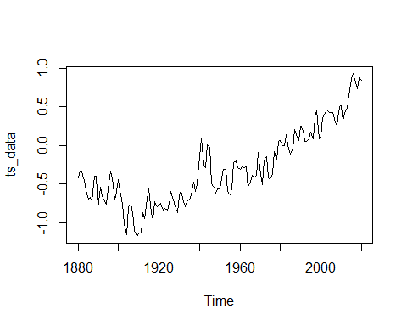
adf.test(ts_data)
##
## Augmented Dickey-Fuller Test
##
## data: ts_data
## Dickey-Fuller = -2.1558, Lag order = 5, p-value = 0.5116
## alternative hypothesis: stationary
ts_diff <- diff(ts_data)
adf.test(ts_diff)
## Warning in adf.test(ts_diff): p-value smaller than printed p-value
##
## Augmented Dickey-Fuller Test
##
## data: ts_diff
## Dickey-Fuller = -6.584, Lag order = 5, p-value = 0.01
## alternative hypothesis: stationary
plot(ts_diff)
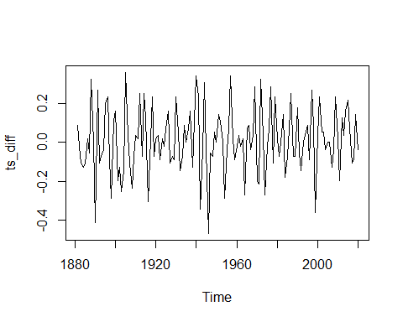
cleaned_data$Year2 <- cleaned_data$Year^2
cleaned_data$Year3 <- cleaned_data$Year^3
poly_model <- lm(`Annual anomaly` ~ Year + Year2 + Year3, data = cleaned_data)
summary(poly_model)
##
## Call:
## lm(formula = `Annual anomaly` ~ Year + Year2 + Year3, data = cleaned_data)
##
## Residuals:
## Min 1Q Median 3Q Max
## -0.43422 -0.11955 -0.00479 0.10381 0.69071
##
## Coefficients:
## Estimate Std. Error t value Pr(>|t|)
## (Intercept) 5.173e+03 2.197e+03 2.355 0.0199 *
## Year -7.736e+00 3.381e+00 -2.288 0.0236 *
## Year2 3.847e-03 1.734e-03 2.218 0.0282 *
## Year3 -6.359e-07 2.964e-07 -2.145 0.0337 *
## ---
## Signif. codes: 0 '***' 0.001 '**' 0.01 '*' 0.05 '.' 0.1 ' ' 1
##
## Residual standard error: 0.1864 on 137 degrees of freedom
## Multiple R-squared: 0.8571, Adjusted R-squared: 0.854
## F-statistic: 273.9 on 3 and 137 DF, p-value: < 2.2e-16
residuals_poly <- residuals(poly_model)
ts_resid <- ts(residuals_poly, start = 1880, frequency = 1)
plot(ts_resid)
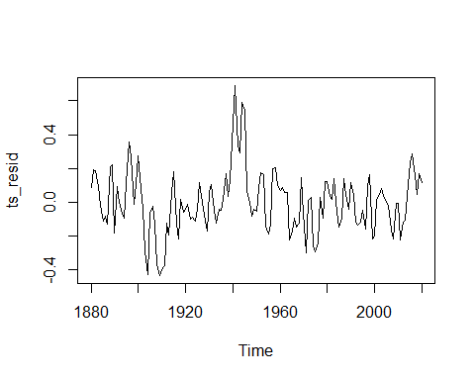
adf.test(ts_resid)
##
## Augmented Dickey-Fuller Test
##
## data: ts_resid
## Dickey-Fuller = -3.4128, Lag order = 5, p-value = 0.05532
## alternative hypothesis: stationary
arma_model <- auto.arima(ts_resid, stationary = TRUE, seasonal = FALSE)
summary(arma_model)
## Series: ts_resid
## ARIMA(2,0,3) with zero mean
##
## Coefficients:
## ar1 ar2 ma1 ma2 ma3
## -0.1335 0.7649 0.9769 -0.4111 -0.4603
## s.e. 0.1373 0.1240 0.1616 0.2591 0.1378
##
## sigma^2 = 0.01902: log likelihood = 81.27
## AIC=-150.53 AICc=-149.91 BIC=-132.84
##
## Training set error measures:
## ME RMSE MAE MPE MAPE MASE
## Training set 0.0003486402 0.135438 0.1070939 94.83983 227.1512 0.8593026
## ACF1
## Training set -0.0222508
future_years <- data.frame(
Year = 2024:2030,
Year2 = (2024:2030)^2,
Year3 = (2024:2030)^3
)
trend_forecast <- predict(poly_model, newdata = future_years)
resid_forecast <- forecast(arma_model, h = 7)$mean
combined_forecast <- trend_forecast + resid_forecast
historical_years <- cleaned_data$Year
forecast_years <- 2024:2030
full_years <- c(historical_years, forecast_years)
full_values <- c(fitted(poly_model) + arma_model$fitted, combined_forecast)
plot(full_years, full_values, type = "l", col = "blue")
lines(cleaned_data$Year, cleaned_data$`Annual anomaly`)
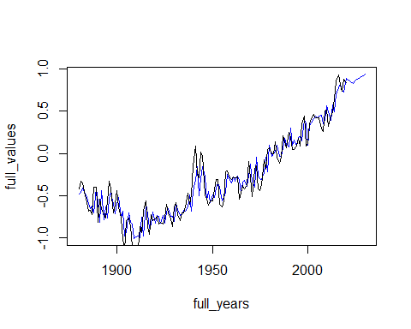
arima_model <- auto.arima(ts_data)
summary(arima_model)
## Series: ts_data
## ARIMA(1,1,3) with drift
##
## Coefficients:
## ar1 ma1 ma2 ma3 drift
## -0.9434 0.8987 -0.5404 -0.5152 0.0090
## s.e. 0.0492 0.0877 0.0933 0.0812 0.0054
##
## sigma^2 = 0.02131: log likelihood = 72.88
## AIC=-133.77 AICc=-133.14 BIC=-116.12
##
## Training set error measures:
## ME RMSE MAE MPE MAPE MASE
## Training set -0.0008190663 0.1428312 0.1115369 7.490705 63.92999 0.8906665
## ACF1
## Training set -0.02827847
autoplot(arima_model)
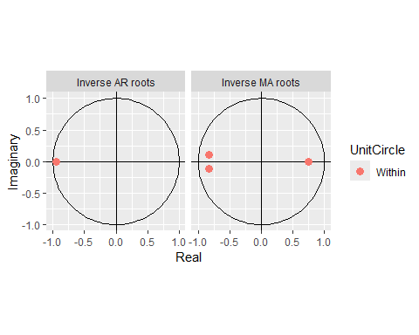
autoplot(forecast(arima_model, h = 10))
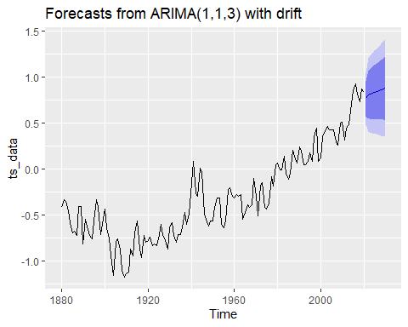
ets_model <- ets(ts_data)
summary(ets_model)
## ETS(A,N,N)
##
## Call:
## ets(y = ts_data)
##
## Smoothing parameters:
## alpha = 0.7575
##
## Initial states:
## l = -0.4012
##
## sigma: 0.1624
##
## AIC AICc BIC
## 189.1233 189.2985 197.9696
##
## Training set error measures:
## ME RMSE MAE MPE MAPE MASE
## Training set 0.01163872 0.1612166 0.1259089 22.30376 73.41161 1.005433
## ACF1
## Training set 0.09267935
autoplot(ets_model)
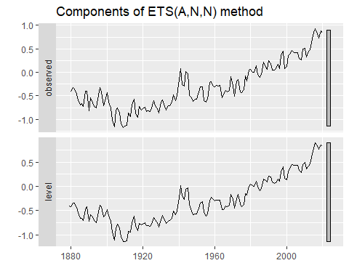
autoplot(forecast(ets_model, h = 10))
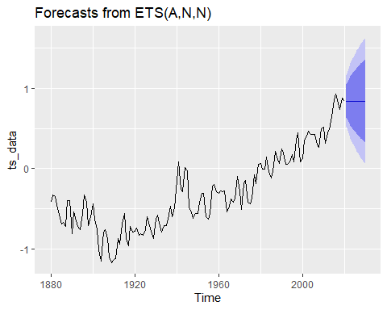
gam_data <- cleaned_data %>% select(Year, Anomaly = `Annual anomaly`)
gam_model <- gam(Anomaly ~ s(Year), data = gam_data)
summary(gam_model)
##
## Family: gaussian
## Link function: identity
##
## Formula:
## Anomaly ~ s(Year)
##
## Parametric coefficients:
## Estimate Std. Error t value Pr(>|t|)
## (Intercept) -0.30038 0.01361 -22.07 <2e-16 ***
## ---
## Signif. codes: 0 '***' 0.001 '**' 0.01 '*' 0.05 '.' 0.1 ' ' 1
##
## Approximate significance of smooth terms:
## edf Ref.df F p-value
## s(Year) 7.586 8.499 133.8 <2e-16 ***
## ---
## Signif. codes: 0 '***' 0.001 '**' 0.01 '*' 0.05 '.' 0.1 ' ' 1
##
## R-sq.(adj) = 0.89 Deviance explained = 89.6%
## GCV = 0.027822 Scale est. = 0.026128 n = 141
ggplot(gam_data, aes(x = Year, y = Anomaly)) +
geom_line(aes(y = fitted(gam_model)))
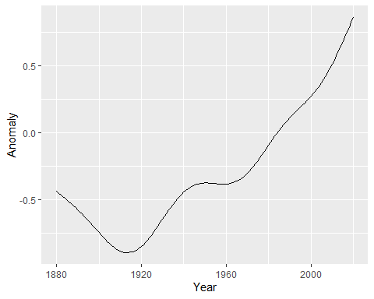
future_years <- tibble(Year = 2021:2030)
future_preds <- predict(gam_model, newdata = future_years, se.fit = TRUE)
future_forecast <- future_years %>%
mutate(
fit = future_preds$fit,
lower = fit - 2 * future_preds$se.fit,
upper = fit + 2 * future_preds$se.fit
)
combined_data <- bind_rows(
gam_data %>% mutate(type = "historical"),
future_forecast %>% rename(Anomaly = fit) %>% mutate(type = "forecast")
)
ggplot(combined_data, aes(x = Year, y = Anomaly)) +
geom_point(data = filter(combined_data, type == "historical")) +
geom_line(size = 1) +
geom_ribbon(
data = filter(combined_data, type == "forecast"),
aes(x = Year, ymin = lower, ymax = upper),
alpha = 0.2, inherit.aes = FALSE
)
## Warning: Using `size` aesthetic for lines was deprecated in ggplot2 3.4.0.
## ℹ Please use `linewidth` instead.
## This warning is displayed once every 8 hours.
## Call `lifecycle::last_lifecycle_warnings()` to see where this warning was
## generated.
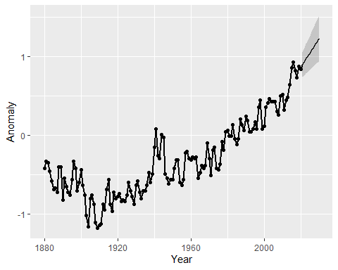
checkresiduals(arima_model)
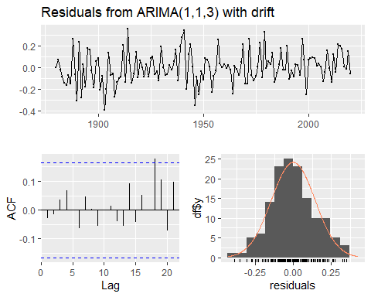
##
## Ljung-Box test
##
## data: Residuals from ARIMA(1,1,3) with drift
## Q* = 2.4303, df = 6, p-value = 0.8762
##
## Model df: 4. Total lags used: 10
checkresiduals(ets_model)
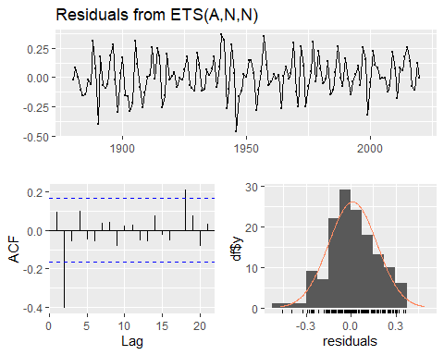
##
## Ljung-Box test
##
## data: Residuals from ETS(A,N,N)
## Q* = 29, df = 10, p-value = 0.001246
##
## Model df: 0. Total lags used: 10

