Lab Assignment No.: 01

NAME: Atharva Mali ROLL NO: 30
NAME: Laukik Avhad ROLL NO: 31
NAME: Avinash Gedam ROLL NO: 32
NAME: Manas Baviskar ROLL NO: 40

CLASS: ET-A BRANCH: E&TC BATCH: Batch 2 GROUP: 3

DATE OF PERFORMANCE: 21/02/2022

Question: Design a static web page, to demonstrate the use of different HTML tags.

CODE:
<html>

<head>
<style>
.city {
padding: 10px;
text-align: center;
}

.center {
display: block;
margin-left: auto;
margin-right: auto;
}

body {
background-image: url('https://source.unsplash.com/featured/?beach');
background-repeat: no-repeat;
background-attachment: fixed;
background-size: cover;
}

</style>

<title>
Book My Travel
</title>
</head>

<body>
<h1 class="city">
Book My Travel
</h1>

<h2>
Why to tour with Us?
</h2>
<p>
Lorem ipsum dolor sit amet, consectetur adipiscing elit. Sed vestibulum lectus at metus blandit congue. Quisque egestas finibus lectus, vel scelerisque ipsum fringilla ac.
</p>

<hr>
<br>

<div style="width: 50%; float:left">
<video src = "http://commondatastorage.googleapis.com/gtv-videos-bucket/sample/ElephantsDream.mp4" width = "640" controls></video>
</div>

<div style="width: 50%; float:right">

<table class="center">
<tr>
<th>Destination</th>
<th>Days</th>
<th>Expense</th>
</tr>

<tr>
<td>Scandinavia</td>
<td>10</td>
<td>$1000</td>
</tr>
<tr>
<td>Bali</td>
<td>14</td>
<td>$1500</td>
</tr>
<tr>
<td>Europe</td>
<td>21</td>
<td>$2000</td>
</tr>

</table>
</div>

<hr>

<h3>
Contact Us
</h3>

<a href="https://en.wikipedia.org/wiki/Main_Page" target="_blank"><img src="https://img.icons8.com/ios/50/000000/wikipedia.png"/></a>
<a href="https://about.facebook.com/meta/" target="_blank"><img src="https://img.icons8.com/fluency/48/000000/meta.png"/></a>
<a href="https://www.instagram.com/" target="_blank"><img src="https://img.icons8.com/color/48/000000/instagram-new--v2.png"/></a>

</body>

</html>

Result:
Landing page:

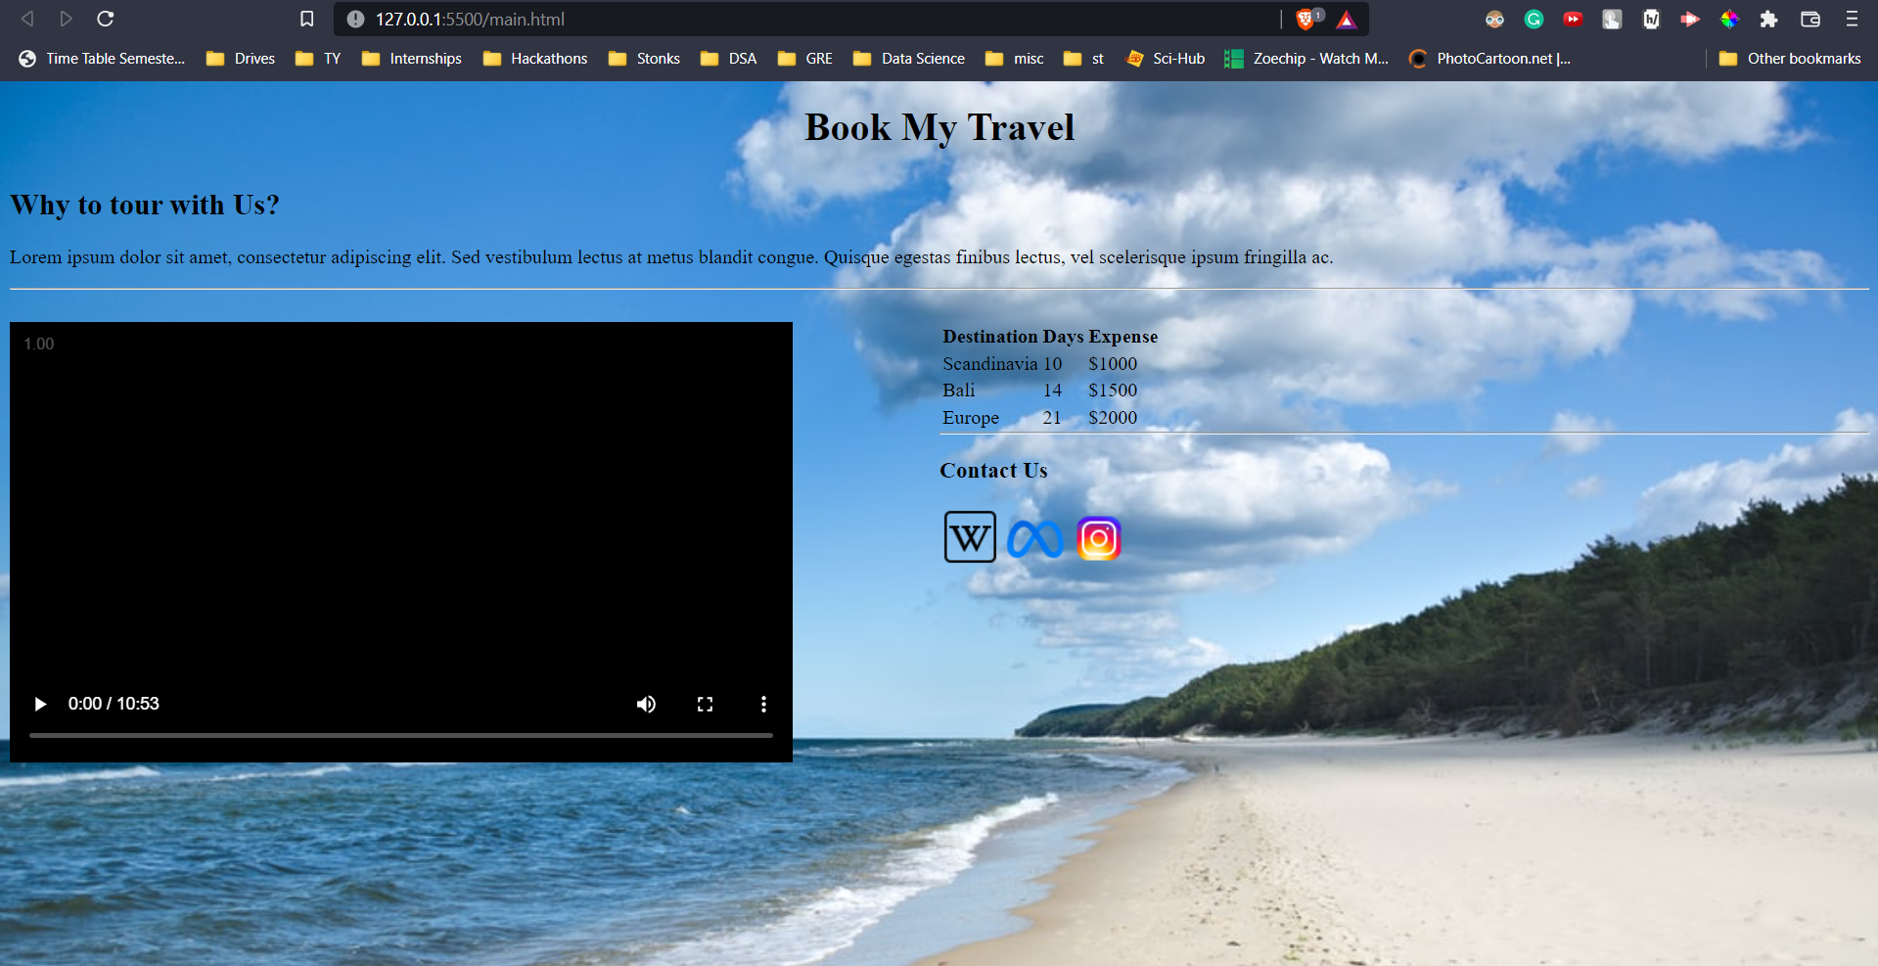

Link to WebPage

Conclusion:
- The use of various HTML tags was demonstrated.
- A webpage for a travel website was developed.
- A background image, video, and hyperlink images were added as a part of the assignment.

