Lab Assignment No.: 02

NAME: Atharva Mali ROLL NO: 30
NAME: Laukik Avhad ROLL NO: 31
NAME: Avinash Gedam ROLL NO: 32
NAME: Manas Baviskar ROLL NO: 40

CLASS: ET-A BRANCH: E&TC BATCH: Batch 2 GROUP: 3

DATE OF PERFORMANCE: 07/03/2022

Question: Design a form for student registration using HTML tags.

HTML CODE:
<!DOCTYPE html>
<html lang="en">
<head>
<meta charset="UTF-8" />
<meta http-equiv="X-UA-Compatible" content="IE=edge" />
<meta name="viewport" content="width=device-width, initial-scale=1.0" />
<title>Student Details</title>
<link href="https://fonts.googleapis.com/css?family=Roboto:300,400,500,700" rel="stylesheet">
<link rel="stylesheet" href="https://use.fontawesome.com/releases/v5.5.0/css/all.css" integrity="sha384-B4dIYHKNBt8Bc12p+WXckhzcICo0wtJAoU8YZTY5qE0Id1GSseTk6S+L3BlXeVIU" crossorigin="anonymous">
<link rel="stylesheet" href="forms.css">

</head>
<body>
<div class="testbox">
<form action="" >
<header><h1>Student Details</h1></header>
<h2>Personal Information</h2>

<div class="item">
<label for="name">Name<span>*</span></label>
<div class="name-item">
<input id="name" type="text" placeholder="First" required/>
<input type="text" placeholder="Last" required/>
</div>
</div>

<div class="item">
<label for="email">Email<span>*</span></label>
<input id="email" type="email" required/>
</div>

<div class="item">
<label for="phone">Phone Number<span>*</span></label>
<input id="phone" type="text" required/>
</div>

<div class="item">
<label for="address">Address</label>
<textarea id="address" rows="3"></textarea>
</div>

<div class="item">
<label for="pincode">Pincode<span>*</span></label>
<input id="pincode" type="text" required/>
</div>

<div class="item">
<label for="bdate">Date of Birth<span>*</span></label>
<input id="bdate" type="date" required/>
</div>

<div class="item">
<label for="bgrp">Blood Group<span>*</span></label>
<select id="bgrp">
<option value="">-- Select --</option>
<option value="">A+</option>
<option value="">A-</option>
<option value="">B+</option>
<option value="">B-</option>
<option value="">O+</option>
<option value="">O-</option>
<option value="">AB+</option>
<option value="">AB-</option>
</select>
</div>

<h2>Parents' Information</h2>
<h3>Father</h3>
<div class="item">
<label for="name">Name<span>*</span></label>
<div class="name-item">
<input id="name" type="text" placeholder="First" required/>
<input type="text" placeholder="Last" required/>
</div>
</div>

<div class="item">
<label for="email">Email<span>*</span></label>
<input id="email" type="email" required/>
</div>

<div class="item">
<label for="phone">Phone Number<span>*</span></label>
<input id="phone" type="text" required/>
</div>
<div class="item">
<label for="prof_father">Profession<span>*</span></label>
<select id="prof_father">
<option value="">-- Select --</option>
<option value="">Service</option>
<option value="">Business</option>
<option value="">Other</option>
</select>
</div>

<h3>Mother</h3>
<div class="item">
<label for="name">Name<span>*</span></label>
<div class="name-item">
<input id="name" type="text" placeholder="First" required/>
<input type="text" placeholder="Last" required/>
</div>
</div>

<div class="item">
<label for="email">Email<span>*</span></label>
<input id="email" type="email" required/>
</div>

<div class="item">
<label for="phone">Phone Number<span>*</span></label>
<input id="phone" type="text" required/>
</div>
<div class="item">
<label for="prof_mother">Profession<span>*</span></label>
<select id="prof_mother">
<option value="">-- Select --</option>
<option value="">Service</option>
<option value="">Business</option>
<option value="">Other</option>
</select>
</div>

<h2>Academics</h2>
<div class="item">
<label for="branch">Branch<span>*</span></label>
<input id="branch" type="text" required/>
</div>
<div class="item">
<label for="year">Year<span>*</span></label>
<input id="year" type="text" required/>
</div>
<div class="item">
<label for="grn">Gr. Number<span>*</span></label>
<input id="grn" type="text" required/>
</div>
<div class="item">
<label for="rollnum">Roll Number<span>*</span></label>
<input id="rollnum" type="text" required/>
</div>

<div class="item">
<label for="semester">Semester<span>*</span></label>
<select id="semester">
<option value="">-- Select --</option>
<option value="">1</option>
<option value="">2</option>
<option value="">3</option>
<option value="">4</option>
<option value="">5</option>
<option value="">6</option>
<option value="">7</option>
<option value="">8</option>
</select>
</div>
<div class="item">
<label for="division">Division<span>*</span></label>
<select id="division">
<option value="">-- Select --</option>
<option value="">A</option>
<option value="">B</option>
<option value="">C</option>
<option value="">D</option>
</select>
</div>

<div class="btn-block">
<button type="submit" href="/">Send</button>
</div>

</form>
</div>
</body>
</html>

CSS CODE:
body, div, form, input, select, textarea, label {
padding: 0;
margin: 0;
outline: none;
font-family: Roboto, Arial, sans-serif;
font-size: 14px;
color: rgb(102, 102, 102);
line-height: 22px;
}

body {
background: linear-gradient(135deg, #71b7e6, #9b59b6);
}

form {
width: 60%;
padding: 20px;
border-radius: 6px;
background: rgb(255, 255, 255);
/* background-color: #ccc; */
}

header h1 {
text-align: center;
font-size: 40px;
color: #636363;
}

h2 {
text-align: center;
font-size: 30px;
color: #9b59b6;
}

/* header {
padding: 40px;
background-color: #ce8b26;
} */

.testbox {
display: flex;
justify-content: center;
align-items: center;
height: inherit;
padding: 20px;
}

.item {
position: relative;
margin: 10px 0;
}

input, select, textarea {
margin-bottom: 10px;
border: 1px solid #ccc;
border-radius: 3px;
}

input {
width: calc(100% - 10px);
padding: 5px;
}

textarea{
width: calc(100% - 12px);
padding: 5px;
}

select {
width: 100%;
padding: 5px;
}

.name-item input, .name-item div {
width: calc(50% - 20px);
}

.gender-div label {
display: block;
}

label.radio {
position: relative;
display: inline-block;
margin: 5px 20px 15px 0;
cursor: pointer;
}

.item:hover p, .item:hover i, .gender:hover p, .gender label:hover, input:hover::placeholder {
color: #9b59b6;
}

.item input:hover, .item select:hover, .item textarea:hover {
border: 1px solid transparent;
box-shadow: 0 0 3px 0 #9b59b6;
color: #9b59b6;
transition: all 0.3s ease;
}

.item span {
color: red;
}

.name-item {
display: flex;
flex-wrap: wrap;
justify-content: space-between;
}

.btn-block {
margin-top: 10px;
text-align: center;
}
button {
width: 200px;
padding: 10px;
border: none;
border-radius: 10px;
background: #9b59b6;
font-size: 18px;
font-weight: bold;
color: #fff;
cursor: pointer;
}
button:hover {
background: #be8dd1;
}

Result:
Landing page:
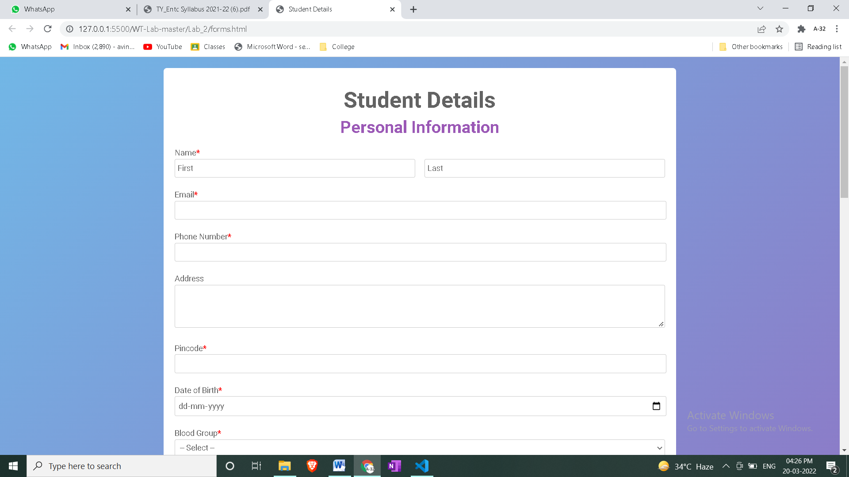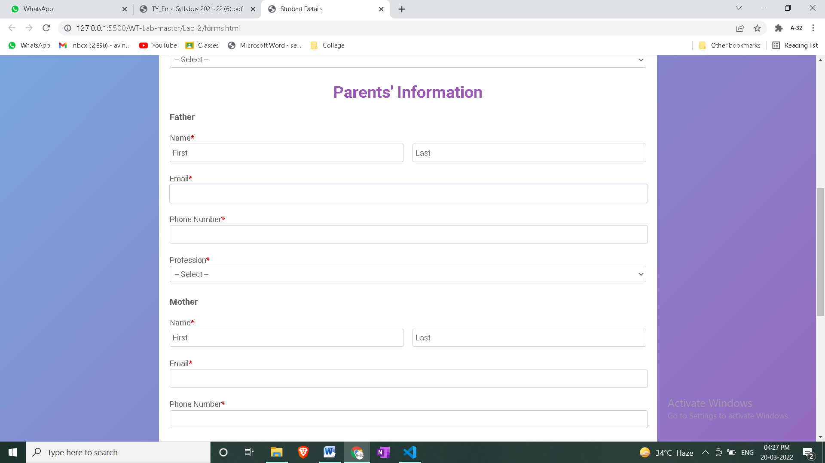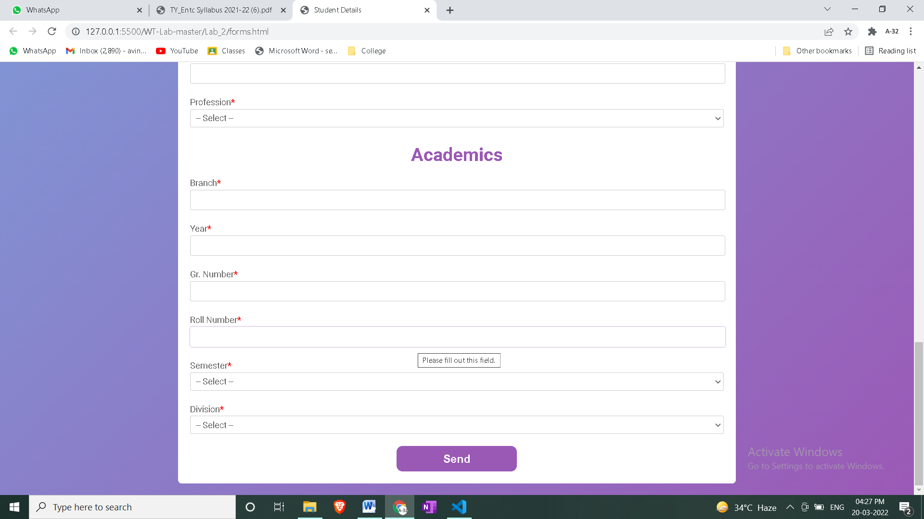

Link to the Webpage

Conclusion:
- The use of various CSS tags was demonstrated.
- A Form asking a student about his Personal Information, Parents Information and his Address is created.
- The background color, text size and font, border, padding and various features like hover are demonstrated using CSS.

