Lab Assignment No.: 03

NAME: Atharva Mali ROLL NO: 30
NAME: Laukik Avhad ROLL NO: 31
NAME: Avinash Gedam ROLL NO: 32
NAME: Manas Baviskar ROLL NO: 40

CLASS: ET-A BRANCH: E&TC BATCH: Batch 2 GROUP: 3

DATE OF PERFORMANCE: 14/03/2022

Question: Design a static web page, to demonstrate the use of CSS.

CODE:
HTML:

<!DOCTYPE html>

<html>
<head>
<meta charset="UTF-8">
<meta name="viewport" content="width=device-width, initial-scale=1.0">
<title> BookMyTravel </title>
<link rel="stylesheet" href="style.css">
<link rel="stylesheet" href="https://cdnjs.cloudflare.com/ajax/libs/font-awesome/5.15.2/css/all.min.css"/>
</head>
<body>
<nav>
<div class="menu">
<div class="logo">
<p>BookMyTravel</p>
</div>
<ul>
<li><a href="#">Home</a></li>
<li><a href="#">About</a></li>
<li><a href="#">Tours</a></li>
<li><a href="#">Contact</a></li>
</ul>
</div>
</nav>
<div class="img"></div>
<div class="center">
<div class="title">Explore the World with Us</div>
<div class="btns">
<button>Learn More</button>
<button>Book Now</button>
</div>
</div>
</body>
</html>

CSS:

Result:
Landing page:

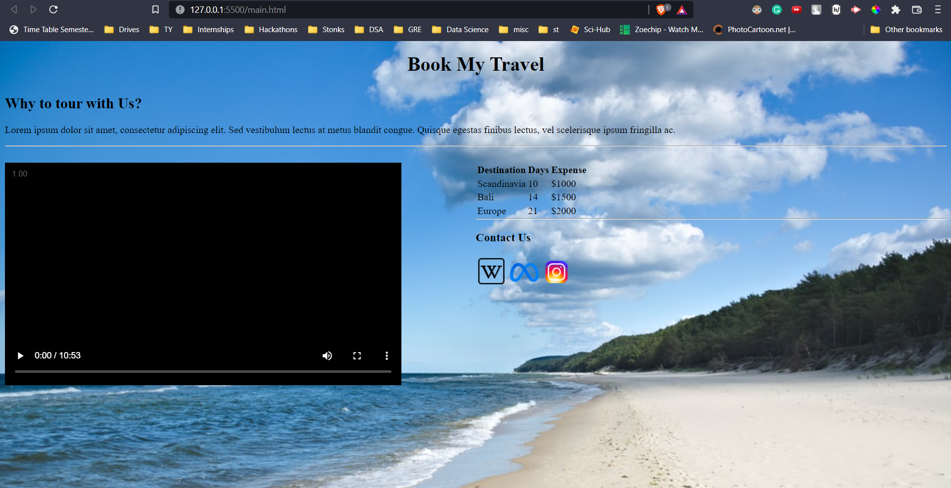

Link to WebPage

Conclusion:
- The use of various HTML tags was demonstrated.
- A webpage for a travel website was developed.
- A background image, video, and hyperlink images were added as a part of the assignment.

