# Apply filters to SQL queries

## Project description

The organization aims to enhance the system security and it is my role to ensure system safety by investigating potential security issues, and updating employee computers as necessary. The following steps illustrate how I utilize SQL with filters to perform security related tasks.

## Retrieve after hours failed login attempts

There was a potential security incident that occurred after 18:00 and all failed login attempts were to be investigated.

The following code demonstrates how I created a SQL query to filter to failed login attempts that occurred after business hours.

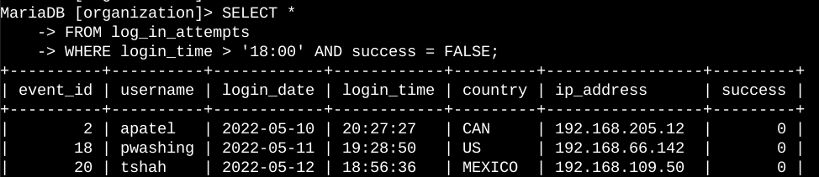

The screenshot shows the query to filter for all log_in_attempts that had occurred after 18:00 and then the WHERE clause with an AND operator to filter results that output failed login attempts that had occurred after 18:00 with the condition set as success = FALSE.

## Retrieve login attempts on specific dates

A suspicious event had occurred on the 2022-05-09 and login activity that had occurred on the day and day before the incident has to be investigated.

The following SQL query is used to filter login attempts on these dates that are to be inquired about.

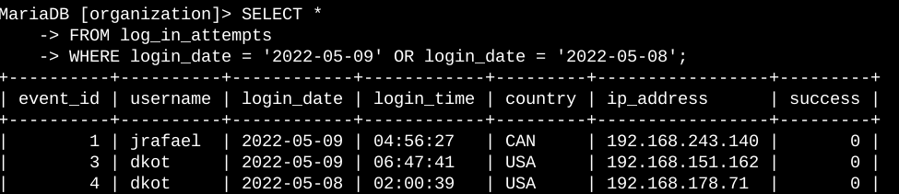

This SQL query gets all the login attempts from 2022-05-09 or 2022-05-08 by using the WHERE clause with an OR condition to include login attempts on two specific dates.

## Retrieve login attempts outside of Mexico

After investigation of the organizations login attempts, it is to be believed that the login attempts had occurred outside of Mexico and that these attempts should be investigated.

The following SQL query demonstrates filtering login attempts outside of Mexico

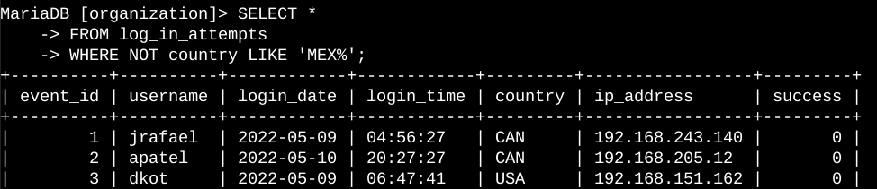

This SQL query filters all login attempts that occurred in countries other than Mexico using the clause WHERE with NOT. The LIKE ‘MEX%’ is used to match datasets such as Mexico with a % sign to represent any unspecified character when used with LIKE.

## Retrieve employees in Finance or Sales

The organization is updating employee machines and information is required about the employees in the finance or sales department.

The following SQL query is used to retrieve records for employees in the finance or sales department.

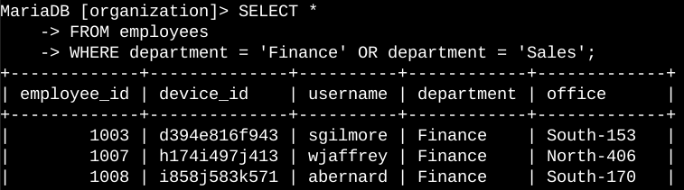

This SQL query returns all employees in the Finance and Sales department by selecting data from the employees table. The WHERE clause with OR is used to filter employees in the Finance and Sales department.

## Retrieve all employees not in IT

The organization needs to make one more security update on employees who are not in the IT Department and in order to make the updates information on these employees are required.

The following SQL query is used to filter for employee machines from employees not in the IT department.’

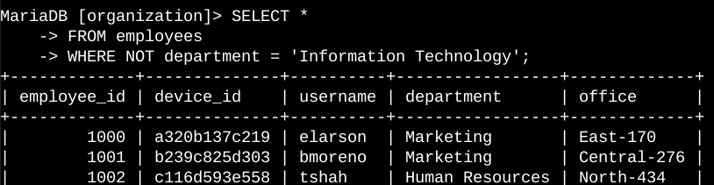

From this SQL query data is selected from the employees table and the WHERE clause is used with NOT to filter out employees not from that department.