CONSTITUTION OF THE AFRICAN SOLIDARITY CIVIC ORGANISATION (ASCO)
GOVERNING DOCUMENT
This Constitution establishes the governance framework, rights, responsibilities and operating principles of the African Solidarity Civic Organisation.
CONSTITUTION OF THE AFRICAN SOLIDARITY CIVIC ORGANISATION (ASCO)
PREAMBLE
We, the members of the African Solidarity Civic Organisation (ASCO), united by the principles of African solidarity, constitutional democracy, human dignity, social justice, equality, accountability, and sustainable development, hereby adopt this Constitution to guide the governance, administration, and operations of the Organisation. ASCO exists to promote social cohesion, good governance, community development, human rights, environmental sustainability, youth empowerment, women’s empowerment, anti-corruption initiatives, public participation, and peaceful coexistence among all people living in Africa.
ARTICLE 1 — NAME
The name of the organisation shall be: African Solidarity Civic Organisation Hereinafter referred to as ASCO.
ARTICLE 2 — LEGAL STATUS
ASCO is a non-profit organisation established and registered in accordance with the laws of the Republic of South Africa. The Organisation shall have perpetual succession and may own property, enter into contracts, institute legal proceedings, and perform all lawful acts necessary to achieve its objectives.
ARTICLE 3 — VISION
To build a united, peaceful, prosperous and socially just Africa where communities actively participate in democratic governance and sustainable development.
ARTICLE 4 — MISSION
ASCO seeks to:
• Promote African solidarity and social cohesion.
• Fight corruption and maladministration.
• Promote constitutional democracy and good governance.
• Protect human rights.
• Promote peace and justice.
• Combat gender-based violence and domestic violence.
• Promote environmental sustainability and climate action.
• Advance youth development.
• Promote women’s empowerment.
• Advocate for quality education and healthcare.
• Promote entrepreneurship and economic empowerment.
• Encourage public participation in governance.
• Strengthening partnerships with government, civil society, business and international organisations.
ARTICLE 5 — VALUES
ASCO shall be guided by:
• Integrity
• Accountability
• Transparency
• Professionalism
• Ubuntu
• Non-racialism
• Non-sexism
• Inclusivity
• Respect
• Excellence
• Service to communities
ARTICLE 6 — OBJECTIVES
ASCO shall:
1. Promote civic education.
2. Encourage active citizenship.
3. Advocate against corruption.
4. Support vulnerable communities.
5. Promote environmental protection.
6. Support disaster relief initiatives.
7. Promote peace-building.
8. Encourage youth leadership.
9. Promote cultural exchange programmes.
10. Build partnerships nationally and internationally.
ARTICLE 7 — THE FOUNDER AND CO-FOUNDER
7.1 Founder The Founder is the individual who conceived, established and led the formation of ASCO. The Founder shall:
• Safeguard the founding vision and values of ASCO.
• Provide strategic leadership and institutional guidance.
• Serve as Patron and Custodian of the Organisation.
• Be recognised permanently in all official records of ASCO.
• Participate in strategic meetings of the Organisation.
• Address the Annual General Meeting.
• Advise the Board on constitutional matters.
• Recommend constitutional amendments where necessary. Unless removed through due legal process for serious misconduct or incapacity, the title of Founder shall remain permanent. 7.2 Co-Founder The Co-Founder shall be recognised as having played a significant role in establishing ASCO. The Co-Founder shall:
• Assist in preserving the founding vision.
• Support strategic development.
• Serve as an ambassador of ASCO.
• Participate in constitutional reviews.
• Advise the Board on institutional development. The title of Co-Founder shall be permanent and honorary. 7.3 Protection of Founding Status Neither the Founder nor the Co-Founder may lose their founding status through resignation from operational positions, provided such recognition does not exempt them from accountability under the law.
ARTICLE 8 — GOVERNANCE
The Organisation shall be governed by a Board of Directors. The Board shall provide strategic oversight and ensure good governance.
ARTICLE 9 — EXECUTIVE DIRECTOR
The Executive Director shall:
• Be the Chief Executive Officer.
• Manage day-to-day operations.
• Implement Board resolutions.
• Manage staff and programmes.
• Represent ASCO externally.
• Prepare annual operational plans.
• Manage finances subject to Board approval. The Founder may serve as Executive Director where appointed by the Board.
ARTICLE 10 — BOARD OF DIRECTORS
The Board shall consist of not fewer than five Directors. Its responsibilities include:
• Strategic planning.
• Financial oversight.
• Risk management.
• Appointment of senior management.
• Policy approval.
• Compliance with legislation.
ARTICLE 11 — OFFICE BEARERS
The Board shall elect:
• Chairperson
• Deputy Chairperson
• Treasurer
• Secretary
• Additional Directors as required
ARTICLE 12 — MEMBERSHIP
Membership shall be open to any person who supports the objectives of ASCO without discrimination.
ARTICLE 13 — GENERAL MEETINGS
The Annual General Meeting shall:
• Receive annual reports
• Receive audited financial statements
• Elect Directors where applicable.
• Consider constitutional amendments.
ARTICLE 14 — FINANCES
Funds may be obtained through:
• Donations
• Grants
• Sponsorships
• Membership fees
• Fundraising
• Investments approved by the Board No profits shall be distributed to members.
ARTICLE 15 — ETHICS
Every member shall:
• Act honestly.
• Avoid corruption.
• Avoid conflicts of interest.
• Respect confidentiality.
• Promote the reputation of ASCO.
ARTICLE 16 — DISCIPLINARY PROCEDURES
Any member guilty of misconduct may be suspended or expelled after a fair disciplinary process.
ARTICLE 17 — AMENDMENTS
This Constitution may be amended by a two-thirds majority at a properly constituted General Meeting. No amendment may remove the historical recognition of the Founder or Co-Founder without their written consent or a competent court order.
ARTICLE 18 — DISSOLUTION
Upon dissolution, all remaining assets shall be transferred to another registered non-profit organisation with similar objectives and shall not be distributed to members.
ARTICLE 19 — INTERPRETATION
Where uncertainty exists regarding this Constitution, the Board shall interpret it in a manner consistent with the Constitution of the Republic of South Africa and the founding values of ASCO.
ARTICLE 20 — MEMBERSHIP PROCEDURES
20.1 Admission to membership shall be open to any person who supports the objectives and values of ASCO and meets any lawful requirements approved by the Board.
20.2 Applications for membership shall be made in the form and manner determined by the Board. The Board may approve or decline an application for reasonable and lawful grounds.
20.3 Members shall have the right to participate in General Meetings, vote where eligible, receive approved reports, and propose matters for consideration in accordance with this Constitution.
20.4 Members shall uphold this Constitution, comply with lawful decisions of the Organisation, act in ASCO’s best interests, and pay any approved membership fees.
20.5 A member may resign by written notice. Membership may be suspended or terminated only in accordance with a fair process and the disciplinary provisions of this Constitution.
ARTICLE 21 — GENERAL MEETINGS AND VOTING
21.1 The Annual General Meeting shall be held once in each financial year at a time and place determined by the Board.
21.2 Members shall receive at least fourteen days’ notice of a General Meeting, stating the date, time, venue or meeting platform, and the business to be considered.
21.3 The quorum for a General Meeting shall be one-third of voting members, subject to any minimum required by applicable law. If a quorum is not present, the meeting may be adjourned and reconvened on notice.
21.4 Each eligible member shall have one vote. Decisions shall be made by a simple majority unless this Constitution requires a higher threshold. The chairperson shall have a casting vote where votes are equal.
21.5 A Special General Meeting may be called by the Board or on written request of at least one-third of eligible voting members, stating the purpose of the meeting.
ARTICLE 22 — BOARD COMPOSITION AND PROCEDURES
22.1 The Board shall consist of not fewer than five Directors. The persons signing this Constitution may include founding members, Directors, office-bearers, or authorised signatories; their capacity shall be recorded in the relevant official resolution or register.
22.2 Directors shall be nominated and elected or appointed in accordance with a procedure approved by the General Meeting and consistent with applicable law.
22.3 Directors shall serve for terms determined by the General Meeting and may be re-elected or re-appointed, subject to the Organisation’s needs and applicable law.
22.4 A Board meeting shall be called on reasonable notice. The quorum shall be a majority of serving Directors. Decisions shall be made by majority vote, with the chairperson having a casting vote in the event of equality.
22.5 A Director may resign by written notice or be removed for serious misconduct, incapacity, persistent non-attendance, or other lawful grounds after a fair process. Vacancies may be filled by the Board until the next General Meeting.
ARTICLE 23 — DUTIES OF OFFICE-BEARERS
23.1 The Chairperson shall lead the Board, preside over meetings, promote good governance, and ensure that Board decisions are properly implemented and monitored.
23.2 The Deputy Chairperson shall support the Chairperson and perform the Chairperson’s functions when the Chairperson is unavailable.
23.3 The Treasurer shall oversee financial reporting, monitor financial controls, and report financial matters to the Board and General Meeting.
23.4 The Secretary shall maintain minutes, notices, registers, official correspondence, and other governance records.
23.5 Office-bearers shall act collectively through the Board and shall remain accountable to the Organisation.
ARTICLE 24 — FINANCIAL GOVERNANCE
24.1 The financial year of ASCO shall be determined by the Board and recorded in the Organisation’s governance documents.
24.2 ASCO shall maintain a bank account or accounts in its name. Payments shall be authorised by at least two approved signatories, subject to the Organisation’s financial policies.
24.3 The Board shall approve budgets and monitor expenditure. No funds shall be used for a purpose inconsistent with ASCO’s objectives.
24.4 The Organisation shall keep proper accounting records and prepare annual financial statements. The statements shall be independently reviewed or audited where required by law, donor conditions, or a resolution of the Board or General Meeting.
24.5 Members may inspect governance and financial records at reasonable times, subject to confidentiality, privacy, and applicable legal restrictions.
ARTICLE 25 — CONFLICTS OF INTEREST
25.1 A Director, office-bearer, employee, or member involved in a decision shall disclose any actual, potential, or perceived personal or financial interest.
25.2 A person with a conflict shall not improperly influence the decision, shall leave the meeting when requested, and shall not vote on the matter unless permitted by law and the Board’s conflict-of-interest policy.
25.3 Disclosures and the steps taken to manage them shall be recorded in the minutes and in a register of interests.
ARTICLE 26 — RECORDS, REPORTING AND TRANSPARENCY
26.1 ASCO shall maintain accurate records of members, meetings, resolutions, finances, assets, policies, contracts, and statutory filings.
26.2 The Board shall provide appropriate annual reports to members and shall make required regulatory and donor reports within applicable deadlines.
26.3 Confidential information and personal information shall be handled responsibly and in accordance with applicable law.
ARTICLE 27 — DISPUTE RESOLUTION
27.1 A dispute concerning the interpretation or implementation of this Constitution shall first be referred to the Board for good-faith internal resolution.
27.2 If the dispute is not resolved, the Board may appoint an impartial mediator or refer the matter to a Special General Meeting. The parties shall attempt mediation before commencing legal proceedings, except where urgent legal relief is required.
27.3 Nothing in this Article prevents a person from reporting unlawful conduct or exercising a legal right.
ARTICLE 28 — COMPLIANCE AND REVIEW
28.1 The Organisation shall comply with the laws of the Republic of South Africa, its registration requirements, donor obligations, and this Constitution.
28.2 The Board shall review this Constitution periodically and recommend amendments where necessary to maintain lawful, effective, and accountable governance.
CHAPTER 21 — SARS PUBLIC BENEFIT AND FIDUCIARY REQUIREMENTS
21.1 The sole or principal object of ASCO is to carry on one or more public benefit activities in a non-profit manner and with an altruistic or philanthropic intent, for the benefit of or widely accessible to the general public.
21.2 ASCO shall identify its primary and additional public benefit activities with reference to the applicable Parts of the Ninth Schedule to the Income Tax Act, including humanitarian relief, welfare, community development, education and development, health, conservation, environmental protection, and advocacy activities to the extent they qualify under applicable law.
21.3 At least three persons who are not connected persons shall accept fiduciary responsibility for ASCO. No single person may directly or indirectly control ASCO’s decision-making powers.
21.4 Funds shall be used solely for the objects for which ASCO is established. No funds or assets may be distributed directly or indirectly to any person except for reasonable remuneration, reimbursement of legitimate expenses, or payment for bona fide services rendered.
21.5 ASCO shall comply with the requirements applicable to approved public benefit organisations and shall submit amendments to its founding documents to SARS when required.
21.6 Any section 18A approval is separate from this MOI and shall be sought only if ASCO qualifies and obtains approval for the relevant activities.
CHAPTER 22 — FOUNDER OVERSIGHT AND FINANCIAL INDEPENDENCE
22.1 Mrs Busisiwe Makhosi Shandu is recognised as Founder and Founding Chairperson and may provide strategic, ethical and institutional oversight to protect ASCO’s founding vision.
22.2 The Founder/Founding Chairperson shall not sign, approve, authorise, initiate, co-authorise or control any financial document, bank mandate, payment, procurement approval, budget, invoice, grant disbursement, financial statement or other financial transaction of ASCO.
22.3 Financial authority shall rest with the Board, Finance and Procurement Committee, Treasurer/Director of Finance, Executive Director and formally appointed financial signatories, in accordance with Board resolutions and financial policies.
22.4 Founder recognition is honorary and historical and creates no ownership, personal financial benefit, unilateral veto, banking authority or power to bypass the Board, financial controls, SARS requirements or applicable law.
22.5 The Founder may sign constitutional, ceremonial or governance documents where appropriate, but such signature shall not be treated as a financial approval or financial mandate.
CHAPTER 23 — DONOR, GRANT AND ANTI-PRIVATE-BENEFIT SAFEGUARDS
23.1 ASCO shall accept funding only where the purpose and conditions are lawful, consistent with its public-benefit objects, and do not compromise its independence or non-partisan character.
23.2 ASCO shall not accept a donation that may be revoked by the donor or that permits the donor or a connected person to obtain a direct or indirect benefit, except where permitted by law and consistent with an approved public benefit activity.
23.3 Restricted grants shall be tracked separately and used only for approved purposes. Donor reports shall be accurate, timely and supported by records.
23.4 ASCO shall conduct proportionate due diligence on donors, partners and major suppliers, maintain anti-fraud and anti-corruption controls, and report suspected misconduct through protected channels.
23.5 Donor requirements shall never override ASCO’s legal duties, safeguarding obligations, independence or fiduciary accountability.
CHAPTER 24 — SAFEGUARDING, ETHICS AND GLOBAL DONOR STANDARDS
24.1 ASCO shall maintain policies addressing safeguarding of children and vulnerable persons, prevention of sexual exploitation and abuse, anti-harassment, whistleblowing, conflicts of interest, procurement, data protection and complaints.
24.2 ASCO shall apply principles of transparency, accountability, participation, non-discrimination, do-no-harm, responsible stewardship and measurable results in its programmes and partnerships.
24.3 Staff, volunteers, Directors, consultants and representatives shall comply with the Code of Conduct and shall disclose actual, potential or perceived conflicts of interest.
24.4 ASCO shall maintain a complaints and incident-reporting mechanism and shall protect persons who report misconduct in good faith.
CHAPTER 25 — FINANCIAL CONTROL AND REPORTING
25.1 The Founder/Founding Chairperson is expressly excluded from financial signing and approval authority.
25.2 The Board shall approve budgets, banking arrangements, financial policies, annual financial statements and material commitments.
25.3 At least two authorised signatories shall approve payments, subject to documented limits. No single person shall exercise unrestricted control over ASCO finances.
25.4 ASCO shall maintain books, records, supporting documents and audit trails for the periods required by law, SARS, donors and applicable standards.
25.5 The Board shall ensure annual financial statements and required tax, PBO, donor and regulatory reports are prepared and submitted.
ADOPTION
This Constitution was adopted by the founding members of the African Solidarity Civic Organisation (ASCO) and shall come into force on the date approved by the Board and members.
SIGNATURES OF THE FOUNDING MEMBERS / BOARD OF DIRECTORS
  CHAIR LADY  Ms. Busisiwe Makhosi Shandu  Signature:  ____________________________  Date: 6 September 2026  ____________________________ |   DIRECTOR: HEAD OF ICT AND COMMUNICATIONS  Mr. Thapelo Nelson Maqalika  Signature:  ____________________________  Date: 6 September 2026  ____________________________
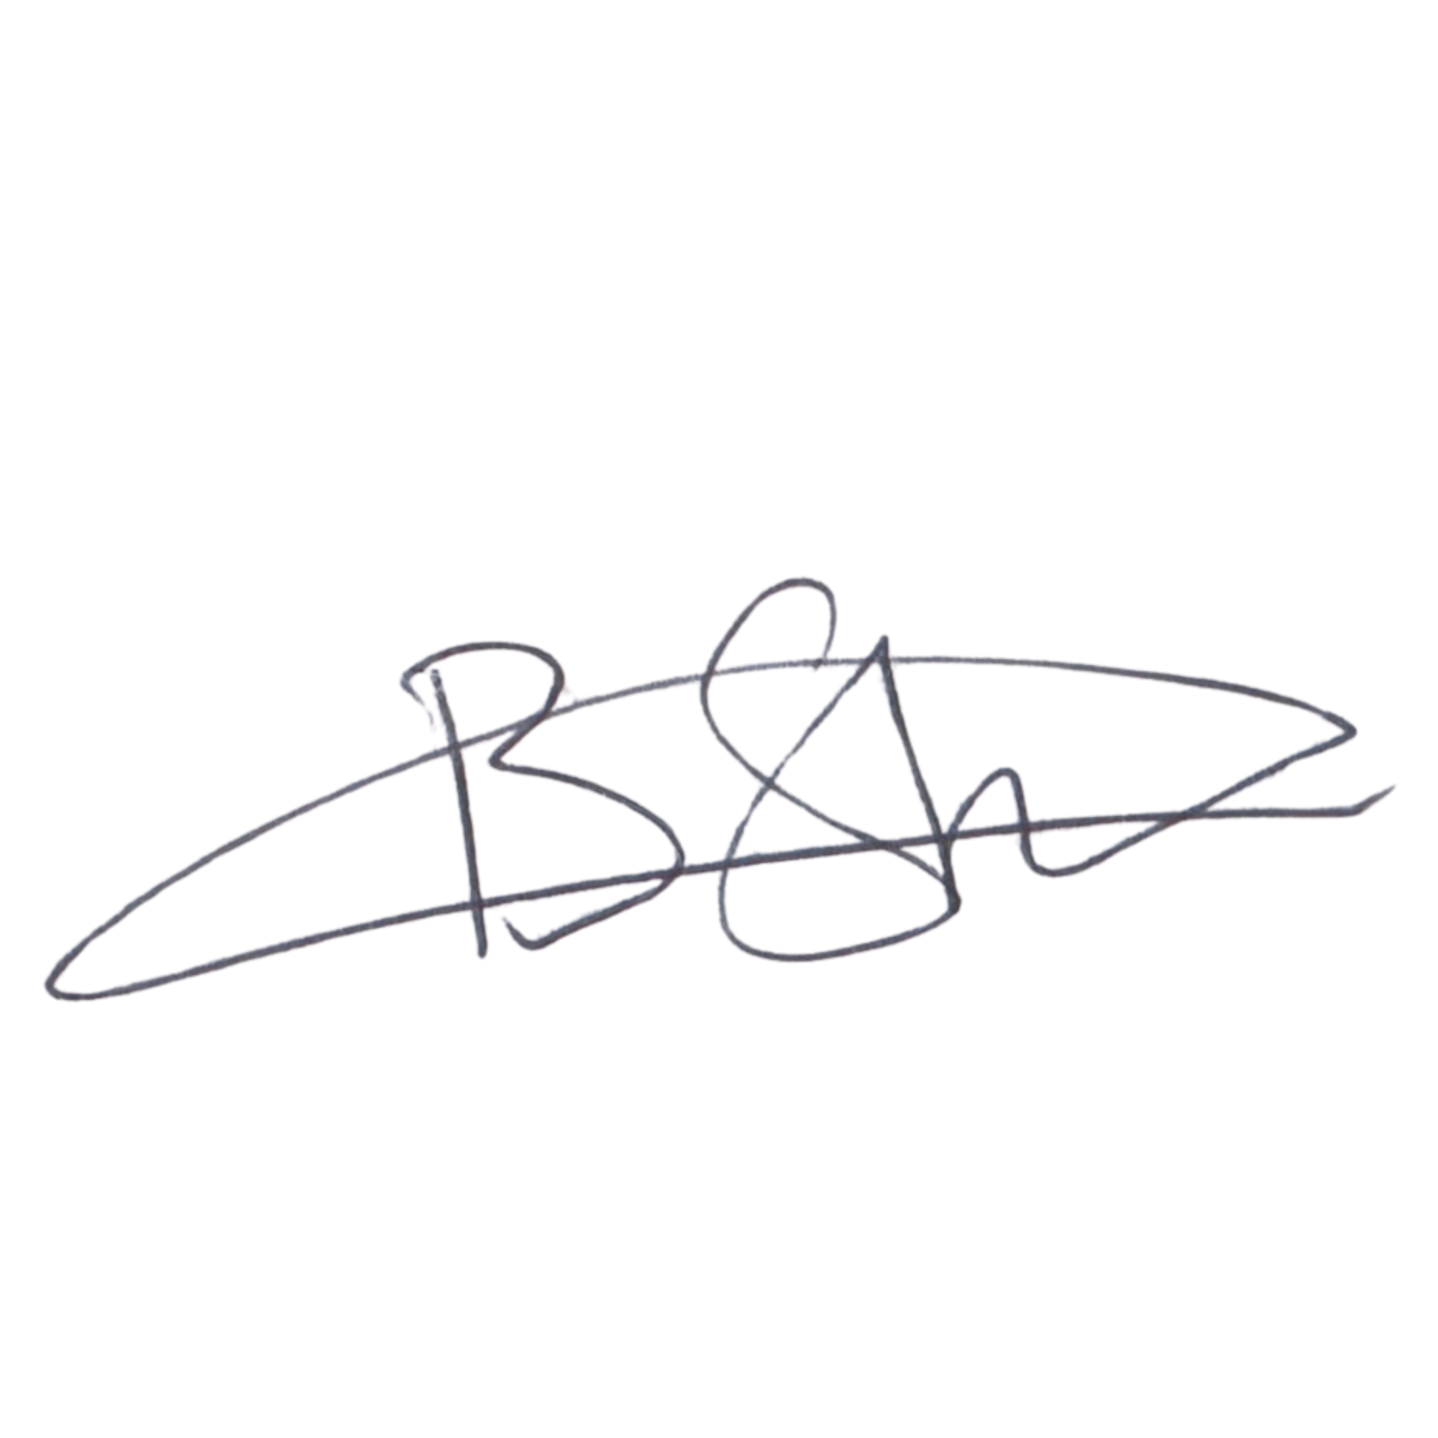  EXECUTIVE DIRECTOR  Mr. Bhekisisa Shandu  Signature:  ____________________________  Date: 6 September 2026  ____________________________ | 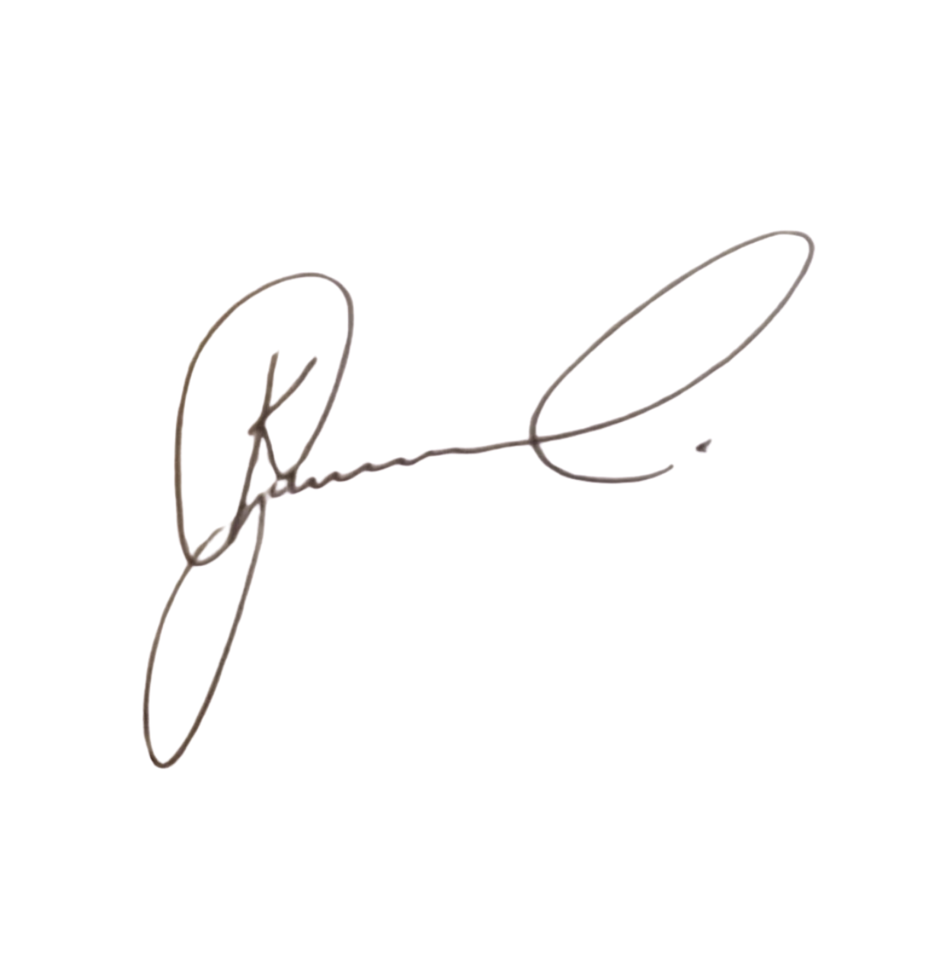  DIRECTOR: PEOPLE AND CULTURE / CHAIRPERSON: FINANCE AND PROCUREMENT COMMITTEE  Mr. Khulekani Gumede  Signature:  ____________________________  Date: 6 September 2026  ____________________________

