MEMORANDUM OF INCORPORATION
OF
AFRICAN SOLIDARITY CIVIC ORGANISATION NPC
(ASCO NPC)
A Non-Profit Company incorporated in terms of the Companies Act 71 of 2008 of the Republic of South Africa
PREAMBLE
We, the founders and custodians of African Solidarity Civic Organisation NPC (ASCO), recognising the interconnectedness of humanity and the shared challenges facing communities across Africa and the world, establish this Organisation as an independent, non-profit, public benefit institution. Inspired by Ubuntu, African solidarity, human dignity, peace, justice, equality and sustainable development, ASCO commits itself to serving humanity through humanitarian action, community development, advocacy, research, education and international cooperation. ASCO recognises that sustainable peace and development require cooperation between communities, civil society organisations, governments, academic institutions, international organisations and responsible private sector partners. ASCO shall operate without unlawful discrimination and shall remain independent, non-partisan and committed to protecting its humanitarian purpose and institutional integrity.
CHAPTER 1 — NAME, STATUS AND LEGAL PERSONALITY
1.1 The name of the Organisation shall be African Solidarity Civic Organisation NPC, abbreviated as ASCO.
1.2 ASCO is a non-profit company incorporated in terms of the Companies Act 71 of 2008 of the Republic of South Africa.
1.3 ASCO is a separate legal entity with perpetual succession, capable of owning property, entering contracts, instituting legal proceedings and performing all lawful acts necessary to achieve its objectives.
1.4 This MOI shall be read with the Companies Act, the Constitution of the Republic of South Africa, and any applicable registration, tax and public-benefit requirements.
CHAPTER 2 — VISION, MISSION AND VALUES
2.1 Vision: To become a globally recognised African organisation advancing solidarity, peace, justice, humanitarian protection and sustainable development for present and future generations.
2.2 Mission: To unite communities, institutions and international partners in addressing humanitarian, social, environmental and developmental challenges through ethical leadership, advocacy, education, partnerships and practical interventions.
2.3 ASCO shall be guided by Ubuntu, solidarity, peace, justice, integrity, accountability, sustainability and inclusivity.
CHAPTER 3 — OBJECTIVES OF ASCO
3.1 To provide humanitarian support to vulnerable individuals and communities affected by poverty, disasters, displacement, conflict and social challenges.
3.2 To promote peaceful coexistence, dialogue, reconciliation, conflict prevention and social cohesion.
3.3 To advance human rights, dignity, equality and social justice through lawful advocacy, education and community programmes.
3.4 To promote African solidarity and establish partnerships internationally to address shared humanitarian and developmental challenges.
3.5 To empower youth through education, leadership development, cultural exchange, skills development and entrepreneurship.
3.6 To protect and empower women, children, elderly persons, persons with disabilities and vulnerable communities.
3.7 To promote environmental protection, climate awareness, sustainability and community resilience.
3.8 To conduct research, public dialogues, educational programmes and policy discussions.
3.9 To cooperate with lawful organisations, governments, civil society, academic institutions and international partners whose objectives align with ASCO.
CHAPTER 4 — MEMBERSHIP FRAMEWORK
4.1 Membership shall be open to persons who support ASCO’s vision, mission, values and objectives, without unlawful discrimination based on race, nationality, ethnicity, gender, religion, culture, social background, disability or political affiliation.
4.2 Membership shall encourage community participation, volunteering, programme involvement, public engagement and support for ASCO objectives.
4.3 Membership does not create ownership rights or voting rights in ASCO and does not confer authority to elect or remove Directors or determine organisational policy.
4.4 The Board may adopt membership procedures, codes and registers consistent with this MOI and applicable law.
4.5 Members shall act in the best interests of ASCO, protect confidential information and comply with lawful organisational policies.
CHAPTER 5 — GLOBAL CHARACTER AND INTERNATIONAL OPERATIONS
5.1 ASCO may operate within South Africa and internationally in accordance with applicable laws.
5.2 ASCO may establish provincial structures, national chapters, regional offices and international representative offices, subject to approval by the Board and compliance with host-country requirements.
5.3 ASCO may enter into partnerships, agreements and memoranda of understanding with organisations that support its objectives.
5.4 ASCO shall remain independent, non-partisan and free from political or commercial influence that compromises its humanitarian mission.
CHAPTER 6 — FOUNDER AND FOUNDATIONAL RECOGNITION
6.1 Mrs Busisiwe Makhosi Shandu is recognised as the Founder and Founding Chairperson of ASCO, having conceived, established and led the formation of the Organisation.
6.2 The Founder shall be recognised in ASCO’s official records and may provide strategic guidance, protect the founding vision and values, participate in strategic meetings, address the Annual General Meeting, advise the Board on constitutional or institutional matters, and recommend amendments where necessary.
6.3 Founder status is honorary and historical. It does not constitute ownership, a personal financial interest, an unrestricted veto, or authority to bypass the Board or applicable law.
6.4 The Founder may serve in operational or governance roles only where properly appointed or elected in accordance with this MOI and applicable law.
6.5 The Board shall protect the historical recognition of the Founder while ensuring accountability, institutional independence and lawful governance.
6.6 The Board may recognise other founding contributors, including a Co-Founder, in official records where appropriate. Such recognition shall not create ownership or control rights.
CHAPTER 7 — BOARD OF DIRECTORS
7.1 ASCO shall be governed by a Board of Directors consisting of not fewer than five Directors, appointed in accordance with this MOI, the Companies Act and any applicable founding documents.
7.2 Directors shall collectively provide expertise in governance, finance, community development, human rights, law, public policy, strategic planning, fundraising and risk management.
7.3 Directors shall be appointed, re-appointed or removed through a lawful process approved by the authorised body. A Director may resign by written notice or be removed for serious misconduct, incapacity, persistent non-attendance or other lawful grounds after a fair process.
7.4 The Board shall appoint a Chairperson and may appoint a Deputy Chairperson, Treasurer or Director of Finance, Secretary and other office-bearers.
7.5 The Board shall determine strategic direction, approve policies and budgets, safeguard assets, monitor performance, appoint senior management, ensure compliance and protect ASCO’s mission.
7.6 The Chairperson shall lead the Board and facilitate effective governance but shall not interfere in routine operations unless authorised by the Board.
CHAPTER 8 — EXECUTIVE MANAGEMENT
8.1 The Executive Director shall manage the day-to-day affairs of ASCO, implement Board decisions, manage programmes and personnel, administer approved finances, represent ASCO externally and report to the Board.
8.2 The Board may delegate operational authority to the Executive Director, Executive Management or committees. Delegation shall be documented, subject to limits and shall not remove the Board’s accountability.
8.3 Directors serving in executive capacities shall distinguish between decisions made as Board members and decisions made in executive management roles.
8.4 The Executive Director shall be evaluated by the Board and shall operate within approved budgets, policies and delegated authority.
CHAPTER 9 — BOARD COMMITTEES
9.1 The Board may establish committees and define their mandates, membership, reporting lines and delegated authority.
9.2 Committees may include:
•Finance, Audit and Risk Committee.
•Procurement Committee.
•Ethics and Governance Committee.
•Programmes and International Relations Committee.
9.3 Committees shall report to the Board, keep appropriate records and may not exceed the authority delegated to them.
9.4 Committee members shall disclose conflicts and act in ASCO’s best interests.
CHAPTER 10 — DIRECTORS’ DUTIES
10.1 Directors shall act honestly, in good faith, for a proper purpose and in the best interests of ASCO.
10.2 Directors shall exercise reasonable care, skill and diligence and protect ASCO’s property, reputation and confidential information.
10.3 Every Director shall disclose actual, potential or perceived conflicts of interest and shall not improperly influence or vote on a conflicted matter.
10.4 Directors shall remain accountable to the Board, applicable law, donors and the public-benefit purpose of ASCO.
10.5 Breach of duty may result in corrective action, removal or other lawful consequences after a fair process.
CHAPTER 11 — FINANCIAL MANAGEMENT
11.1 ASCO shall maintain bank accounts in its name and shall operate them through approved signatories and documented financial controls.
11.2 The Board shall approve annual budgets, monitor expenditure, review financial reports and approve audited or independently reviewed financial statements where required.
11.3 Payments shall be authorised by at least two approved signatories in accordance with delegated limits. The Board may appoint the Executive Director, Mr. Bhekisisa Shandu, as primary operational banking authority; Mr. Thapelo Nelson Maqalika as secondary banking authority; and Mr. Khulekani Gumede as financial oversight signatory, subject to formal resolutions and bank requirements.
11.4 No person shall exercise unrestricted control over ASCO finances. All expenditure shall be supported by proper documentation.
11.5 ASCO shall maintain accurate accounting records and comply with applicable tax, reporting and donor requirements.
CHAPTER 12 — DONATIONS, GRANTS AND PARTNERSHIPS
12.1 ASCO may accept donations, grants, sponsorships, membership fees, fundraising income, investments approved by the Board and other lawful funding.
12.2 Funding may be accepted only where its conditions are lawful, consistent with ASCO’s objectives and do not compromise independence, dignity, accountability or non-partisan status.
12.3 Donor conditions shall be documented, monitored and reported on. Restricted funding shall be used only for its approved purpose.
12.4 ASCO may enter corporate, governmental and international partnerships subject to due diligence, written agreements and Board oversight.
12.5 No partnership shall permit an external party to control ASCO’s governance, appoint its Directors or compromise its public-benefit purpose.
CHAPTER 13 — PUBLIC BENEFIT ORIENTATION
13.1 ASCO shall operate for public benefit and shall apply its income, property and resources towards its objectives.
13.2 No income or asset shall be distributed directly or indirectly to a member, Director, founder or private person except for reasonable remuneration, reimbursement or payment for legitimate services.
13.3 ASCO shall maintain policies and records supporting alignment with SARS public-benefit organisation requirements and, where applicable, readiness for section 18A approval. This clause does not itself constitute SARS approval.
13.4 On dissolution, remaining assets shall be transferred to an eligible non-profit or public-benefit organisation with similar objectives and shall not be distributed to private persons.
CHAPTER 14 — RECORDS, REPORTING AND TRANSPARENCY
14.1 ASCO shall maintain accurate records of Directors, members where applicable, meetings, resolutions, interests, assets, contracts, finances, policies and statutory filings.
14.2 The Board shall prepare annual reports and financial statements and make required regulatory and donor submissions on time.
14.3 Members and authorised stakeholders may access approved records at reasonable times, subject to confidentiality, privacy and legal restrictions.
14.4 ASCO shall protect personal and confidential information and maintain appropriate information-security procedures.
CHAPTER 15 — INTERNATIONAL CHAPTERS AND REPRESENTATIVES
15.1 The Board may establish international chapters or appoint representatives where this supports ASCO’s mission and is lawful in the relevant jurisdiction.
15.2 Chapters and representatives shall operate under written mandates, approved budgets, reporting requirements and brand-use guidelines.
15.3 No chapter or representative may bind ASCO beyond written authority or undertake activities contrary to this MOI or host-country law.
CHAPTER 16 — STRATEGIC PARTNERSHIPS
16.1 ASCO may establish strategic partnerships with civil society organisations, governments, academic institutions, international organisations and responsible private-sector partners.
16.2 Partnerships shall be subject to due diligence, written agreements, safeguarding requirements, conflict-of-interest controls and periodic review.
16.3 ASCO shall not enter a partnership that compromises its independence, humanitarian purpose, non-partisan character or accountability.
CHAPTER 17 — ADVISORY COUNCILS AND GLOBAL AMBASSADORS
17.1 The Board may establish Advisory Councils or appoint Global Ambassadors to provide non-binding advice, representation, technical expertise and support.
17.2 Advisory Council members and Global Ambassadors shall not possess governance, ownership, banking or contracting authority unless separately appointed under a written mandate.
17.3 Their appointments, duties, term, expenses and reporting obligations shall be documented and reviewed by the Board.
CHAPTER 18 — AMENDMENTS TO THE MOI
18.1 This MOI may be amended only in accordance with the Companies Act, applicable filing requirements and a properly authorised resolution.
18.2 Proposed amendments shall be circulated with reasonable notice and recorded in the minutes.
18.3 No amendment may undermine ASCO’s non-profit character, public-benefit purpose, independence, asset-protection provisions or lawful dissolution requirements.
CHAPTER 19 — DISSOLUTION AND DISPOSAL OF ASSETS
19.1 ASCO may be wound up or dissolved only in accordance with the Companies Act and applicable law.
19.2 Upon dissolution, all liabilities shall be settled and remaining assets shall be transferred to another non-profit company, public-benefit organisation or institution with similar objectives.
19.3 No remaining asset shall be distributed to a member, Director, Founder, employee or private person except as lawfully permitted for legitimate obligations.
CHAPTER 20 — ADOPTION AND SIGNATURES
20.1 This Memorandum of Incorporation is adopted by the authorised founders and Board of Directors of African Solidarity Civic Organisation NPC.
20.2 It shall take effect upon approval and registration in accordance with applicable law.
ADOPTION AND SIGNATURES
  CHAIR LADY  Ms. Busisiwe Makhosi Shandu  Signature:  ____________________________  Date: 6 September 2026  ____________________________ |   DIRECTOR: HEAD OF ICT AND COMMUNICATIONS  Mr. Thapelo Nelson Maqalika  Signature:  ____________________________  Date: 6 September 2026  ____________________________
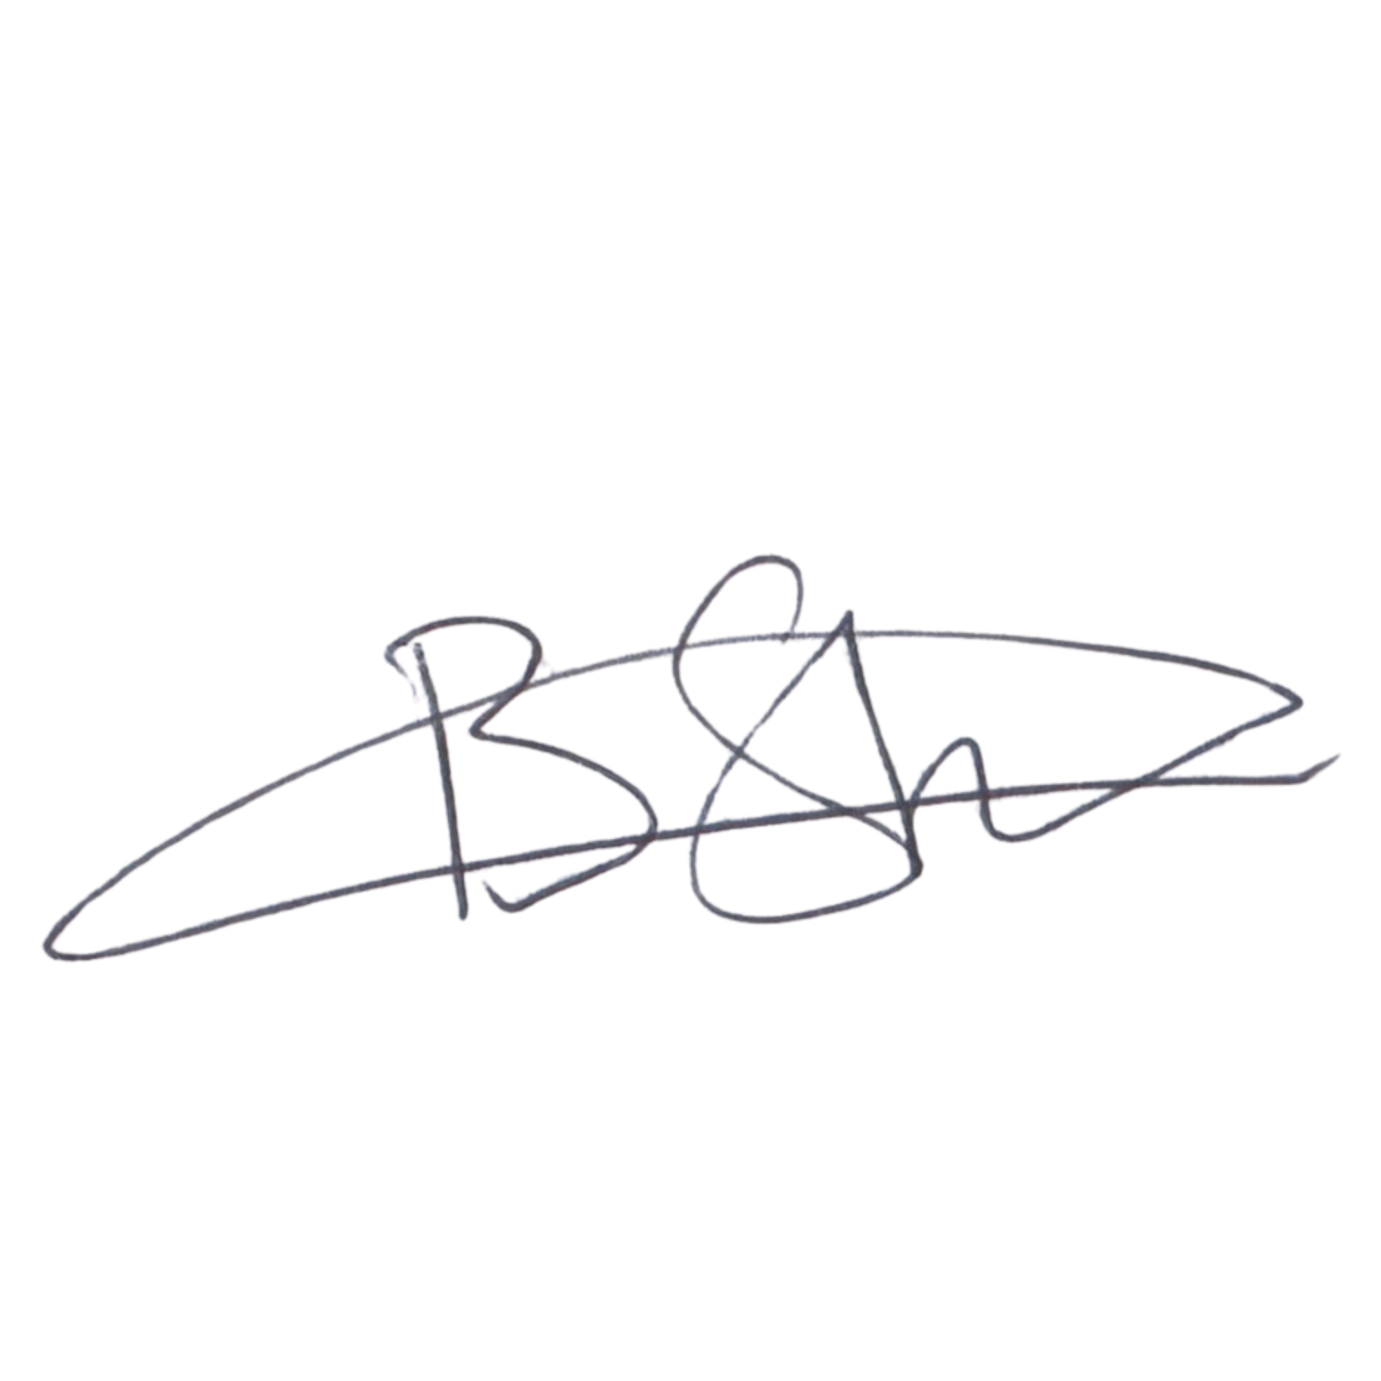  EXECUTIVE DIRECTOR  Mr. Bhekisisa Shandu  Signature:  ____________________________  Date: 6 September 2026  ____________________________ |   DIRECTOR: PEOPLE AND CULTURE / CHAIRPERSON: FINANCE AND PROCUREMENT COMMITTEE  Mr. Khulekani Gumede  Signature:  ____________________________  Date: 6 September 2026  ____________________________

