API documentation
For detail information go to: https://documenter.getpostman.com/view/5463900/T1Dtfb8x

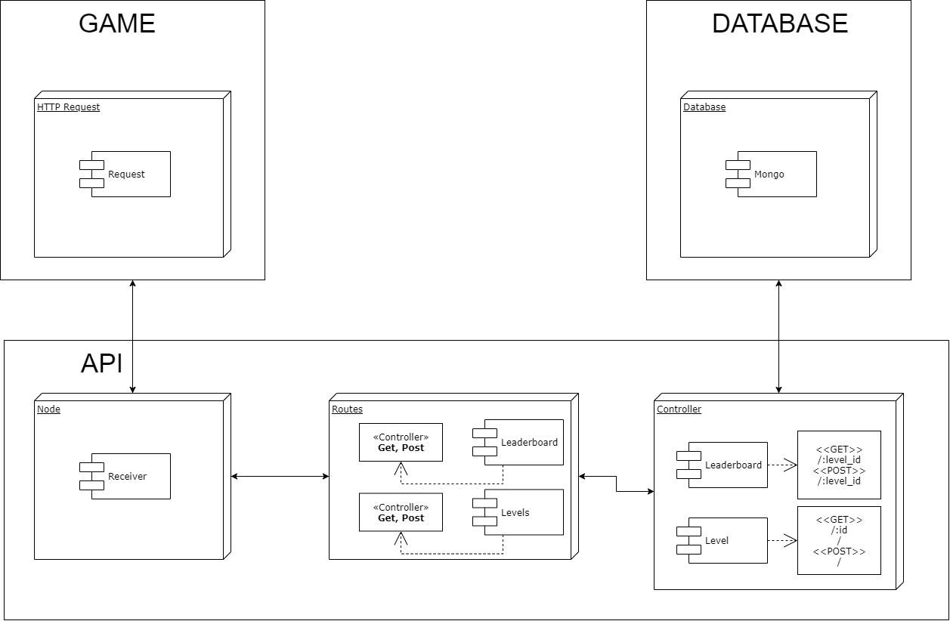
ROUTE | NAME | METHOD | BODY/PARAMS | RESPONSE
api/v1/level/ | Get levels | GET |  | "status": "success",  "results": 0,  "data": {  data[...]  }
api/v1/level/:id | Get level | GET |  | {  "status": "success",  "data": {  "data": {...}  }  }
api/v1/level/:id | Create level | POST | {  “image”: FILE,  “index”: 4,  “name”: level4,  “description”: “Some generic desc”  } | {  "status": "success",  "data": {  "data": {...}  }  }
api/v1/leaderboard/:level_id | Get leaderboard | GET |  | {  "status": "success",  "results": 5,  "data": {  "data": [...]  }  }
api/v1/leaderboard/:level_id | Add Score to leaderboard | POST | {  "player": "genericPlayer1",  "score": 20  } | {  "status": "success",  "data": {  "data": {...}  }  }

