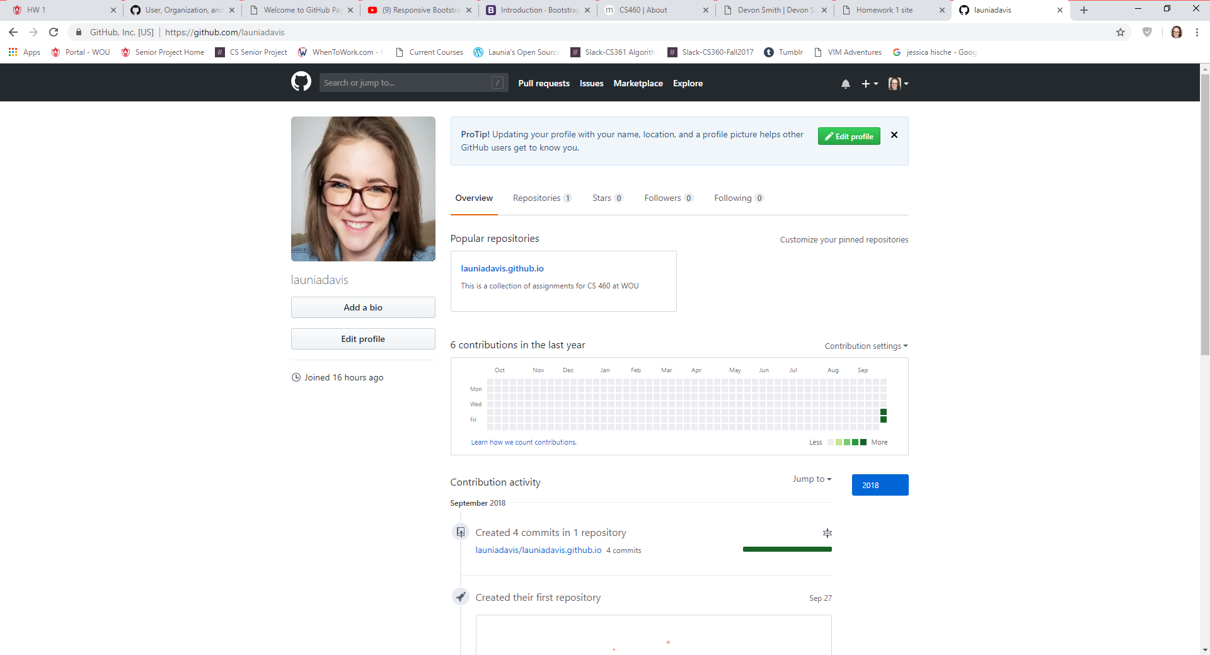

Creation of GitHub account and created repository with my user name

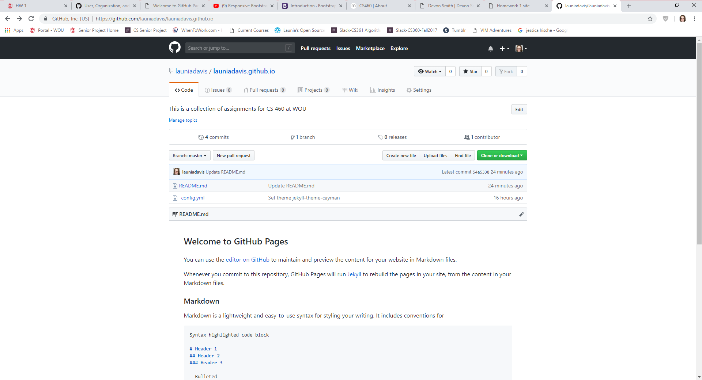

GitHub pages

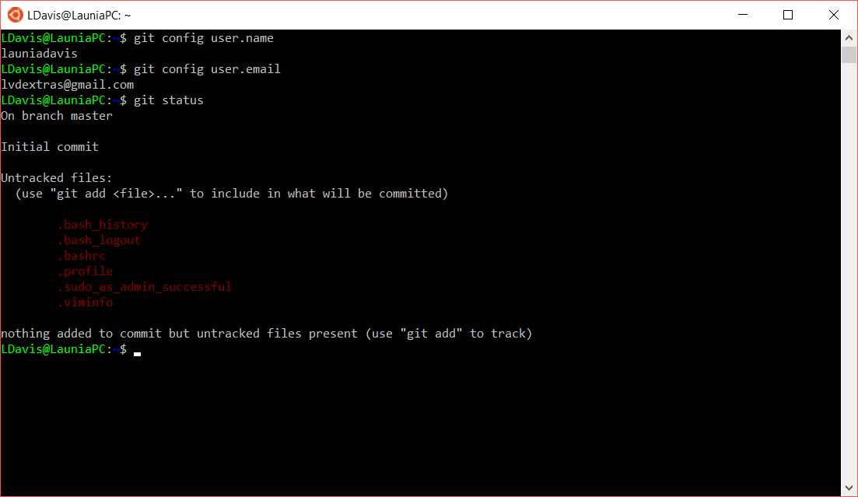

Setting up user name and user email for GitHub

Checked status, shows that I haven’t created/pushed anything to repository yet

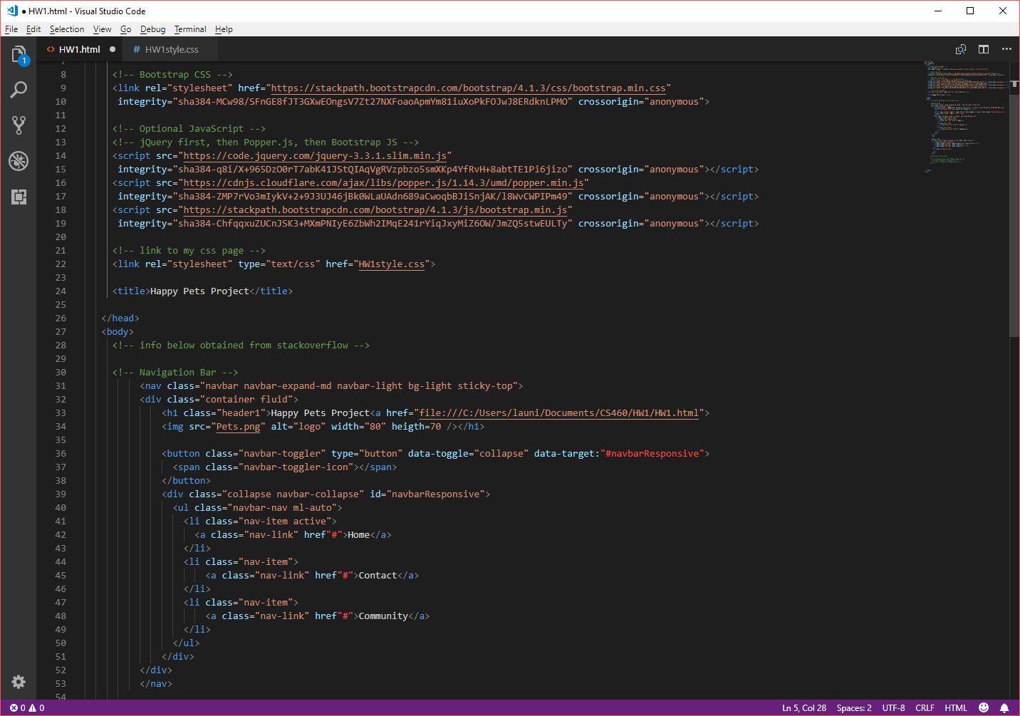

Staring point with creating the website. Creating a navigation bar with the header of my site along side the navigation menu.

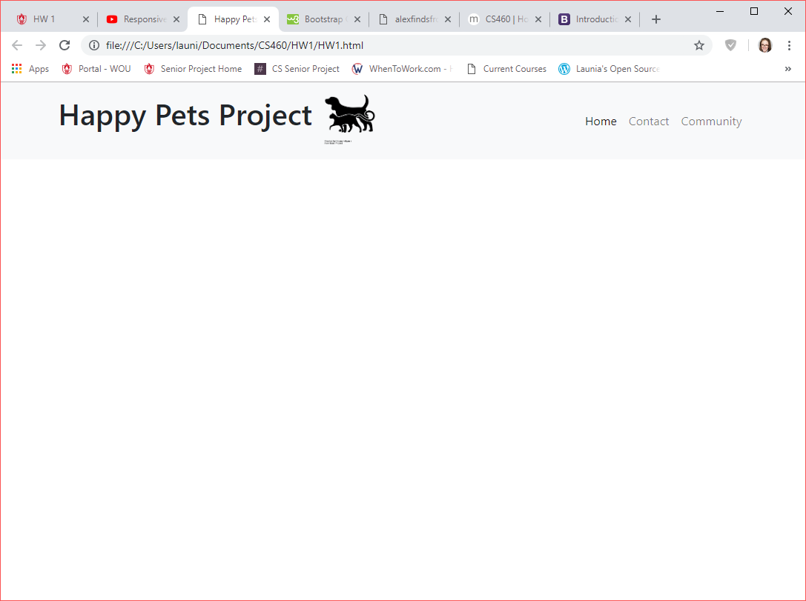

Navigation bar is created

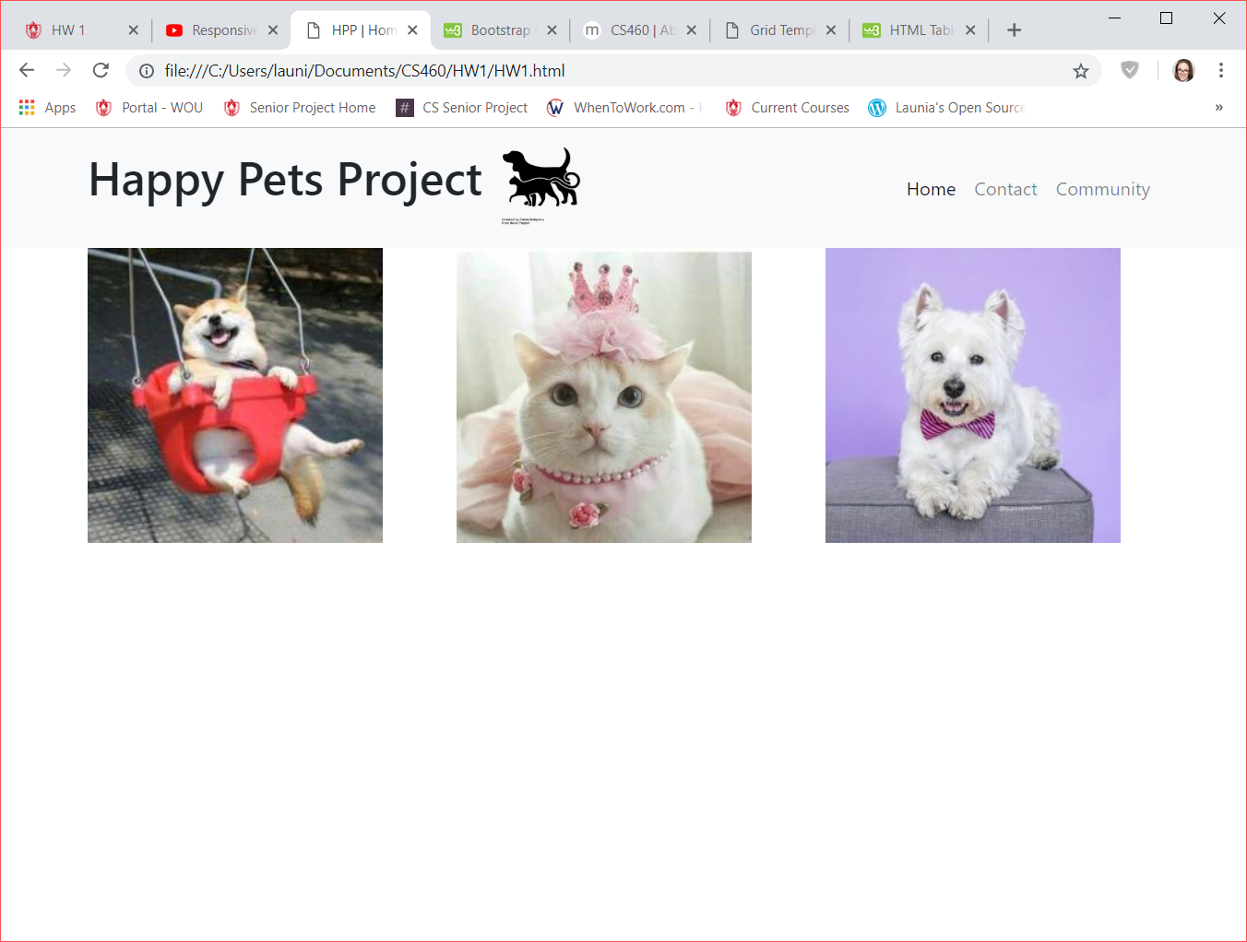

Creating three column layout in code. I was having issues with getting the images to show. My alternate was popping up but not the actual image. After a good time of frustration, it was brought to my attention that I had typed in “scr” and not “src” when sourcing the image.

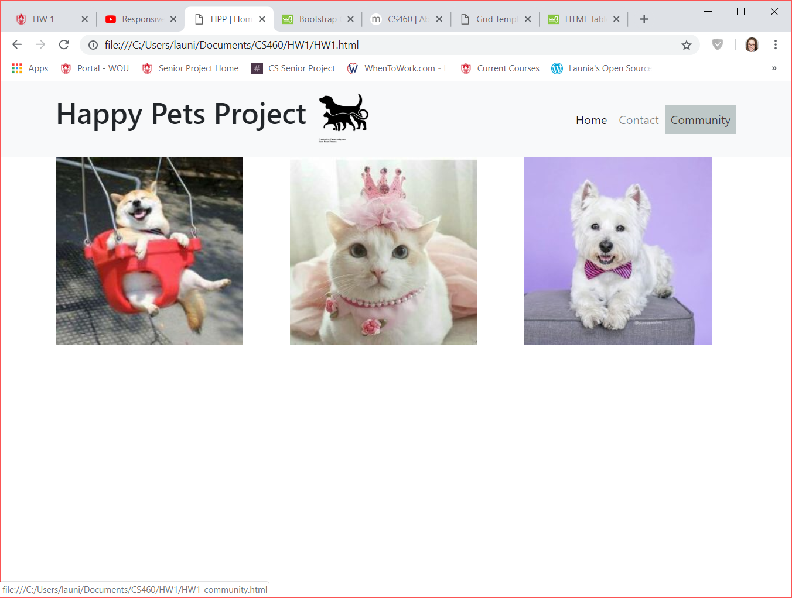

Testing navbar hover and selection to another page.

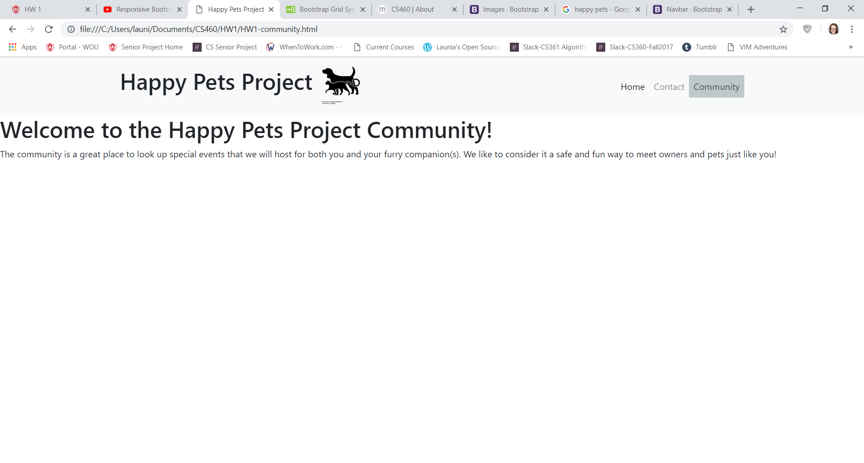

At new page after selection on navbar

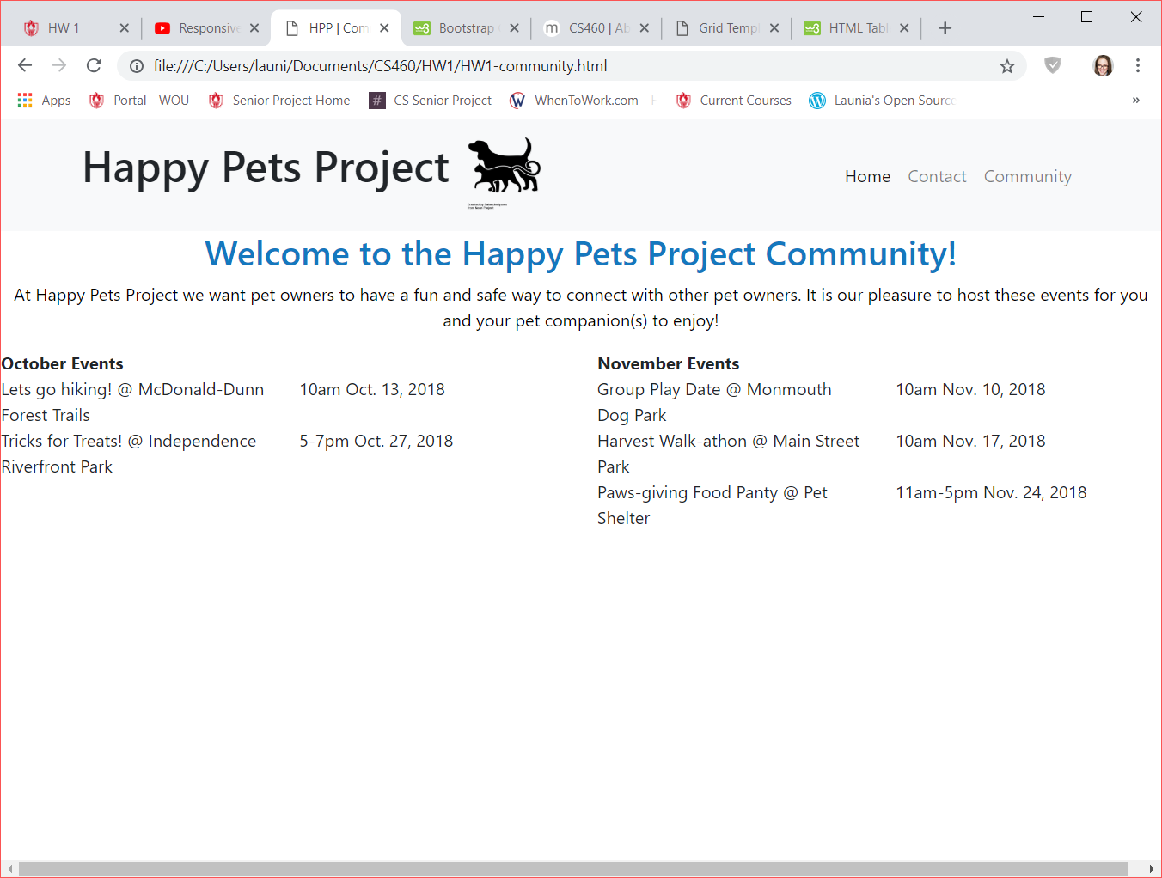

Creation of two column layout (event listings) with nested columns inside the two main columns. I realized that I could have created lists here instead of nested columns but it was something I wanted to try.

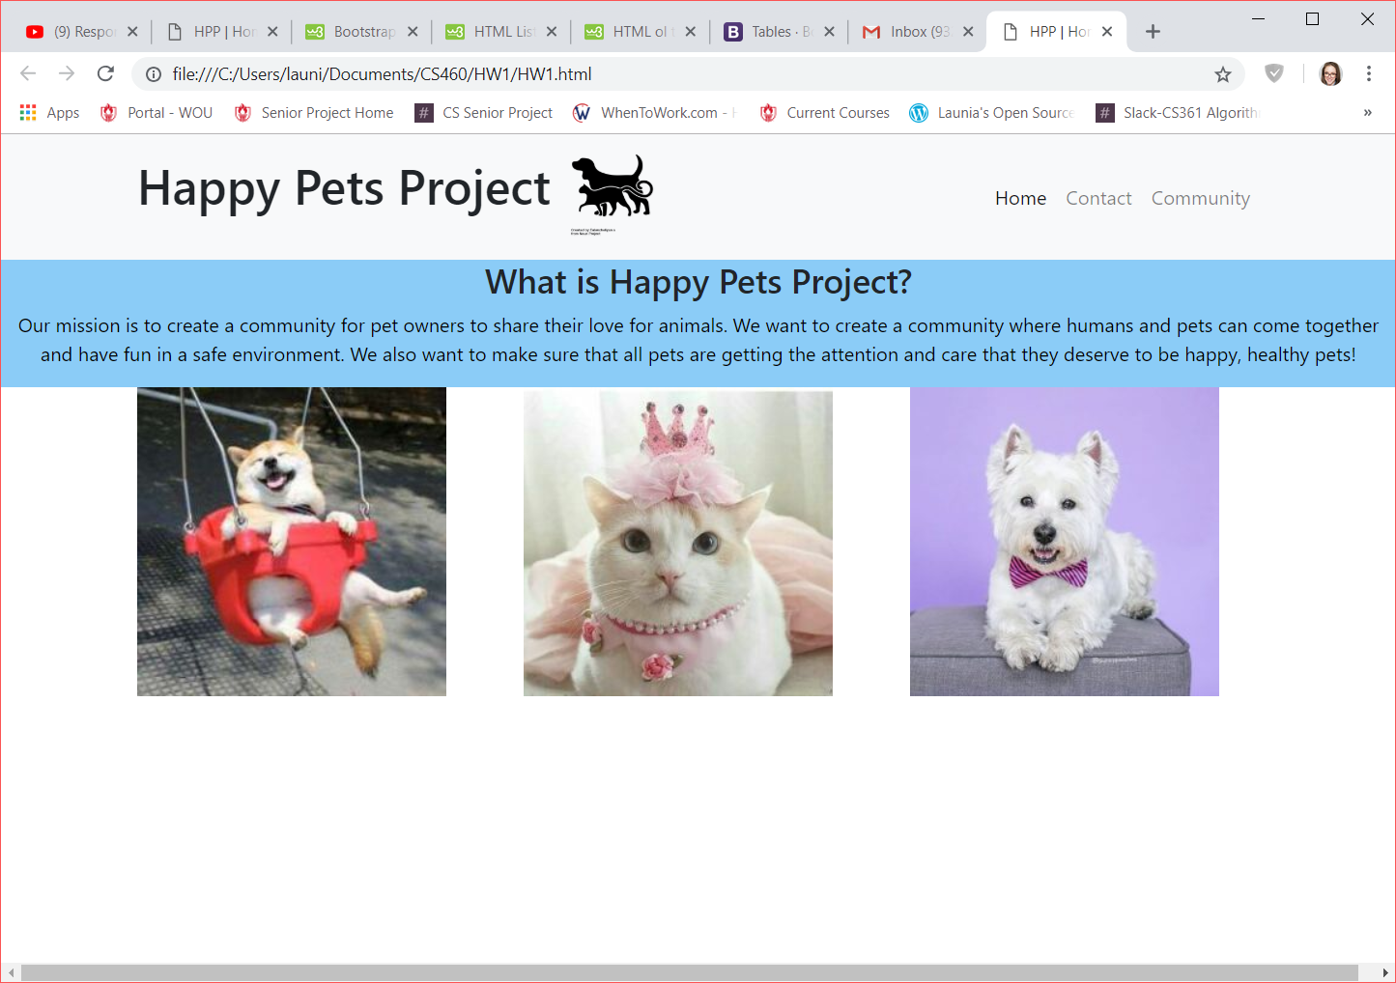

Single column layout created (blue section) with a header and paragraph.

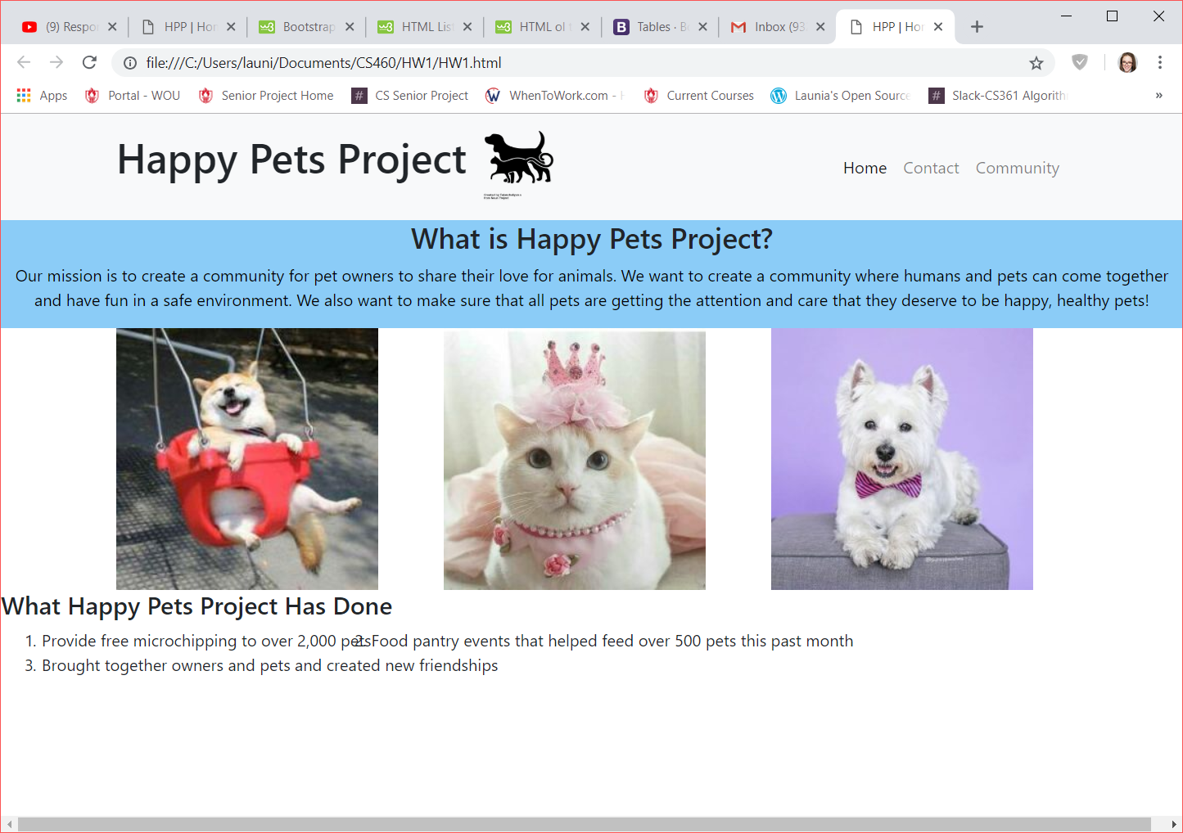

Created an ordered lists, however, I am having some formatting issues (overlapping)

\*edit-solved\* placed in a break after each item. It’s a temporary fix for now

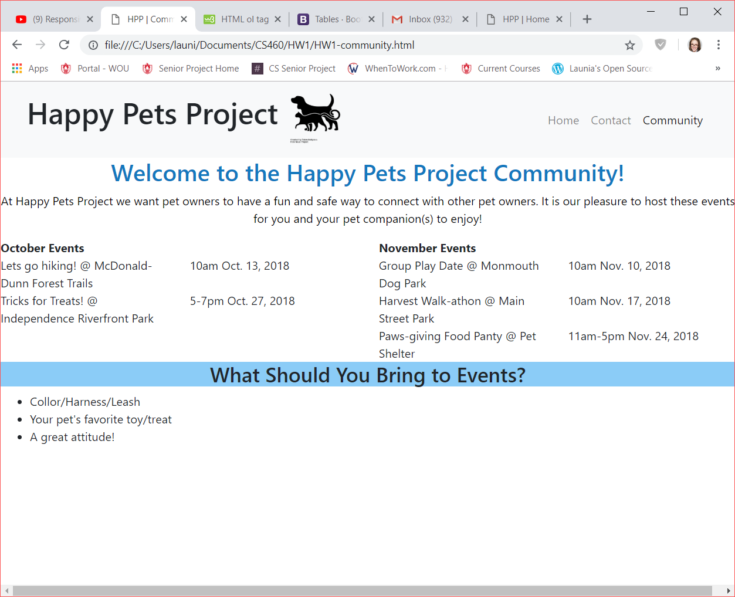

Unordered list. I had the same issue with overlapping but placed in the break and no each item of the list has its own line.

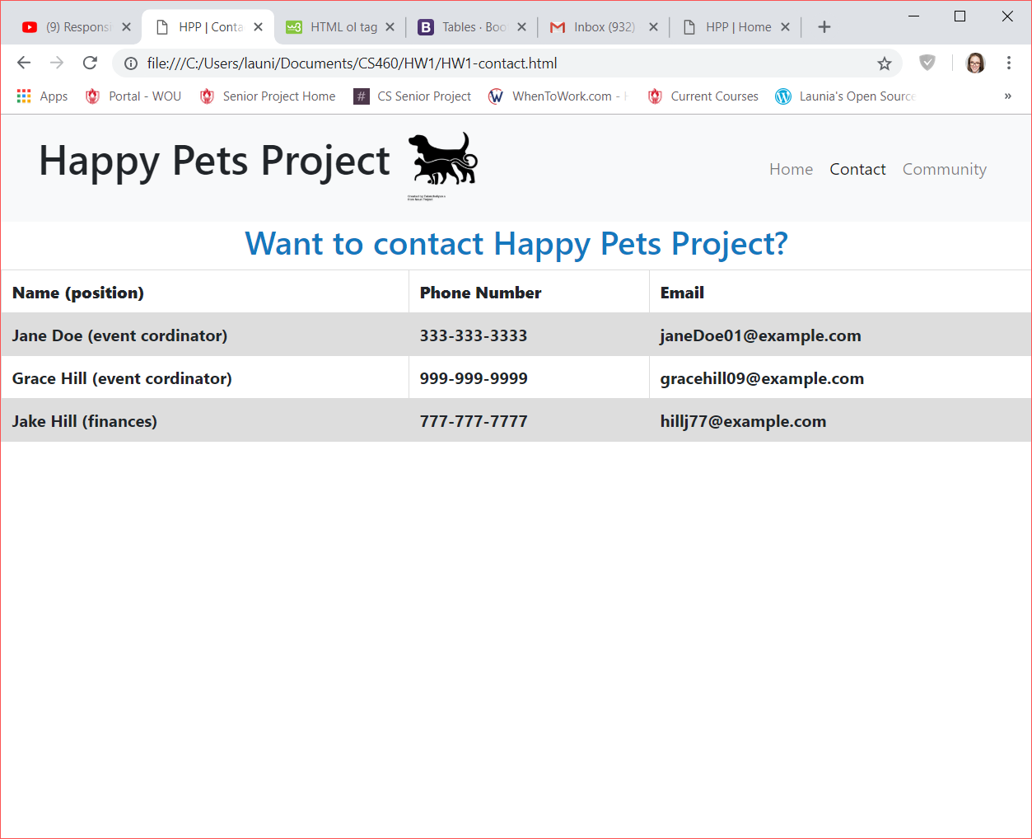

Here is the table.

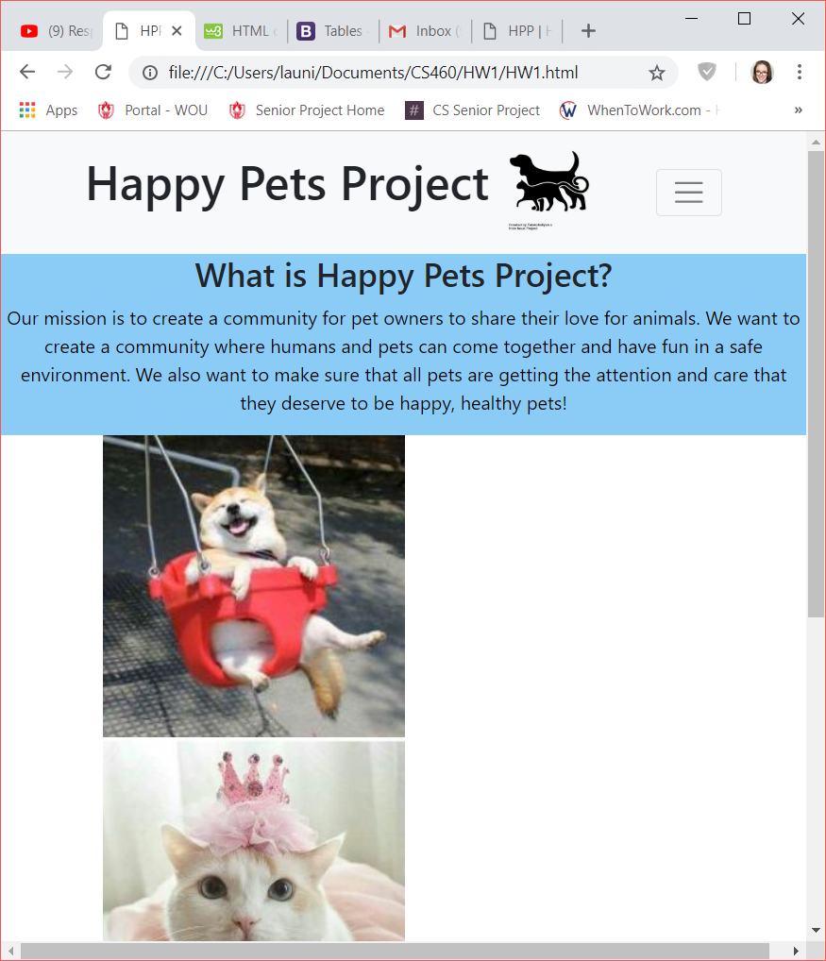

Back to the navigation bar, when the screen is small enough it will no longer show the menu items “Home”, “Contact” and “Community” but it will show a drop menu icon and when you select it then the drop menu will appear.

