- (1) The Arthur Rackham Fairy Book: A Book of Old Favourites With New Illustrations
Introductions: By 1933, the Bluebeard illustration tradition had run for over a century. The turbaned despot of Colman and Kelly's 1798 stage melodrama had passed through Victorian pantomime, through the Edwardian gift-book renaissance, through the post-war elaborations of Robinson and Clarke, and had arrived here: in the hands of the oldest and most celebrated illustrator in this exhibition, in the darkest political year Europe had seen since the Armistice. Hitler came to power in January 1933. The Ottoman Empire whose imagery had structured the tradition had been dissolved for eleven years. The world in which the decorative Orientalist gift-book had flourished — the long Edwardian afternoon of expensive colour-plate volumes and prosperous middle-class Christmas gift-giving — was itself a historical artifact. Rackham was seventy years old and knew it.
The Arthur Rackham Fairy Book is in many ways a retrospective volume — a gathering of old favourites, as the subtitle announces, by an illustrator who had spent fifty years defining what English fairy tale looked like. That Rackham chose, at this late stage, to illustrate Bluebeard in pure black-and-white silhouette — abandoning the watercolour technique that had made his name, stripping away colour, costume detail, facial expression, and all the decorative apparatus of the Orientalist tradition — is the most formally radical decision in this exhibition. It is the choice of a man who had watched the visual tradition age, and who understood that what it had always really been about was not colour or costume but structure: the shape of enclosure, the architecture of a story about a building and the women kept inside it.

About the Illustrator:Arthur Rackham (1867–1939) was the dominant figure of the Edwardian gift-book golden age, the period roughly between 1900 and 1914 when British publishers produced lavish colour-plate volumes for the Christmas market and illustrators like Rackham, Dulac, and their contemporaries became household names. His watercolour work — atmospheric, intricate, populated with gnarled ancient trees, ethereal women, and creatures on the boundary between human and natural — defined the visual imagination of English fairy tale for a generation. His illustrated editions of Rip Van Winkle (1905), Peter Pan in Kensington Gardens (1906), and A Midsummer Night's Dream (1908) established him as the preeminent illustrator of the fantastical in British art.

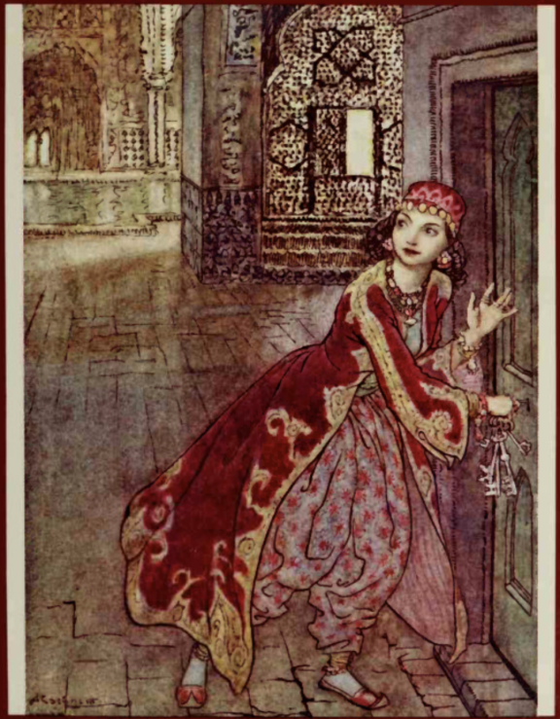 The Bookcover of 1978 version, not by Rackham
The wife here is the most fully Ottomanized female figure in the entire exhibition. She wears şalvar trousers in floral printed fabric, a deep crimson outer robe swith gold embroidered trim, jewelled headpiece, earrings, layered necklaces, and pointed slippers — the complete visual vocabulary of Ottoman feminine dress. The keys she clutches in her right hand are the only narrative marker distinguishing her from the other women of Bluebeard's household. Remove them, and she is indistinguishable from his world.

1 of 1 The Ending
Left page
Bluebeard stands inside the ground-floor archway of the Ottoman palace, small within the architecture, holding what appears to be his scimitar vertically — a staff-like posture, slightly formal. His turban is clearly readable even at this scale: the rounded dome of wrapped fabric sitting above şalvar-clad legs. The building around him is rendered with horseshoe arches, a domed pavilion above, a crescent moon finial at the very top. He is framed by the arch, contained within the building rather than dominating the space. The text beside this image describes the climactic moment: scimitar raised, wife on her knees, brothers about to arrive, but Rackham illustrates not the violence itself but the moment before: Bluebeard hunting the wife, Sister Anne calling for aid.
Right page
The building here is the very architecturally elaborate, with a multi-storey Ottoman palace rendered in cross-section, its interior spaces simultaneously visible. Horseshoe arches at ground level open onto stairs. A latticed mashrabiyya screen is visible mid-right. Staircases ascend in multiple directions. At the upper level, a domed open pavilion or gazebo with hanging bells or ornaments. A dragon or griffin bracket supports a lantern on the right exterior. An urn of flowers on a balustrade. Decorative finials crown every tower.
Within this building, two female figures. At ground level, the wife rushes hurriedly through an interior archway, her body leaning forward to check Bluebeard’s position. Above, at the very top of the building, Sister Anne leans over a parapet, arms raised, body posed in a gesture of signalling. She overhangs the architecture, her figure almost escaping the building's boundaries.
At seventy years old, at the end of his career, in 1933, Rackham has distilled the entire Ottoman Bluebeard visual tradition into its essential element: not the turbaned despot himself, not the harem interior, not the decorative colour-plate fantasy, but the building and the shadow and shape cut from black paper against white. What remains is the text, which still says scimitar, and the shadow, which shows a building crowned with a crescent. The substance has departed, while the outline remains.
By 1933 Rackham had outlived the world that had made him. The gift-book market had collapsed with the Depression. The Edwardian confidence that had sustained the tradition of beautiful, expensive illustrated volumes for prosperous households was gone. He was working in a Europe that had not, after all, learned the lessons of the Great War: a Europe in which the carefully restored world of domestic pleasure and fine illustration that the 1921 Robinson volume had tried to rebuild was being dismantled again. Whether or not Rackham consciously registered all of this in his formal choices, his 1933 Bluebeard illustrations feel like the product of a man who had stopped believing in the power of prettiness to contain a dark story. He gave the tale its shadow and its bones, and left the colour out.

