GeomaticTouch and ROS

How to use GeomaticTouch and ROS on a Windows by installing ubuntu 24.04 via WSL2

1. Download on Ubuntu: Open Haptics Linux 3.4 version and Touch Drivers: <https://support.3dsystems.com/s/article/OpenHaptics-for-Linux-Developer-Edition-v34?language=en_US>

And unzip the tar.gz file

1. Install dependencies :

- usbutils

- libglut-dev

- libusb-1.0-0

- zlib1g-dev

**-** build-essential

- freeglut3-dev

- libncurses5 and libtinfo5 with:

>wget http://archive.ubuntu.com/ubuntu/pool/universe/n/ncurses/libncurses5_6.2-0ubuntu2.1_amd64.deb

>wget http://archive.ubuntu.com/ubuntu/pool/universe/n/ncurses/libtinfo5_6.2-0ubuntu2.1_amd64.deb

>dpkg-deb -x libncurses5_6.2-0ubuntu2.1_amd64.deb nc5

>dpkg-deb -x libtinfo5_6.2-0ubuntu2.1_amd64.deb t5

>sudo mkdir -p /usr/local/lib/openhaptics

>sudo cp nc5/lib/x86_64-linux-gnu/libncurses.so.5* /usr/local/lib/openhaptics/

>sudo cp t5/lib/x86_64-linux-gnu/libtinfo.so.5* /usr/local/lib/openhaptics/

>export LD_LIBRARY_PATH=/usr/local/lib/openhaptics:$LD_LIBRARY_PATH

>sudo nano /etc/ld.so.conf.d/openhaptics.conf

And add at the end of the file:

/usr/local/lib/openhaptics

Close and save

>cd /usr/local/lib/openhaptics

>sudo rm /usr/local/lib/openhaptics/libncurses.so.5

>sudo rm /usr/local/lib/openhaptics/libtinfo.so.5

>sudo ln -s libtinfo.so.5.9 libtinfo.so.5

>sudo ln -s libncurses.so.5.9 libncurses.so.5

>sudo ldconfig

1. Install Open Haptics and Touch Drivers (follow README_INSTALL):

>cd ~/openhaptics_3.4-0-developer-edition-amd64/

>sudo ./install

>cd ~/TouchDriver_2024_09_19

>./install_haptic_driver (without sudo command but password required)

1. Check if the device is connected :

>lsusb (lists all USB devices connected to the Ubuntu system)

OR

>cd TouchDriver_2024_09_19

>./ListCOMPortHapticDevices

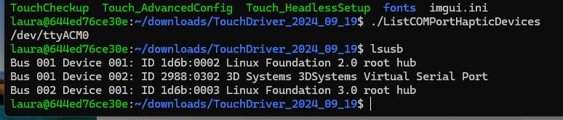

If you see:

Go to step 7

1. Share devices WINDOWS – WSL :

On windows, download usbipd-win 5.1.0 on git: <https://github.com/dorssel/usbipd-win/releases/tag/v5.1.0>

On powershell admin:

>cd ‘C: \Program Files\usbipd-win\’

>.\usbipd.exe list (lists the USB devices connected to the Windows PC that are compatible with WSL2.)

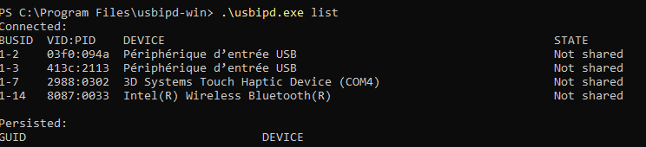

>.\usbipd.exe bind --busid 1-7 (Attaching the USB device to the Windows USBIP system, instead of leaving it controlled by Windows.)

>.\usbipd.exe attach --busid 1-7 --wsl (Bringing USB into WSL2)

1. Check the connection with step 4
2. Configure Geomagic Touch driver :

>sudo usermod -a -G dialout $USER

Reboot the PC

>cd TouchDriver_2024_09_19/bin

>./Touch_HeadlessSetup

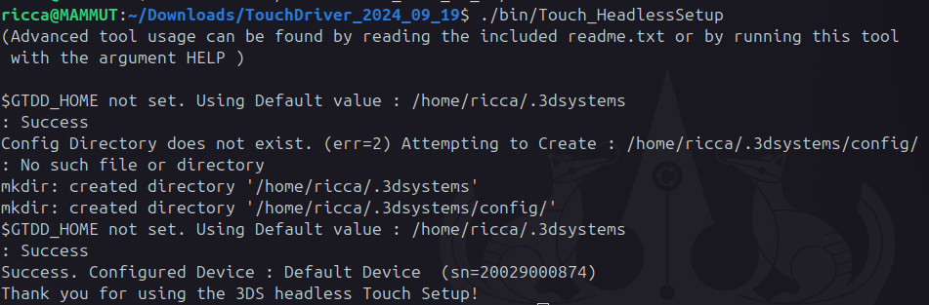

1. Access to GeomaticTouch hardware and software parameters:

>cd /.3dsystems/config

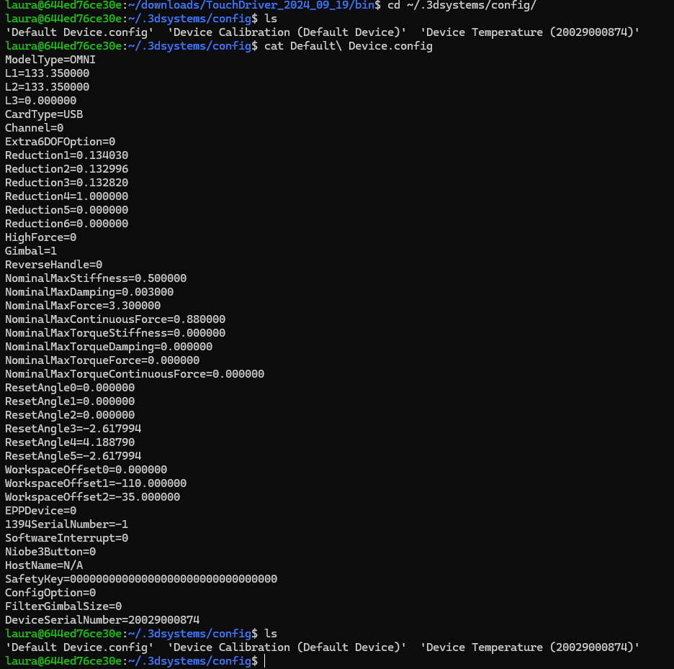

1. Build and Execute:

>cd /opt/OpenHaptics/Developer/3.4-0/examples/HD/console

>make all