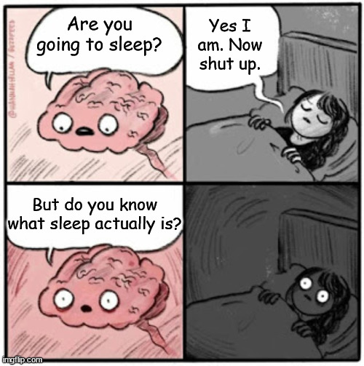Our research question:

* Can a specific type of **brain activity** be boosted through dim **flickering light** during **sleep**?
* If we find positive effects in young & healthy people, this could be valuable for the prevention of Dementia.

Time and place:

* June – November 2023
* Sleep lab at Klinikum rechts der Isar, Ismaninger Str. 22, 81675 Munich

Your participation:

* Come to the lab for one short session (1 h) and two nights (2 x 10 h)
* In the **short session**, light stimulation is applied while awake
* **1st night**: sleep at the lab while your brain activity is measured
* **2nd night**: additionally, dim light stimulation is activated while you sleep

We offer you:

* For full study completion: **100 €**
* Personalized sleep reports

You may take part if:

* You are 18 – 35 years old and healthy (no sleep / neurological / psychiatric disorders, no colour blindness, no drug abuse)