Project Sprint #1

The Solitaire game is described in CS449HomeworkOverview. You should read the description very carefully.

In this assignment, you aim to specify the requirements (i.e., user stories and acceptance criteria) of the target software that allows a human player to play a Solitaire game. These requirements will be fully implemented by the end of sprint 3. The minimum features include choosing the board size and type, starting a new game, making a move, determining if a game is over. The following is a sample GUI layout.

Board size
Board Type  - English  - Hexagon  - Diamond | 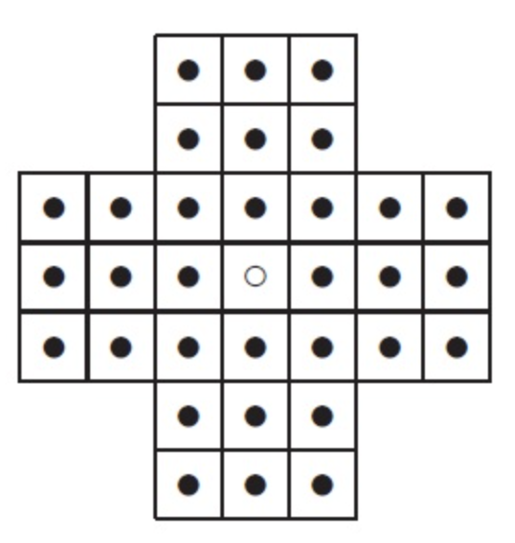
Figure 1. Sample GUI layout of the first working program by the end of Sprint 3

Use the following tables to document your user stories and acceptance criteria.

You are required to use the free ChatGPT or another LLM to complete two user stories and two of their respective acceptance criteria. You must ensure that the generated user stories are correct and fix them if not. At the end of the submission, provide screenshots of your LLM prompts and answers, along with the description of errors the LLM made that you had to correct. Points will be deducted if no screenshots/description are provided.

For the other user stories and acceptance criteria, you are not required to use LLM.

- User Stories (3 points)

- User Story Template: As a <role>, I want <goal> [so that <benefit>]

ID | User Story Name | User Story Description | Priority | Estimated effort (hours)
1 | Choose a board size | As player, I want to choose the board size so that I can adjust game’s difficulty and layout | High | 2
2 | Choose the board type | As player, I want to choose board type between English, hexagon, or diamond so I can play different game variants | High | 2
3 | Start a new game of the chosen board size and type | As player, I want to start a new game with the chosen board size and type so that I can play on a freshly initialized board | High | 3
4 | Make a move in a game | As player, I want to select peg and jump over to adjacent peg into an empty space so that I can remove the jumped peg | High | 5
5 | A game is over | As player, I want the system to detect when no legal moves remain so that I know if I have won or lost | Medium | 3

- Acceptance Criteria (AC) (12 points): Add/delete rows as needed.

User Story ID and Name | AC  ID | Description of Acceptance Criterion | Status (completed, toDo, inPprogress)
1. Choose a board size | 1.1 | AC 1.1 default board size selection  Given the game launcher/setting window is open  When player does not change the size setting  Then the standard/default board size is selected | toDo
1. Choose a board size | 1.2 | AC 1.2 changing board size  Given game setup screen is visible  When player selects a diff valid board size from the size option  Then system updates the board display to match selected dimensions | toDo
2. Choose the board type | 2.1 | AC 2.1 selecting a board shape/type  Given main setup screen is displayed  When player selects “english,” “hexagon,” or “diamond”  Then board preview updates to reflect the chosen shape configuration | toDo
2. Choose the board type | 2.2 | AC 2.2 invalid combination handling  Given specific board type is chosen  When incompatible board size is selected  Then system prompts user or disables invalid size options | toDo
3. Start a new game | 3.1 | AC 3.1 default game initialization  Given player opens the application setup screen  When player clicks the “NEW GAME” without modifying anything  Then new game starts using default options with all pegs in starting positions and a single empty space in center | toDo
3. Start a new game | 3.2 | AC 3.2 starting a game with custom valid options  Given valid board type options and valid board sizes are available on setup screen  When player selects a valid board type and size and clicks “NEW GAME”  Then game board initializes matching the selected size and layout configuration | toDo
4. Make a move in a game | 4.1 | AC 4.1 valid move execution  Given game is active and selected peg has adjacent peg with an empty space directly beyond it along a valid path  When player executes a jump over adjacent peg into the empty space  Then selected peg moves to destination empty space and jumped peg is removed from the board | toDo
4. Make a move in a game | 4.2 | AC 4.2 invalid move rejection  Given game is active and peg is rejected  When player attempts an illegal move like jumping over empty space or jumping diagonally on gird where diagonal moves are disabled or landing on occupied space  Then move is rejected and warning or error will pop up and the board state remains unchanged | toDo
5. A game is over | 5.1 | AC 5.1 game over detection  Given game is in progress  When no valid jumps are remaining for any peg on board  Then game declares game over and displays total remaining pegs | toDo
5. A game is over | 3.2 | AC 5.2 win condition achieved  Given a game is in progress  When only 1 peg remains on the board  Then system displays history notification | toDo

Gemini does a good job on making these stories!
