Budapest Schools — Geospatial Data Quality Project
Extracting, cleaning, and visualizing OpenStreetMap data in Power BI
Goal: Extract, clean, and analyze publicly available geospatial data (OpenStreetMap) on schools in Budapest, with a focus on data quality assessment and visualization.
Tools: Overpass Turbo (data extraction), Oracle SQL / APEX (storage & analysis), Power BI (visualization).

Table of Contents
Table of Contents 2
1. Data Extraction — Overpass Turbo 3
2. Designing the Data Structure — SQL Table 3
3. Data Loading 3
4. Data Quality Analysis — Completeness 4
5. Identifying Near-Empty Records 5
6. Building a Data Quality Flag 5
7. District-Level Distribution 8
8. Exporting Data for Power BI 9
9. Loading Data into Power BI 10
10. Map Visualization 11
11. Color-Coding by Data Quality 11
12. District Bar Chart and Interactivity 11
13. Data Quality Breakdown — Pie Chart 12
14. Final Dashboard 13
Summary 13
Lessons Learned 14

1. Data Extraction — Overpass Turbo
What I did: I queried all locations tagged amenity=school within Budapest's administrative boundary, using the Overpass QL query language.
Why this approach: I retrieved both node and way types (not just one), because in OSM a school can be tagged as a single point or as a building outline — retrieving only one type would have caused data loss.
Result: 526 results (119 nodes, 407 ways).
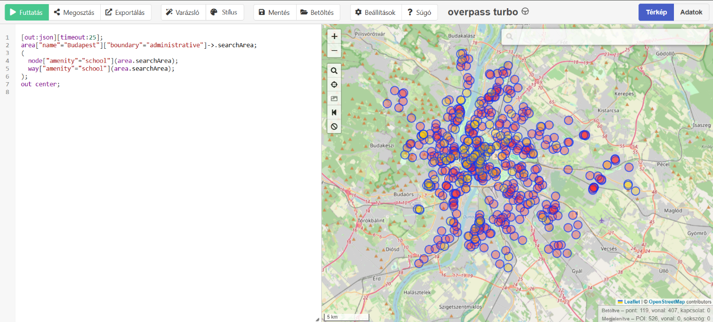
The Overpass Turbo query and the resulting map

2. Designing the Data Structure — SQL Table
What I did: I created a SCHOOLS_RAW table in Oracle SQL with 10 columns (identifier, type, name, address fields, coordinates).
Why this approach: The GeoJSON contained around 20 fields, but I deliberately excluded rarely-populated, low analytical-value fields (e.g. wikidata, contact:facebook) based on a quick data profiling pass — these would not have contributed to the quality or spatial analysis.
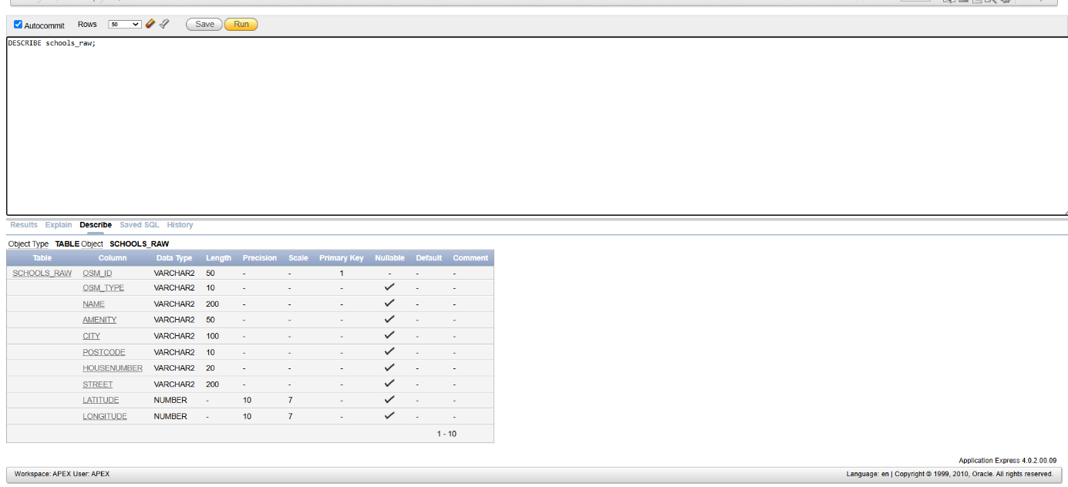
Running the CREATE TABLE statement

3. Data Loading
What I did: I converted the GeoJSON to CSV format, then loaded it into the SCHOOLS_RAW table using the APEX Data Load Wizard.
Result: 526/526 rows loaded successfully, 0 errors.
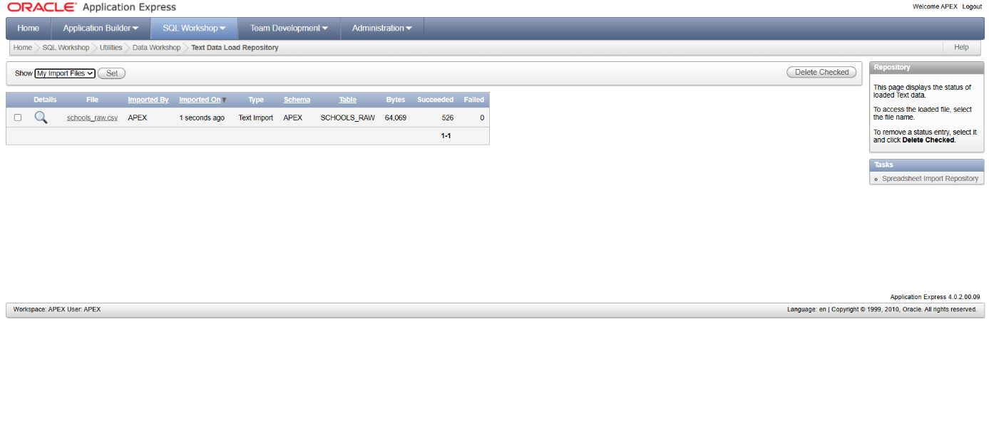
The data load report

4. Data Quality Analysis — Completeness
What I did: I used an SQL query to check, field by field, what percentage of the data was populated.
- name: 95.8%
- city: 91.4%
- postcode: 89.2%
- housenumber: 89.0%
- street: 89.0%
Finding: The name field is the most reliable, while the address-related fields (city, postcode, housenumber, street) are consistently somewhat weaker — suggesting the same records tend to be incomplete across several address fields at once, rather than the gaps being independently distributed.
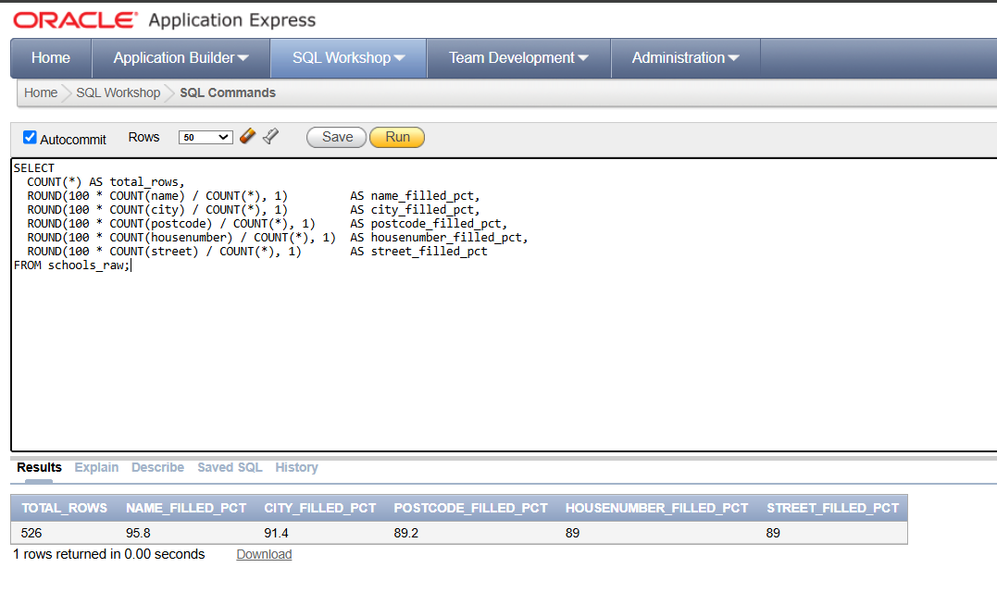
The completeness percentage results

5. Identifying Near-Empty Records
What I did: I used an SQL query to identify the records missing the most key fields (name, city, postcode, housenumber, street), using a simple scoring logic (CASE WHEN).
Why this approach: Rather than manually reviewing all 526 rows, I ranked records by degree of incompleteness using an automated query — a method that scales to much larger datasets.
Result: 13 records were missing all 5 key fields (all of these were way-type entries); a second group had 4 missing fields while the name field was populated.
Finding: Two distinct incompleteness patterns emerged: (1) minimally tagged way entries carrying only the "school" label and nothing else; (2) records with a name but no address data at all. This suggests the incompleteness is not random, but tied to who contributed the data to OSM and how.
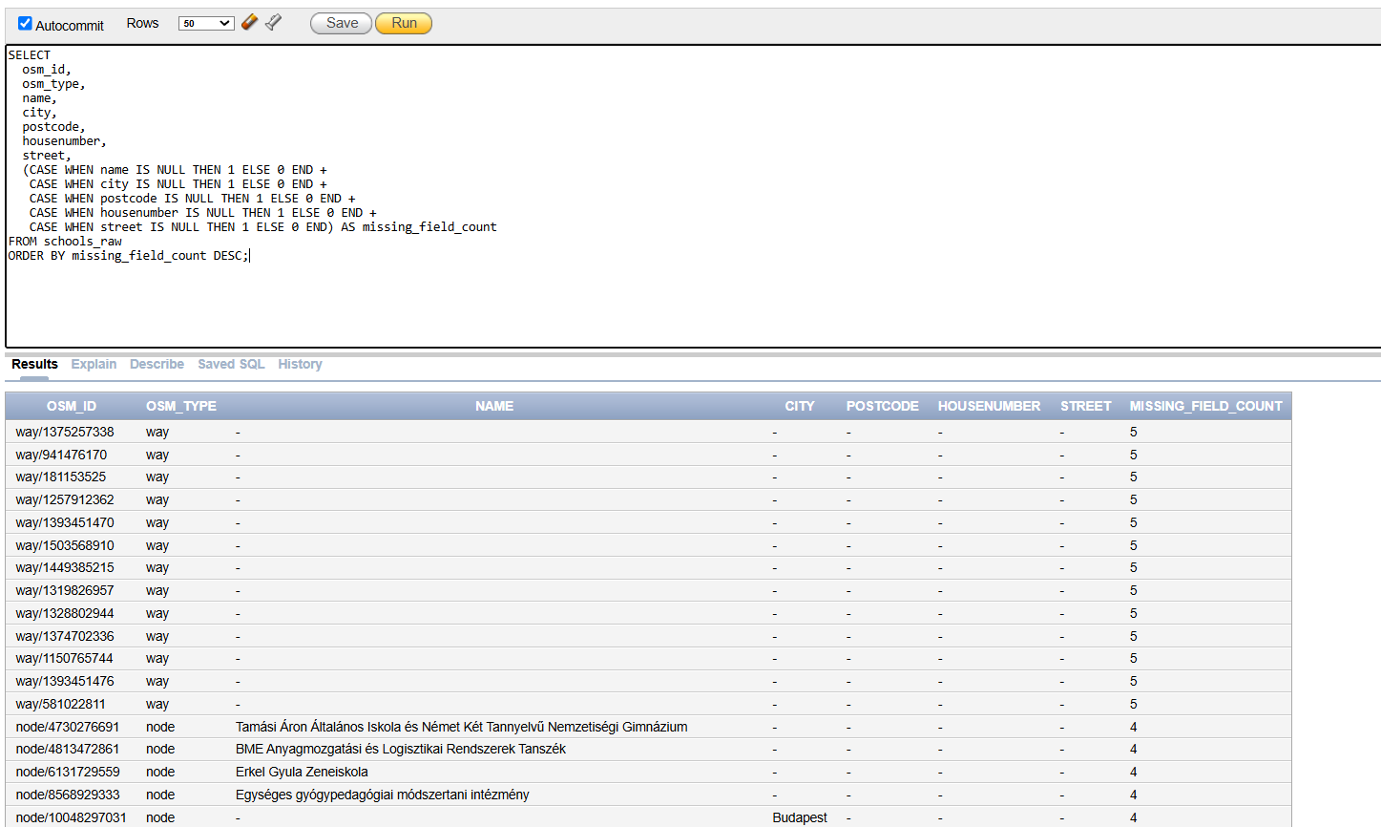
Results of the incompleteness-ranking query

6. Building a Data Quality Flag
What I did: I added a new data_quality_flag column to the table (ALTER TABLE), then used an UPDATE statement to classify records into three categories: complete (all key fields populated), needs_review (name present, address incomplete), low_quality (all key fields missing).
Why this approach: I chose flagging over deletion so that no data would be lost, and any record could be included or excluded downstream as needed.
Result: 471 records (89.54%) complete, 42 records (7.98%) needs_review, 13 records (2.47%) low_quality.
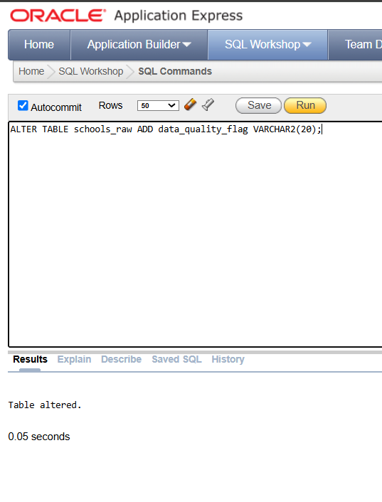
Adding the column (ALTER TABLE)
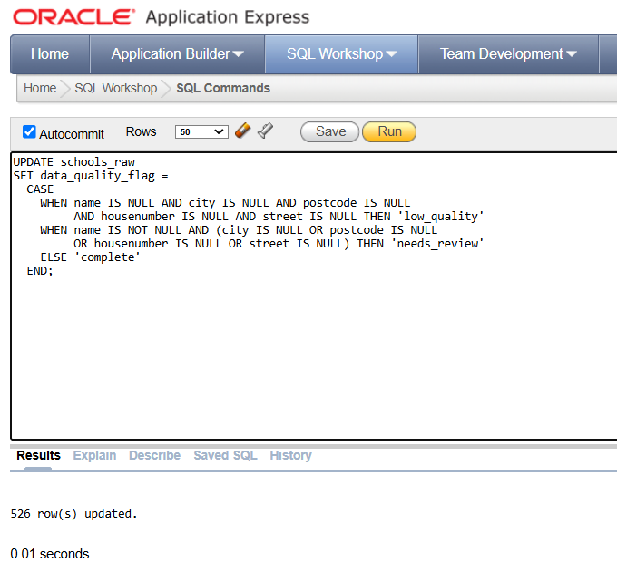
Running the classification logic (UPDATE)
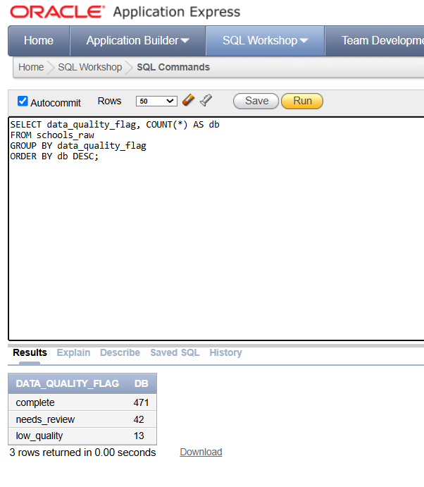
Verifying the result by category

7. District-Level Distribution
What I did: I aggregated the number of schools by district, extracting the district number from the middle two digits of the postcode.
Why this approach: I used the postcode field to determine the district rather than coordinates, since it's a simpler and more reliable method when precise spatial computation (e.g. exact distance or density per km²) isn't yet required. I deliberately excluded records with a missing postcode (roughly 10–11%) from this analysis, these were already flagged via data_quality_flag, so the resulting data loss remains traceable.
Result: The most schools are located in District XI (43) and District XIV (39); the fewest in District XXIII (4).
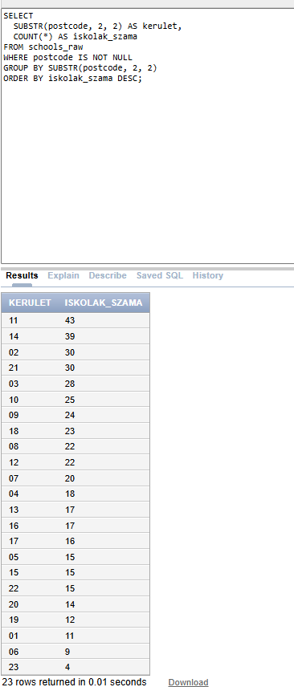
School count by district (23 rows)

8. Exporting Data for Power BI
What I did: I exported the schools_raw table as CSV from Oracle APEX, including the previously created data_quality_flag and kerulet (district) fields, so all the necessary data would be available together in Power BI.
Why this approach: I chose a CSV export over a direct database connection because it's simpler, avoids driver dependencies.
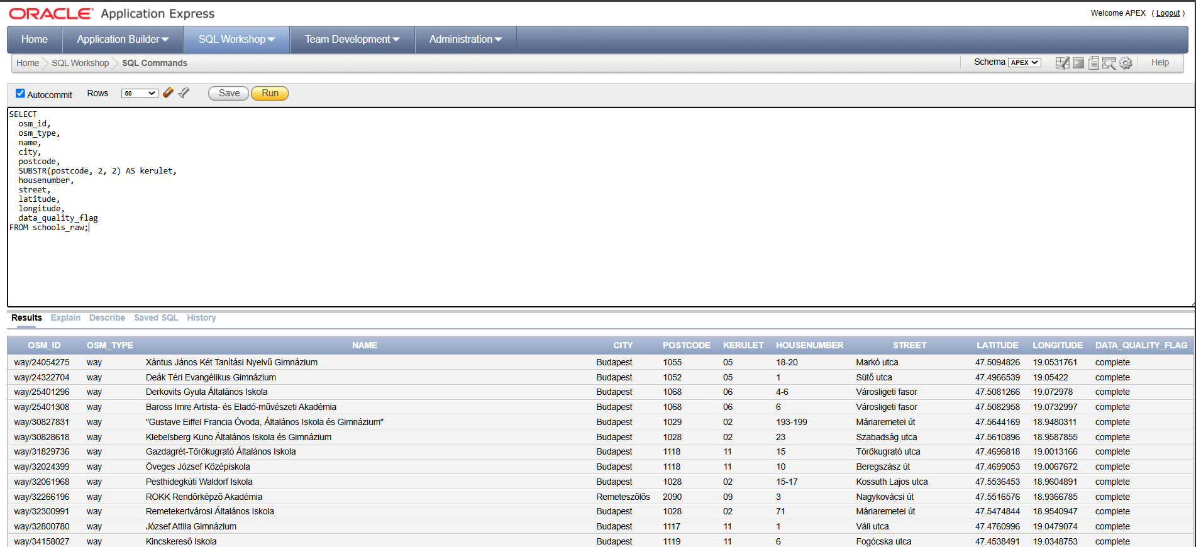
The final export query and its result

9. Loading Data into Power BI
What I did: I loaded the CSV file exported from Oracle into Power BI Desktop (Get Data → Text/CSV → Load).
Result: The data loaded successfully; the "report" table appeared in the Data pane, containing all 10 relevant fields (identifier, type, name, address fields, district, coordinates, data quality flag).
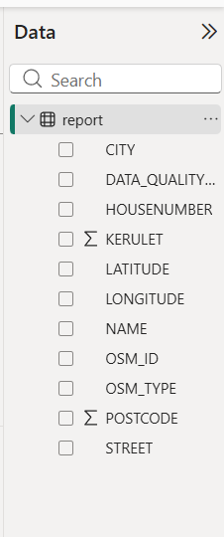
The loaded table in the Data pane

10. Map Visualization
What I did: I created a map visual in Power BI and dragged the latitude/longitude fields into the Latitude/Longitude wells. (Map visuals first had to be enabled in Power BI's security settings: File → Options and settings → Options → Global → Security.)
Result: All 526 school points appeared on the map, spread across Budapest.
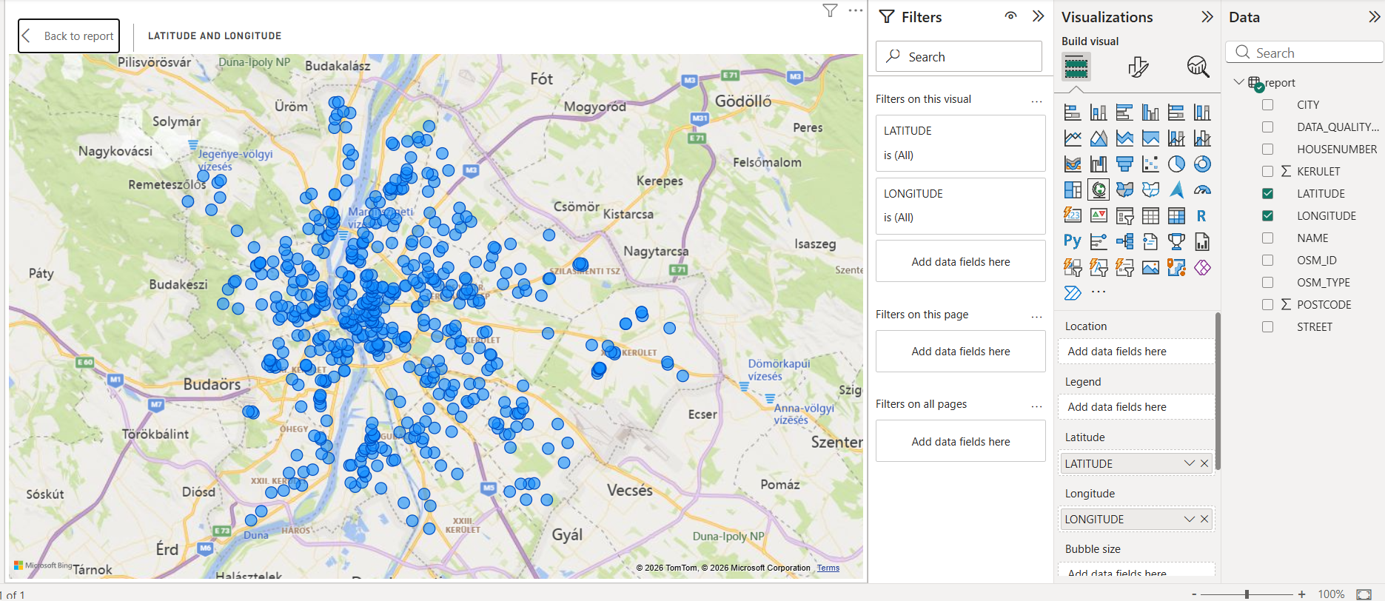
The first map visualization

11. Color-Coding by Data Quality
What I did: I dragged the data_quality_flag field into the map's "Legend" well, so points would be color-coded by data quality.
Result: The map now shows points in 3 colors (complete, low_quality, needs_review). The majority (complete) are evenly and densely distributed across the city center and larger districts. The needs_review points are scattered rather than concentrated in one area.
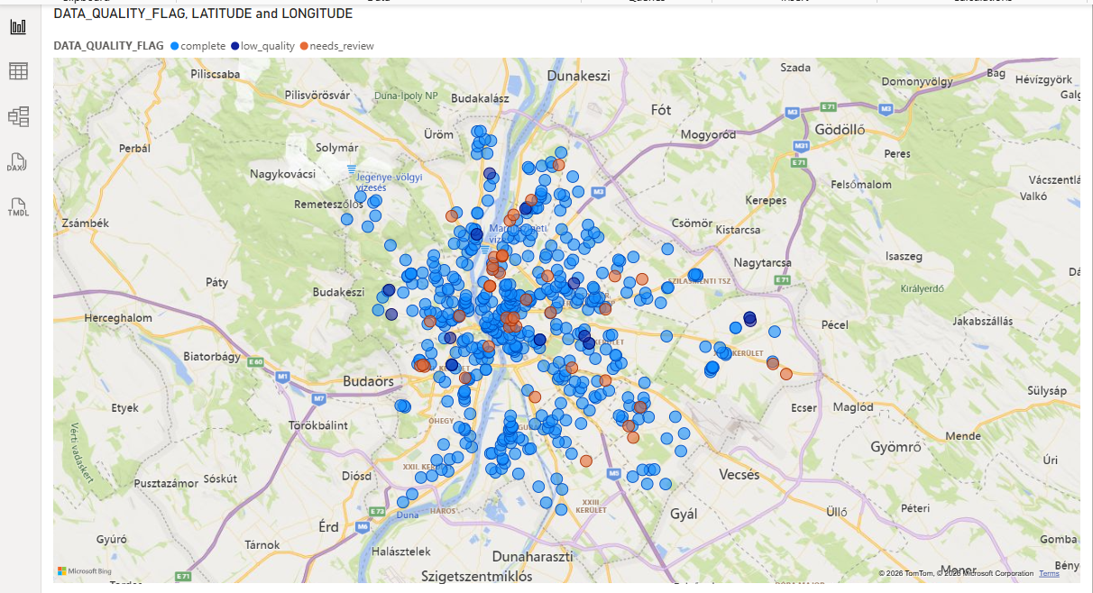
Map color-coded by data quality

12. District Bar Chart and Interactivity
What I did: I built a bar chart by the kerulet (district) field, showing the count of schools (Count of osm_id).
Result: The chart visually confirmed the earlier SQL result (District XI and XIV leading).
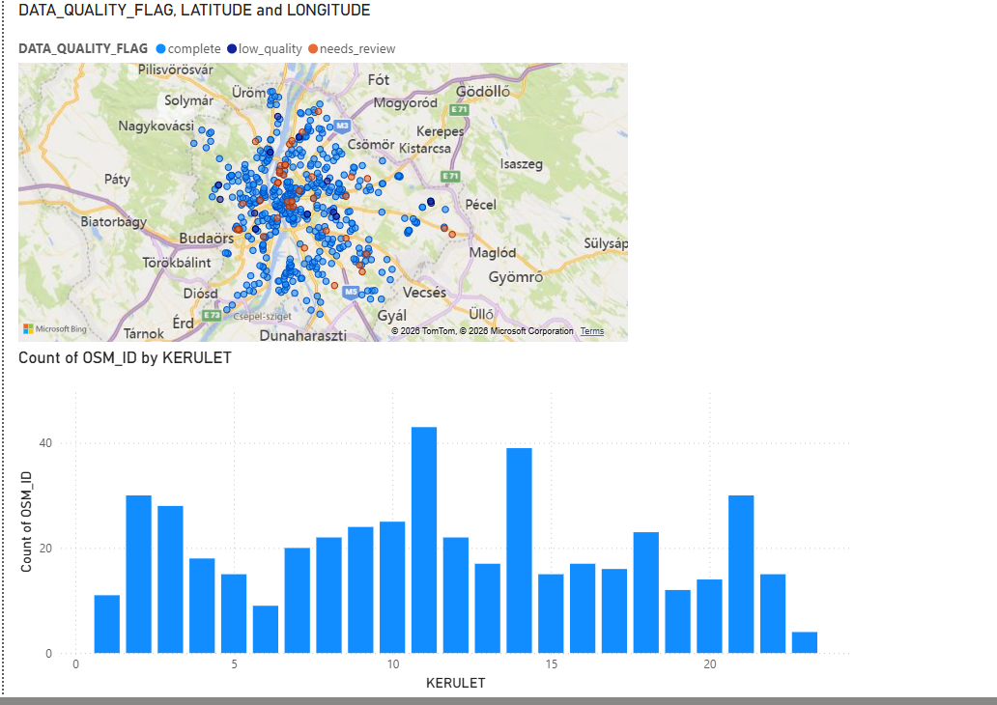
Map and bar chart together, with cross-filtering
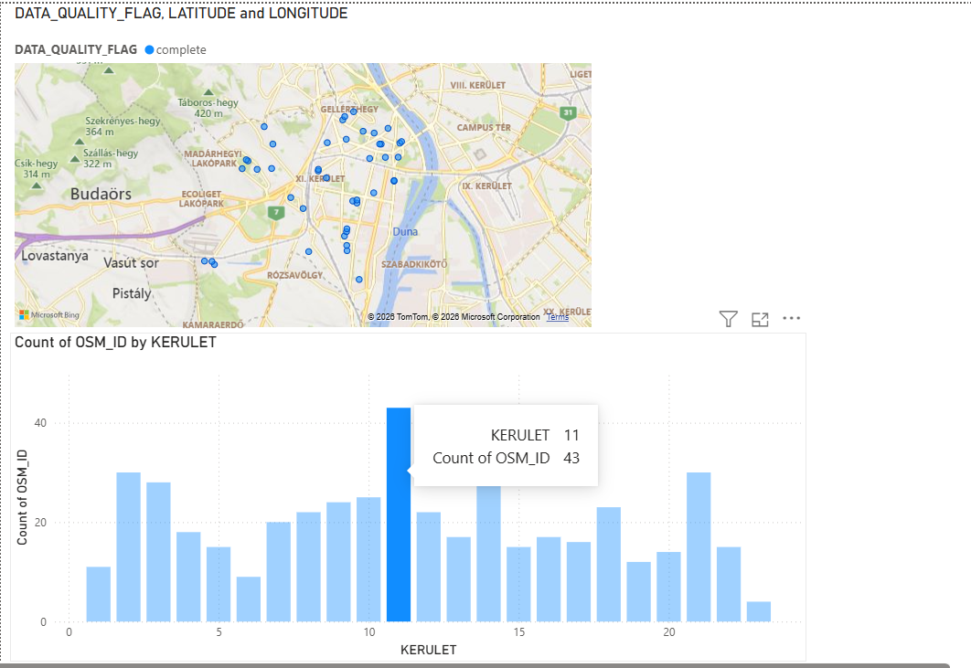
Cross-filtering demonstrated: clicking District XI's bar

13. Data Quality Breakdown — Pie Chart
What I did: I built a pie chart by the data_quality_flag field, so the dataset's overall reliability would be visible at a glance.
Result: 471 records (89.54%) complete, 42 records (7.98%) needs_review, 13 records (2.47%) low_quality, confirming the earlier SQL calculation, now in an accessible visual form.

14. Final Dashboard
I arranged all three visuals (map, pie chart, bar chart) on a single page.
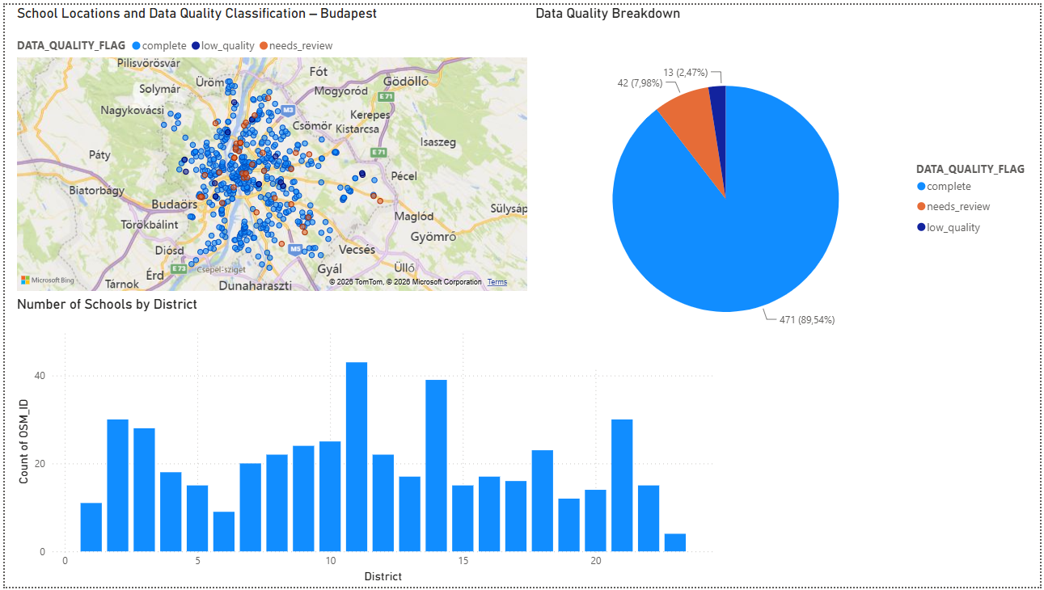
The final dashboard, with English titles

Summary
Project: Geospatial Data Quality Analysis — Budapest Schools
Goal: Extract, clean, and analyze publicly available geospatial data (OpenStreetMap) on schools in Budapest, with a focus on data quality assessment and visualization.
Tools: Overpass Turbo (data extraction), Oracle SQL / APEX (data storage & analysis), Power BI (visualization).
Process summary:
1. Extracted 526 school records from OpenStreetMap via Overpass QL, covering both point and area-based entries.
2. Designed and created a relational table structure in Oracle SQL, selecting only the fields relevant to quality and spatial analysis.
3. Loaded the data and validated the import (526/526 successful).
4. Conducted a completeness analysis across key fields (name, address components) — found 95.8% completeness for name, ~89–91% for address fields.
5. Identified and flagged records by data quality tier (complete, needs_review, low_quality) instead of deleting incomplete records, preserving all data while enabling flexible downstream filtering.
6. Performed district-level aggregation using postcode parsing.
7. Built an interactive Power BI dashboard with a map, quality breakdown, and district distribution, all cross-filtered.
Key finding: 89.5% of records were fully complete; the remaining ~10.5% were flagged rather than discarded, preserving the dataset's usability.

Lessons Learned
- Data quality issues found: missing name/address fields (in roughly 10.5% of records), completely empty, minimally tagged way entries (13 records), and structural node/way inconsistency in the source data.
- How they were handled: classification and flagging (data_quality_flag) instead of deletion — keeping the dataset complete while allowing any record to be included or excluded during analysis as needed.
- Key takeaway: incompleteness is often not random but follows a pattern; and visualizing data quality (in Power BI) is just as important as the analysis itself, since it makes the dataset's limitations transparent to others.

