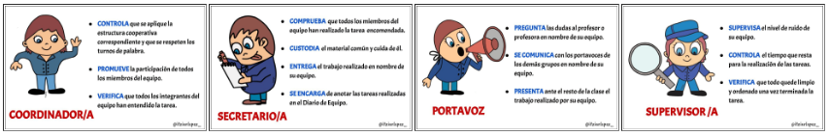
Tips to work cooperatively

Teamwork skills are essential for success in all areas of life: school, sports, etc. Therefore:
- Communicate effectively
- Collaborate
- Think Together
- Listen actively
- Solve problems
- Manage time efficiently
- Show leadership: establish team rules
- Be flexible and empathetic
- Be positive and do not complain
- Share enthusiasm
Moreover:
- Know your goal. People in teams are working towards a common goal.
- Clarify your roles. Within a team, everyone should also understand their responsibilities.

Images from @itziarlopez in OER ‘Somos un Equipo’
Apart from distributing roles and functions among the members of the team, it is necessary to keep in mind some basic principles:
- Our goal as a team is for all of us to learn more and better.
- All the members of the team are special and necessary because we all have something to contribute.
- Agreements are made by consensus.
- We must all strive to fulfil the responsibilities and functions that our role entails and contribute responsibly to the success of our project.
Finally, if we are not used to work as a team and a small conflict arises, we will try to fix it ourselves but, if we can't, we will ask for help to our teacher, we will so that we can continue moving forward without problems.

