**ie**

L. Durieux

Abstract

This guide explains how to prepare the Analog Signal PCB by cleaning flux residues and adjusting the differentiator stage. Simple steps with jumpers and potentiometers allow users to optimize frequency response for reliable signal recordings.

Guide Analog pcb

English – v1.0

Table of Contents

Introduction 2

1. Receiving the board 2

2. Cleaning the board 2

3. Available adjustments 3

3.1 Enabling or disabling the differentiator 3

3.2 Adjusting the differentiator effect 3

4. Verification after adjustment 4

Conclusion 4

Versioning 5

# Introduction

When you receive the Analog Signal PCB, it is already assembled and ready to use. However, to ensure optimal performance and remove any manufacturing residues, it is important to clean the board before use. Then, with a few simple adjustments, you can adapt the board’s response to your experimental conditions.  
  
This step-by-step guide will show you how to:  
1. Properly clean the board.  
2. Identify and understand the available adjustments.  
3. Tune the board according to your recording needs.

# 1. Receiving the board

Upon delivery, the board arrives fully assembled with all components soldered. Assembly quality is usually good, but there are often traces of solder flux remaining.

# 2. Cleaning the board

Before using the board, it is recommended to remove any solder flux residues. For this, use ready-to-use wipes soaked in isopropyl alcohol. They provide a simple, quick, and effective cleaning method.

Practical tips:  
- Gently wipe the surface of the board with the alcohol wipe.  
- Allow the board to dry for a few seconds before handling.

# 3. Available adjustments

The board has two main adjustments that influence how the signal is processed:  
- Whether or not the differentiator is active (J3 for channel 1; J10 for channel 2).  
- The jumpers that controls the amplification of higher frequencies (J6 for channel 1; J14 for channel 2).

## 3.1 Enabling or disabling the differentiator

By default, a jumper (small black connector) is placed to activate the differentiator.  
If you wish to disable the differentiator, move the jumper to the two upper pins.

Expected effect:  
- With differentiator: higher frequencies are more strongly amplified.  
- Without differentiator: the signal bypasses the differentiator.

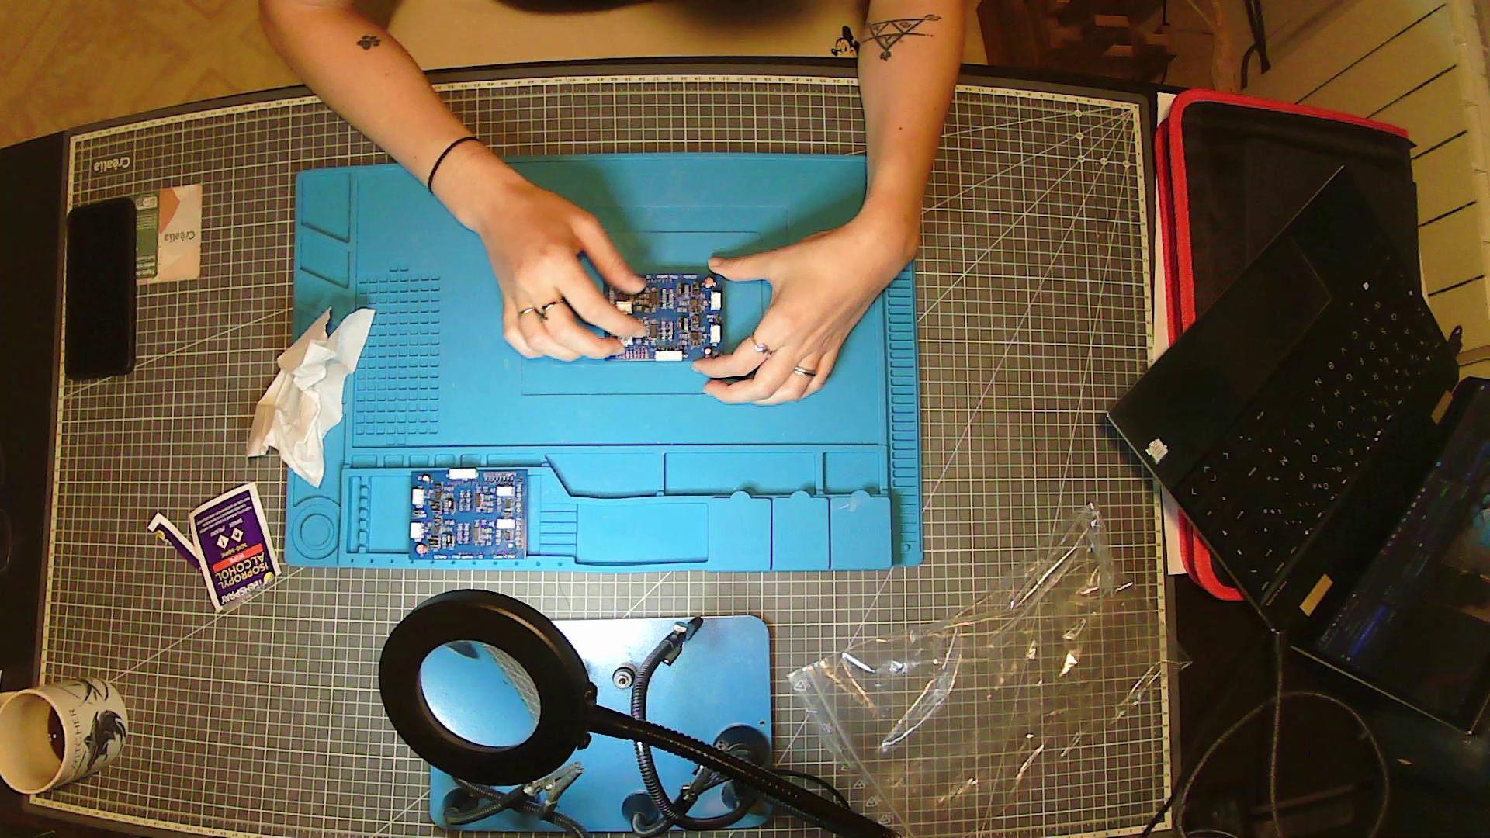

## 3.2 Adjusting the differentiator effect

In addition to the previous jumper, another jumper (2x3 pins header) allows fine-tuning of the amplification applied to higher frequencies.  
  
- Moving it upwards: reduces the effect of the differentiator.  
- Moving it downwards: increases the effect of the differentiator.

Practical tip: always start with the jumper set in the middle position. Then adjust according to test recordings (for example depending on distance or type of signal captured).

# 4. Verification after adjustment

Once cleaning and adjustments are done:  
1. Connect the board to your system (computer + acquisition software).  
2. Perform a test recording.  
3. Check if the obtained spectrum matches your expectations.  
  
Adjust the jumpers if necessary and keep the position that gives the best results for your experimental setup.

# Conclusion

To summarize:  
- Clean the board upon receipt using ready-to-use isopropyl alcohol wipes.  
- Choose the differentiator configuration according to your needs.  
- Adjust the jumpers, starting from the middle position, if needed.  
  
With these simple steps, your Analog Signal PCB will be clean, adjusted, and ready for experiments.

# Versioning

|  |  |  |  |
| --- | --- | --- | --- |
| Authors | Version | Date | Comment |
| L. Durieux | V1.0 | 23.09.25 | Document first release |
|  |  |  |  |