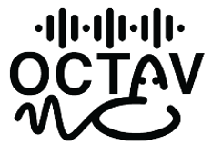

**ie**

L. Durieux

Abstract

This document describes the complete testing protocol for the full OCTAVie system, including the microphone, acquisition unit, and software interface. It outlines the procedure to verify proper communication and synchronization between all subsystems, as well as to assess overall signal quality and system performance. The test includes setup instructions, signal generation, data recording, and result interpretation. Although not mandatory, this full-system test is highly recommended to confirm global functionality and ensure reliable operation before experimental use.

Full System Protocol Test

English – v1.0

Table of Contents

Section 1 — Material needed 2

Section 2 — Protocol 2

License Information 3

Versioning 4

# Section 1 — Material needed

To be completed

# Section 2 — Protocol

To be completed

# License Information

**Hardware license**: CERN Open Hardware License v2 (Strongly Reciprocal – OHL-S).

**Software license**: GNU General Public License v3 (GPLv3), ensuring that all modifications remain open-source.

**Documentation license**: Creative Commons Attribution-ShareAlike 4.0 International (CC-BY-SA 4.0).

# Versioning

|  |  |  |  |
| --- | --- | --- | --- |
| Authors | Version | Date | Comment |
| L. Durieux | V1.0 | 26.10.25 | Document first release |
|  |  |  |  |