Test1

laura

2023-03-08

Question 4 Explain the following concepts of ggplot and give examples of each concept using code and figures generated with ggplot using the data of your choosing. (layering, scales, themes, facet)

library(ggplot2)

## Warning: package 'ggplot2' was built under R version 4.1.2

library(tidyr)  
cbbPalette <- c("#000000", "#E69F00", "#56B4E9", "#009E73", "#F0E442", "#0072B2", "#D55E00", "#CC79A7")

vertical <- ggplot(ToothGrowth, aes(x = dose , y = len, fill = supp))+  
 stat_summary(fun=mean, geom = "bar")+  
 stat_summary(fun.data = mean_se, geom = "errorbar")+  
 ylab("length odontoblasts")+  
 xlab("dose")+  
 geom_point(position = position_jitterdodge(), shape = 0, alpha = 0.5)+  
 scale_fill_manual(values = c("#E69F00","#0072B2"))+  
 facet_wrap(~supp)+  
 theme_light()  
vertical + theme(axis.text.x = element_text(angle = 60, hjust = 1))

## Warning: `position_jitterdodge()` requires non-overlapping x intervals  
## `position_jitterdodge()` requires non-overlapping x intervals

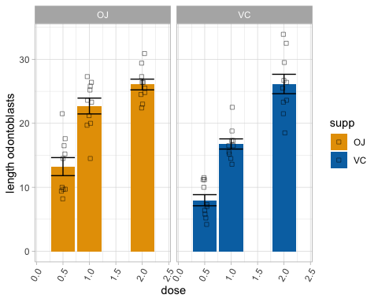

Question 5 Explain the differences and similarities between a vector, matrix, and dataframe. Demonstrate you know how to subset a dataframe in two ways using dataset‘ToothGrowth’ with the prompts below:  
1Subset ToothGrowth to include rows such that supp is equal to VC 2Subset ToothGrowth to include rows such that supp is equal to VC and dose is equal to 0.5 3Subset ToothGrowth to include the values of len such that supp is equal to VC and dose is equal to 0.5

subse1<- ToothGrowth[ which(ToothGrowth$supp=='VC'), ]  
subse2 <-ToothGrowth[ which(ToothGrowth$supp=='VC' & ToothGrowth$dose == 0.5), ]  
subse3 <- subse2[1]  
subse1

## len supp dose  
## 1 4.2 VC 0.5  
## 2 11.5 VC 0.5  
## 3 7.3 VC 0.5  
## 4 5.8 VC 0.5  
## 5 6.4 VC 0.5  
## 6 10.0 VC 0.5  
## 7 11.2 VC 0.5  
## 8 11.2 VC 0.5  
## 9 5.2 VC 0.5  
## 10 7.0 VC 0.5  
## 11 16.5 VC 1.0  
## 12 16.5 VC 1.0  
## 13 15.2 VC 1.0  
## 14 17.3 VC 1.0  
## 15 22.5 VC 1.0  
## 16 17.3 VC 1.0  
## 17 13.6 VC 1.0  
## 18 14.5 VC 1.0  
## 19 18.8 VC 1.0  
## 20 15.5 VC 1.0  
## 21 23.6 VC 2.0  
## 22 18.5 VC 2.0  
## 23 33.9 VC 2.0  
## 24 25.5 VC 2.0  
## 25 26.4 VC 2.0  
## 26 32.5 VC 2.0  
## 27 26.7 VC 2.0  
## 28 21.5 VC 2.0  
## 29 23.3 VC 2.0  
## 30 29.5 VC 2.0

subse2

## len supp dose  
## 1 4.2 VC 0.5  
## 2 11.5 VC 0.5  
## 3 7.3 VC 0.5  
## 4 5.8 VC 0.5  
## 5 6.4 VC 0.5  
## 6 10.0 VC 0.5  
## 7 11.2 VC 0.5  
## 8 11.2 VC 0.5  
## 9 5.2 VC 0.5  
## 10 7.0 VC 0.5

subse3

## len  
## 1 4.2  
## 2 11.5  
## 3 7.3  
## 4 5.8  
## 5 6.4  
## 6 10.0  
## 7 11.2  
## 8 11.2  
## 9 5.2  
## 10 7.0